Yellow Spelling Homework

This week we are learning the ‘e_e’ phoneme.
Practise the words below from the ‘e_e’ spelling list and common words by completing some of the suggestions from the spelling menu.
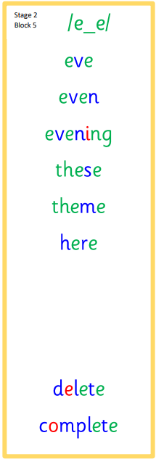
.

Chalk Words | Silly Sentences | Rainbow Writing
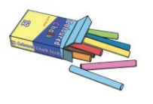  Use chalk to write your words outside. | Use silly sentences using a spelling word in each sentence. Please underline your spelling words. | Use different coloured pencils to write your words three times.

