Orange Spelling Homework

This week we are learning the ‘qu’ phoneme.
Practise the words below from the ‘qu’ spelling list and common words by completing some of the suggestions from the spelling menu.

Passing Practise | Chalk Words | Rainbow Writing
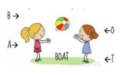  Ask someone to pass a ball with you. Take turns at saying the next letter of the word as you pass. | 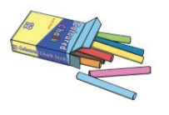  Use chalk to write your words outside.. | Use different coloured pencils to write your words three times.

