Green Spelling Homework

This week we are learning the ‘e_e’ phoneme.
Practise the words below from the ‘e_e’ spelling list and common words by completing some of the suggestions from the spelling menu.
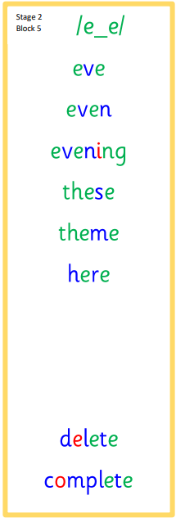
.

Silly Sentences | Spelling Story | Rainbow Writing
Use silly sentences using a spelling word in each sentence. Please underline your spelling words. | 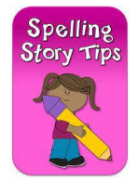  Write a spelling story using each of your spelling words. Be sure to underline your words as you use them. | Use different coloured pencils to write your words three times.

