Blue Spelling Homework

This week we are learning the ‘ou’ phoneme.
Practise the words below from the ‘ou’ spelling list and common words by completing some of the suggestions from the spelling menu.
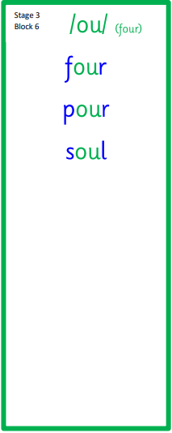

Silly Sentences | Spelling Story | Rainbow Writing
Use silly sentences using a spelling word in each sentence. Please underline your spelling words. | 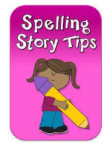  Write a spelling story using each of your spelling words. Be sure to underline your words as you use them. | Use different coloured pencils to write your words three times.

