
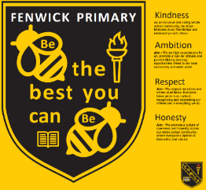
School Improvement Committee
Digital Committee
Minutes
Date of meeting:

What we discussed:
- We made are e-safety guardians have superpowers
- We made a slide about are e-safety guardians



Action Points:
- Share with are classes like p1 p2 p3 p4/5 p5/6 p7.

