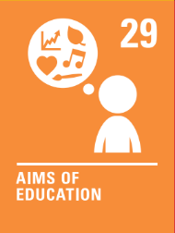

Fenwick Pupil Council
Agenda
Date: | 3rd December 2025
Present: | Mrs McKillop, Mason, Freya, Jim, Emily
Playground – focus for this school year | Mrs McKillop spoke to the Parent Council about meeting to work together with the Pupil Council to work out ideas for the playground.  - Ask Mr Houston for a meeting.  - Ask Parent Council for a meeting
Date of next meeting: | With Mr Houston then a date to be arranged with Parent Council in January

