Sports Scotland School Improvement Committee

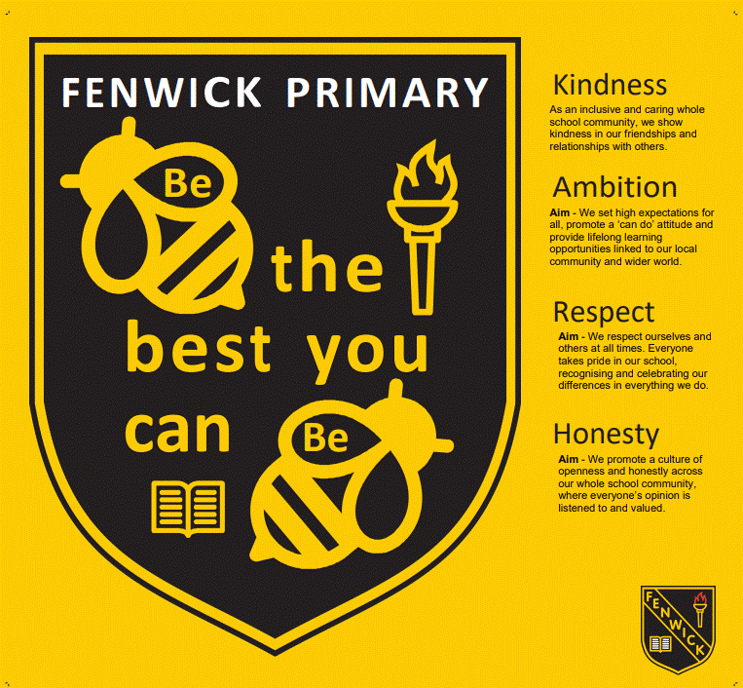

Date:25.9.25

Written by: Mrs Ross

**Who was at the meeting:**

|  |  |  |  |  |  |  |
| --- | --- | --- | --- | --- | --- | --- |
| Tommy  P7 | Tianna  P7 | Naila  P7 | Lily  P7 | Archie  P7 | Colin  P7 | Mrs Ross |
| Erik  P5/6 | Brodie  P5/6 | Finley  P5/6 | Henry  P5/6 | Cole  P5/6 | Lily K  P5/6 | Ilaria  P5/6 |
| Chelsey  P4/5 | Rosie  P4/5 | Cameron P4/5 | Erin  P4/5 | Hannah  P4/5 | Matilda  P4/5 | Chloe  P4/5 |
| Lily P3 | Barry P3 | Kayden P3 | Noah P3 | James P3 | Jervaise P3 | Miss Cunningham |

**Action points:**

* Ideas:
* utilise the field
* Extra curricular clubs – boxing, volleyball . lunch time clubs – football , athletics
* Teach the school how to respect the resources we have
* PE lessons – equipment needed : tennis racquets, badminton racquets (and grips) volley balls, nets, hoola hoops, 7 a side football nets, outdoor throwing bean bags , outside footballs,boxing equipment
* New lines on the courts
* Trampette

**What we discussed:**

* What we think the priorities are for the committee this year
* Vote for Chairperson, Secretary, Media Managers