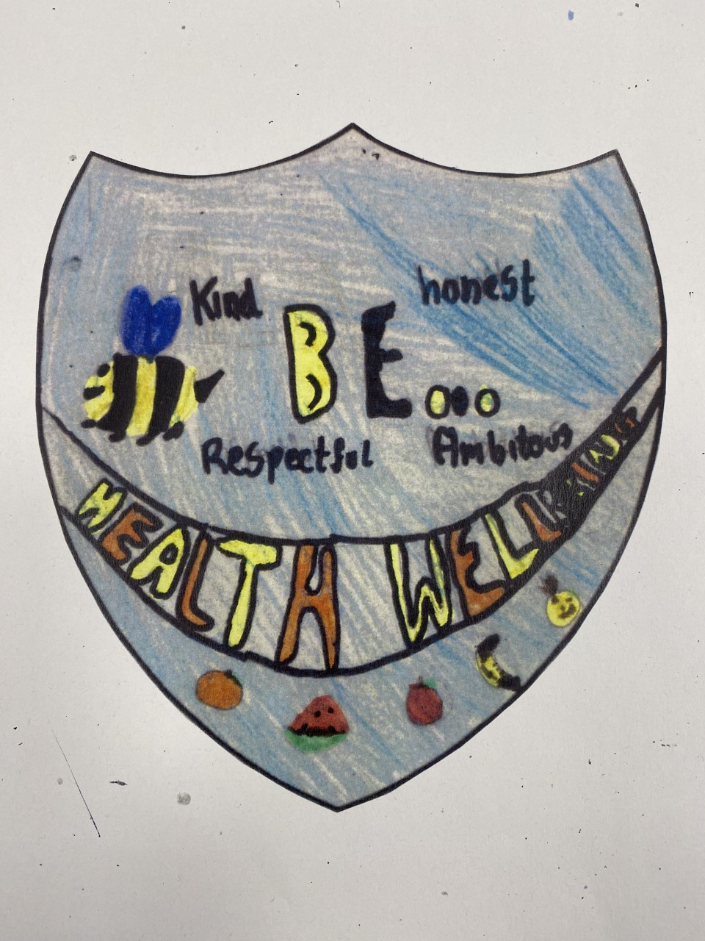
Health and Wellbeing Committee
Minutes

Date:6.10.23
Written by: Mrs Ross
Who was at the meeting:
Samuel Tannahill | Mason Millard | Margaret Stewart
Brodie Fleming | Archie Hynds | Scarlett McPhee
Theo Mitchell Watson | Amy Wilson | Lacey Reid
Abbie Steven | Elvie Donovan | Sienna Townsley
Sophie Mitchell | Kade Hearns | Oscar Chesterman
 | Emily Robinson | Calum Brown
 | Casey Clocherty | Miami Stewart
 | Matthew Wynne
 | Joey Daly

What we discussed:
- Voting for Chair person, Vice Chair, Secretary and Marketing/Media Officer
- Discuss key points for Action Plan 2023-2024
- Photo of Committee for display

Action points:
- Type up Action plan using notes from committee – Mrs Ross
- Meet up one lunchtime to start planning lunchtime clubs – Mrs Ross & committee
- Plan with Mr Houston and CAs wet lunch rooms to help with noise and behaviour in classrooms – Chair and Vice chair to meet with Mr Houston to discuss ideas

