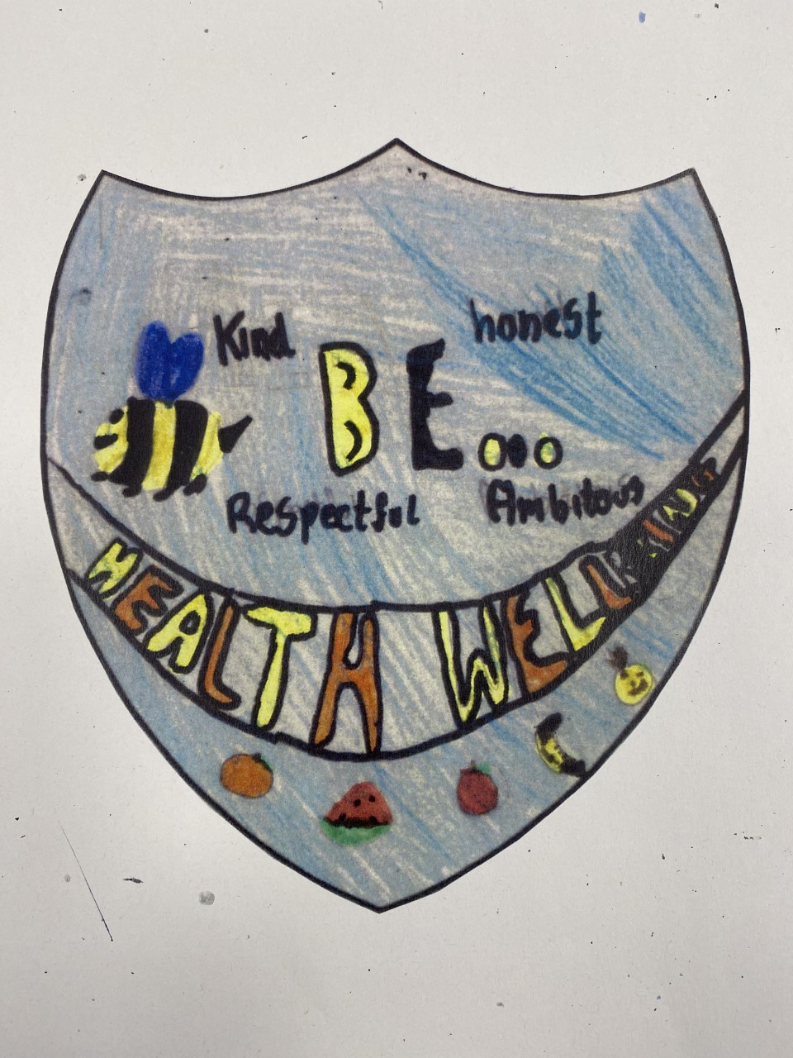
Health and Wellbeing Committee
Minutes

Date:
Written by:
Who was at the meeting:

Mrs Ross Mrs Sweeney Ruaridh Luke Rosie Ellie Renesmee Samuel Theo Regan Mason Crae Murray Elvie Oscar Emily Joey Eoin Sienna Kitty Angel John Cole

What we discussed:
What UNCRC articles are included in our committee : 3 4 7 8 12 13 14 15 17 24 28 29 31
We watched a video about Children’s Mental Health Week
We learned the theme is Let’s Connect
We made hot air balloons about who we are connected to and how they support us
Our lunch time clubs have been a success so we are going to start them again

We are going to add an outdoor club on a Tuesday and Thursday during CMHW

Eoin suggested a worry monster for every class

Action points:
- Organise lunchtime clubs and restart on Wednesday
- CMHW – Tuesday and Thursday outdoor clubs
- Ask Mrs G if she can help with outdoor fitness during CMHW
- Make 2 worry boxes for upper classes
- Find another worry monster
- Explain to classes about worry monsters
- Tell classes about CMHW on 6th February

