Health and Wellbeing Committee
Agenda

Date : 24.1.23

- Discuss UNCRC Articles that relate to what our HWB committee is doing at Fenwick PS and ECC

- Children’s Mental Health Week – watch PPT and video

- Create Hot Air Balloon of people in our life who support our wellbeing and lift us up

- Discuss, review and revise our lunch time clubs

- Ideas for clubs to run during CMHW

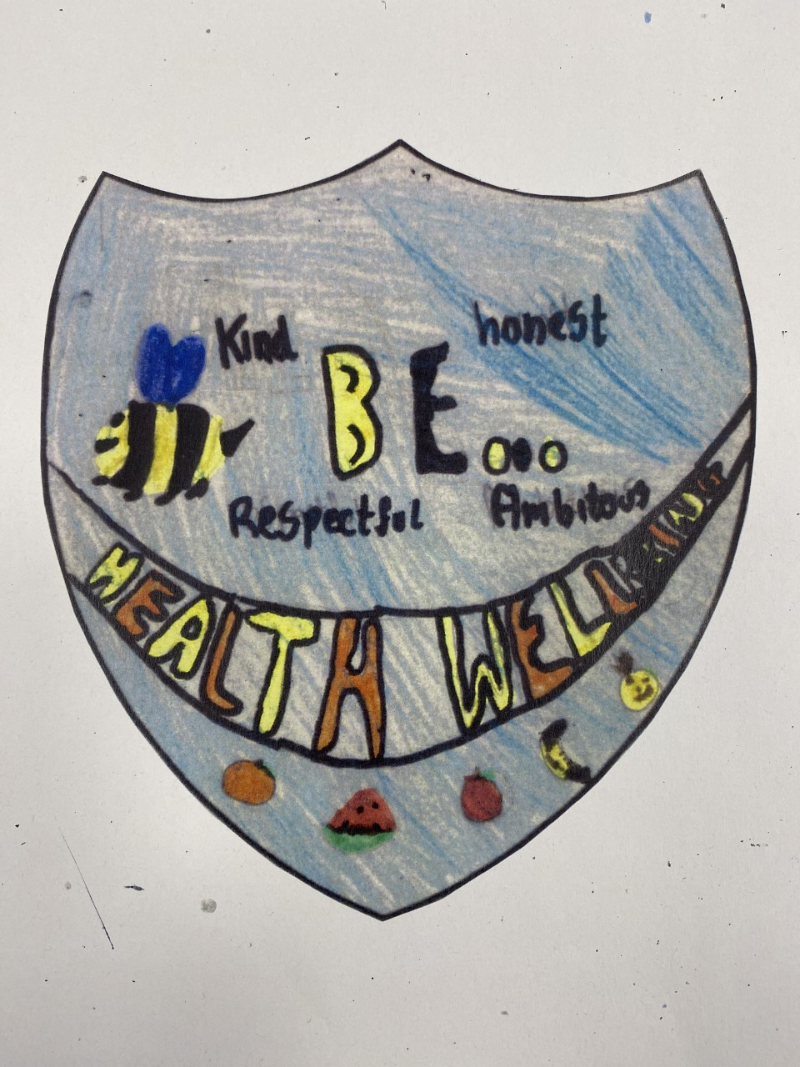
- Worry box

AOB

