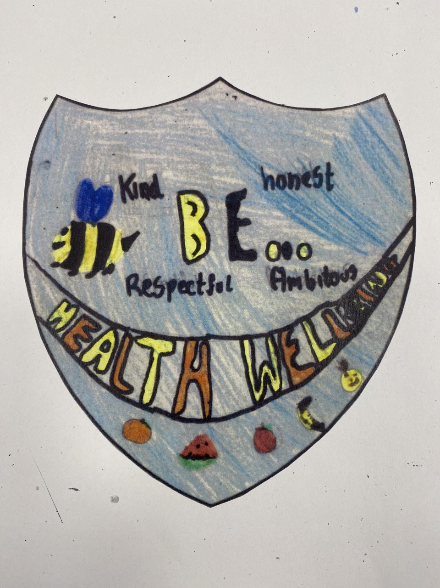
Health and Wellbeing Committee
Minutes

Date: 31.5.23
Written by: Emily R
Who was at the meeting:

Mrs Ross Mrs Sweeney Luke Rosie Ellie Renesmee Samuel Theo Ilaria Regan Mason Crae Murray Elvie Oscar Emily Joey Eoin Sienna Kitty Angel John

Action points:
Create lunch time clubs on Tuesday and Thursday
Work with the eco committee to plan for wellbeing time in the garden
Check all clases have a shanarri poster
Organise fundraisers
Bring animals into school
What we discussed:
We are talking about what we have done and what we should do
We talked about what pupils did to improve the school
We were talking the RRS visit
We talked about what articles are in the health and wellbeing committee

