

KILMARNOCK ACADEMY

Evaluation of PEF Interventions
2022-2023

What is Pupil Equity Funding?

“Pupil Equity Funding (PEF) is additional funding allocated directly to schools and targeted at closing the poverty-related attainment gap. The Scottish Government has committed to this funding as part of the Scottish Attainment Challenge (SAC) programme from 2017/18 up until 2025/26. Pupil Equity Funding is part of the Attainment Scotland Fund (ASF).”- National Operational Guidance 2022

How can it be used?
The funding should be focused on resources, activities and approaches focussed on learners impacted by poverty, which will lead to improvements in literacy, numeracy and support health and wellbeing. Leadership; learning & teaching; and families and communities continue to be recognised as useful organisers to consider when determining interventions and approaches.
Headteachers should use their discretion when deciding which pupils will benefit from Pupil Equity Funding, as well as engaging with teachers, when deciding which approaches would have the most impact for children and young people impacted by poverty.
The following five key indicators may be helpful and should be taken into consideration.
- Attainment
- Attendance
- Inclusion
- Engagement
- Participation
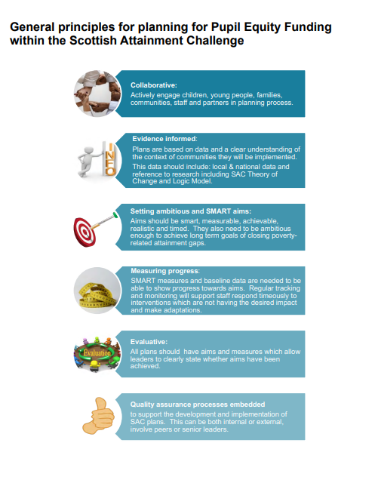

22.23 Consultation Process
The following consultation process took place for the 22.23 PEF Plan. All teaching staff were consulted on PEF as part of the SIP planning and every department submitted a PEF response. All stakeholders and partners were consulted and were asked to complete an e-form. Almost all stakeholders and partners provided feedback. Both Parent Councils and Pupil Forums were consulted.

Kilmarnock Academy 2022-23 SIMD Profile

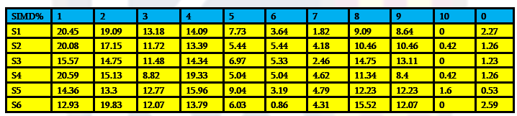

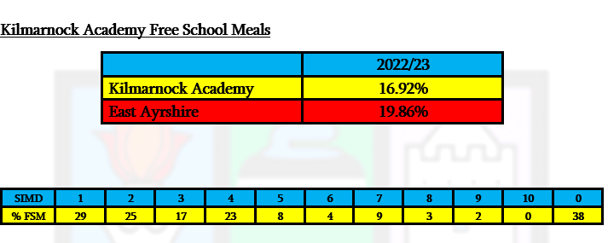

Literacy and Numeracy Intervention
Priority: Raise attainment for all learners across the curriculum with a focus on literacy and numeracy (NIF Driver 1)
Rationale: “ Lower attainment in literacy and numeracy is linked to deprivation throughout primary school. By age 12–14 (S2), pupils from better-off areas are more than twice as likely as those from the most deprived areas to do well in numeracy. Attainment at 16 (the end of S4) has risen overall, but a significant and persistent gap remains between groups”- Closing the Attainment Gap, Joseph Rowntree Foundation
P7 ACEL and Transition data were scrutinised to identify targeted groups. Attendance and SIMD data of this list was analysed to identify pupils with high attendance and low SIMD who would benefit from Primary Specialist. Improvements were tracked through BGE tracking and monitoring and reading ages (using Accelerated Reader)
Organisers: Learning and Teaching/ Families and Communities.
Key Target Area: Attainment
Measures To Track Improvement: Improvements were tracked through BGE tracking and monitoring and reading ages (using Accelerated Reader) three times a year. S3 SNSA and ACEL data use to generate comparisons.
PEF Spend: Joint Campus Primary Specialist to support the closing of the attainment gap by providing Early and First Level Intervention to targeted S1 and S2 pupils as well as supporting transition; Accelerated Reader Programme used to monitor and track reading ages and promote reading engagement at home; SUMDOG subscription (jointly paid by SFL) to support improvement in multiplication tables and spelling, identified numeracy resources
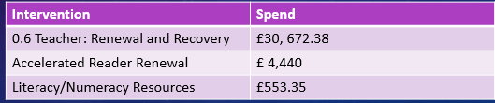
Intended Impact (taken from SIP):
- Improve reading ages, writing, and numeracy levels for targeted groups so that by the end of S3 all pupils have achieved Level 2
- Make 4-5% gains for S3 Level 3 ACEL data in Reading (currently 83%), Writing (currently 81%, and Listening and Talking (currently 87%)
- Make 2% gains for S3 Level 4 ACEL data in Reading (currently 45%), Writing (currently 25%), and Listening/Talking (currently 46%)
- Year on year increases in Reading Ages for targeted groups
Summary of Impact:
- Awaiting ACEL data that will be published in June
- A 15% increase in pupils achieving Level 4 writing (May 2023)
- On average S1 pupils gained six months on their reading ages in a four month period. For pupils in SIMD 1-2, the average increase was 8 months.
- By the middle of S2, pupils have, on average, gained a 1 year 1 month since the start of S1. This was also true for pupils in SIMD 1 and 2
- For S3 pupils that received Primary Specialist intervention in S2 (100% SIMD 1-4, 38% FME): the average reading age increased from 7.9 to 11.8. The average SNSA Band was 8.0 for Reading and 8.2 for Writing which is the national average. Of the targeted pupils, the majority of those with sustained attendance achieved Level 3 in at least one area in Literacy.
- Current S2 pupils that have received Primary specialist intervention in S1 and S2 in Literacy (93% SIMD 1-3): The average reading age increased from 7.2 at the start of S1 to 9.6 in the middle of S2. This is an average increase of 2 years, 4 months. Out of 14 pupils targeted, 12 made gains in their reading ages.
- Current S1 pupils who have received intervention from August 2022 ( 100% SIMD 1-4): The average reading age increased from 7.3 to 8.3. This is an average increase of 1 year.
Collaboration: Joint initiative with James Hamilton Primary, transition meetings with feeder primaries, support from EAST.
Future Considerations: Primary Specialist delivering training to staff in the Literacy and Numeracy group in Early and First Level. SIP Priority for 23.24 for all departments to develop Early/ First Level work.

Improving Pedagogy and Skills
Priority: All young people will achieve their full potential including our most disadvantaged learners (NIF 2)
Rationale: “ The best available evidence that great teaching is the most important lever schools have to improve outcomes for their pupils.” – Educational Endowment Foundation
SLT, Departmental, Pupil Forum and Parent Council minutes reflect the need for high quality learning and teaching.
Organisers: Learning and Teaching/ Leadership
Key Target Area: Attainment and Engagement
Measures To Track Improvement: HGIOS 4 ratings (as recorded in iAbacus) and Pupil Voice will track improvements. Use of tapestry resources are monitored
PEF Spend: PT Pedagogy and Skills, Resources for Tapestry boxes for each classroom, iAbacus self evaluation software
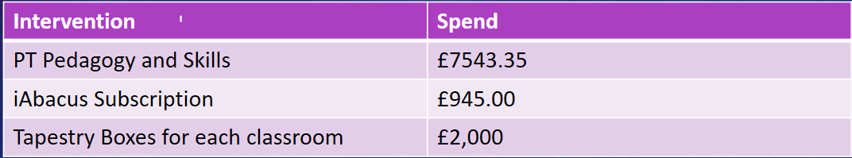
Intended Impact
- School is rated excellent in for QI 2.3- Learning, Teaching and Assessment
- Pupil feedback consistently highlights excellent teaching and learning
- All staff feel confident in delivering high quality teaching and learning including the use of digital technologies
Summary of Impact
- School’s self-evaluation rating is very good for session 22.23
- 100% of pupil feedback agreed or strongly agreed that they were given the opportunity to lead learning.
- 92% of pupil feedback agreed or strongly agreed that they enjoyed learning at school because their teacher uses engaging teaching strategies
- 93% of pupil feedback said that they were given the opportunity to influence what and how I learn through activities such as creating learning intentions and success criteria and through learner conversations.
- 99% of pupil feedback said that that the feedback they receive on their work helps them improve their learning
- All staff trained in the MetaSkills 4 framework to allow a consistent understanding and approach across all subjects. A Baseline survey has been completed which will allow progress through priority to be measured and enable a more focused approach moving forward.
- Learning observations evidence that tapestry techniques are being used to support learning and teaching, however, a wider variety of approaches could be trialled and used more consistently across the school. This should be a focus for next term
- All Learning Facilitators have received refresher training in Tapestry
- All staff have completed online Promethean Training with departmental representatives receiving more advanced training
- All classroom have tapestry boxes and use of tapestry techniques is part of every departmental observation strategy
- Almost all joint leaders are now fully conversant in the use of iAbacus to support self evaluation. Built into the Quality Assurance calendar this session are opportunities to evaluate progress through the Quality Indicators allowing for an improved cycle of action planning and evaluation.
Collaboration: Tapestry Leader (EA Council) and Promethean Leader training
Future Considerations: Training for all staff and Learner Facilitators (including refresher training for new staff and NQTs) ensures skills are embedded across the school.

Raising Attainment
Priority: All young people will achieve their full potential including our most disadvantaged learners (NIF 2)
Rationale: "the poverty-related attainment gap remains wide and inequalities have been exacerbated by Covid-19."- Audit Scotland
Insight 2022 data highlighted that the performance of top 20% in Quintile 1 and 2 was less that East Ayrshire. Attainment gap highlighted in the BGE
Organisers: Leadership/ Learning and Teaching
Key Target Area: Attainment, Participation
Measures to Track Improvement: Insight Data (national and local measures) to identify and evaluate high level targets. Termly tracking and monitoring of Working Grades in Senior Phase to ensure targets are being met. Departmental Impact Reviews will track progress. Whole staff feedback on BGE Benchmarks training. Use of CAT data to set target grades. Supported study engagement. Pupil feedback on supported study
PEF Spend: PT Raising Attainment, Intensive Mentors and resources for pupils receiving intensive mentoring. Supported study bus, study pack resources
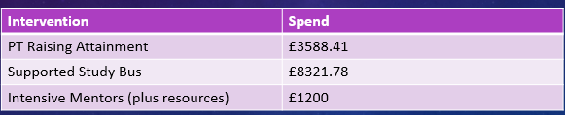
Intended Impact:
- Increase number of pupils achieving 3+ SCQF Level 6 Awards with no attainment gap between the most and least deprived pupils
- Increase number of pupils achieving 3+ A passes at SCQF Level 6 in S5 with no attainment gap between the most and least deprived pupils
- Increase number of pupils achieving 5+ SCQF Level 5 in S4 with no attainment gap between the most and least deprived pupils
- Increase number of pupils achieving 3+ A passes at SCQF Level 5 in S4 with no attainment gap between the most and least deprived pupils
- Increase number of total tariff points of top 20% in S4
- Increase number of total tariff points of top 20% in S5
- Improved attainment in BGE through a whole school understanding and approach to assessing benchmarks
- Improved attendance and engagement at supported study
Summary of Impact:
- High level targets shared with all staff and a focus of each Impact Review. Awaiting Sept Insight Data.
- High level targets shared with all staff
- 34 S4 and S5 Pupils received intensive mentoring with 59% in SIMD 1-4. Meetings were held with all parents and they received weekly updates with study resources purchased as necessary.
- Whole staff BGE Benchmarks sharing understanding event in Feb Inservice
Collaboration: Intensive Mentors were in weekly contact with parents/carers
Future Considerations: Systems established to identify, track and evaluate high level targets and pupils which will be used in future years.

Closing the Gap
Priority: All young people will achieve their full potential including our most disadvantaged learners (NIF 2)/ Placing the Human Rights of every young person at the centre of Education (NIF 5)
Rationale: “ To use education to improve outcomes for children and young people impacted by poverty with a focus on tackling the poverty related attainment gap.” Scottish Attainment Challenge
Analysis of SIMD and Attendance data at all stages including P7 in order to identify targeted groups. SIMD data included in all tracking spreadsheets (BGE/SP). Attendance data monitored throughout the year in order to provide targeted intervention.
Organisers: Leadership
Key Target Areas: Attainment, Attendance, Inclusion
Measures To Track Improvement:. Target and Working Grades at both BGE and SP in order to track progress. Insight data (literacy and numeracy, leaver destinations, improving attainment for all, attainment v deprivation) used to set high level targets. Impact Reviews to analyse progress. Monthly Capturing Attainment reviews as monitored through spreadsheet. Pupil Forum and Parent Council Minutes.
PEF Spend: DHT: Integrated Support with strategic responsibility for improvement planning and policy pertaining to Closing the Gap, PT English backfill
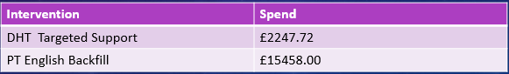
Intended Impact:
- 100% of leavers achieving at least 5 N3 Qualifications
- 100% of leavers achieving Level 4 Literacy and Numeracy (2021-93.81%)
- Increase number of leavers achieving Level 5 Literacy and Numeracy (2021- 75.77%)
- To be above Virtual, East Ayrshire, SWEIC, and National measures for all attainment cohorts
- To continue to be above National Establishment total tariff points for pupils in SIMD 1-3
Summary of Impact (2021/22 Insight Data- Leavers):
- Performance of pupils in SIMD 2 was identified as greater than the National Establishment.
- Performance of pupils in SIMD 3 was higher than the National Establishment
- Performance of pupils in SIMD 1 was marginally lower than the National Establishment
- 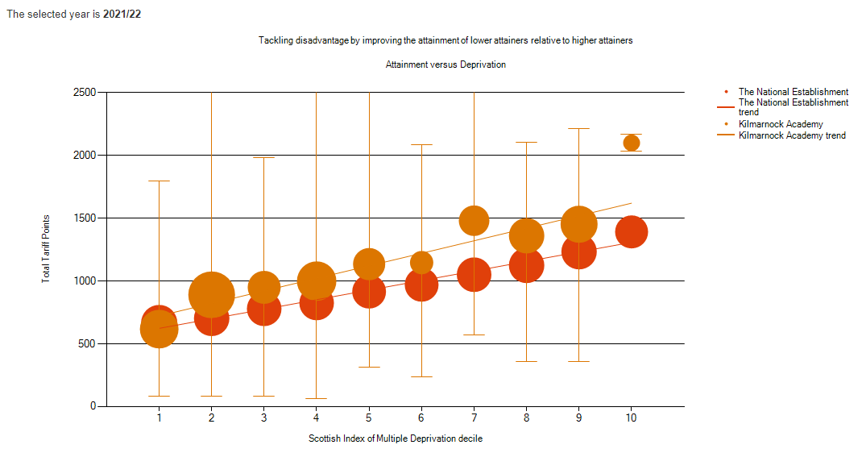
- Performance in Literacy and Numeracy at Level 5 is much greater than Virtual Comparator – 85.34%
- Performance in Literacy and Numeracy at Level 4 is greater than Virtual comparator – 98.28%

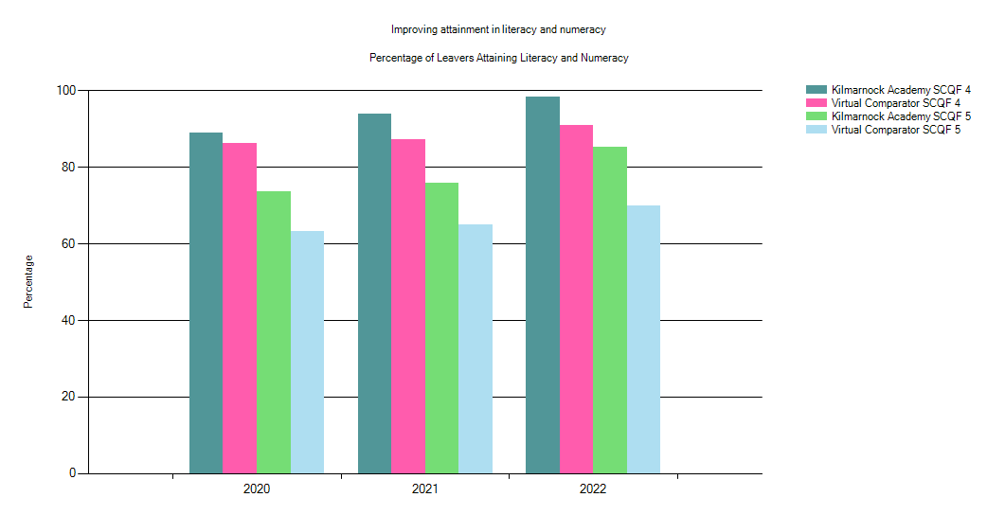

- Performance of all attainment cohorts is above Virtual, East Ayrshire, SWEIC and National Measure
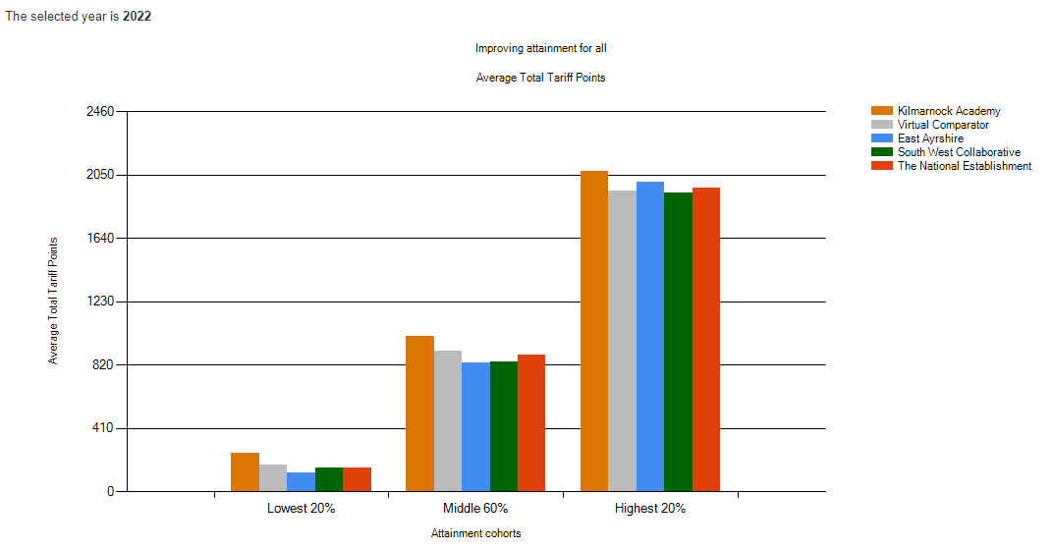

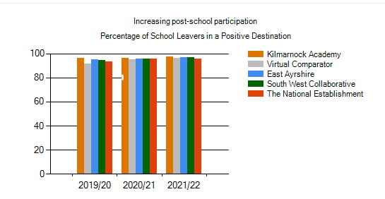
Collaboration: Partnerships with: Connect Support Worker, Homelink Team, Vibrant Communities, SL33 and other agencies to support pupil attainment and attendance.
Future Considerations: Robust systems now in place, role can be subsumed into substantive DHT’s remit.
Positive Relationships
Priority: Improvement in children and young people’s health and wellbeing (NIF 3)/ Placing the Human Rights of every young person at the centre of Education (NIF 5)
Rationale: “: “Punishment doesn't teach better behaviour, restorative conversations do.”.- Paul Dix
Previous PEF Funding used to engage with Pivotal Education. Pupil, Staff and parental feedback highlighted the need for visible consistencies and restorative approaches.
Organiser: Leadership
Key Target Areas: Inclusion, Participation and Engagement
PEF Spend: PT Positive Relationships
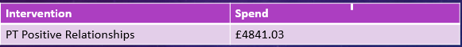
Measures to Track Improvement: The number of referrals are monitored throughout the year as well as the number of restorative conversations. Each learning observations includes feedback on visible consistencies. Pupil voice is captured as part of the Pupil Forum.
Intended Impact:
- Visible Consistencies used by all staff will make pupils feel safe at the school
- Reduction in the number of behaviour referrals
- Improved relationships in school
Summary of Impact:
- Respectful relationships training took place with all staff to relaunch whole school visible consistencies. NQT training delivered as well as for the S6 prefects. The school agreed to retain mobile phone consistencies as well as retain previous consistencies such as meet and greet.
- Led by the PT Positive Relationships, the Positive Relationships Champions are a committed group of young people keen to work on embedding our ethos across the school. They have developed wellbeing resources and activities for Anti-Bullying week and Positive Noticing Day. Next step is to create PSE lessons aimed at promoting positive behaviour amongst S2 towards Prefects. (SIP)
- An enthusiastic Positive Relationships staff group has been created and includes a selection of staff from across departments. Good practice has been shared along with strategies to improve relationships across the school. (SIP)
- Referrals and restorative conversations monitored and feedback for first and second terms provided at SLT in December 2022. Statistics show an increase in the number of restorative conversations compared to 2021/22 session and increased

- requests from individual pupils. Aspire restorative conversations have been well received by the majority of pupils, helping create strong positive relationships with a variety of pupils and in year groups. Decrease in the number of

- referrals from Term 1 to Term 2, due mainly to the increased focus on particular year groups and accelerating next steps by PTs/DHTs. (SIP)
- 98% of pupil feedback from learning observations agreed or strongly agreed that visible consistencies were used by staff and this helped them feel safe.
- 76% decrease in the number of restorative conversations related to bullying
- Collaboration: Previous collaboration with Pivotal Education
- Future Considerations: Maintaining and embedding Positive Relationships Policy so that all staff are confident with restorative conversations and visible consistencies
Improving Parental Engagement
Priority: All young people will achieve their full potential including our most disadvantaged learners (NIF 2)
Rationale: The average impact of the Parental engagement approaches is about an additional four months’ progress over the course of a year. There are also higher impacts for pupils with low prior attainment.” – Education Endowment Fund
Engaging with parents consistently highlighted as a priority in staff and parent consultation process for the SIP.
Organiser: Families and Communities
Key Target Areas: Attendance, Inclusion, Participation
Measures to Track Improvement: Attendance at Parents’ Evening will be tracked and the engagement of parents/carers in SIMD 1-3 will be compared to SIMD 4-10. Number of parents engaging with Satchel One will be monitored. Attendance at Enhanced Transition events as well as pupil attendance throughout the year.
PEF Spend: Electronic Parents’ Night Booking System, Satchel One (Show My Homework) and Enhanced Primary Transition Programme for targeted P7 Pupils.
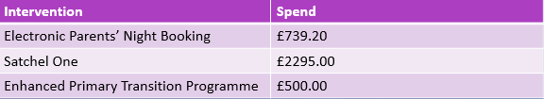
Intended Impact:
- Increase in attendance at Parents’ Evenings with no attendance gap between SIMD 1-3 and SIMD 4-10
- Almost all parents signed up to Satchel One and regularly engaging with app
- Attendance of all targeted parents/carers at Enhanced Primary Transition Programme. Feedback from parents/carers will be positive and pupils will have over 80% attendance in S1.
Summary of Impact
Below is a summary of average Parents’ Evening Attendance

- Parental Engagement with Satchel One: 805 parents signed up
- Enhanced Primary Transition: 25 Families involved in Enhanced Transition Programme with the 88% of families attending majority of the sessions with almost all young people stating they felt more confident about starting Kilmarnock Academy. The majority of parents involved stating they would wish to participate in further parental engagement programmes
- The average S1 attendance for those in the programme was 80.84%. 11/25 pupils have Out of 25 families- 18 attended S1 Parents’ Evening (72%).
Collaboration: School Catering Service, St Andrew’s First Aid. Cross Curricular involvement with Art Department
Future Considerations- Financing of Parental Booking System through school Fund? Consider monitoring the parental involvement with Satchel One. How do we develop our partnership working to support transition- are there other funding streams?

Supporting Wellbeing of Pupils
Priority: Improvement in children and young people’s wellbeing (NIF 3)/ Placing the Human Rights of every young person at the centre of Education (NIF 5)
Rationale: “Children and young people from lower income families had higher levels of emotional difficulties, such as feeling unhappy or worried, being clingy and experiencing physical symptoms associated with anxiety than those from high income households. In other words, these findings indicate that the pandemic has already had a significant impact on the mental health of children and young people, with particular effect on the most deprived families and their children.”- National Children’s Bureau- The Impact of the Covid-19 Pandemic on the Mental Health and Well-being of Children and Young People
Since pupils have returned to full time learning since the end of lockdown, PTsPS have reported an increased number of pupils that require wellbeing intervention.
Organisers: Learning and Teaching/ Families and Communities
Key Target Areas: Attendance, Inclusion, Participation, Engagement, Attainment
Measures to Track Improvement: Attendance statistics monitored in order to target interventions. Number of referrals made to Connect Hub. Boxalls completed to show impact as well as pupil feedback.
PEF Spend: PT Targeted Support, Connect Support Worker, Connect Classroom Assistant, Connect resources
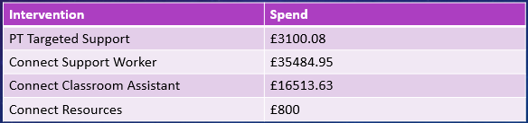
Intended Impact:
- To support a flexible and integrated curriculum for pupils who attend the Inclusion Hub/ Connect Hub, there will be additional staffing allocated which will enable pupils who are on a flexible timetable to be taught by a subject specialist.(SIP Target)
- Increased number of pupils who are able to access the Connect Resource
- Increased number of pupils accessing timetabled classes
- Improved pupil wellbeing
- Improved pupil attendance
- Summary of Impact:
- Appointment of PT Targeted Support in Oct 2023 has led to the creation of small groups in order to improve transition
- The appointment of additional staff has enabled the number of pupils accessing Connect to increase. The Connect resource is now able to support over 50 active referrals.
- Almost all pupils accessing the Connect Hub are back in at least one timetabled class
- Almost all pupils accessing the Connect Support Hub have said that it has supported them attend school.
- Almost all pupils who have accessed the support hub have had improved attendance but this is not always sustained as they transition back to timetabled classes.
Collaboration: The Connect Support Hub works with the Homelink team, Mentoring Developing Officers, Enable and the Educational Psychologist
Future Considerations: Robust systems in place to track referrals. Training of Learning Facilitators to work in the Connect Hub. Continue to have staff ambassadors that will support small group working. Consider whether the Connect Support Worker can be part of core staffing.

Supporting Inclusion
Priority: Improvement in children and young people’s wellbeing (NIF 3)/ Placing the Human Rights of every young person at the centre of Education (NIF 5)
Rationale: “There must be clear values-driven leadership, shared communication, support and challenge at all levels of the system to ensure that the experiences and achievements of children and young people with additional support needs are visible and continue to be improved.” Additional Support for Learning Action Plan
The Morgan ASL Review (2020) outlined the increasing number of pupils with complex individual needs. The Pandemic has exacerbated existing barriers and gaps in learning; particularly for the most deprived pupils and those with ASN. This has resulted in the school’s decision, with consideration of national data and local contexts, to implement a new integrated support strategy that will allow the school to meet the needs of each individual regardless of their overarching high level barrier to learning
Organisers: Learning and Teaching/ Leadership
Measures to Track Improvement: Attendance of pupils with Social Communication Needs will be monitored. Minutes of TAC meetings will track progress and engagement with bespoke plans.
Key Target Areas: Inclusion and Participation
PEF Spend: Three members of Integrated Support Faculty were trained in Dyadic Developmental Practice. Resources for newly created sensory and Social Communication spaces and curriculum.
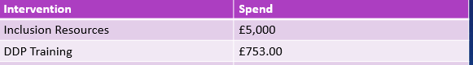
Intended Impact (taken from SIP):
- The school will develop and allocate resources (PEF Funded) in order to meet the needs of pupils with SCN. This will include the development and introduction of a sensory space.
- The school will improve the professional learning and development of staff at all levels in order to support pupils with SCN. Working in partnership with educational partners, the school will develop a calendar of CPL in line with the recommendations outlined in The Morgan ASL Review and Autism Action Plan. This will include: DDP Training for identified staff in the Integrated Support Faculty; training in the Circle Framework for key staff; additional CLPL on ‘We Were Expecting You!” for NQTs and student teachers; and an Introduction to Autism and Inclusive Practice for all staff. This will support confidence for all individuals across the school who are working with pupils with SCN.
- CLPL for Pupil Support assistants in Inclusive Practice and SCN will enhance the targeted support provision of young people.
Summary of Impact:
- 12 members of the ISF have completed an NME book study in order discuss trauma informed approaches. Good practice will be identified and shared within an ISF.
- Two new SCN spaces have been created to meet the needs of pupils with SCN. This includes an individual sensory space and a small adapted classroom used for one to one support. The initial plan of adapting a larger area of the school to be used as a sensory space was not financially viable at this stage.
- To put in place appropriate targeted interventions for pupils with social communication needs, observations of new S1 pupils took place in the first two weeks of August. Professionals meetings took place for all identified pupil and support webs and planning wheels were developed and implemented in order to identify individualised support. Bespoke interventions were put in place for all pupils who required support for Social-Communication Needs with plans reviewed on a regular places: New interventions and supports included: bespoke wellbeing class led by teacher inclusion

- to provide additional support and bespoke timetables overseen by teacher of inclusion. Almost all pupils with identified socio-communication needs have engaged with support and attending the majority of their timetabled classes.
Collaboration: The Support for Learning Department work closely with the Educational Psychologist and resources were bought based on their recommendation
Future Considerations: The investment in physical resources will ensure sustainability for future cohorts

Ensuring Equity
Priority: All young people will achieve their full potential including our most disadvantaged learners (NIF 2)
Rationale: “There is a clear link been family income and educational attainment (Cooper and Stewart, 2013). Specific impacts of income on education outcomes include parents’ ability to pay for resources (e.g. childcare, educational resources (e.g. computers, internet access), transport costs and extra-curricular activities) (White, 2018). Participating in out of-school activities has been evidenced to be associated with positive educational outcomes and children from lowincome households are markedly less likely to take part in organised out-of-school activities (Chanfreau et al., 2016).”- Poverty Related Attainment Gap- A Review of Evidence
34% of pupils in SIMD 1-2, 21% of young people are in receipt of FSM. Cost of the School Day Parental Feedback highlighted the number of families facing financial constraints- particularly those who are not entitled to government support.
. Organiser: Families and Communities
Measures to Track Improvement: Attainment of those in SIMD 1-2 is analysed through Insight. The attendance figures of pupils in this cohort will be analysed as well as participation in extra curricular activities. Feedback from Parental Cost of the School Day Survey helps support improvement.
Key Target Areas: Attendance, Inclusion, Engagement and Participation
PEF Spend: Any cost related to the school day
Intended Impact (taken from SIP)
- In response to new economic and social challenges, the school will, support families to access appropriate guidance and support including support to improve digital literacy and how to access appropriate financial support.
- The school will fully consider and undertake actions aligned to the Scottish Government’s Child Poverty Plan’ Every Child, Every Chance’ and evaluate impact if such actions.
- Relaunch summer pop up shop which will provide uniform and other school resources in order to support families in need and to promote sustainability.
- The school will improve the average attendance of its most disadvantaged pupils
Summary of Impact:
- In line with the Scottish Government’s Poverty Plan, the school launched KA Cares which seeks to address the cost of living crisis. 120 parents responded to The Cost of the School Day survey which identified potential barriers to learning. In response to feedback, the school created a Cost of the School Day page on the school blog which collated all relevant information relating to access to financial support.
- In order to reduce barriers to learning relating to poverty (and to promote sustainability), the school ran a summer pop up shop for school uniform and a campus wide KA Cares event working in partnership with Vibrant Communities and the Financial Inclusion Team. The event provided winter clothing and financial support to families to help with the cost of living crisis.

- For Insight Data- please see Closing the Gap analysis
- Pupil Feedback highlights that the majority of young people feels that the school provides appropriate resources in relation to the school day.
- The average attendance for pupils in SIMD 1-2 is 78.27%
Collaboration: Homelink Team, Vibrant Communities, The Financial Inclusion Team with consultation from wider school community.
Future Considerations: Work in partnership with financial inclusion team to target intervention. Cost of the school day considerations become part of departmental budgets. School fundraising will raise money for the school fund.

Pupil Voice
Priority: Placing the Human Rights of every young person at the centre of Education (NIF 5)
Rationale: “Every child has the right to express their views, feelings and wishes in all matters affecting them, and to have their views considered and taken seriously”- Article 12 UNCRC
Pupils raise concerns through termly Pupil Forums
Data to Support Analysis: Pupil feedback based on minutes from pupil forum and pupil improvement groups.
Organisers: Leadership
Key Target Areas: Participation and Engagement
PEF Spend: The following spend was based on pupil feedback: REDCOIN REWARDS merchandise and cameras to ensure safety in toilets.
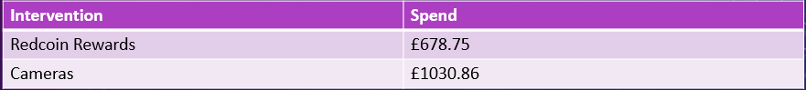
Intended Impact:
- All pupils have a say in the school’s PEF Plan
- All pupils report feeling safe in school
- REDCOIN further embedded and gold coin introduced as part of the rewards system (SIP)
Summary of Impact:
- 98% of pupils surveyed as part of Learning Observations agreed or strongly agreed that they felt safe in school.
- Pupil Forum minutes highlighted that the majority of respondents felt that the cameras had led to improved safety in the toilets.
Collaboration: Pupils involved in participatory budgeting
Future Considerations: The investment in physical resources will ensure sustainability

