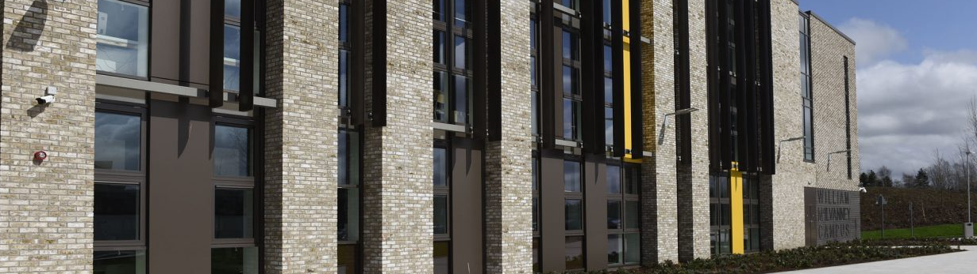
Our School In Context
October 2023

KILMARNOCK ACADEMY

Aspire Together, Achieve Together
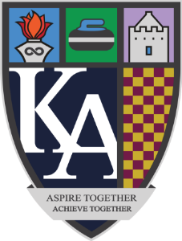

East Ayrshire Council
East Ayrshire is a desirable part of Scotland in which to live. Situated within easy reach of Glasgow and the seaside towns of the west coast, East Ayrshire combines an idyllic mix of rural beauty and urban living for those seeking a high quality of life. It is set in the midst of Scotland’s finest countryside with strong, safe and vibrant communities where everyone has a good quality of life and access to opportunities, choices and high-quality services which are sustainable, accessible and meet people’s needs.
East Ayrshire Council is one of 32 Scottish unitary local authorities, serving a community of over 120,000 residents in West Scotland. We share our borders with our neighbours in South Ayrshire, North Ayrshire and Dumfries and Galloway and our location and ever improving transport links mean that Glasgow, Ayr, Dumfries, East Kilbride and Paisley are within easy reach.
Learning- We are committed to ensuring that children and young people have the best possible start in life and that this follows through into education and employment. We believe that high quality learning and teaching underpins this outstanding successes that our learnings achieve and our workforce experience high quality leadership, support and professional opportunities.
This Education Service is responsible for the legal discharge of the Council’s function as an Education Authority under the Education (Scotland) Act 1980 as amended and incorporates all Early Years and Childcare Services and school services (i.e. 0-18 years). This reconfigured service will ensure that there is enhanced continuity to the educational services provided to children and young people. From the early years through to primary and secondary education and beyond. Focus will be on raising educational attainment, achievement and equipping our young people for the world of work.
The Council has invested heavily in Education infrastructure over the last few years and plans are currently in hand to replace a further 12 schools with new state of the art facilities.
Housing- East Ayrshire is an excellent choice for anyone wishing to purchase an established property or a new property. Excellent quality housing at affordable prices is available throughout the area.
Health- The area is well served by excellent health facilities- GP practice and Health Centre primary care facilities and secondary care facilities in the form of University Hospital Crosshouse in Kilmarnock, East Ayrshire Community Hospital in Cumnock and Kirklandside Community Hospital in Kilmarnock.
Leisure- East Ayrshire boasts an excellent range of sporting and leisure activities including a range of sports and fitness centres, the first-class Galleon Centre offering leisure pool, ice-skating rink, bowling hall, and fitness suite with Visions Centre in Cumnock offering leisure pool and fitness suite. The Ayrshire Athletics Arena in Kilmarnock is set amongst a sporting environment of athletics, cricket, rugby, judo, gymnastics and football facilities. There’s a multi-screen cinema, arts venues, extensive golfing, all weather tennis facilities and 450 square miles of countryside and beautiful country parkland providing a place for blissful escape on long rambling walks or cycle rides on rights of way and national cycle routes. It’s also the perfect destination for wildlife lovers.
Shopping- Kilmarnock town centre is compact, stylish and accessible with a mix of large stores and speciality shops. Independent retailers throughout East Ayrshire, large and small, traditional and modern, believe in the highest standards of personal service to their customers. Other quality retailers are within easy reach at Glasgow and the rest of Ayrshire.
Food and Drink- Eating out in East Ayrshire offers a wide choice of formal and casual dining opportunities, with many establishments making best use of local produce. The area also has strong traditional links with the food and drinks industry, with whisky, spring water and traditional Scottish foods all produced locally.
Economy- Recently there have been major changes in the local and national economy. East Ayrshire is responding to these changes so that it remains a competitive place for the future. The aim of East Ayrshire’s partners in economic development is
of vocational to above the Scottish average.
Transport- The area’s transport links boast a network of fast motorway links, dual carriageway and rail services. East Ayrshire is within a 30 minute drive of Prestwick Airport and within reasonable travelling distance of the major airports in Glasgow and Edinburgh.
Our Vision
“East Ayrshire will be a place with strong, vibrant communities where everyone has a good quality of life and access to opportunities, choices and high-quality services which are sustainable, accessible and meet people’s needs.”
Since it was formed in 1996, East Ayrshire Council has rapidly established its own and distinctive identity as a Council dedicated to the people of its area. Here effective service delivery and improvement of provision have been the hallmarks. Servicing a diverse area of rural and urban settlements everyone is entitled to the best the Council can offer.
Education Services
Primary and Secondary Education is provided principally through the 51 primary, secondary and special schools run by the Council. The largest schools have rolls of approximately 1240 children, while the smallest have less than 26 pupils. Early education and childcare is developed through 33 centres, some of which are standalone, while others are integrated with primary schools. Gaelic Medium Education is presently delivered from the early years through to secondary at the William McIlvanney Campus in Kilmarnock.
The policy of the Council is wherever possible to integrate all children into mainstream setting. There are, however, 3 special schools and a number of specialist bases attached to mainstream schools. In addition, the East Ayrshire Support Team (EAST) provides a range of support to young people.
Educational Psychology Services are provided by a team based at Civic Centre, Kilmarnock. The Creative Minds Team supports specific aspects of the curriculum development including music instruction, enterprise education and cultural coordinators.
The Education Service supports the vision, aims and objectives of the Scottish Government in the development and sustainability of high quality, integrated services that give children and young people the opportunity to have the best possible start in life.
The Education Service will comprise:
- Schools and early childhood centres
- Early Education and Childcare
- Opportunities for All
- Support for children with additional support needs including East Ayrshire Support Team (EAST), Special Schools and Supported Learning Centres, out with placements and commissioned services.
- Educational Psychology Services
- Specialist educational support services, including instrumental music services, creative minds team, outdoor education and direct support for the curriculum
- Technicians Service

The Education Service within East Ayrshire Council has recently transformed its education management arrangements to ensure that educational establishments are supported and empowered to improve attainment and close the gap. This new and innovative approach to the management and leadership of education services will ensure that educational establishments are equipped to respond effectively to the current and emerging demands and local and national drivers for change facing the Education Service, for example:

- The Children and Young People (Scotland) Act 2014
- Education (Scotland) Act 2016
- Developing Scotland’s Young Workforce
- National Improvement Framework for Scottish Education
- The Early Years Framework
- Gaelic Language Plan
- Scottish Attainment Challenge
- Raising Attainment for All
- Attainment for Looked After Children

Within East Ayrshire, we recognise that inequalities are caused by a fundamental inequity in the distribution of power, money and resources.
In 2016, we were selected by the Scottish Government as one of nine Scottish Challenge Authorities to deliver a focused and accelerated programme of improvement, targeting activity in literacy, numeracy, health and wellbeing across the Council area.
It supports and complements the broader range of initiatives and programmes undertaken by the Council to ensure that all of East Ayrshire’s children and young people reach their full potential.
The Service Improvement Plan 2018-2021 sets out our vision to ‘inspire, support and challenge all children and young people to be the best that they can be.’
It provides a framework for the work of the East Ayrshire and showcases how the Council will develop and monitor its services to schools, teachers, parents, young people and children as we move towards our goal of improving educational achievement.
We are committed to delivering a challenging programme of work with performance targets in relation to:
- Raising standards for all
- Closing the performance gap, increasing access and equality to excellent education services
- Developing the education workforce
- Improving the learning environment and
- Transforming the governance and management of education.
This is a further step in the exciting journey of organisational transformation and modernisation.
We are committed to continuously improving educational outcomes for all our children and to ensuring equality access to excellent education services. We now have a unique opportunity to shape the future of education services for the benefit of generations to come.


Kilmarnock Academy
Kilmarnock Academy opened in the new William McIlvanney Campus in April 2018 which merged Kilmarnock Academy and James Hamilton Academy. Kilmarnock Academy is a non-denominational school with a very proud tradition, and many of our students have gone on to achieve acclaim in their field of work. Most notably, Kilmarnock Academy is the only school in Scotland to boast two Nobel Prize winners as former students. In fact only Eton competes with this tremendous accolade. Indeed the school also boasts five Moderators of the Church of Scotland, the current head of the RAF and many sporting, artistic and musical successes. We strive to ensure all pupils are challenged to achieve their full potential in a nurturing environment of trust and mutual respect. The positive ethos at Kilmarnock Academy allows all kinds of learning to flourish: an environment in which all of our young people can develop their own personalities, talents and mental and physical abilities to the full, both educationally and socially, in cultural, sporting and leisure pursuits. At Kilmarnock Academy we seek for our pupils an education which will meet their needs, and which will prepare then to take their place in society and in the ever changing world of work. For this, they will need to develop competence in a wide range of skills, a sense of self-reliance and, increasingly, the ability to adapt to changing circumstances. Our values underpin all aspects of our school community and in 2019 we launched our exciting new RED COIN rewards’ system. Our motto is: “Aspire Together, Achieve Together.” which reflects not only the inclusive and nurturing environment of our school community but our high expectations for all of our young people.
As such the Kilmarnock Academy vision for our young people is set out as follows:
“Kilmarnock Academy strives, as a community, to ensure that all young people reach their full potential and have opportunities to achieve qualifications, learn new skills, develop as individuals and gain key employability experiences within a nurturing environment.”
One of the first pieces of collegiate activity which the new school community of staff and pupils undertook was to establish a set of core values that now underpins the school vision. These values are:
- Respect
- Valuing one another and treating everyone fairly
- Determination
- Encouraging perseverance and promoting a can-do attitude
- Compassion
- Showing sympathy, kindness and a willingness to help others
- Integrity
- Being true to yourself, honest and representing yourself in a positive way
Catchment
The school currently serves the town centre area and east side of Kilmarnock. In particular, the school is associated with Loanhead, Whatriggs, James Hamilton and Onthank primary schools. A number of parents from out with the catchment area have also chosen to make placing requests for their child to attend the school.
There are several schools which are part of the Kilmarnock Education group. They include:
James Hamilton Primary, Kilmarnock | Lorraine Dougan, Head Teacher
Onthank Primary, Kilmarnock | Alison Wright, Head Teacher
Whatriggs Primary, Kilmarnock | Diane MacKinnon, Head Teacher
Loanhead Primary, Kilmarnock | Amanda Milne, Acting Head Teacher
Staff
Appointed in January 2017, David Rose is the Head Teacher of Kilmarnock Academy. He is supported by 4 Depute Head Teachers and 1 DHT: Integrated Support (PEF funded), 9 Principal Teachers (Curriculum), 8 Principal Teachers of Pupil Support, 1 Principal Teacher of Support for Learning, and a Principal Teacher for Inclusion (SAC Funded). Our staffing entitlement is currently 82.2 FTE. There is also 1FTE Gaelic, 0.2 FTE DYW and 2FTE Inclusion funded teachers. There are four Principal Teachers funded by PEF who are leading initiatives in: Raising Attainment and Achievement; Pedagogy and Skills; Restorative Approaches; and Positive Destinations. There is also a 0.6 PEF funded teacher specialising in Literacy and Numeracy.
As well as teaching staff, we also have: 14 Classroom Assistants ( 12 Core and 2 Inclusion Funded), 1 Connect Support worker and Classroom Assistant (PEF Funded), 2 Inclusion Support Workers (SAC Funded), 2 Homelink Workers, 2 Careers’ Advisors, 1 Librarian, 2 Educational Pyschologists, and 1 Campus Police Officer working within the school. We also have Mentoring Developing Officers, a Financial Inclusion Officer, an Attendance Support Worker (PEF Funded), an ESOL teacher, lecturers from Kilmarnock College, and music instructors working in the school.
- Mr David Rose (HT)
SENIOR LEADERSHIP TEAM
- Mrs Angela Brownlie (Wallace House)
- Mrs Elaine Dykes/ Mr Chris Hodge (Burns House)
- Mrs Andrea Mossie (Fleming House)
- Mrs Claire Wallace (Orr House)
- Mrs Hayley Fitzpatrick (DHT: Integrated Support)

- Burns House: Mr Stewart Colville (B1)/ Mr Stuart Cartner (B2)
PRINCIPAL TEACHERS OF PUPIL SUPPORT
- Fleming House: Mr Chris Cowan (F1)/ Mrs Allana Simpson and Mr Robin Erskine (F2)
- Orr House: Mrs Asmara Azeem(O1)/ Mrs Lorna Snodgrass (O2)
- Wallace House: Mrs Kirsty Dalgleish (W1)/ Mrs Gemma Clark (W2)

PRINCIPAL TEACHER OF SUPPPORT FOR LEARNING

- Mrs Karen Dale

- Art, Home Economics and Creative Industries: Mrs Gillian Gabriel
PRINCIPAL TEACHERS OF CURRICULUM
- English and Literacy: Miss Colette Gribben (Acting)
- Maths and Numeracy: Mrs Michele Johnston and Mr Chris Hodge
- Modern Languages and Gaelic: Mr Gary Reid
- Performing Arts: Mrs Rachel Hyslop
- Physical Education and Outdoor Learning: Mr Stuart Edgar
- Science and Stem: Mrs Sarah Wright (Acting)
- Social Subjects, RME, and Citizenship: Ms Fiona Milne
- Technologies and Skills for Work: Mrs Jayde Malloch

- Attainment and Achievement: Mr Stewart Struthers
PRINCIPAL TEACHERS:
(PEF FUNDED)
- Pedagogy and Skills: Miss Bethany McGrath
- Restorative Approaches: Mrs Katy Noakes
- Positive Destinations: Mr Cameron McClurg

PRINCIPAL TEACHER OF INCLUSION (SAC FUNDED)
-Mr Scott Dunlop

SIMD Profile
SIMD is the official tool for finding the most deprived areas in Scotland SIMD20 was published in January August 2020. SIMD:
- shows where Scotland’s most deprived areas are, so organisations know where their work can have the biggest impact
- is a relative measure of deprivation across small areas in Scotland
- looks at multiple deprivation. ‘Deprived’ does not just mean ‘poor’ or ‘low income’. It can also mean people have fewer resources and opportunities, for example in health and education.
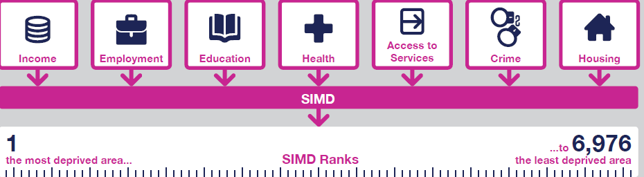

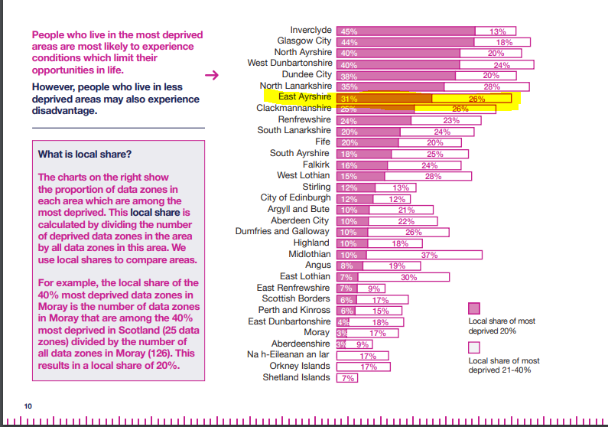

Kilmarnock Academy Profile: 2023/24
Roll
Year Group | S1 | S2 | S3 | S4 | S5 | S6 | Total
2016/17 | 222 | 240 | 221 | 216 | 176 | 95 | 1170
2018/19 | 213 | 222 | 240 | 221 | 185 | 119 | 1200
2019/20 | 243 | 218 | 211 | 236 | 180 | 118 | 1206
2020/21 | 252 | 242 | 215 | 215 | 202 | 101 | 1227
2021/22 | 244 | 221 | 215 | 237 | 184 | 135 | 1261
2022/23 | 219 | 239 | 243 | 237 | 187 | 115 | 1244
2023/24 | 259 | 216 | 238 | 238 | 201 | 112 | 1264

SIMD PROFILE BY DOMAIN (2022/2023 CENSUS)
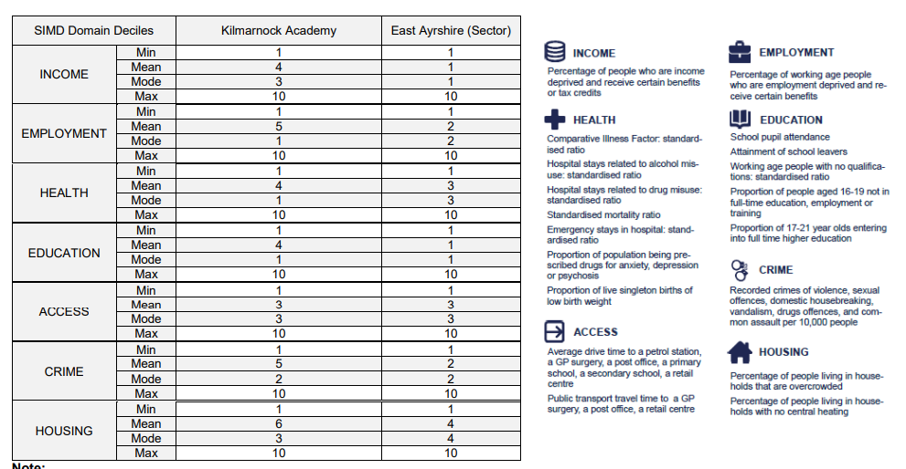

SIMD | 1 | 2 | 3 | 4 | 5 | 6 | 7 | 8 | 9 | 10 | 0
PUPILS | 207 | 213 | 150 | 190 | 80 | 55 | 45 | 153 | 140 | 4 | 29
% | 16.35 | 16.82 | 11.85 | 15.01 | 6.32 | 4.34 | 3.55 | 12.09 | 11.06 | 0.32 | 2.29

SIMD% | 1 | 2 | 3 | 4 | 5 | 6 | 7 | 8 | 9 | 10 | 0
S1 | 12.02 | 17.44 | 14.73 | 13.95 | 5.43 | 3.49 | 4.26 | 13.57 | 11.63 | 0 | 3.49
S2 | 20.28 | 17.51 | 13.36 | 13.82 | 7.37 | 3.23 | 2.3 | 10.14 | 8.29 | 0 | 3.69
S3 | 21.34 | 18.41 | 11.3 | 13.81 | 5.44 | 4.6 | 3.77 | 9.21 | 10.46 | 0.42 | 1.26
S4 | 15.48 | 15.48 | 11.3 | 14.64 | 7.11 | 5.44 | 2.09 | 14.64 | 12.55 | 0 | 1.26
S5 | 14.93 | 17.91 | 9.95 | 18.91 | 5.47 | 5.47 | 4.48 | 10.95 | 9.45 | 0.5 | 1.99
S6 | 12.5 | 11.61 | 8.04 | 16.07 | 8.04 | 3.57 | 5.36 | 15.18 | 16.07 | 1.79 | 1.79

Kilmarnock Academy SIMD Profile vs East Ayrshire (SIMD 1&2)
 | 2018/2019 | 2019/20 | 2020/21 | 2021/22 | 2022/23 | 2023/24
Kilmarnock Academy | 38.8% | 38.78% | 33% | 34.85% | 34.17% | 33.17%
East Ayrshire | 35.8% | 33.69% | 31% | 32.01% | 31.94% | 31.66%

Kilmarnock Academy Free School Meals
 | 2022/23 | 2023/24
Kilmarnock Academy | 16.92% | 18.33%
East Ayrshire | 19.86% | 19.08%

SIMD | 1 | 2 | 3 | 4 | 5 | 6 | 7 | 8 | 9 | 10 | 0
% FSM | 33 | 22 | 22 | 24 | 10 | 5 | 9 | 6 | 1 | 0 | 47

Kilmarnock Academy Additional Support Needs vs East Ayrshire
 | 2018/2019 | 2019/20 | 2020/21 | 2021/22 | 2022/23 | 2023/24
Kilmarnock Academy | 23.9% | 24.96% | 21.52% | 22.65% | 24.2% | 34.3%
East Ayrshire | 28.9% | 29.1% | 27.88% | 26.9% | 26.8% | 31.0%

Kilmarnock Academy Looked After and Accommodated vs East Ayrshire*
*Census data does not include Previously Looked After for 2021/22
 | 2018/2019 | 2019/20 | 2020/21 | 2021/22 | 2022/23 | 2023/24
Kilmarnock Academy | 2.21% | 2.24% | 2.20% | 2.50% | 4.4% | 1.89%
East Ayrshire | 5.8% | 5.4% | 2.31% | 2.0% | 3.5% | 3.7%

Kilmarnock Academy Attendance vs East Ayrshire
Attendance Rates (%) | 2017/18 | 2018/19 | 2019/20 | 2020/21 | 2021/22 | 2022/23
Kilmarnock Academy | 89.13 | 89.43 | 89.43 | 90.37 | 85 | 83
East Ayrshire | 92.2 | 90.0 | 89.6 | 90.64 | 86 | 85
Kilmarnock Academy SIMD 1&2 Pupils | 86.79 | 85.56 | 86.41 | 87.38 | 80 | 77.8
East Ayrshire SIMD 1&2 Pupils | 90.2 | 85.5 | 85.9 | 87.36 | 81 | 80.2
Kilmarnock Academy SIMD 3-10 Pupils | 91.38 | 90.56 | 90.60 | 92.02 | 87 | 87.9
East Ayrshire SIMD 3-10 Pupils | 93.3 | 91.2 | 90.9 | 92.19 | 88 | 90.6

Kilmarnock Academy Exclusions vs East Ayrshire
Number of Exclusion Incidents | 2018/19 | 2019/20 | 2020/21 | 2021/22 | 2022/23
Kilmarnock Academy | 3 | 0 | 0 | 0 | 3
East Ayrshire (secondary sector) | 156 | 84 | 123 | 195 | 222

Kilmarnock Academy Attainment Profile: BGE

S3 Achievement of a Level *
*In years 2019/20 and 2020/21- no teacher judgement data was provided to the SG

S3 Numeracy
 | 15/16 | 16/17 | 17/18 | 18/19 | 21/22 | 22/23
S3 % Achieved Third Level (or above) | 94 | 79 | 86 | 86 | 86 | 90
East Ayrshire (%) | 87 | 83 | 90 | 89 | 90 | 88
S3 % Achieved Fourth Level | 40 | 38 | 63 | 61 | 63 | 63
East Ayrshire % | 48 | 49 | 59 | 69 | 64 | 65

S3 Reading
 | 15/16 | 16/17 | 17/18 | 18/19 | 21/22 | 22/23
S3 % Achieved Third Level (or above) | 83 | 94 | 82 | 81 | 85 | 85
East Ayrshire (%) | 77 | 83 | 86 | 83 | 86 | 87
S3 % Achieved Fourth Level | 37 | 61 | 24 | 37 | 46 | 59
East Ayrshire % | 22 | 40 | 46 | 49 | 54 | 59

S3 Writing
 | 15/16 | 16/17 | 17/18 | 18/19 | 21/22 | 22/23
S3 % Achieved Third Level (or above) | 78 | 93 | 81 | 74 | 84 | 85
East Ayrshire (%) | 71 | 82 | 84 | 80 | 84 | 86
S3 % Achieved Fourth Level | 27 | 48 | 18 | 24 | 27 | 59
East Ayrshire % | 20 | 35 | 41 | 45 | 54 | 61

S3 Listening and Talking
 | 15/16 | 16/17 | 17/18 | 18/19 | 21/22 | 22/23
S3 % Achieved Third Level (or above) | 84 | 90 | 82 | 76 | 87 | 91
East Ayrshire (%) | 98 | 96 | 95 | 86 | 90 | 89
S3 % Achieved Fourth Level | 19 | 54 | 7 | 23 | 46 | 60
East Ayrshire % | 46 | 75 | 28 | 46 | 54 | 61

SNSA RESULTS 2022/23

Kilmarnock Academy Attainment Profile 2022/23: Senior Phase

The following INSIGHT Results are based on Local Measures- published September 2023

Improving Attainment for All: Local Benchmark Measure
Please note tariff points are cumulative
S4:
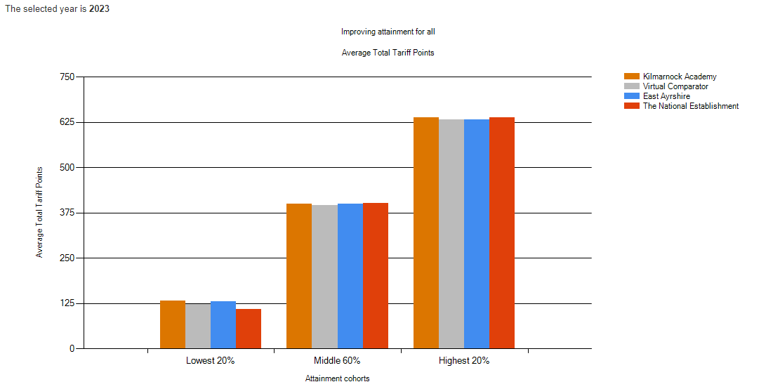
 | Year | Lowest 20% | Middle 60% | Highest 20% | Number in Cohort
Kilmarnock Academy | 2023 | 132 | 400 | 639 | 237
Virtual Comparator | 2023 | 122 | 395 | 632 | 2370
East Ayrshire | 2023 | 131 | 401 | 632 | 1239
National | 2023 | 109 | 402 | 638 | 57053
Kilmarnock Academy | 2022 | 173 | 417 | 637 | 212
Virtual Comparator | 2022 | 123 | 405 | 619 | 2120
East Ayrshire | 2022 | 131 | 417 | 632 | 1264
National | 2022 | 112 | 400 | 624 | 55044

S5:
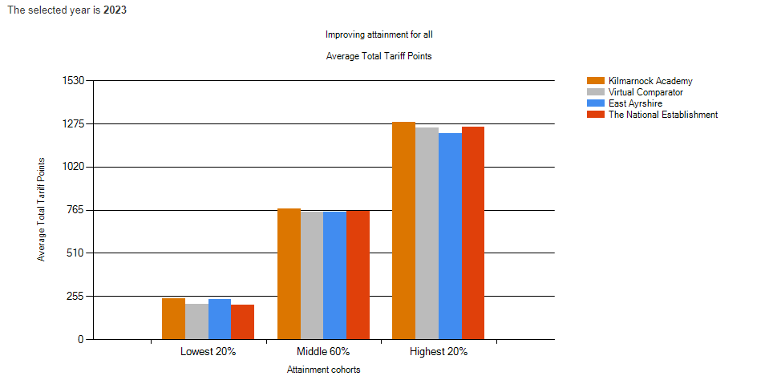

 | Year | Lowest 20% | Middle 60% | Highest 20% | Number in Cohort
Kilmarnock Academy | 2023 | 243 | 773 | 1284 | 188
Virtual Comparator | 2023 | 210 | 751 | 1250 | 1880
East Ayrshire | 2023 | 235 | 755 | 1220 | 1065
National | 2023 | 202 | 761 | 1256 | 48317
Kilmarnock Academy | 2022 | 283 | 783 | 1227 | 183
Virtual Comparator | 2022 | 228 | 733 | 1209 | 1830
East Ayrshire | 2022 | 180 | 734 | 1221 | 1048
National | 2022 | 208 | 756 | 1245 | 47430

S6:
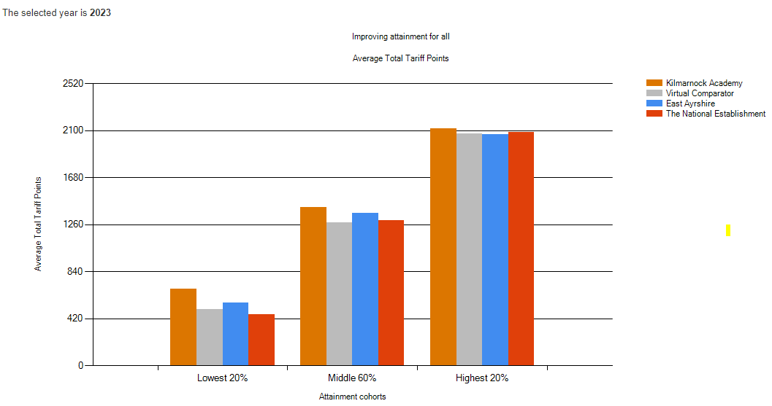
 | Year | Lowest 20% | Middle 60% | Highest 20% | Number in Cohort
Kilmarnock Academy | 2023 | 685 | 1414 | 2121 | 116
Virtual Comparator | 2023 | 503 | 1280 | 2072 | 1160
East Ayrshire | 2023 | 561 | 1362 | 2068 | 634
National | 2023 | 459 | 1297 | 2084 | 31865
Kilmarnock Academy | 2022 | 576 | 1414 | 2175 | 142
Virtual Comparator | 2022 | 508 | 1316 | 2090 | 1420
East Ayrshire | 2022 | 479 | 1333 | 2135 | 698
National | 2022 | 462 | 1310 | 2091 | 33621

Attainment v Deprivation:
S4:
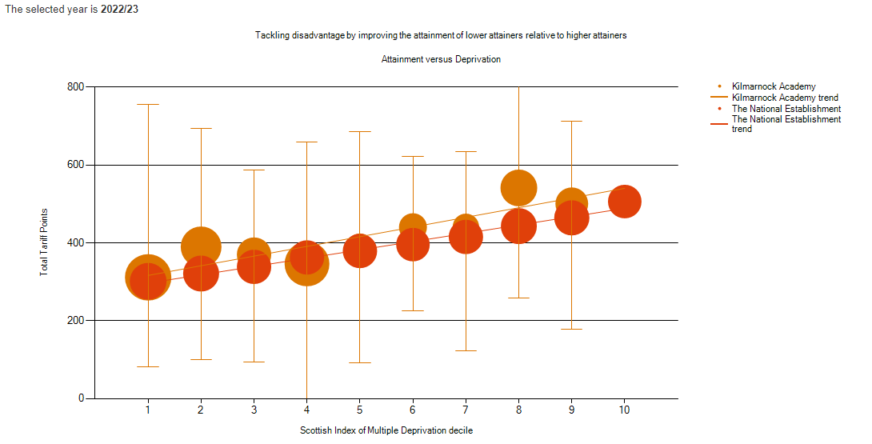
Establishment | Number in Cohort | SIMD 1  Average | SIMD 2  Average | SIMD 3  Average | SIMD 4  Average | SIMD 5  Average | SIMD 6  Average | SIMD 7  Average | SIMD 8  Average | SIMD 9  Average | SIMD 10  Average
Kilmarnock Academy | 237 | 312 | 390 | 370 | 346 | 390 | 441 | 442 | 541 | 501 | 0
National | 57053 | 302 | 321 | 339 | 363 | 379 | 396 | 416 | 443 | 465 | 506
S5:
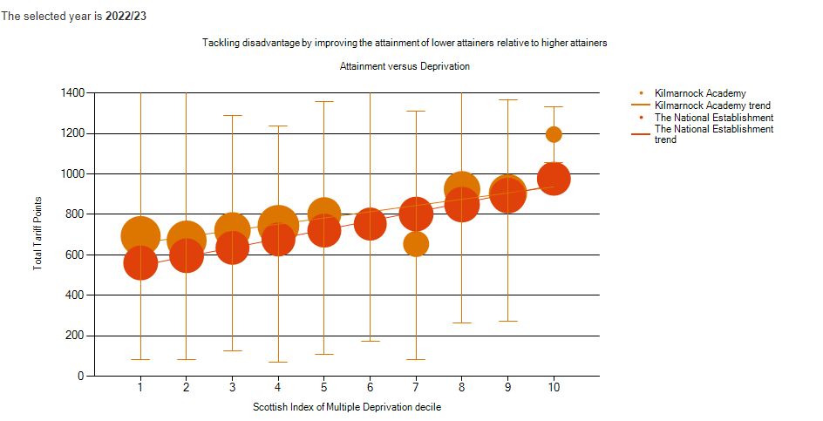

Establishment | Number in Cohort | SIMD 1  Average | SIMD 2  Average | SIMD 3  Average | SIMD 4  Average | SIMD 5  Average | SIMD 6  Average | SIMD 7  Average | SIMD 8  Average | SIMD 9  Average | SIMD 10  Average
Kilmarnock Academy | 188 | 694 | 672 | 722 | 744 | 802 | 751 | 654 | 924 | 906 | 1196
National | 48317 | 561 | 596 | 636 | 677 | 721 | 753 | 802 | 849 | 894 | 977

S6:
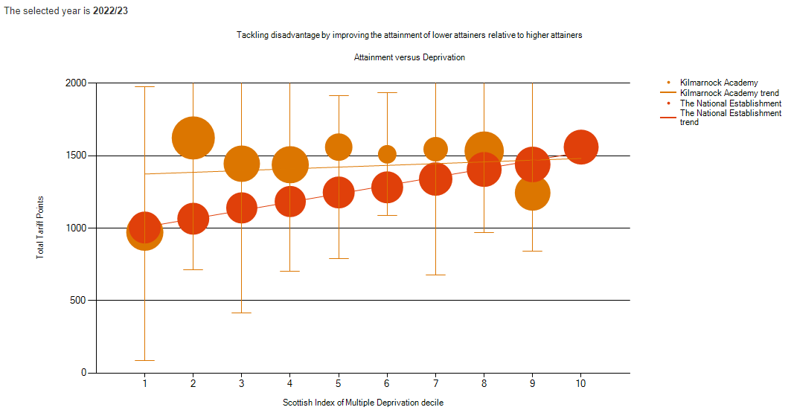
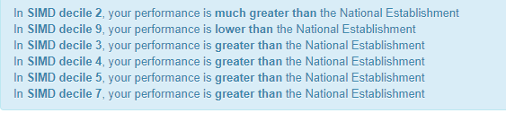
Establishment | Number in Cohort | SIMD 1  Average | SIMD 2  Average | SIMD 3  Average | SIMD 4  Average | SIMD 5  Average | SIMD 6  Average | SIMD 7  Average | SIMD 8  Average | SIMD 9  Average | SIMD 10  Average
Kilmarnock Academy | 116 | 973 | 1623 | 1445 | 1438 | 1560 | 1510 | 1546 | 1532 | 1244 | 0
National | 31865 | 1005 | 1066 | 1140 | 1184 | 1247 | 1282 | 1340 | 1405 | 1440 | 1560

Attainment in Literacy and Numeracy
S4:
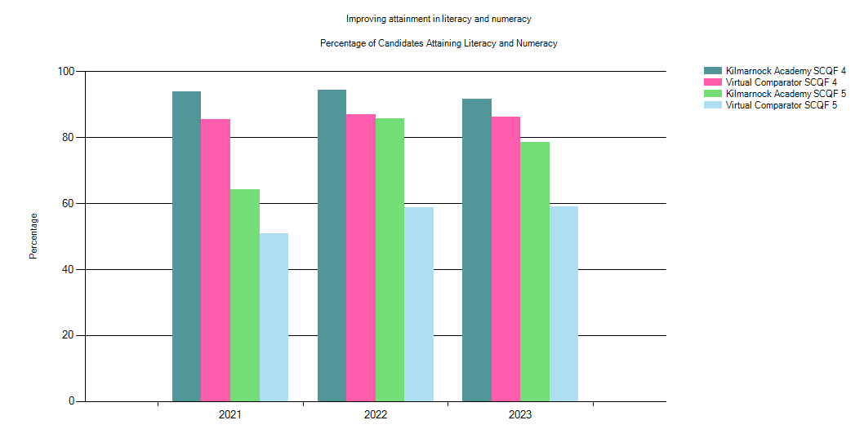
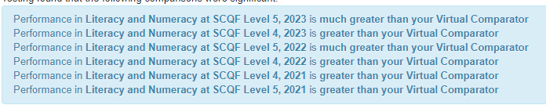

 | Year | % Level 4 Literacy and Numeracy | % Level 5 Literacy and Numeracy | Number in Cohort
Kilmarnock Academy | 2023 | 91.56 | 78.48 | 237
Virtual Comparator | 2023 | 86.29 | 59.11 | 2370
East Ayrshire | 2023 | 90.64 | 61.26 | 1239
National | 2023 | 85.72 | 60.05 | 57053
Kilmarnock Academy | 2022 | 94.34 | 85.85 | 212
Virtual Comparator | 2022 | 86.98 | 58.82 | 2120
East Ayrshire | 2022 | 90.03 | 62.66 | 1264
National | 2022 | 85.49 | 57.51 | 55044

S5:
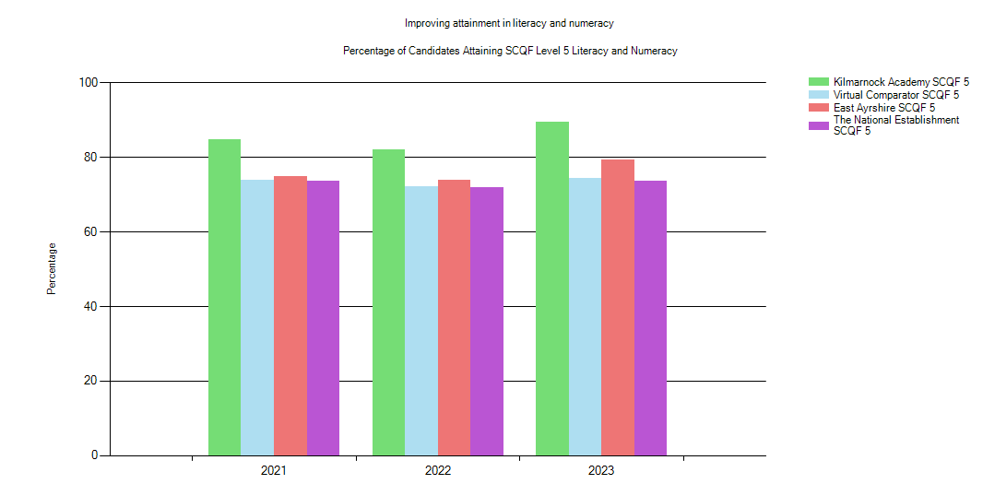
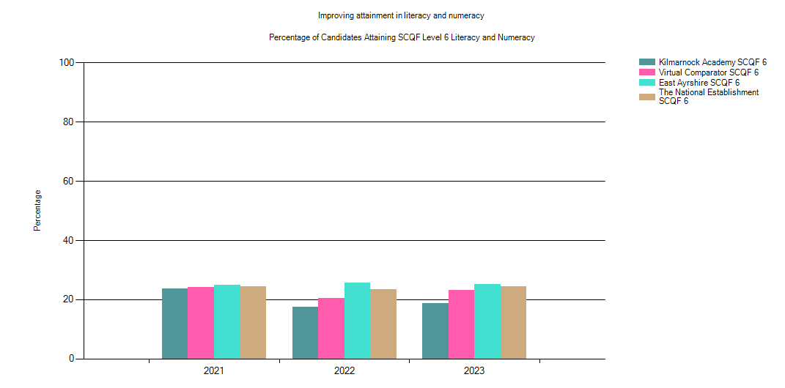

 | Year | % Level 5 Literacy and Numeracy | % Level 6 Literacy and Numeracy | Number in Cohort
Kilmarnock Academy | 2023 | 89.36 | 18.62 | 188
Virtual Comparator | 2023 | 74.41 | 23.30 | 1880
East Ayrshire | 2023 | 79.34 | 25.26 | 1065
National | 2023 | 73.73 | 24.45 | 48317
Kilmarnock Academy | 2022 | 81.97 | 17.49 | 183
Virtual Comparator | 2022 | 72.24 | 20.55 | 1830
East Ayrshire | 2022 | 73.95 | 25.67 | 1048
National | 2022 | 71.87 | 23.37 | 47430

Attainment in Numeracy
S4:
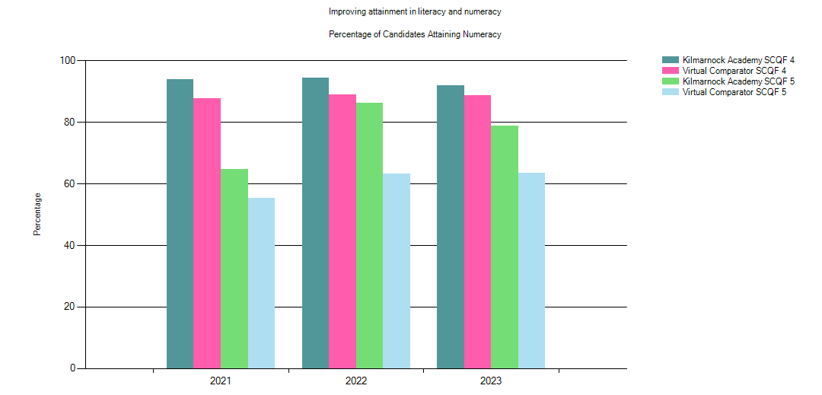

 | Year | % Level 4 Numeracy | % Level 5 Numeracy | Number in Cohort
Kilmarnock Academy | 2023 | 91.98 | 78.90 | 237
Virtual Comparator | 2023 | 88.69 | 63.46 | 2370
Kilmarnock Academy | 2022 | 94.34 | 86.32 | 212
Virtual Comparator | 2022 | 89.06 | 63.21 | 2120

S5:
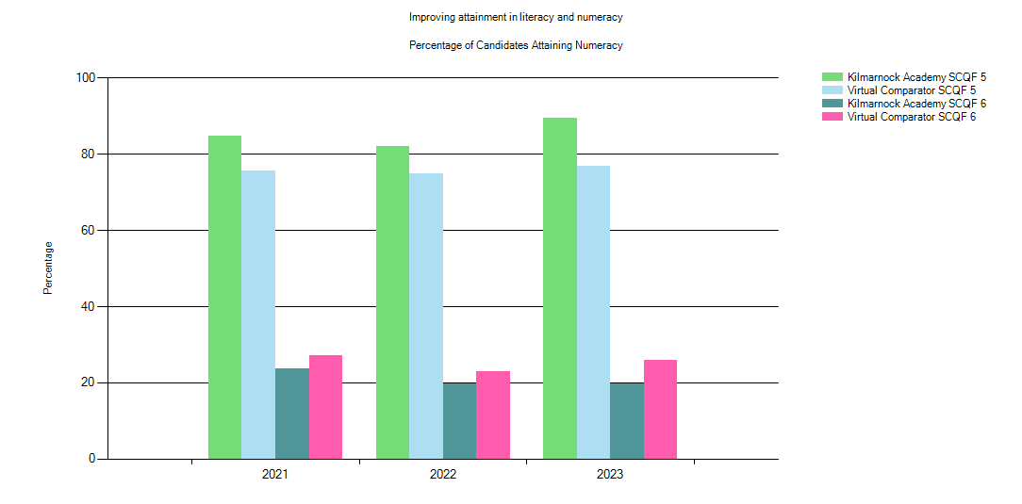
 | Year | % Level 5 Numeracy | % Level 6 Numeracy | Number in Cohort
Kilmarnock Academy | 2023 | 89.36 | 19.68 | 188
Virtual Comparator | 2023 | 76.76 | 25.90 | 1880
Kilmarnock Academy | 2022 | 81.97 | 19.67 | 183
Virtual Comparator | 2022 | 74.86 | 23.01 | 1830

Attainment in Literacy
S4:
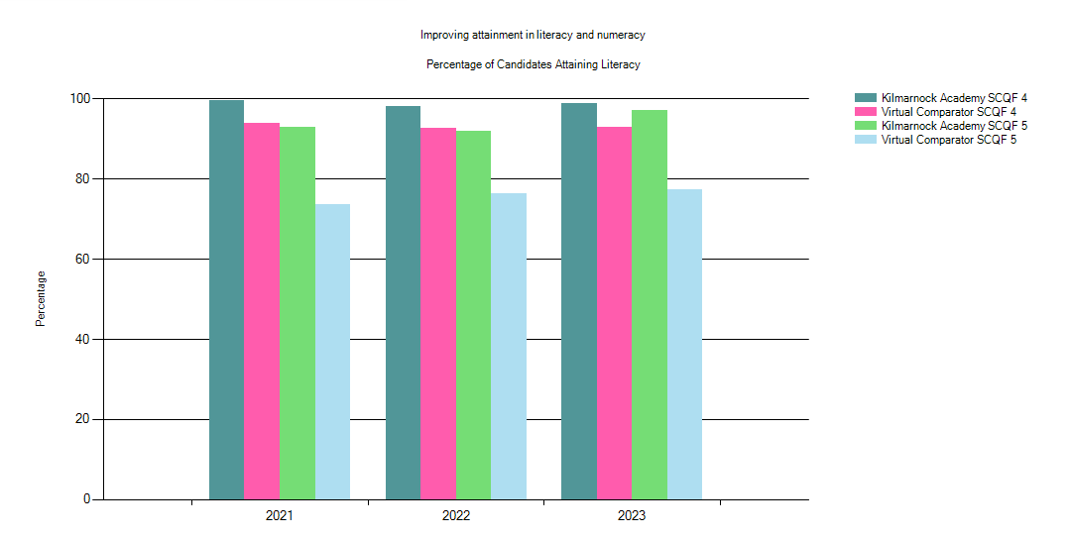

 | Year | % Level 4 Literacy | % Level 5 Literacy | Number in Cohort
Kilmarnock Academy | 2023 | 98.73 | 97.05 | 237
Virtual Comparator | 2023 | 92.95 | 77.38 | 2370
Kilmarnock Academy | 2022 | 98.11 | 91.98 | 212
Virtual Comparator | 2022 | 92.59 | 76.27 | 2120

S5:
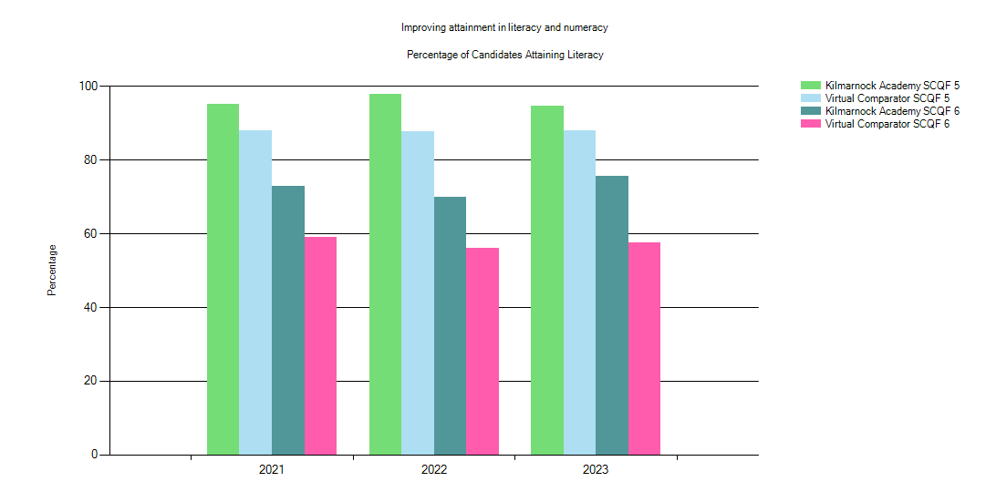

 | Year | % Level 5 Literacy | % Level 6 Literacy | Number in Cohort
Kilmarnock Academy | 2023 | 94.68 | 75.53 | 188
Virtual Comparator | 2023 | 88.03 | 57.50 | 1880
Kilmarnock Academy | 2022 | 97.81 | 69.95 | 183
Virtual Comparator | 2022 | 87.60 | 56.07 | 1830

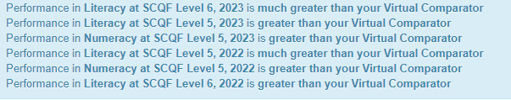

Candidate Initial Leaver Destinations:

S5: Leavers
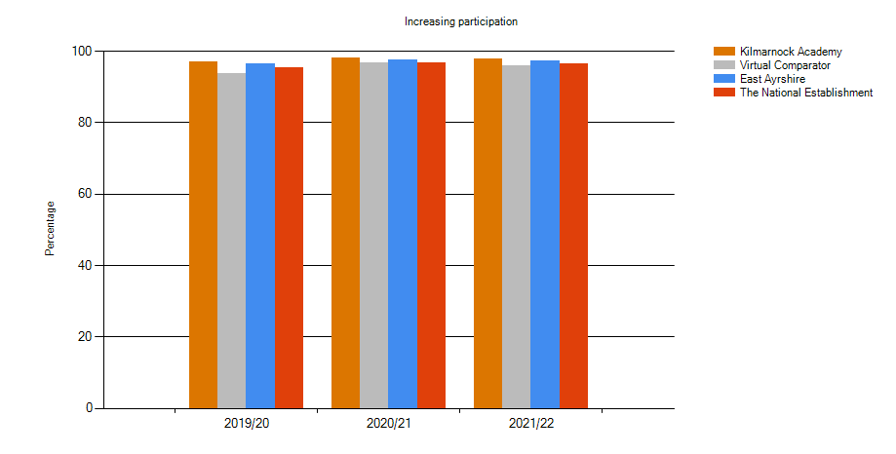
 | Year | % of Candidates in a Positive Destination | Number in Cohort
Kilmarnock Academy | 2021/22 | 97.81 | 183
Virtual Comparator | 2021/22 | 95.90 | 1830
East Ayrshire | 2021/22 | 97.14 | 1048
National | 2021/22 | 96.43 | 47430
Kilmarnock Academy | 2021/22 | 98.02 | 202
Virtual Comparator | 2020/21 | 96.73 | 2020
East Ayrshire | 2020/21 | 97.41 | 1083
National | 2020/21 | 96.63 | 46903

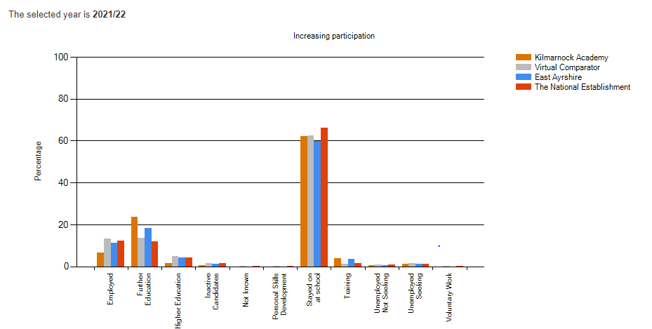
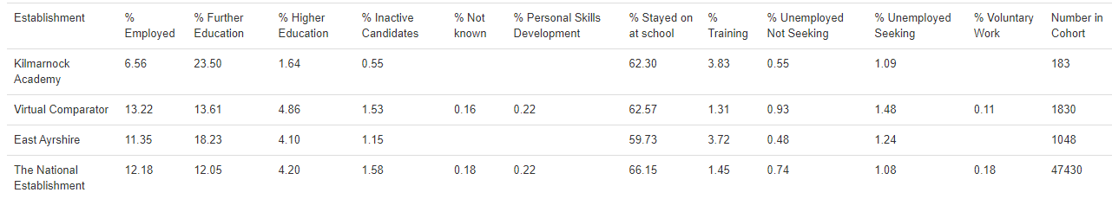
Senior Phase Attainment: Breadth and Depth
S4:
All Candidates: KA- Cohort 237
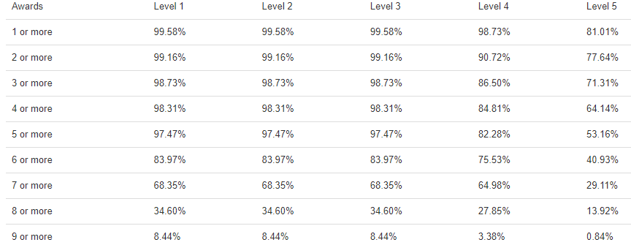

All Candidates: Virtual Comparator- Cohort 2370
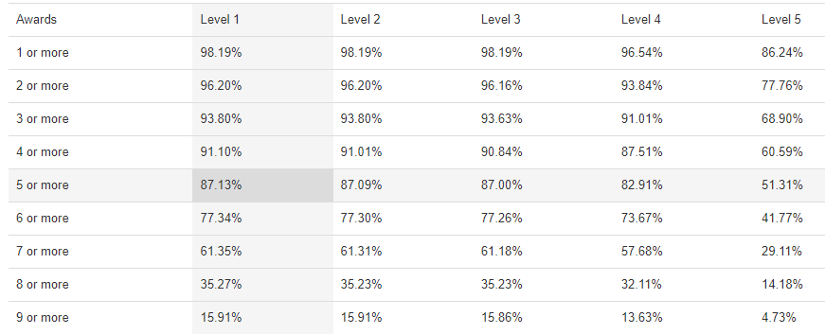
Most Deprived 20%- Cohort 85
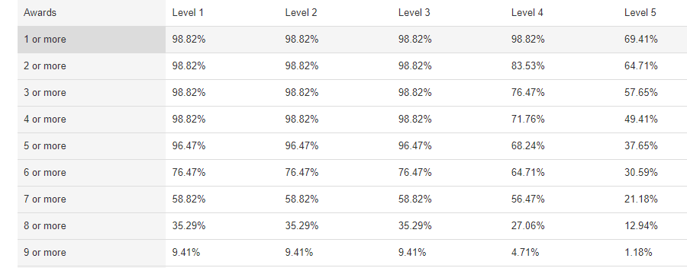

Most Deprived 20%- Cohort 850
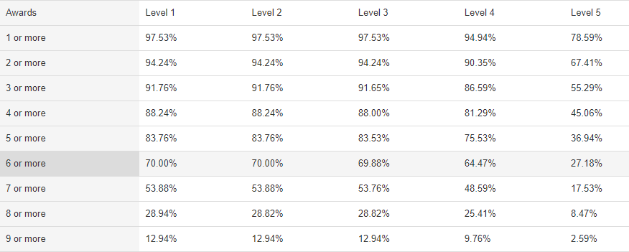
S5:
All Candidates: KA- Cohort 188
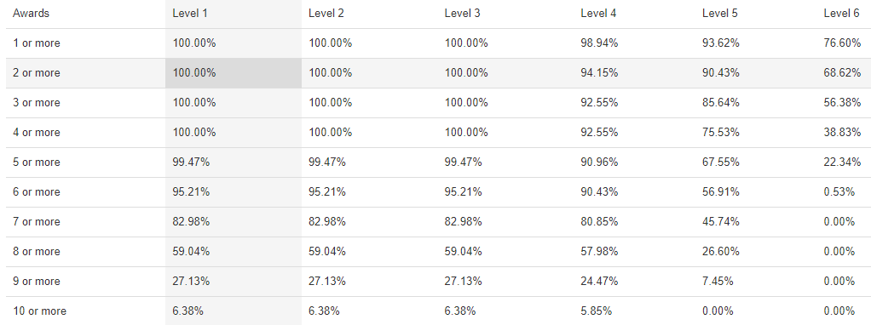

All Candidates: Virtual Comparator- Cohort 1880
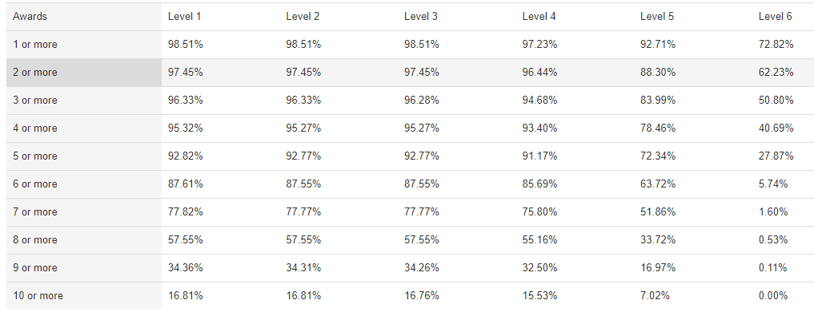
Most Deprived 20%: KA- Cohort 54
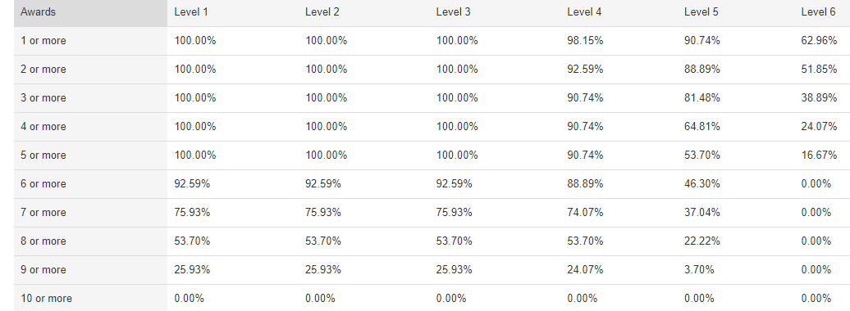
Most Deprived 20%: Virtual Comparator- Cohort 540
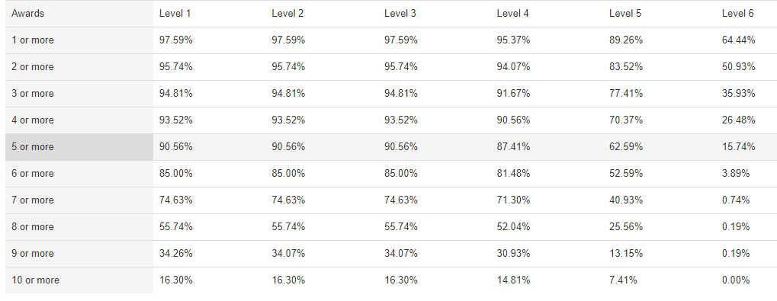
S6:
All Candidates: KA – Cohort 116
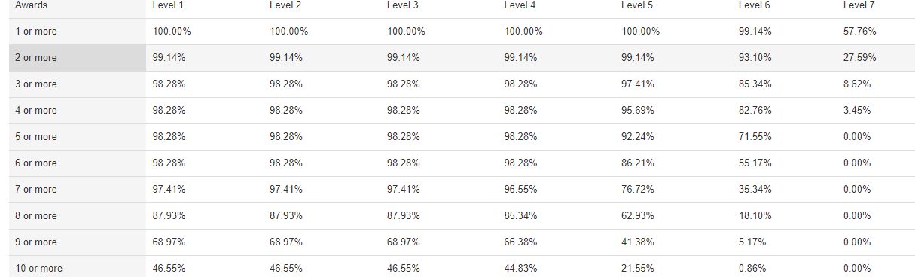

All Candidates: Virtual Comparator – Cohort 1160
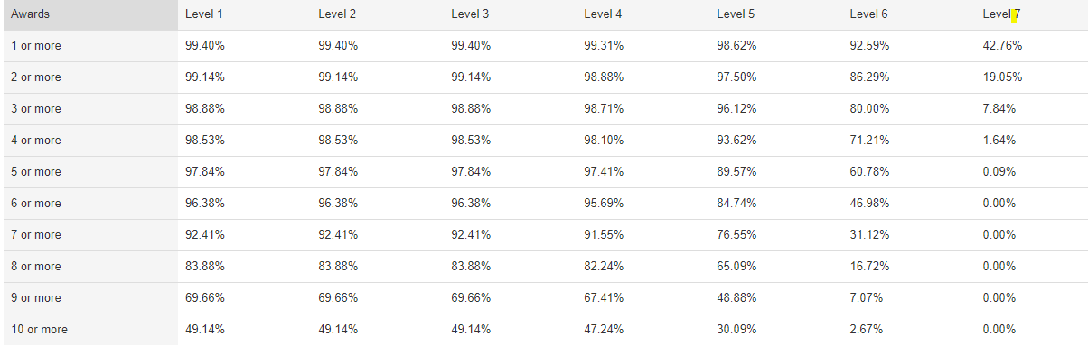

Most Deprived 20%: KA- Cohort 39
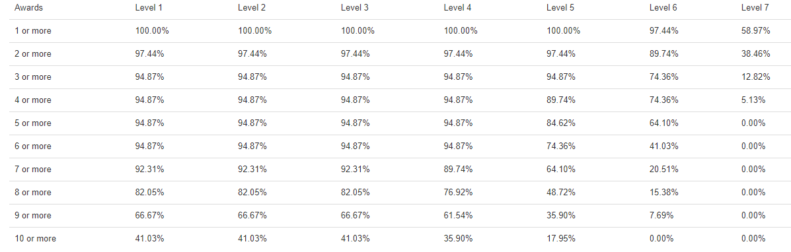
Most Deprived 20%: Virtual Comparator- Cohort 390
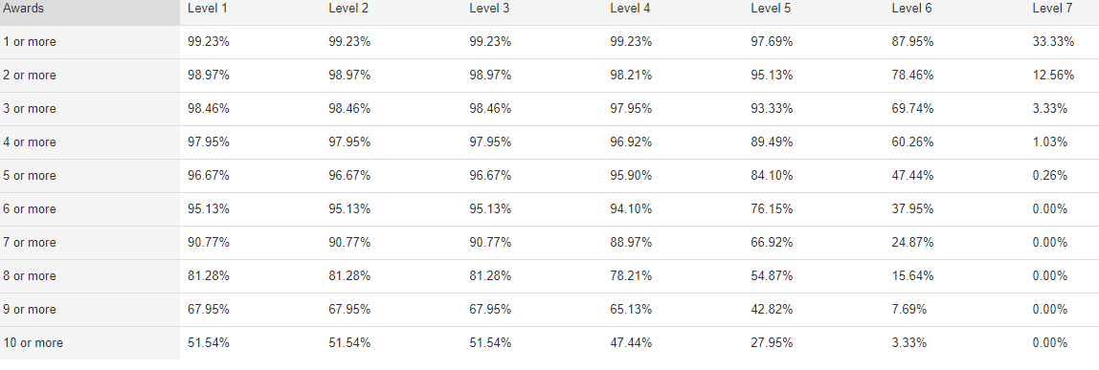

Labour Market Intelligence: Ayrshire
All data taken from Regional Skills Assessment Ayrshire – November 2022
