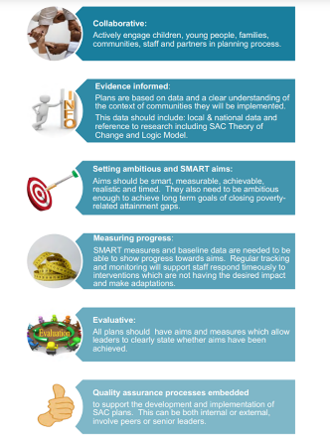



EAC PEF Refresh Session

21st April 2023

9.15 – 12.30

Loudoun Academy Assembly Hall

East Ayrshire PEF bolg | Just another blogs.glowscotland.org.uk – East Ayrshire site

9.15 – 9.30 Coffee
9.30 – 9.45 PEF Spend Template Gordon Pearson
9.45 – 10.15 National and local practice Chris / Andy Boyle
10.15 – 10.40 Participatory Budgeting Catrina / Fiona Greig
10.40 – 10.45 Questions
10.45 – 11.00 Coffee
11.00 – 11.30 PEF sharing practice (trios) All HTs
11.30 – 11.45 PEF Refresh Materials Catrina
- Draft PEF paperwork
- Learning review - PEF Impact
11.45 – 12.00 Group discussion and feedback on draft paperwork
12.00 – 12.20 EAC Procurement Framework
- Overview Ian / Paula Raymond
- EAC Procurement Catalogue Good Practice
12.20 – 12.30 Summary and next steps Catrina / Chris
