East Ayrshire Council PEF Impact Visit Template

Sharing progress and practice

Date | School | Attendees
6.3.23 | Netherthird Primary School
PEF Spend outline | Allocation  Funding committed to staffing  Funding committed to resources  Underspend | £68,240  £53,000 approx.  £16,000 approx.  £4000 approx.

Consultation took place with all stakeholders alongside Improvement Plan priorities. GLOW form available
What is going well?  Intervention | How do you know?  What is the data telling you?  Impact/outcome | Any challenges?  Any changes to PEF plan? | Support required?  Feedback  Next steps
- ELCP Contract PEF, Aug 22 - June 23  - CA 18.40 hrs, Aug 22 - June 23  - Music, Teacher 0.2FTE, Aug 22 - June 23  - Cumnock Juniors Sports  - Outdoor learning resources (underspend)  - parental engagement workshops (underspend)  - ECC (underspend) | Play based environment within both p1/2 classes - support from ELCP  ELCP extracts and works on individuals – please see evidence attached to support. Appendix 1 – P1/2D  ELAT, Talk Boost, In class data  Supports with transitions ECC to P1 – Invaluable  This supports with attendance, inclusion and SIMD, hidden children.  Appendix 2 – ELCP View  Core hours not enough from authority to run this size of school.  Cover in playground/playtime/lunchtime – would not be possible with 1 x CA that is allocated  This CA also focusses on 5 min box across all stages as an intervention – please see attached evidence and data to suggest this is also invaluable.  See attached data – Appendix 3  Health and wellbeing and music is so important now more than ever. The impact on all of our pupils with this input is invaluable. Please see attached evidence to support.  We have found that our new music room is having a huge impact on mood and level of participation.  This supports with attendance, inclusion and SIMD, hidden children.  Appendix 4  Another invaluable resource that also helps cover NCT within our school. Also supports staff leadership and CPD.  Please see attached evidence from pupils.  This supports with attendance, inclusion and SIMD, hidden children - Appendix 5  We have only just begun to purchase resources due to not being moved back – this will go into next year’s PEF spend and improvement plan  This element will also be carried forward to next session – due to not moving.  Please see attached powerpoint | N/A  The move has had a significant impact on this – utilising  N/A  Strike days and closure days have meant this funding has not been used fully – we have utilised remaining funds to support music equipment  Due to not being moved back in September – we have not utilised these funds as well as we had hoped and will be carried forward to next year’s spend and allocated to outdoor resources – some resources we found difficult to purchase from a procurement point of view  Funds for this haver not been utilised due not being in our new school. | This is an invaluable resource to our school and our attainment in closing the gap – I plan to utilise PEF spend as long as it continues to fund this.  This is an invaluable resource to our school and our attainment in closing the gap – I plan to utilise PEF spend as long as it continues to fund this.  This is an invaluable resource to our school and our attainment in closing the gap – I plan to utilise PEF spend as long as it continues to fund this.  Support from procurement – to make it easier to purchase resources – looking for 3 quotes, specifications etc has been a challenge and this needs to be changed in order for us to purchase the resources we require to make a difference and impact  We plan to utilise money on family learning and engagement next session and this will also be incorporated into our improvement plan. Evidence from our self-evaluation suggest we need to further develop in this area

FEATURES OF HIGHLY EFFECTIVE PRACTICE | CHALLENGE QUESTIONS | Comments
CONTEXTUAL ANALYSIS  The school has set out a clear rationale and plan for its allocation of Pupil Equity Funding taking full account of national and local guidance.  The school’s plan is well-considered and based on robust self-evaluation including the views of children and young people, parents, partners and staff. | - To what extent is our self-evaluation informed by effective analysis of data focused on the poverty related attainment gap?To what extent is our rationale for spending our allocation of PEF based on robust self-evaluation with relevant stakeholders?  - How effectively have we involved children and young people, parents and partners in decision making around PEF?
IDENTIFIED GAP & OUTCOMES AND MEASURES:  The school has used a range of data and evidence to identify attainment gaps for groups and individual children and young people. As a result, appropriate interventions and approaches are now in place, with a clear focus on improvements in health and wellbeing, numeracy and literacy. | - To what extent are we clear and specific about our targets, interventions and approaches?  - How well have we considered how we will evidence the impact of our interventions and approaches?
INTERVENTIONS  A range of interventions, such as classroom-based activity, additional targeted support and extended opportunities and experiences in and beyond school are in place. | - How effectively are we tracking and monitoring our progress?  - How confident are we about making timely informed changes to our Pupil Equity Funding and approaches if they are not achieving their intended impact?
IMPACT  Effective systems are in place to monitor and track the progress of individuals and groups. Schools and local authorities are able to evidence impact on raising attainment and closing the povertyrelated attainment gap. | - How well are we using our Pupil Equity Funding to ensure sustainable improvements in culture, ethos and pedagogy to improve outcomes for learners?  - To what extent is our use of Pupil Equity Funding improving outcomes of children and young people and closing the poverty-related attainment gap?
Sustainability  How are you building sustainability into your plans? | - How have you built in sustainability to your projects so that the work will continue when the funding comes to an end?
LESSONS LEARNED  Over the course of the PEF initiative what lessons have you learned about supporting children and young people where poverty is a barrier to learning. | - Looking back, what might you do differently?  - Anything you would share with other colleagues?

Appendix 1

Evidence PEF ELCP

Literacy
- TalkBoost
- Phonological Awareness
- Phonics Assessments
- Small group consolidation activities (Structure weekly)
- Writing (P1s progression)
Numeracy
- Topic consolidation activities that have been covered in class. With a busy curriculum, recapping and consolidation is pivotal and can be done more consistently with Kerry.
Other
- Supporting play in the classroom/taking out small groups of children to open area spaces/outdoors. This supports smaller group sessions with quality learning and enhanced relationships.
- Art/Topic in afternoons – gives all children a chance to be involved in different/same activity to support CT. Busy play environment can influence how many children are able to complete an art activity etc.
- Creating and helping to make resources.

Class Teacher Comment – P1/2D Miss Fulton
Our ELCP Kerry has been invaluable to P1/2D this year. As a probationer Kerry has supported not only the learning taking place but the learning environment. Kerry and I have formed a close working relationship. P1/2D is a play-based learning environment, where the pupils are pulled in small groups for teaching inputs with class tasks and activities taking place around free play. P1/2D has 25 learners, which can sometimes be a busy, loud environment due to the work taking place. Therefore, when Kerry Ho is available, shared with P1/2C, she is used to support this learning and environment at the same time. She takes small groups, reducing the number in the classroom, helping the class teacher, and giving the children a new space to learn, quality learning in a smaller setting and enhances relationships outside the classroom doors.

Kerry has supported phonological awareness assessments that are time consuming and crucial to see progression and next steps. These have been done throughout the year with a few children who have challenges in literacy (P1). Kerry uses a Monday afternoon on a shared timetable to support TalkBoost children from both classes. These children are developing their language and communication as a result and progression is happening here. This is helping with in class development and the children in this group are involved much more in class now.
Phonics assessment take place regularly and Kerry helps this get done in a timely manner and not take away huge blocks of learning.
Throughout the week, Kerry is available for P1/2D for one big block each day (1 hour and 40 minutes). She plans with Miss Fulton weekly to plan her own activities based on outcomes given to her. This is split equally between numeracy and literacy every second day to allow Kerry to support both curricular areas. She will always recap the previous day’s learning allowing for this consistent and regular learning experiences. Kerry has a bank of personal resources and activities that she can use as well as new and exciting learning experiences she plans each week. Kerry is always happy to work on a specific activity that the class teacher requires to be completed.
Kerry has supported primary ones writing journey since term one. Brogan Fleming (Mentor of Dana Fulton) has lead writing with P1/2D and formed a close working relationship with Mrs Fleming to support writing every week. Progression of primary one writing jotters can be seen and evidenced below.

Writing Evidence (Pupil A – P1 – Beginning to write independently 0.3)
Progression from September 2022 – March 2023 with Kerry Ho (all P1 groups)
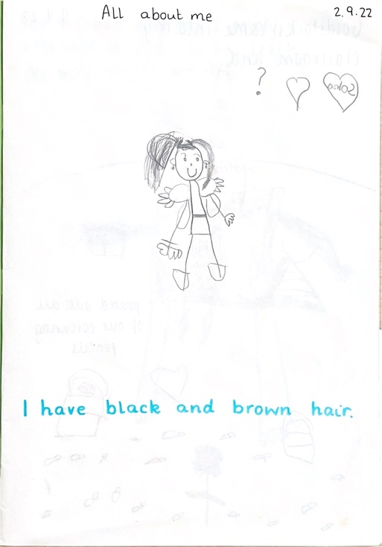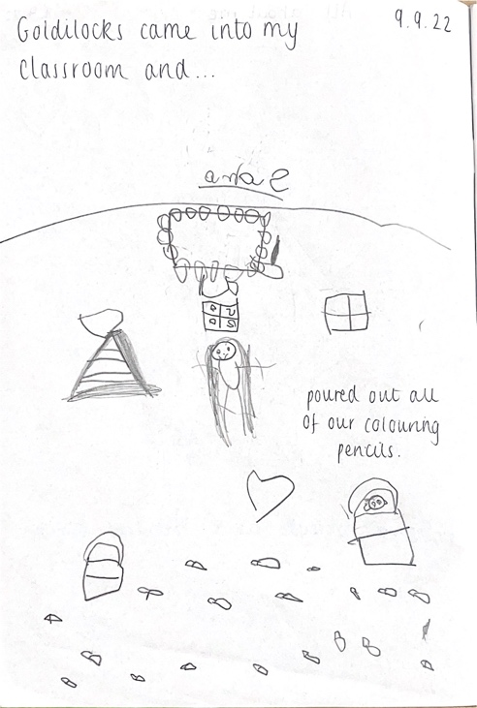

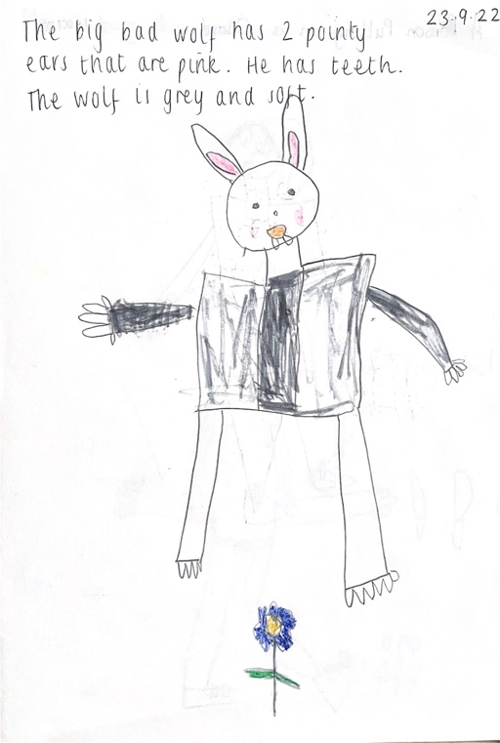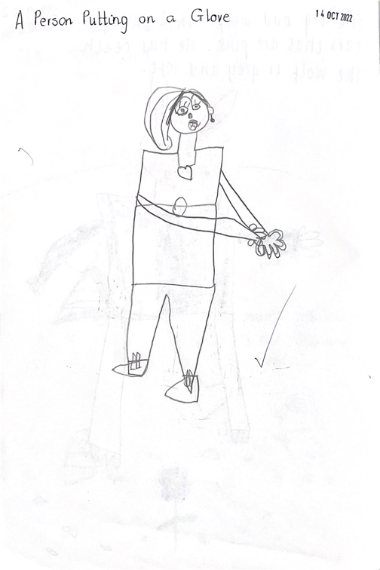

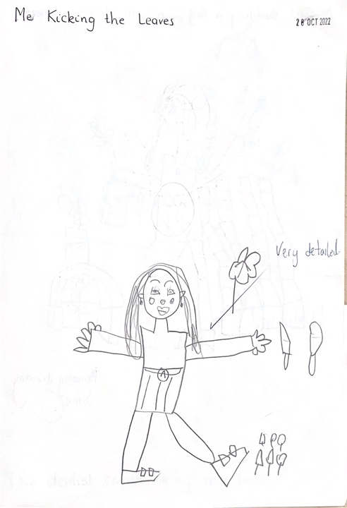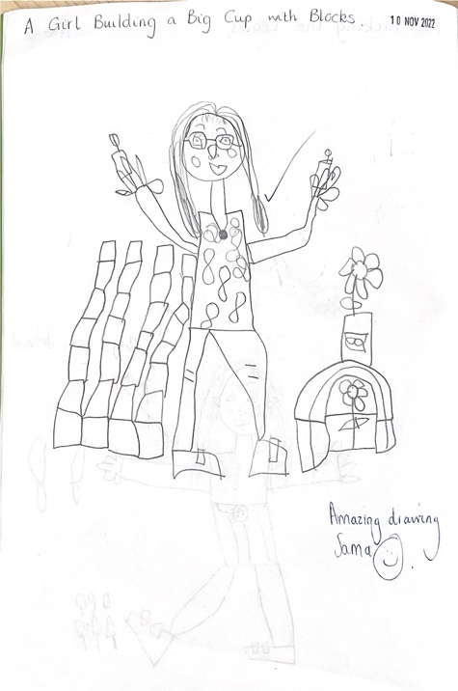

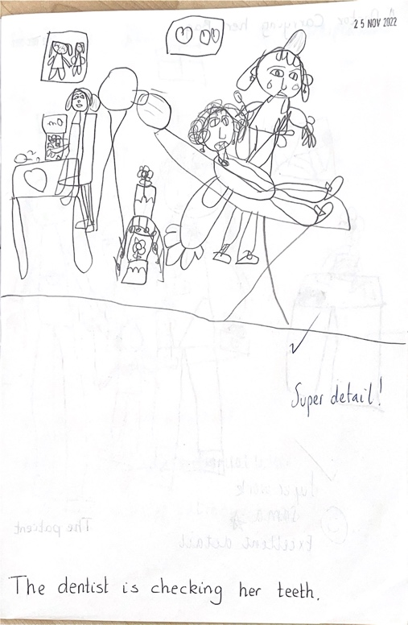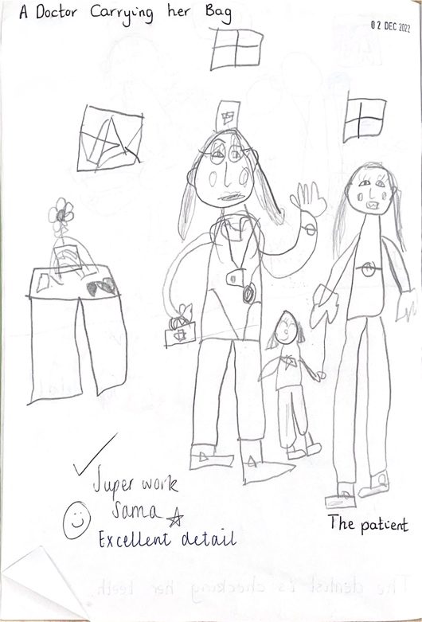

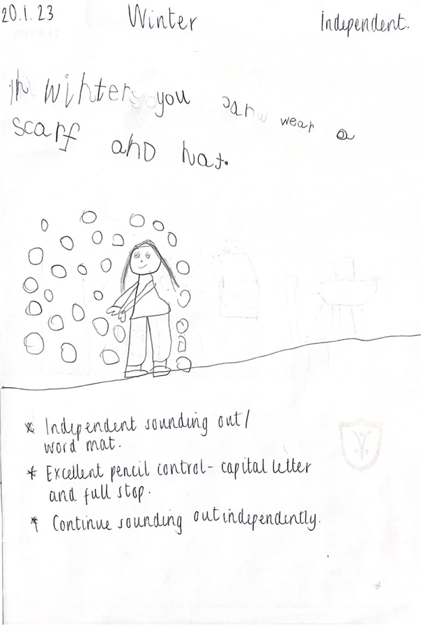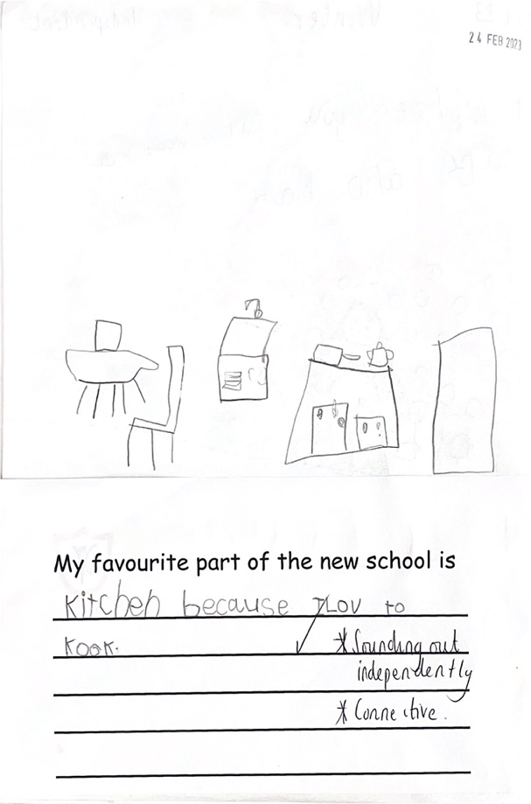

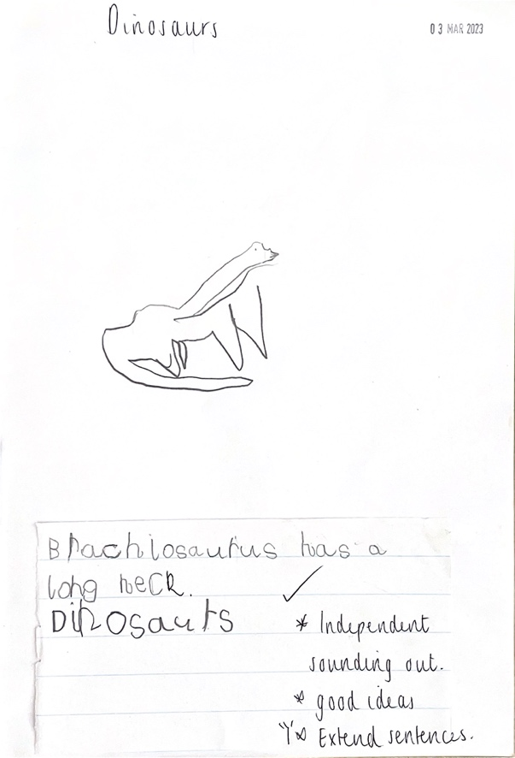

(Pupil B – P1 – Beginning to write independently with support 0.3)

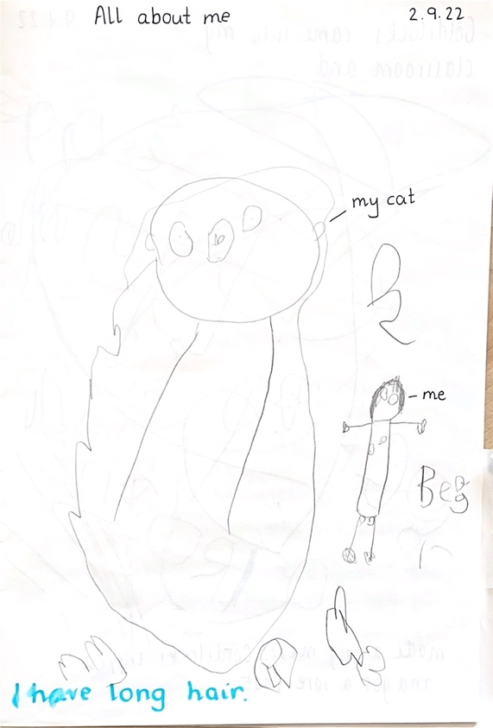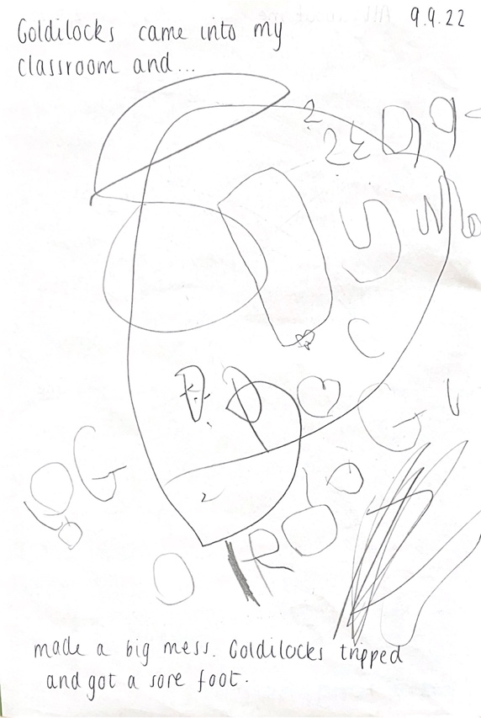

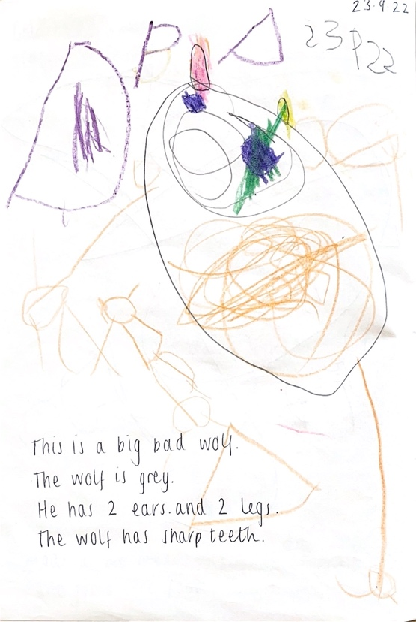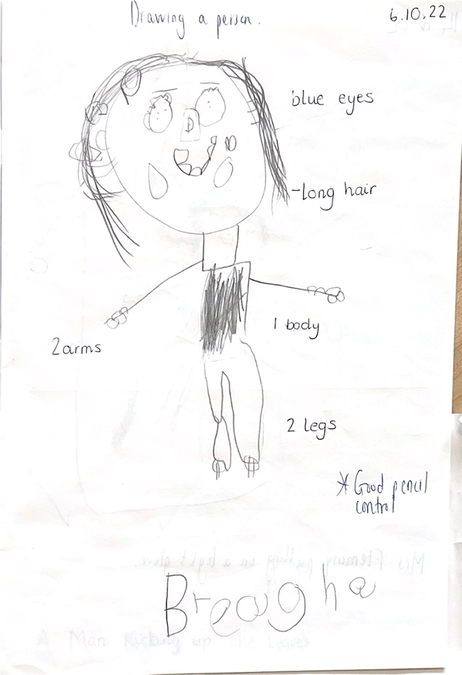

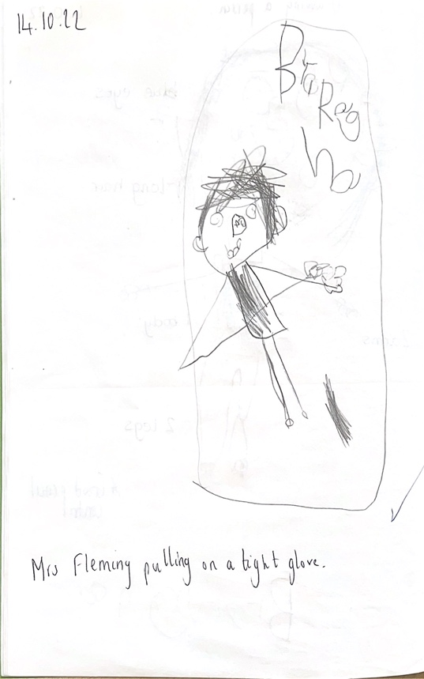
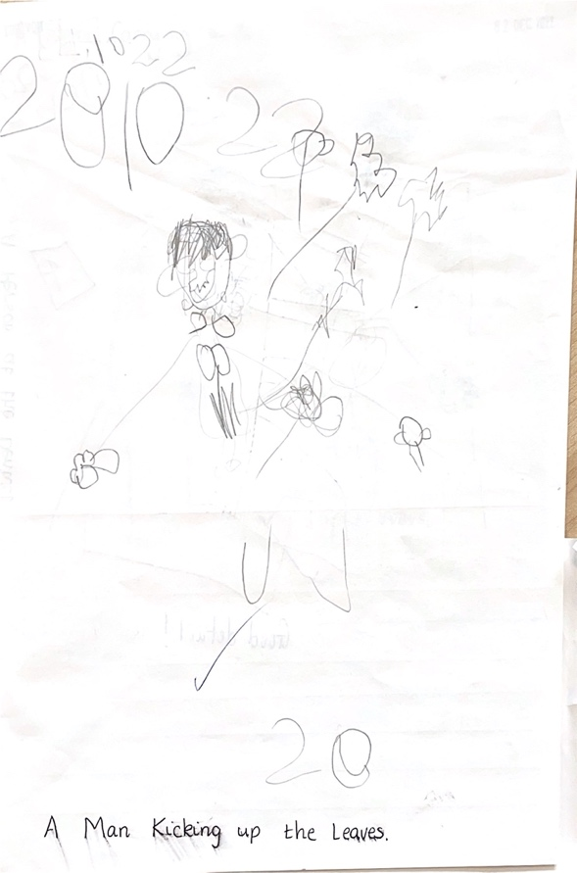

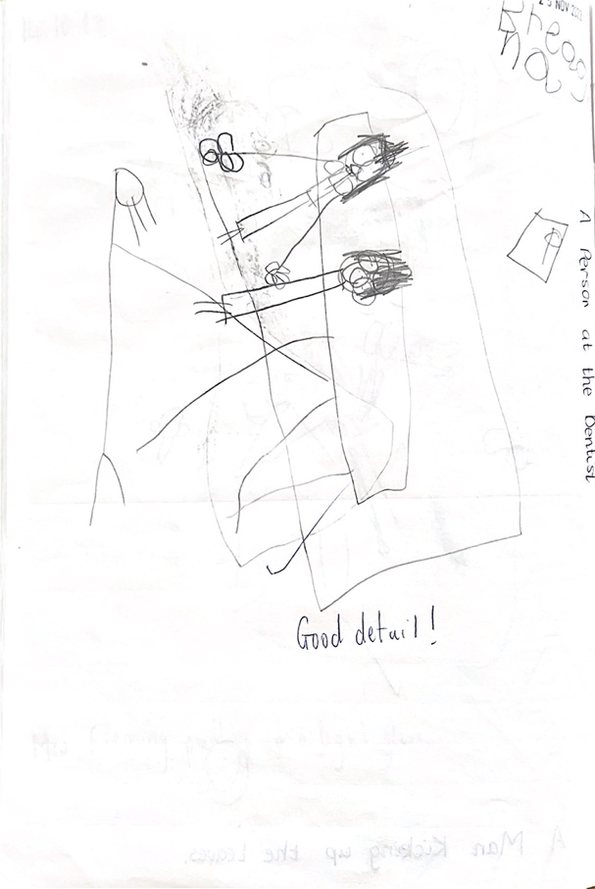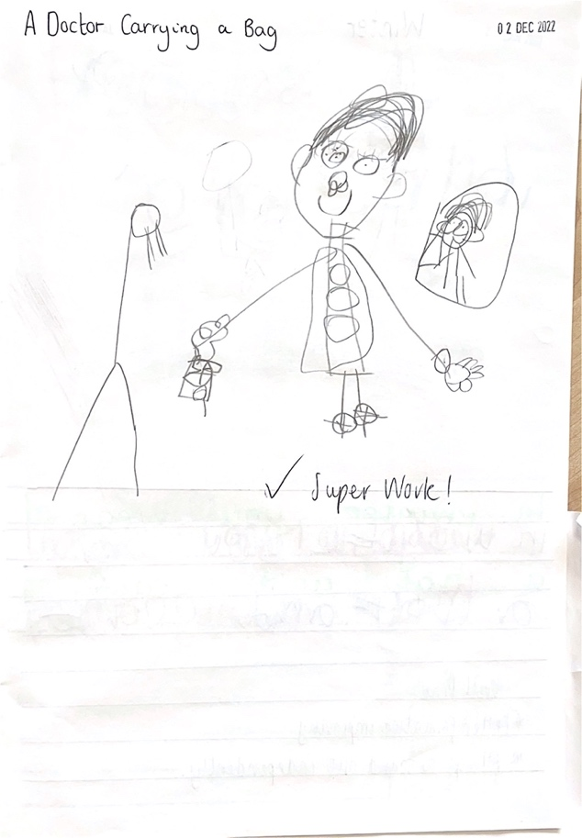

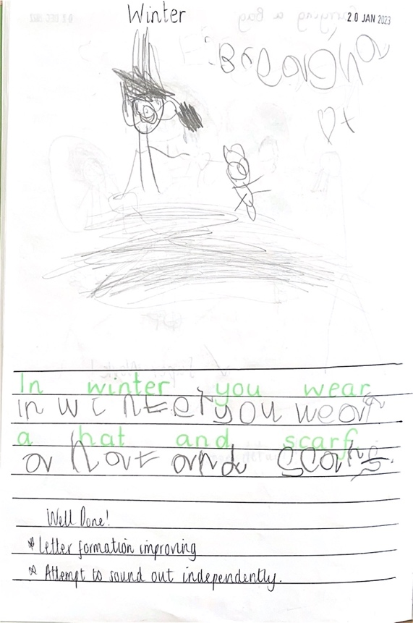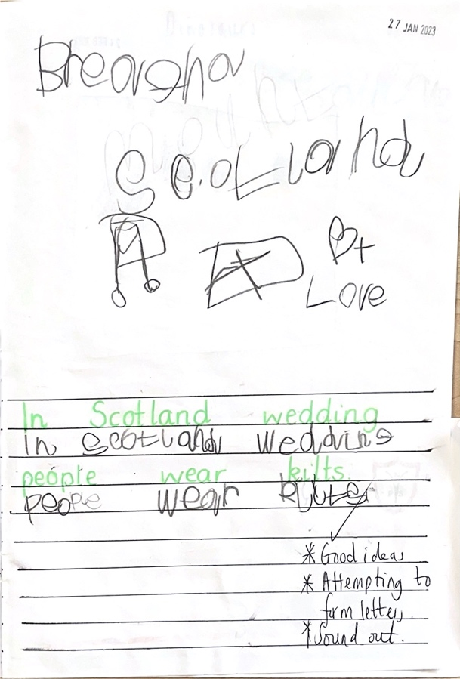

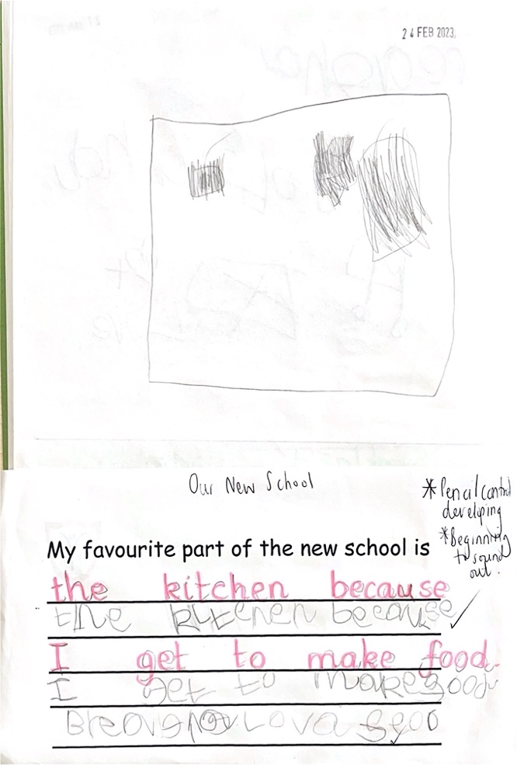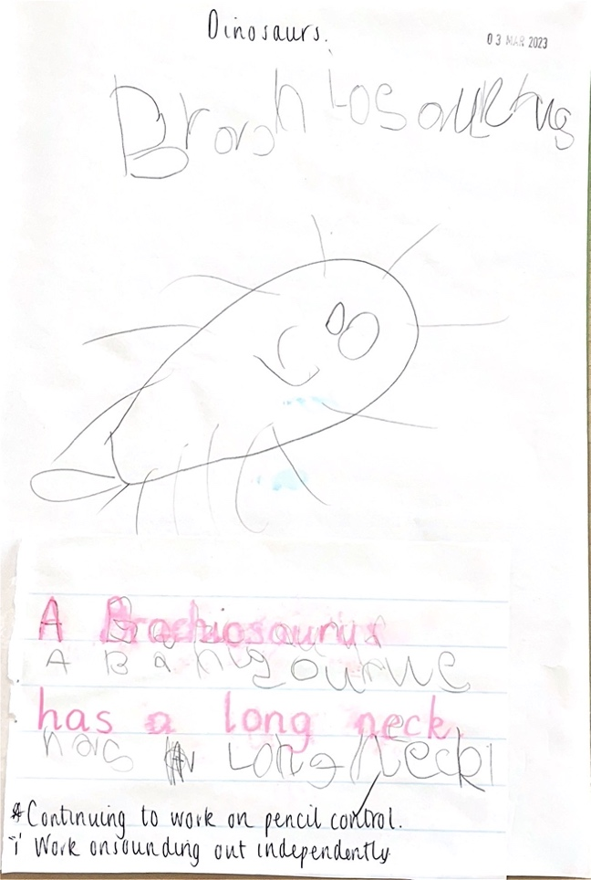

(Pupil C – P1 – Working to write with support/scribed descriptions 0.2)

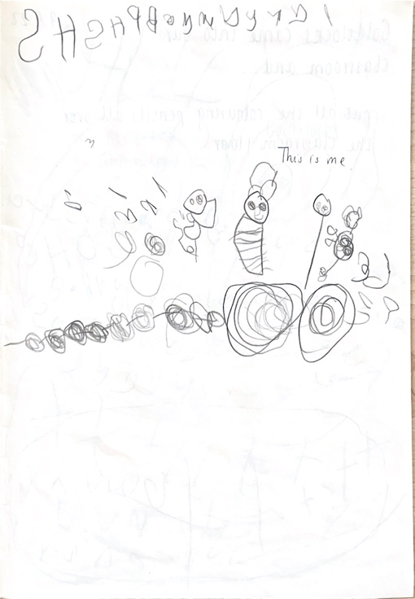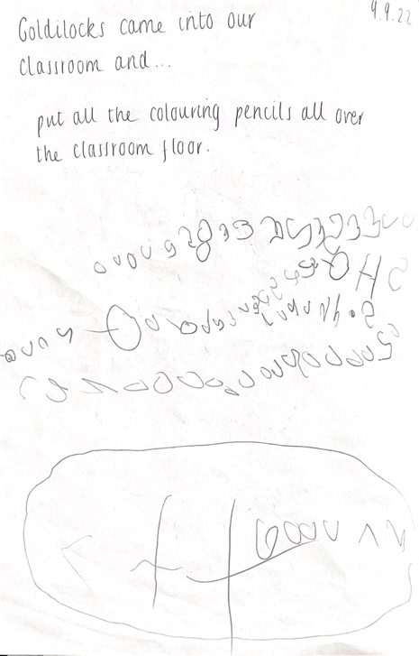

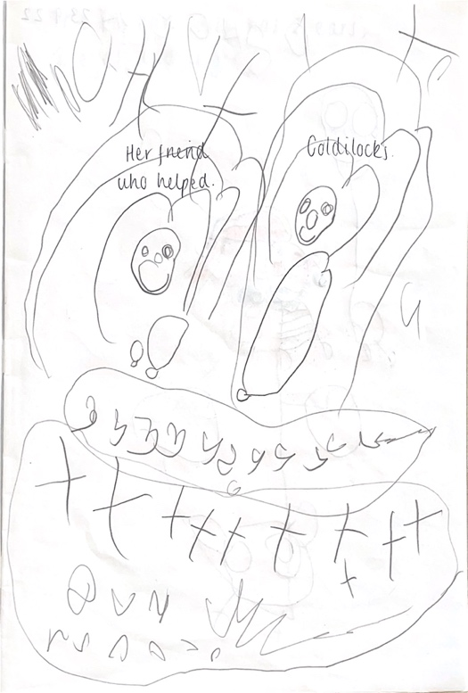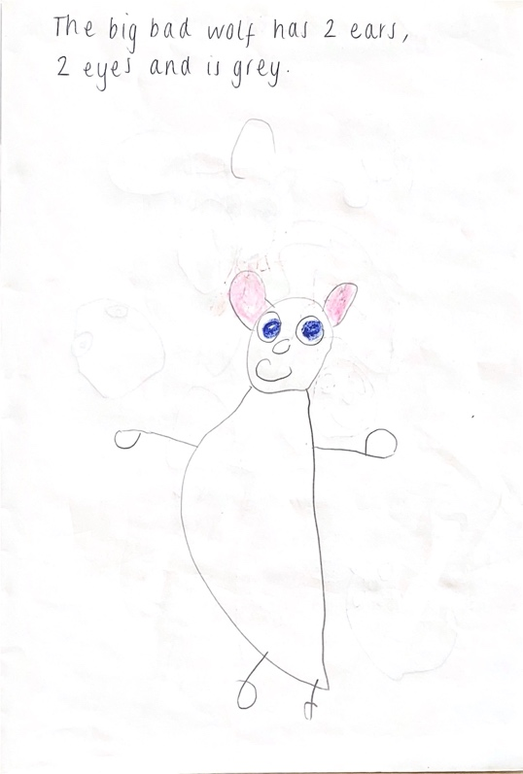

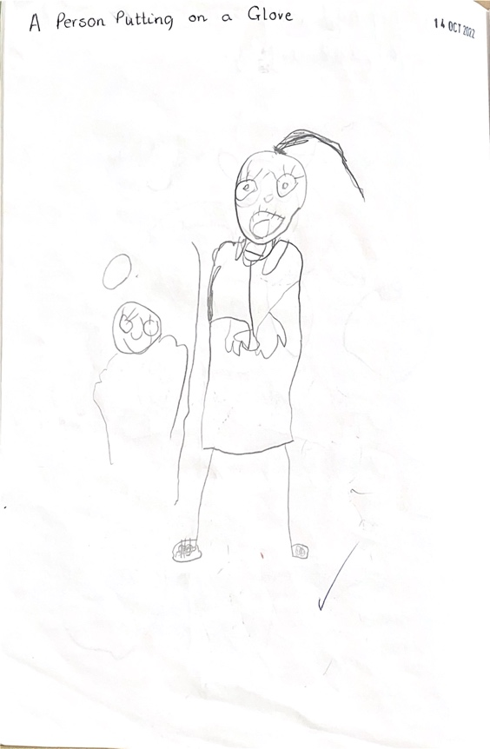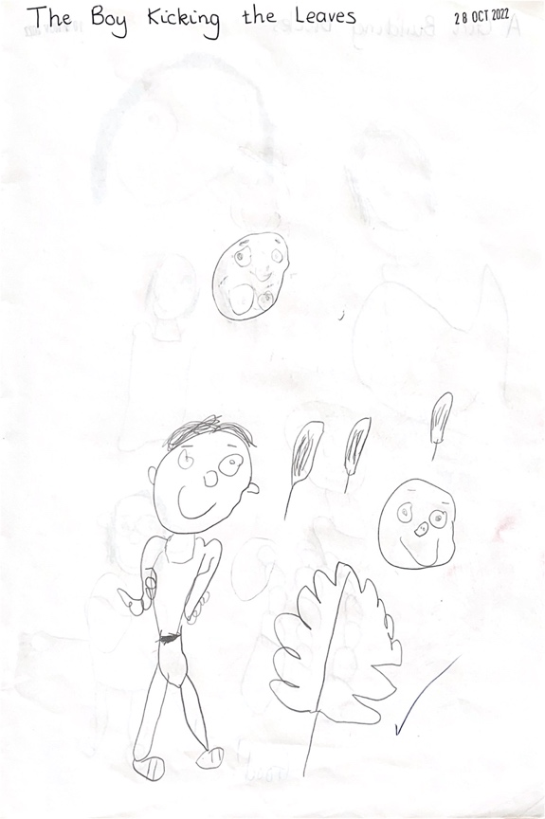

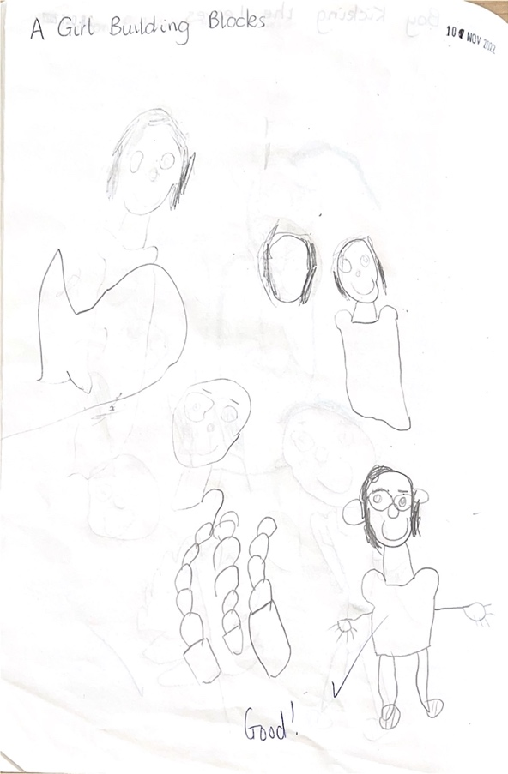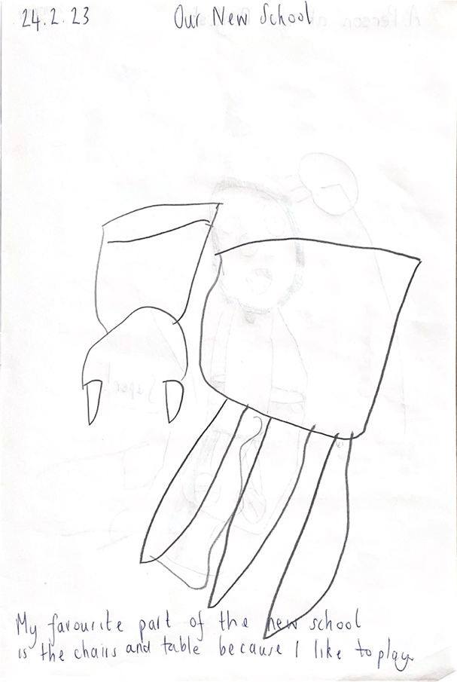

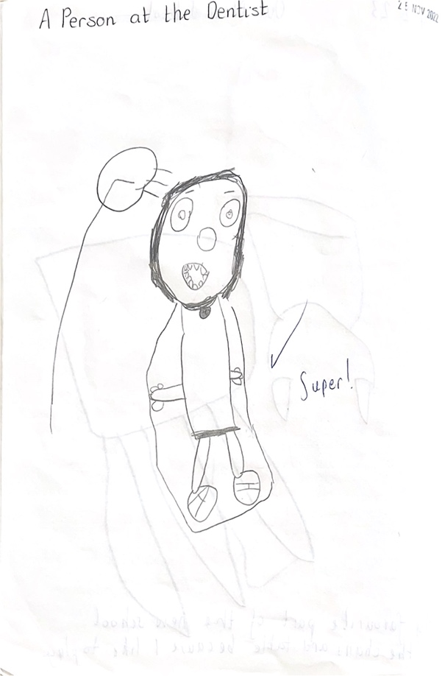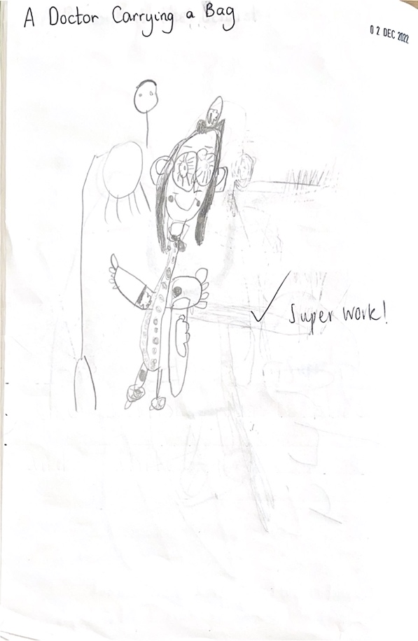

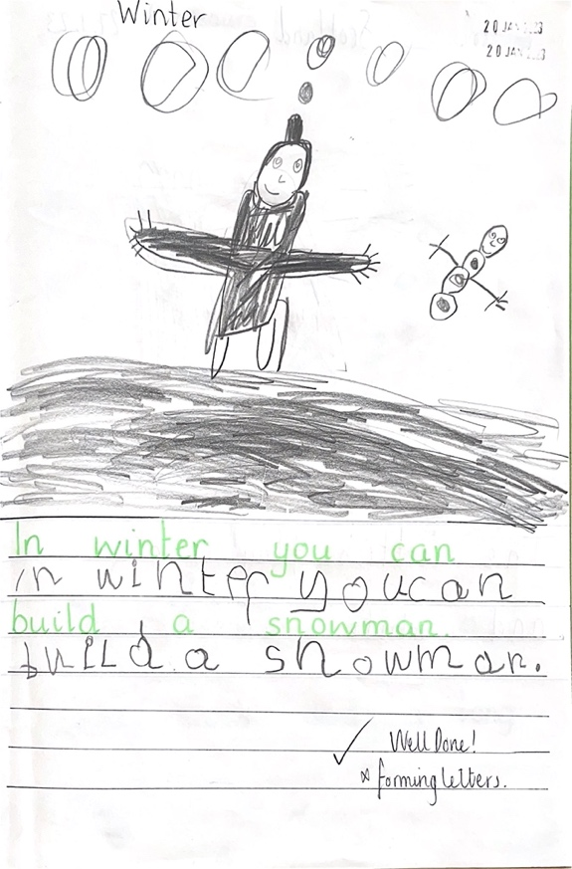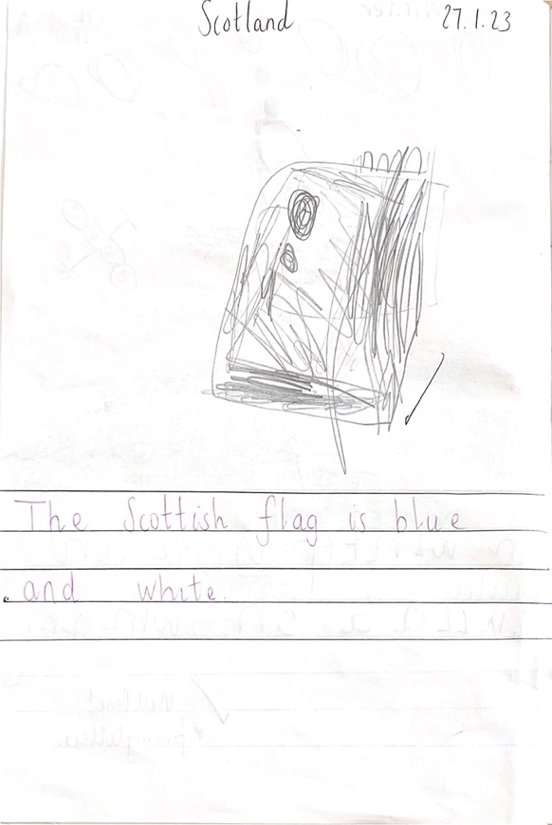

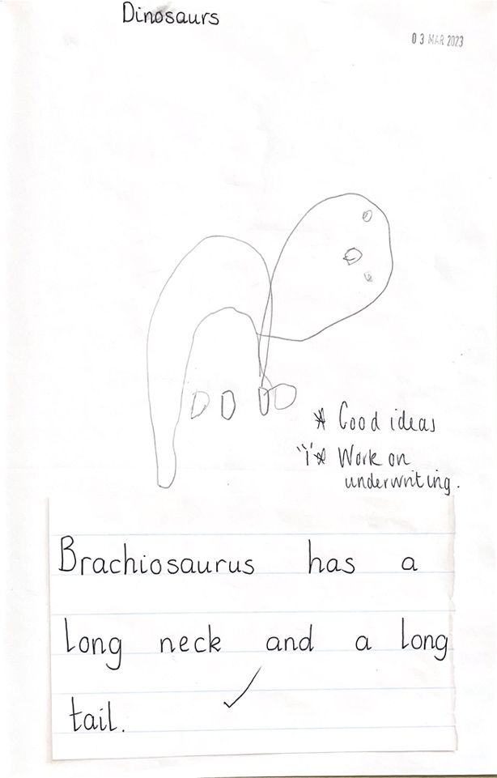

Appendix 2

Impact of PEF - ELCP
Literacy
To support attainment in literacy, I create resources and games to consolidate phonemes, common words taught by Miss Cree and Miss Fulton. Extracting literacy groups, I also help support with activities such as letter formation; blending and reading words; dictation and reading books. I have also supported P1 writing weekly with P1/2D where children have developed skills from holding a pencil (from fine motor activities); drawing detailed pictures to set a scene and retell a story or event; retelling and describing what their writing is about; and finally writing a structured sentence.

Phonological Awareness Group
Children who have needed further support in early literacy have been supported by a Phonological Awareness group once a week. The extra interactions and focused tasks within the group have shown that there has been progression. Using the Phonological Awareness Assessment and producing a spreadsheet to track scores has shown necessary target areas. Furthermore, a baseline assessment and follow up assessment in P1/2C has shown that most children have progressed.
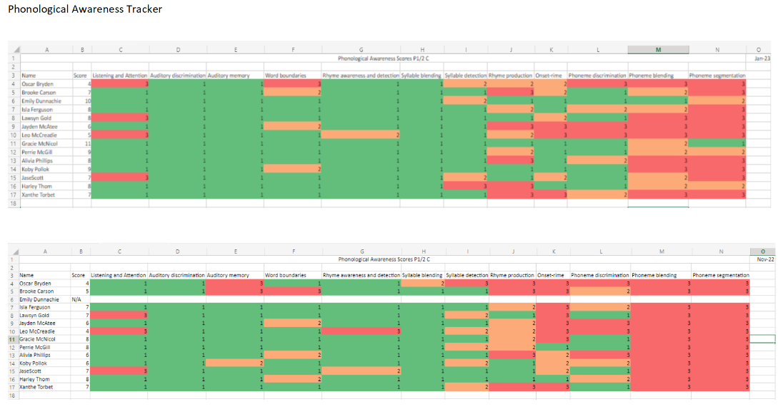

Talkboost Group
Along with Lyndsey Thompson, I take a group of 3 children once a week (Lyndsey, 2 times a week) for Talkboost – an intervention programme designed to support children in talking and listening and extending their vocabulary. Through some repetitive activities, the children have remembered what it takes to have good listening skills and can demonstrate these throughout the session – sometimes gentle reminders are needed. Other activities have supported children to extend the use of vocabulary through describing pictures, each other and everyday objects around them. The children have shown their ability to make use of their vocabulary and explain using full sentences. In addition, they are know when to listen and talk within the group, understanding when is appropriate or not. Lyndsey has yet to review.

Literacy Intervention Group
Following discussion with both Miss Cree and Miss Fulton, it was agreed that a minority group of children from both classes would need further support in literacy. This hasn’t commenced yet but, it will be in the form of restarting the Active Literacy Programme and taking the group in short, regular sessions. A baseline assessment of Stage 1 Block 1 phonemes and common words will be completed to show what each child is capable of and how to set up sessions following it.

Numeracy
As planned with teachers, I set up activities and games correlating to what is being taught in the classrooms. I have been fortunate to be present in numeracy classes with Jennifer Elstone which has enhanced my understanding and practice in providing numeracy activities that support how numeracy is being taught through the language used and the use of number talks. When extracting groups during numeracy, I observe children and pass information on to their teacher regarding their capabilities. Furthermore, I have supported Miss Cree in assessing children in Early Level Numeracy using the ELNMAT.
Child led learning
Learning through play, children have shown their creativity and inspired teaching topics. I have supported this by enriching learning areas such as construction area and role play areas where children have had the opportunity to play and learn through helping the set up and make resources. Takin in to account their views and suggestions, we have constructively designed playful, learning experiences that have been valuable to them.
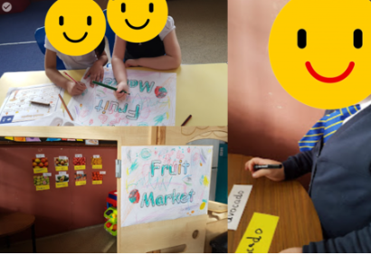

Health and Wellbeing
Having built strong relationships with the children in both classes, I have supported some children who are a little less confident or have additional support needs. Carrying out wellbeing webs and GMWP wellbeing profiles, children have been able to discuss their feelings openly and comfortably; and evaluate their choices according to the SHANARRI indicators.

First Aid
Being an additional trained first aider within the school, I provide children with immediate care in the playground during break and lunch time duty as well as in class.

Parental Links
Using Learning Journals, I provide families with evidence of learning and experiences children are involved in through photographs and videos. Where observations have been uploaded linking to the curriculum, I have shown the skills children have gained through the experiences given and provide next steps and suggestions to further learning where appropriate.
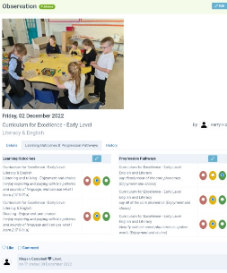

Appendix 3 – 5 min box data – CA ROLE

Appendix 4 – Lesley Hill data – music

Appendix 5 – Sports data Kerry

