
Rationale & Aims

Muirkirk Primary and ECC’s core values have been created in partnership with staff, parents/carers and children. Our core values are to encourage all to be Successful, Happy, Achieving, Respectful and Positive (SHARP). All members at of the Muirkirk Primary and ECC community does their upmost to live up to our motto ‘ every child counts’ and ‘every moment matters’ We strive to ensure that every pupil and staff member works in a positive learning environment through ensuring that our motto and values are embedding in everything that we do.

We also continue to fully embed the key nurture principles, through our understanding of attachments, trauma informed practice and our awareness of adverse childhood experiences. We also ensure that the GIRFEC approach contained within the Children and Young People (Scotland) Act 2014 also determines eight areas of wellbeing which are the basic requirements for all children and young people. We strive to ensure that all children feel –

- Safe
- Healthy
- Achieving
- Nurtured
- Active
- Respectful
- Responsible
- Included

Working together to promote positive relationships

Positive relationships among all members of the school community produce an environment that is conducive to all aspects of learning and without which learning can be greatly impeded. We aim to increase the effectiveness of preventive practices and use restorative practices to create a safe learning environment in which every learner thrives. This is through a variety of ways –

Whole school

- Daily routines - Senior Leadership Team and Class Teachers greeting children on entry to the school and classes.
- Breakfast club – accessible for all children throughout the school in all school days. This also includes active games offered on a daily basis to support physical wellbeing before school.
- Emotional regulation visuals displayed around the school for all children to use, following the PATHS approach.
- Vision and class values displayed within every classroom.
- Weekly whole school assemblies celebrating success of learners who have displayed the school values.
- Whole school assemblies that discuss the SHANARRI indicators.
- Whole school house token reward system linked to the promotion of displaying the school values.

Classrooms
- Classroom charters created in collaboration between class teachers and learners.
- Daily feeling check in’s displayed in all classes.
- VIP selected each day in every class to provide compliments and promote self -esteem.
- Wellbeing and Inclusive Practice resource boxes available in all classes if and when required.
- Social and emotional lessons implemented using PATHS programme and East Ayrshire Health and Wellbeing framework.
- Participation in class projects to develop leadership qualities e.g. Active Schools leadership programme.

Playground
- Playground buddies from P5-7 trained in using a consistency in language and approaches within the playground to support all learners
- Classroom Assistants/ support staff have received appropriate training in order to ensure a whole school consistency in language and approaches within the playground to support all learners
- Visuals within the playground to support children who are feeling dysregulated.
- Wellbeing box available during playtimes and lunchtimes for those who require it and can be accessed from a member of the SLT’s rooms.

Planning and assessment

We ensure that careful consideration is not only given to the curricular pathways of health and wellbeing but the eight wellbeing indicators. This is through a range of experiences such as –
- Using East Ayrshire Health and Wellbeing progression frameworks from early level to second level.
- Barnardo’s PATHS programme used in a weekly basis in all classrooms to ensure social and emotional learning is carefully considered and there is a consistency in language and approaches throughout the school.

We also assess health and wellbeing through a variety of methods in order to ensure that all learners wellbeing needs are met –

- PASS via GL assessment suit – Results analysed two times per session (or more for children who are being monitored for health and wellbeing).
- Monitoring and tracking of Health and wellbeing curriculum – three times per session.

Targeted support within the school

We recognise that some learners may require further support than the universal supports available. Therefore, if and when required our learners can access more targeted support within the school. This can include –
- Exchange counselling service – This is a specialist counselling service funded through the local authority which helps to develop the skills children need to improve overall resilience and wellbeing.
- Exchange BEAR resilience cards to help identify key areas to be developed and create a targeted support plan.
- Classroom assistant delivery of Developing the Young Workforce or social skills groups as required/deemed appropriate.
- East Ayrshire Support Team who may take responsibility for wellbeing groups (until EAST restructure occurs). Groups are carefully considered and can take the form of groups with a focus on social and emotional wellbeing and the development of communication skills.
- Respect, Empowerment, Support and Teamwork programme – This programme focusses on developing essential social skills through games and active health activities to enable the children to practice the social skills and emotional regulation activities required in real life situations.
- Working in partnership with other external providers who would be able to assist or provide support that would help with agreed targets for individuals or groups of pupils.

Restorative Practices

Restorative approaches is a national tool which every authority is being encouraged to implement. Education Scotland has identified the key principles of Restorative Approaches. They are –

- Being responsible for one’s own actions and their impact on others.
- Respecting other people, their views and feelings.
- Empathising with the feelings of others.
- Being fair
- Everyone in school being actively involved in decisions about their own lives.
- Returning issues of conflict to the participants
- Willingness to create opportunities for reflective change in pupils and staff.
- Some children might need further supports to engage in restorative conversations but the same principles will still apply

It is a short discussion where a member of staff leads the conversation using open questions and reflective listening. It begins with a review of what happened, discusses the consequences of a behaviour and ends with suggestions of how the relationship can be repaired and strategies to ensure that the issue doesn’t happen in the future.

A restorative conversation is more than a process and the behaviour of the child lies at the heart of it all and how it has impacted on others. It typically follows a process of asking five of the following suggestions:

- What happened?
- What were you thinking at the time?
- What have you thought since?
- How did this make people feel?
- Who has been affected?
- How have they been effected?
- What should we do to put things right?
- How can we do things differently in the future?

Whole school procedures to follow

When an incident occurs, it is important that there is consistency in the approaches used across the school. Therefore, we have created a whole school diagram to support all staff and children in supporting the choices being made.

Please see the diagram on the following page.


Relationships policy
Are you following our SHARP values?







Reminder of our school values



Time to calm down

Restorative chat – how can I make it better?

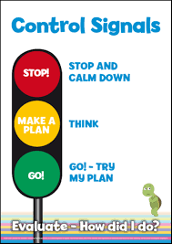
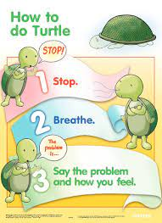



Is the problem fixed?

HT or DHT Chat

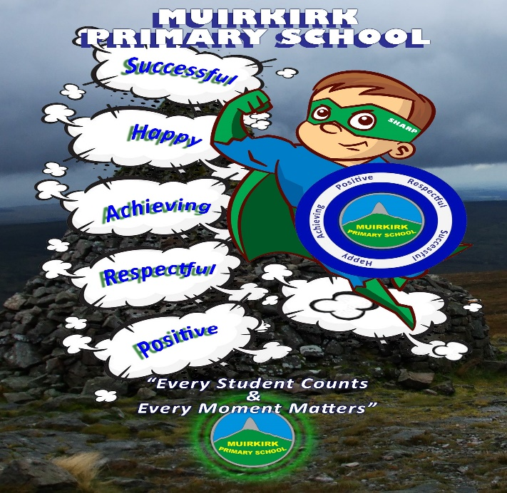


Restorative action if required


Contact Home

Policy reviewed – April 2026

