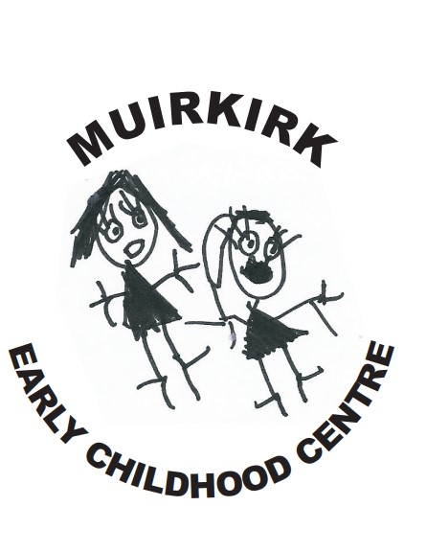

Standards and Quality Report
2025-2026

Muirkirk Primary School & ECC
Establishment Context
Muirkirk Primary is in a new build Primary School and Early Childhood Centre located in the heart of Muirkirk. This new build has given staff, pupils, parents/carers and the local community huge pride in their community.

The school is non-denominational and provides an inclusive, differentiated and appropriate curriculum for all pupils. We are proud of our multi campus provision, which enables us to build early partnerships and work together with parents/carers to ensure that children progress from one sector to next, continually building on their prior learning.

In session 2025/2026 the final school roll was 115 pupils in 5 mainstream classes and an Early Learning and Childhood Centre with the provision and support for 2-year-old places.

87% of the children in the school lived in SIMD decile 1 or 2.

34% of our pupils were in receipt of free school meals.

38% of our pupils are on the ASN log

The Senior Leadership Team includes Mrs Anne McLean, Head Teacher, Mr Christopher Jackson, Depute Head Teacher and Mrs Lauren Griffiths, Senior Lead ELCP

The school is also well supported by permanent and peripatetic teaching staff, ELCPs, as well as the invaluable input of non-teaching staff in the form of our classroom assistants, clerical assistant and our janitorial, cleaning and catering staff. Parents/carers and a range of community partners also provide support which enables us to provide high quality learning experiences for all our pupils.

Key strengths:
Our self-evaluation processes and HMIE report shows we have the following strengths:

- The headteacher, and all staff, demonstrate a clear commitment to improving outcomes for all children. They value children as individuals and constantly seek opportunities to help them develop as successful, happy, achieving, respectful and positive (SHARP) people.
- Staff have a clear, shared understanding of the local context and of the increased challenges for children and their families.
- Staff have created a calm, positive, nurturing learning environment that reflects the school’s vision and values. This ethos is underpinned by mutual respect and a commitment to children’s rights. Children benefit from being part of this strong learning community in which there are positive and respectful relationships with staff and peers. Children are considerate of others, respectful, helpful and mannerly.
- At all stages, children have regular opportunities to learn outdoors. The local area is used extensively in interdisciplinary learning activities. Children engage well in these activities and are developing an awareness of how to be a responsible citizen.
- The school has an open door policy and prioritises building positive relationships with children and their families. Parents appreciate being kept up to date with the work of the school through regular use of the school app, newsletters, website and texts.
- Staff provide a safe, nurturing, inclusive environment where all children feel valued and included. Respectful relationships, based on mutual trust, honesty and kindness are evident across the school. Children are very aware of the wellbeing indicators and what each means for them. They talk confidently, for example, about what it means to be safe and achieving.
- Staff help children recognise and celebrate diversity through lessons and school assemblies. The school is working towards the Rights Respecting Schools silver award which is helping children recognise and value individual similarities and differences. Staff promote equality for all and actively seek to create an environment where everybody is represented, included and valued for who they are. The inclusive nature of family service at lunchtime exemplifies this.

In November 2024, the school had an Authority Learning Visit which highlighted the following strengths:

- The staff have a clear understanding of their local context and the challenges for children and families. They work in partnership to negate the impact of these and improve experiences and outcomes for learners.

- The relationships throughout the school are strong, respectful and caring.

- The school have strong links with partner agencies within and out with the local community to better address the needs of their families.

- The school has a positive ethos with an inclusive environment.

- The SLT lead a strong strategic vision for improvement and are clear on the schools next steps for progression moving forward.

In arriving at our improvement priorities, we took account of East Ayrshire’s Integrated Children and Young People’s Service Plan and East Ayrshire Council’s Community Plan. We also took account of the legislative responsibilities in respect of GIRFEC, parental involvement, health promotion, disability and equality. Further consideration has been in line with on National Improvement Framework and HIGIOS 4

In our Early Childhood Centre we also take account of the principles set out in the Pre-birth to Three guidelines, Realising the Ambition and the local priorities detailed in The Best Start in Life document. Further consideration has been given to HGIOELC.

Our recent HMIE inspection can be found at
https://education.gov.scot/inspection-and-review/find-an-inspection-report/find-an-inspection-report/details?id=3765

Our excellent work in leading improvements with dysregulated behaviours can be found

https://education.gov.scot/resources/bullying/responding-to-bullying/high-quality-professional-learning/professional-learning-at-muirkirk-primary-school/

Establishment Vision, Values and Aims
Our “Sharp” Values for the pupils in our school is for them to be:
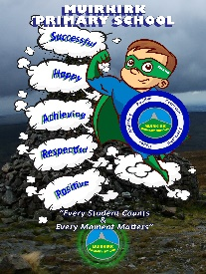
Successful
Happy
Achieving
Respectful
Positive

Our motto and vision is “Every Student Matters and Every Moment Counts.”

Establishment Aims

- Through continuous improvement in learning and teaching create a climate of high expectation, confidence, achievement and resilience

- To offer equal opportunities for every child to achieve his/her potential in a welcoming, happy, healthy and inclusive environment.

- To foster a positive ethos, to care for and work with each other.

- To promote responsibility and pride in all aspects of school and community life.

- To work meaningfully with parents, the community and external agencies to provide support and opportunity for all.

Improvement Priority  (Expressed as outcomes for learners) | Improvement Priority (Expressed as outcomes for learners)  - By the end of session 2025-2026, all children will develop resilience within numeracy and maths and further build problem solving skills to increase their confidence in Numeracy and beyond.  - Throughout the session 2025-2026, all pupils in P4 – P7 will experience further opportunities to lead their learning and develop Leadership and Meta skills through Leadership Groups.  - Throughout session 2025-2026 all pupils within the school and ECC will experience the tangible benefits of a rights-based education, leading to improved well-being, empowerment and achievement. | Education Service Improvement Plan 1: Our Leadership  We actively support, promote and enact leadership at all levels. Our young people are supported to be leaders of their learning in our centres, schools and wider life experiences. All staff have ready access to appropriate CLPL and experiences to promote leadership in every classroom, playroom and centre.
Our Leadership
Progress and Impact | THINKING CLASSROOM  This session we have continued TLC Community work on The Thinking Classroom with Quality Improvement Manager, Robert McCallum. This session we have embedded previous strategies and focussed on the main themes of  - How we answer questions  - When, where and how tasks are given  - What homework looks like  - How we foster student autonomy  From our self-evaluation, classroom observations and feedback from pupils we note that our pupils are keen to contribute ideas more readily, there is less reliance on the class teacher and visible thinking strategies are evident in all classrooms.  Classroom Observations and Learning Walks show consistent use of vertical surfaces and random groupings. Classroom layout in almost all rooms has changed with teachers avoiding a ‘front facing lecture’ setup. This has allowed classrooms to become more agile, collaborative and discussion focussed.  PHOTOS IN HERE OF CLASSROOM SET UPS  Children have reported through an end of year self-evaluationhttps://forms.office.com/e/DyWGLKsvrw?origin=lprLink  86% prefer to work in randomised grouping, providing reasons like:  “We work with people we don’t normally talk to”  “When we go to work when we are older we will have to talk to people we don’t know.”  “When you work with friends all time, you might not be sensible.”  The role of the teacher has also changed. From observations and discussions with staff, it is apparent that staff have become facilitators, observers and questioners as opposed to teachers during certain lessons. Teachers are becoming more adept at resisting the urge to ‘rescue’ struggling pupils, encouraging peer learning, giving all pupils access to meaningful participation.  However, we have discovered that some children still need and want explicit instruction, whether this is due to their personality or additional support needs. We cater for all our pupils as we know the needs of our children well.  Staff have adjusted their assessment tasks to ensure answers require reasoning not just answers. Classroom observations show that children are more ready and willing to give answers as the fear of being wrong has diminished. There has been a real shift in culture in this respect. Through self evaluation pupils reported that they can show their thinking:  “In ‘Think it Through jotters.”  “White boards.”  “Post It Notes”  “By lots of discussion with friends.”  This session we invited Robert McCallum, Quality Improvement Manager to Muirkirk to participate in Quality Assurance observations with the Head Teacher. Feedback included:  - There was evidence of the children thinking about the strategies they might use. Class Teachers let the children lead their own thinking.  - Co-operative learning in pairs through randomised groupings.  - Questioning used higher order thinking skills.  - Children were encouraged to find a way to record their thinking. Personalisation and choice built in.  - Class teachers reiterated that it was ok to get it wrong and encouraged children to try again thus building resilience.  Our evidence shows our pupils demonstrate a greater conceptual understanding – this is evidenced by their ability to explain reasoning, apply knowledge to familiar and unfamiliar problems and are making connections across problems. GL Assessments showed an increase in conceptual understanding and mathematical reasoning, particularly at the P5 and P6 stage with both these classes scoring higher than the national average.  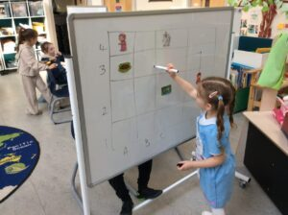  PROBLEM SOLVING  This session staff have fully embedded our school problem solving planner to ensure problem solving experiences are being planned within Numeracy and Mathematics experiences and into the wider school curriculum. This has been successful.  94% of children say they enjoy problem solving more now than they did at the start of the session  93% of children reported that they feel more confident when attempting problem solving activities than they did at the start of the session.  As mentioned above, problem solving goes beyond getting an answer right. In Muirkirk it involves the children choosing strategies independently, explaining reasoning and applying their knowledge across the curriculum. Our classroom observations show evidence of problem solving within Science, Literacy, inference and interpretation.  Training has developed confidence in designing tasks that are open ended. Structured discussions have helped pupils articulate and refine their thinking. Scaffolding – using prompts, models and worked examples. By planning these explicitly shows effective practice.  BOOST GROUPS  This session, we took the decision to challenge our more able learners within maths. Mrs Connor established a Boost Group which consisted of pupils from P4 – P7.  Group A (P7 & P5/6 pupils) focused primarily on ‘Explain, Convince and Prove’, ‘Visualising and Representing’, ‘Algebra’, ‘Explore and Notice’ and ‘Conjecturing and Generalising’ strategies. All pupils involved have been engaged, communicated well and solved problems logically. The problems have helped dispel some misconceptions e.g. 2D shape qualities and that = only means the answer. Through algebra work, it became apparent that a knowledge of BIDMAS was required so we had a mini focus on this and all pupils are now confident in its use. Most pupils feel their problem solving skills, as well as Communication, Perseverance, Risk Taking and Meta skills have improved (see survey, April 2026). Next step: Further practise in a range of problems, focussing on previous and new strategies.  Group B (P5/6 and P4/5 pupils) has been working primarily on a range of strategies to boost perseverance, as well as focussing on ‘Working Systematically’, ‘Explore and Notice’ and ‘Conjecturing and Generalising’. Although pupils were able to explain working systematically, it took several sessions to establish this strategy in their workings, but now, pupils are making useful notes, minimising changes and taking more time to plan their approach. Some pupils have varying levels of engagement/flow, depending on their perceived difficulty of the task, but I have observed an improvement over the year. Most pupils feel their problem solving skills, as well as Communication, Perseverance, Risk Taking and Meta skills have improved (see survey in previous link).  Every child who was a part of this group increased their Standard Age Score (SAS) on their Progress Test in Maths (PTM) GL Assessment. This the most important piece of information derived from PTM. The SAS is based on the student’s raw score which has been adjusted for age and placed on a scale that makes a comparison with a nationally representative sample of students of the same age across the UK. The average score is 100. The SAS is key to benchmarking and tracking progress and is the fairest way to compare the performance of different students within a year group or across year groups.  LEADERSHIP GROUPS  Following discussion with the pupils, around they types of Leadership Groups they would like to participate in, thus ensuring pupil voice, staff ‘signed up’ to a leadership Group of interest to them. This also formed part of their PRD.  Children from P4 – P7 were then given the choice of which Leadership Group they wanted to participate in. Staff then worked collaboratively with the pupils to consider what the aims of the group would be. Groups met monthly, to work towards their goals. Notice boards for each group were created so information was easily shared. Information was also disseminated at assemblies led by the children. Members from each group were also responsible for ensuring the P1 – P3 classes were kept informed of ongoing work. Details and impact of each group are described below:  Staff Leadership  As a staff we have continued to lead our individual Leadership Groups and ensure that ‘Leadership Update’ became a standing item on every staff meeting, ensuring all staff were aware of the ongoing work each group were participating in. Staff also participated in and delivery of many CLPL opportunities to enhance their skills within their leadership area. Examples include:  Mr Jackson attended Reading Schools CLPL, then delivered training sessions to all school staff.  Miss Bell attended an information and CLPL session on STEM Nation Award and cascaded her learning to the whole staff team, putting together an Action Plan for session 2026-2027  Mr Wallace participated in Clean Green training and gave his class the opportunity to lead learning at assembly, applying for various awards and accolades.  Quality Assurance of Leadership Groups was done by discussing Minutes of Meetings, observation of groups in action and self evaluation for staff and children.  Unfortunately, we were unable to encourage any parents/carers to join us for leadership time. Parents reported that they were busy, working or had other commitments. Although disappointed, we will continue to encourage this collaborative working. That being said, many parents joined us for our leadership events and sharing the learning opportunities.  RRSA  This session we were delighted to achieve our Silver Rights Respecting Schools Award (RRS). Report is attached below. To secure this award our school, ECC and leadership group worked hard to embed the rights across the school, making them visible and relevant to all pupils. To ensure this remains high profile, the RRS Leadership Group deliver at our whole-school assemblies in relation to our Right of the Month. This allows the rights to be explained in a child-friendly manner for all pupils to understand, as well as being displayed in each classroom, ECC playroom and around the school. Our RRS group have also worked alongside our ECC to display rights around, making sure our nursery playrooms and classrooms are consistent with displays. Parental displays have also been created to showcase to our parents how we uphold the rights within our whole establishment.  PICTURES INCLUDING ECC  We have worked hard to cross-reference and coincide our SHARP values with the Rights of the Child within each class charter which has allowed the children to become more familiar and comfortable with using the language of the rights, such as ‘Right Holders’ and ‘Duty Bearers’. Children’s rights are discussed, explored and taught across the curriculum through IDL. For example, P2/3’s topic of the Global Goals, P4/5’s topic of climate change and P4-7’s topic of Parliament and Democracy. Collaborating with other leadership groups has allowed pupils to explore and advocate for local community and environment such as litter-picking, our ‘Drain Campaign’ and creating dog-waste dispensers.  Our RRS group represented the school with confidence and enthusiasm on the day of our Silver Award, online visit. Each pupil was able to speak knowledgeably about our journey to Silver, and their hard work reached us to achieve this. Our group then decided the best way to celebrate would be with a ‘Rights Respecting Rave’ for the whole school! This took place shortly after our accreditation in October 2025.  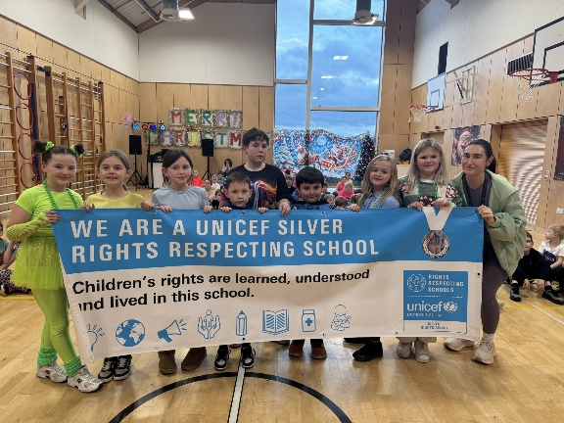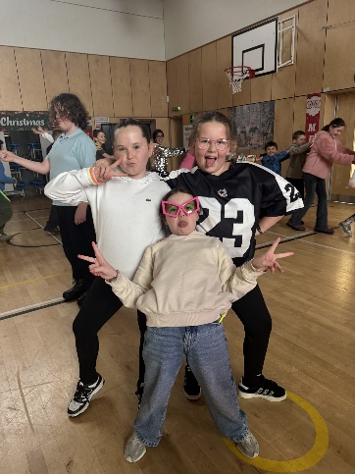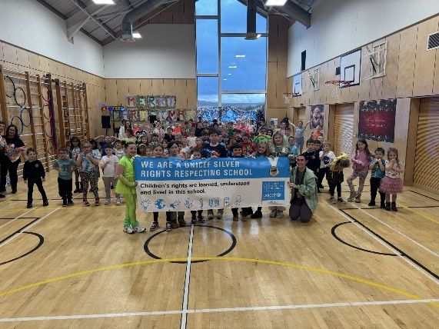  Moving forward, we aim to achieve our Gold award and are currently working towards this. A significant part of our journey to Gold will be continuing what we have already put in place, however, there are some areas we will be developing such as:  - Making rights clear for pupils, why do we have rights and what do these allow us to do?  - Develop children’s knowledge of global issues and how UNICEF protects children’s rights across the world  - Continue to diversify our curriculum by working with the Reading School leadership group to identify books that could help with promoting equality, diversity and respect  .
  Class | % of children who scored average and above on GL Maths | Fluency in Conceptual Understanding |  | Mathematical Reasoning
   |  | National Average | Group Average | National Average | Group Average
  P4 | 77% | 41% | 38% | 41% | 41%
  P5 | 78% | 64% | 66% | 25% | 54%
  P6 | 80% | 46% | 49% | 49% | 50%
  P7 | 77% | 62% | 55% | 35% | 55%
  Child | SAS Score October | SAS Score May | Increase
  AK | 124 | 130 | +6
  PY | 108 | 109 | +1
  ZA | 114 | 117 | +3
  ES | 113 | 128 | +15
  Leadership Group | Aims | Success and Impact
  Reading Schools  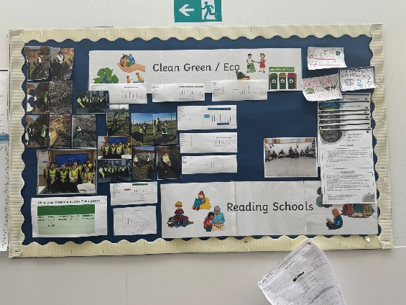 | - To work on achieving the core award accreditation from Reading Schools.  - To raise the profile of reading for pleasure across the school, ECC and our local community.  - To create inviting and comfortable spaces that promote reading for pleasure  - To provide opportunities for children and staff to enjoy sharing what they have been reading with others.  - To acquire feedback from children and staff and put required actions into place | - Established and embedded daily opportunities for reading for pleasure through DEAR time and Story Swap  - Sourced and requisitioned furniture to create a new and inviting ‘cosy’ library area in the school  - Created power of reading posters that are displayed around the school  - Created posters recommending books to other children that are displayed prominently in the library.  - Requisitioned a listening post that can be used in each class  - Provided regular opportunities for pupils to share what they have been reading in class and at assembly  - Ran a Mascot competition for Muirkirk Reading Schools across the school and ECC  - Conducted regular surveys to gain insight into how reading for pleasure is progressing  - Researched books with an equality focus and created a requisition list to make our library more inclusive  Impact  - Classes are using the new library area as a space to enjoy reading and listening to stories as an extension of the classroom. It is becoming a more prominent feature in weekly timetables.  - The listening posts are used frequently in class to build in a multimedia approach to literacy education.  - Children are now more willing to discuss what they have been reading and have a greater knowledge of different authors and genres of books.  - There is a greater variety of reading materials for children to select from, and most are now able to find a book in line with their interest.  - There are now higher engagement levels with reading for pleasure and an improvement in the number of pupils who chose to read in their free time
  Clean Green/Eco Group  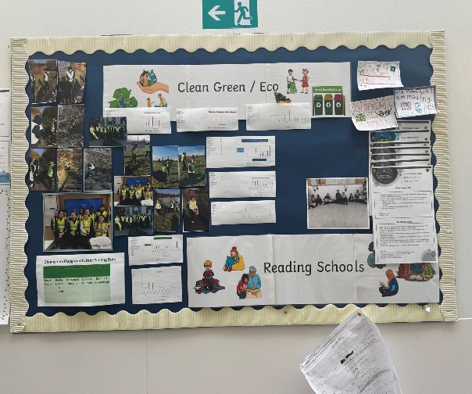  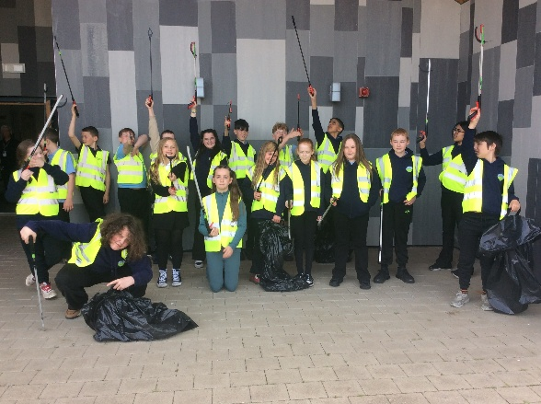 | - Develop pupil leadership and teamwork skills.  - Increase awareness of environmental issues.  - Encourage sustainable practices within school and the local community.  - Promote pride and responsibility for the local environment.  - Support biodiversity and wildlife within the community.  - Achieve the next level of the Clean Green award.  - To renew or Green Flag as part of Eco Schools | The Eco Group completed a range of environmental projects and awareness campaigns, including:  Litter surveys of our local area around the school to monitor environmental impact and recorded this information. They then used ICT to present their findings. They group then carried out litter-pick activities in the area to reduce the amount of litter present.  The Big Battery Hunt – organised a battery recycling station in the school. Batteries were collected, counted and numbers entered into the BBH website and batteries were then sent to a local recycling centre.  Due to a problem with dog fouling. The group created and installed dog poo bag dispensers for local walkways to help to reduce the instances of dog fouling in our local area.  To support biodiversity, the group planted a number of flowering and fruit trees (obtained from the Scottish Woodland Trust) around the school.  As part of a local initiative, members of the group planted flowers at the new picnic stop park area. This helped to foster cross generational learning and interest in and care for our local environment.  The children also created posters encouraging reduced electricity use in the school. They were also involved in promoting and participating in Walk to School Week.  The group also created litter rotas and volunteered to litter pick the school playground after every break and lunch time.  The group also made bird feeders to encourage and support local wildlife during the Winter months.  The group also presented findings from surveys and discussed improvements and targets during Leadership group meetings.  Impact  The Eco Group had a positive impact on both pupils and the wider community. Pupils developed confidence, leadership, communication and teamwork skills through planning and leading activities.  Environmental awareness across the school increased, particularly around littering, recycling, energy conservation and active travel.  The projects improved the appearance of the local environment and encouraged community involvement through initiatives such as the dog poo bag dispensers and tree planting. Pupils also developed a greater understanding of biodiversity and the importance of protecting local wildlife and green spaces.  Overall, the Eco Group successfully encouraged pupils to take responsibility for caring for their environment and helped promote positive environmental behaviours across the school community.
  Pupil Voice  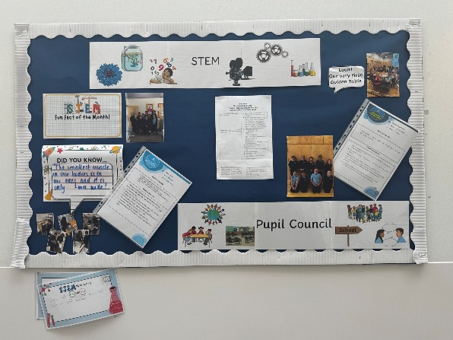 | - To promote pupil voice and participation in school matters.  - To enhance communication and collaboration  - To empower pupils to speak up and support others. | This group completed speech and language training on “Getting Wee People Talking.” This educated them on how to speak and play with our youngest children in the ECC. On a monthly basis this group went into the ECC and worked with the children, putting into practice wheat they had learned.  Recognising the terrible amount of litter within the local community, the Leadership group, in consultation with the Eco Group organised a Community Spring Clean, where our whole school with the help or parents, carers and relatives went to different highlighted areas within Muirkirk to carry out a litter pick. The group created a risk assessment, letter for parents/carers and created a timetable.  Children from this group also made up a Focus Group for our DHT Interviews. They created questions, interviewed each candidate, scored them and fed back to interview panel, their thoughts and opinion.  Impact  Children have developed leadership/metaskills. They have learned how to make decisions, solve problems and work with others.  Children have a feeling of ownership within the school, taking responsibility and having a voice.  The work with Getting Wee People Talking’  Has given children a firm understanding of early communication skills and how important it is to OWL! (Observe, Wait, Listen)  Children know Muirkirk Primary is THEIR school, they have an increased sense of belonging and pride. As was evident in feedback/self evaluation.
  STEM  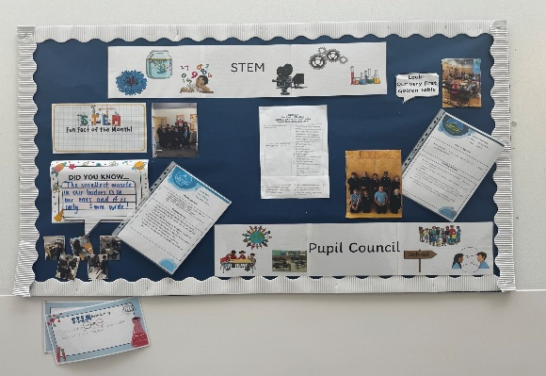 | - To promote STEM awareness and engagement throughout the school and ECC.  - To develop critical thinking and problem solving skills  - To build a supportive STEM culture throughout the whole school community | Throughout the year, STEM has increasingly been embedded across the school’s practice, with a focus on developing pupils’ skills, raising aspirations and strengthening the profile of STEM across learning.  The STEM Leadership Group has supported this through a range of purposeful activities, including improving and organising the STEM room to ensure resources are accessible to all learners, including ECC. This was done to promote consistent access to high-quality STEM resources, which has resulted in increased pupil engagement and more effective use of the space across stages.  Pupils within the group explored influential women in STEM to promote equality and equity, challenging stereotypes and encouraging all learners to see themselves as future STEM contributors. This has helped increase awareness of diversity in STEM and supported more inclusive attitudes and aspirations across the school.  To further embed STEM in real-world contexts, the school welcomed visitors from STEM-based careers who shared their experiences and pathways into their professions. This was planned to raise aspirations and help pupils understand the relevance of STEM learning beyond school. Pupils were highly engaged, asking thoughtful questions and showing increased curiosity about future career options, which has strengthened motivation and relevance in STEM learning.  A key achievement of the group was the successful planning and organisation of activities to celebrate British Science Week across the school. Pupils within the STEM Leadership Group prepared and practised experiments before confidently leading them with infant classes during the week. This provided valuable leadership opportunities, reinforced the skills they had developed, and created a highly engaging experience for younger learners, resulting in a meaningful celebration of STEM learning across the school.  These developments have strengthened the school’s STEM culture, improved pupil engagement and leadership opportunities, and supported progress towards the STEM Nation Award by clearly demonstrating how STEM is embedded across learning and wider school experiences.
  Digital  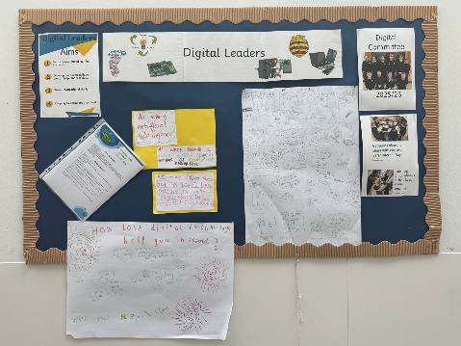 | Aims:  - Help improve the digital learning in classes.  - Develop our digital skills so we can help others in class.  - Share information digitally.  - Keep digital resources organised. | Progress and Impact  We searched online for, and chose, ideas to plan an Internet Safety Day then emailed our plans to the ECC and teachers. Committee members tried out the AI coding task beforehand, so members could help in classes if needed. All classes took part in Internet Safety Day and increased their awareness and skills in using AI and coding.  Both existing and new Chromebooks were labelled and organised, including setting up the new charging unit. We made new posters for each area, to share storage expectations. This means everyone has easy access to resources and knows how to keep them tidy.  We shared information on our Digital Committee noticeboard to keep everyone informed. We also used Question Posters on the noticeboard, that people could write on, so we could gather views and information.  Collaboratively, on an Excel document, we started a list of apps and their uses, so teachers can see ideas for use in class. The noticeboard question posters, Digital Evidence Sway and our own experiences in class, provided us with the ideas. This app idea document is shared on the Teachers Team and can be added to over time.  - Last session, the committee created a Wellbeing video. The current committee decided to update the video, ready to share in August 2026 so we start the new school year with healthy digital habits.
  RRS  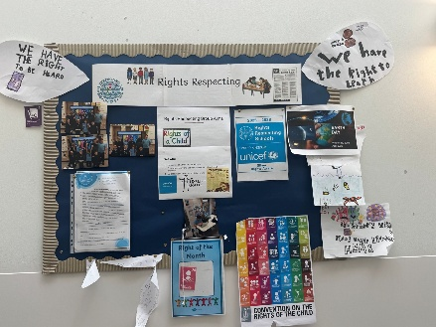 | - To promote awareness and understanding of Children’s Rights.  - To build on our respectful and inclusive school culture.  - To empower pupils voice and participation.  - To build further partnerships with the wider school community  - To achieve our Silver RRS Award | Details below.
Next Steps | - Continue to embed The Think Classroom approaches.  - Continue Leadership Groups and opportunities across all ages and stages.  - Provide opportunities for all staff to lead groups of pupils.  - Work towards Gold RRS Award.

Improvement Priority  (Expressed as outcomes for learners) | Improvement Priority (Expressed as outcomes for learners)  Throughout session 2025 – 2026 all children will always experience high quality learning and teaching in all classes.  By the end of session 2025-2026 all children within the CC and school will develop the skills, confidence and curiosity to succeed in STEM subjects throughout the course of the year.  Throughout the session 2025-2026, all learners will further develop digital literacy skills through the use of Digital Technology across the curriculum.  Throughout session 2025-2026 a culture of reading for pleasure will be embedded across the whole school and ECC, leading to100% of learners, being exposed to daily reading for enjoyment | Education Service Improvement Plan Priority 2: Teaching and Learning Together  Our young people should experience a teaching, learning and curriculum offer that meets their needs, and those of our local and national context. All staff should be supported to deliver in new and innovative ways by accessing CLPL relevant to their needs and those of our young people.
Teaching and Learning Together
Progress and Impact | EXCELLENT LESSON  This session we have embedded The Excellent Lesson.  Through feedback from pupils and through self-evaluation we can evidence that, almost all our children are able to discuss what an excellent lesson is, explain the elements of an excellent lesson and why this standard is so important. In our pupil Self Evaluation, children were able to discuss The Recipe for SHARP TEACHING (Child Friendly Excellent Lesson). They said things like:  “Incorporating things students like into lessons.”  “The teacher speaks with detail.  “Providing examples.”  “Sharing L.I. and S.C.”  “Everyone getting work they can do.”  All SLT observations this session has remained focussed on the elements of the excellent lesson. Our observation paperwork was updated to include a section called ‘The Thinking Classroom’, as this was an element the whole staff felt contributed to an excellent lesson. We also wanted to ensure our learning from The Thinking Classroom CLPL was high priority in our practice. Peer observations also used the same paperwork, making it easy for staff to identify what constitutes excellence in daily practice  Teachers have reported through Quality Assurance meetings and self-evaluation that knowing the expectations helps them make better decisions with regards to pacing, questioning, activities and support strategies. It also helps us a school improve consistency and student outcomes.  Leaders of Learning  Across the session, we have focussed on our delivery, creation, sharing and presentation of Learning Intentions and Success Criteria. Through the Leaders of Learning sessions, the focus soon became continuity throughout the school. This is when the Muirkirk Learning Tree was developed. Mrs Musson, in her capacity as Leader of Learning, collaborated with staff to create the Learning Tree. Every class has been given the same flipchart with the same wording and logo. The reasoning behind this was, that although some of our younger or less able pupils may not be able to read some of the information, their recognition of the tree and what it represents will filter through every year group ensuring that consistency of approach.  The learning intentions are shared at the start of the lesson and success criteria is also shared or in many cases now, co-created with the pupils. The Learning Tree is discussed at the start and the end of the lesson, as part of the plenary.  With meta-skills at the forefront of our development, we included a section within our Learning Tree to link our meta-skills that are being used throughout the activity.  Teaching staff have reported that they really like the Learning Tree and that it keeps everything clear and concise. Pupils say that they know that when the flipchart appears they know that they will find out what their learning intentions will be and they will be able to see what success will look like.  As a staff, we are encouraged that we have continuity across the school, meaning that if we were to teach in another class for the day or change stage next session, the delivery of learning intentions and success criteria is already there and established.  Following the development of learning intentions and success criteria clarity, the session looked at delivery of teaching within the classroom. There was a large focus on The Thinking Classroom and the ideas, theory and principles behind it. As a school, we are a step ahead with this as The Thinking Classroom is becoming more established and definitely apparent across the school and in each classroom  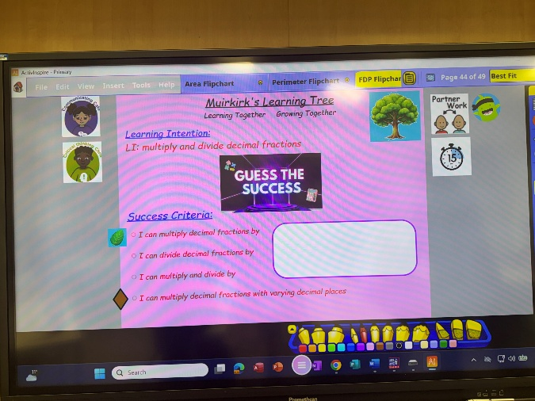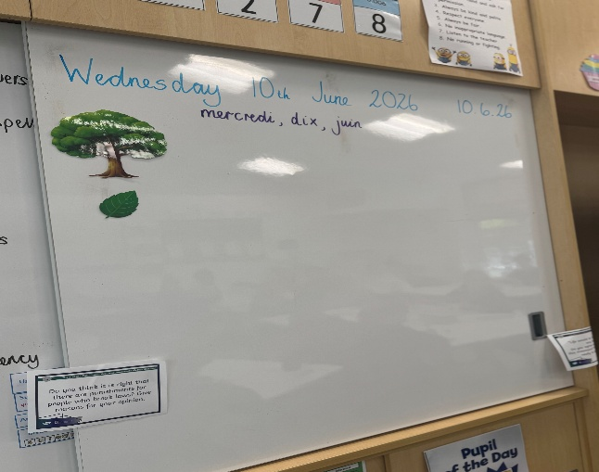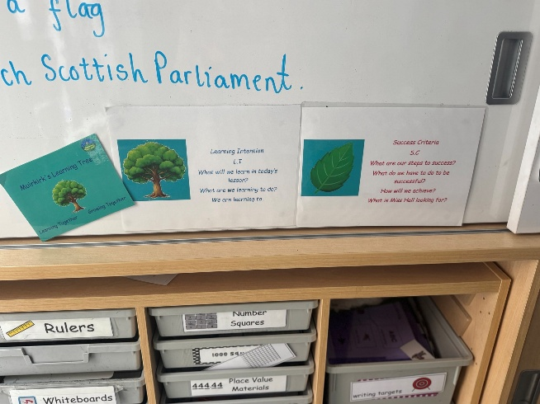  STEM  Continued use of the STEM room has taken place this session. This has been both to support the teaching of STEM and wider IDL work. A timetable was created at the start of the session, and most classes have utilised one session per fortnight in the STEM Room for science and technology lessons where Science has formed part of the backdrop planner for that term. There has been increased use to of the room to support the Thinking Classrooms pedagogy also. The ECC have also utilised the room weekly, aiding transition for pre-school children. The ECC have also incorporated many accessible resources suitable for Early Level.  Staff received further input on E-Sgoil resources and lessons that could be used within the classroom. As well as supporting STEM through one off and sequenced lessons, the input from E-Sgoil has also contributed to learning about the world of world and developing skills for learning, life and work. The input has mostly been in the upper school and was used to give pupils real-life examples of jobs within the STEM field and the skills and qualities required.  Staff continued to use the 3-year rolling program for science. This will ensure that all children have the opportunity to progress across the 5 organisers at each level. Staff have used their professionalism to move some of the science themes to different terms that best suit contribution to wider IDL topics to try and ensure that science is not always taught as a standalone topic. Staff continually feedback on the rolling program through discussions at planning meetings to ensure fidelity. The Muirkirk Learning Tree format is also used with STEM lessons to not only make Learning Intentions and Success Criteria clear for learners, but also to highlight the metaskill(s) that pupils are developing.  We have continued our partnership with Scottish Power Renewables, and we were delighted to able to offer all classes the opportunity to take part in a sequence of STEM lessons that culminated in an opportunity to complete at activity at Glasgow Science Centre. Instead of attending the Science Centre, Primary 1/2 were visited by Owl Magic which helped them bring their IDL learning to life. These sequence of lessons and workshop visit to the Science Centre was able to enrich the learning of pupils and provide current and engaging resources to bring STEM learning to life.  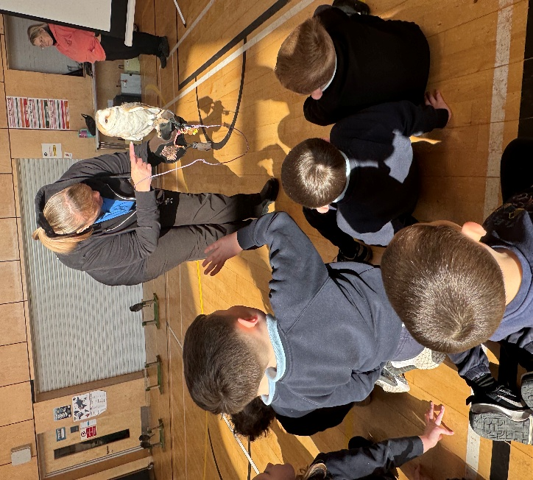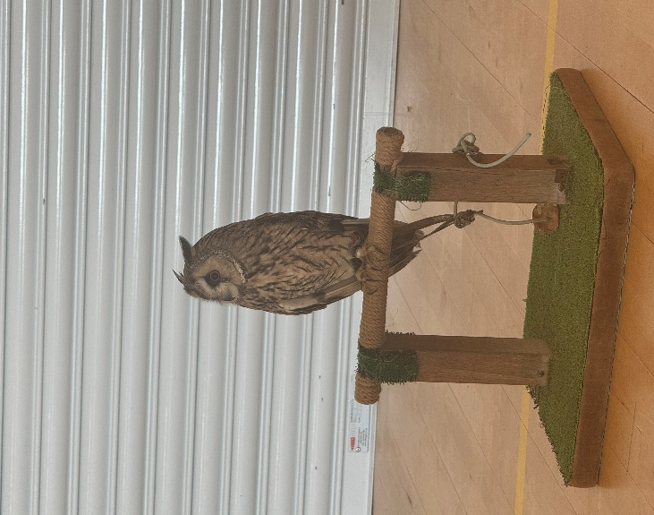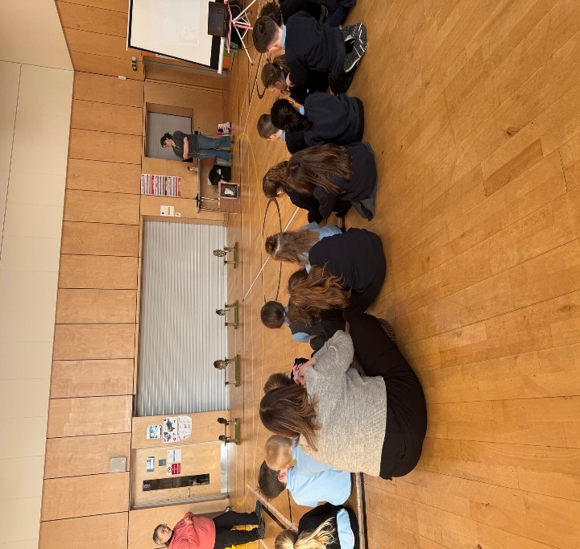  Glasgow Science Centre also delivered a whole day of activities for all classes in the school via a roadshow. This gave pupils opportunities to take part in interactive workshops and in engaging lessons. These focussed on the Human Body and provided pupils with access to interactive activities and current technologies to help develop the young workforce.  We have also continued our partnership work with Coalfields Regeneration Trust and hosted students from East Tennessee University who come into the school to work with our senior classes to deliver lessons related to energy flow and transfer.  British Science Week was planned for by Miss Bell and her Leadership Group. In March 2026 with the theme of ‘Curiosity: What is your question’ The STEM pupil leadership group planned and delivered a fantastic and extremely successful Science Week. The group delivered lessons to the ECC, P1/2 and P2/3 and throughout the week, STEM professionals visited classroom and the ECC to help wider pupil knowledge regarding the range of STEM jobs that are available. Some classes went on local visits to see how STEM has an impact in their local communities. Our ECC and P1 visited the Fire Station and P5/6 visited Galawhistle Windfarm. In order to be eligible for a CREST Award, all classes had to have at least 6 lessons delivered to them. To our delight, all our pupils have secured a CREST Award this session.  A STEM job of the week is now discussed at assembly, using different pictures to show the children role models of different backgrounds. Children are now much better able to discuss the skills and qualities needed for a variety of STEM jobs and also explain how their activities in the school might contribute to a job within this field.  Within the ECC STEM resources are embedded and readily available for children to access or explore through their daily play. Resources and areas are non-gender biased and accessible to all. MORE INFO TO COME FROM ECC  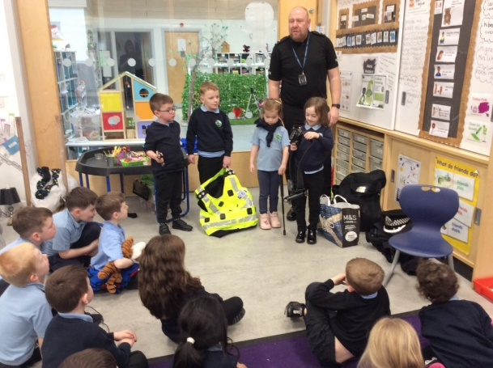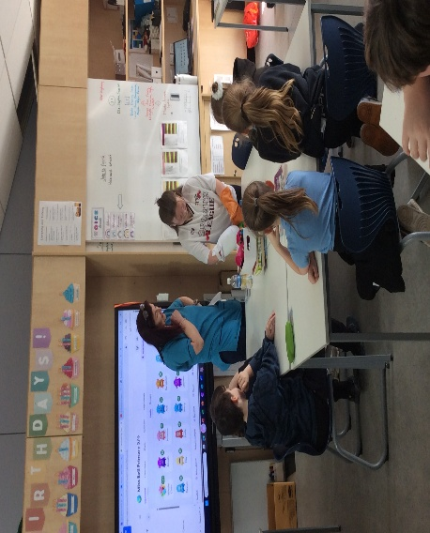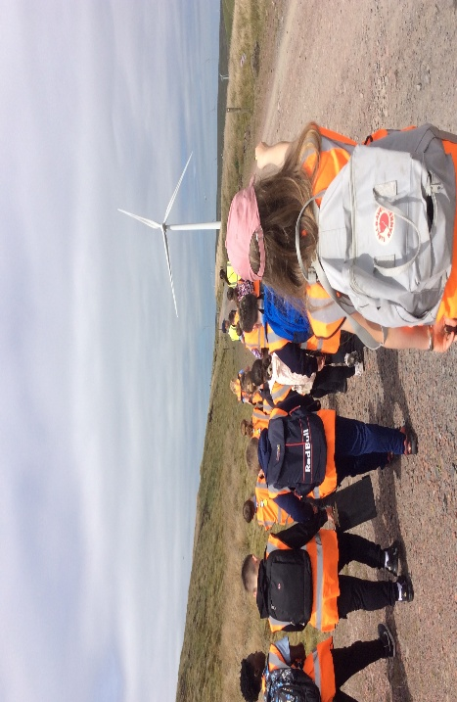  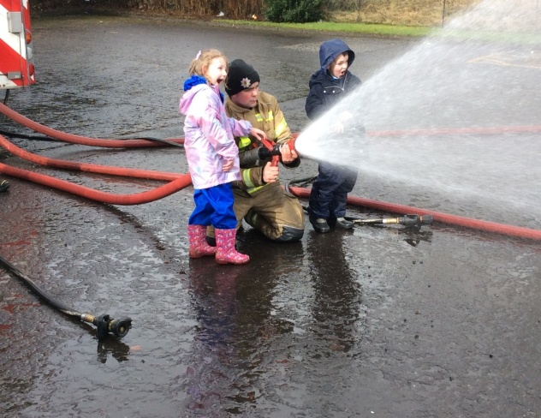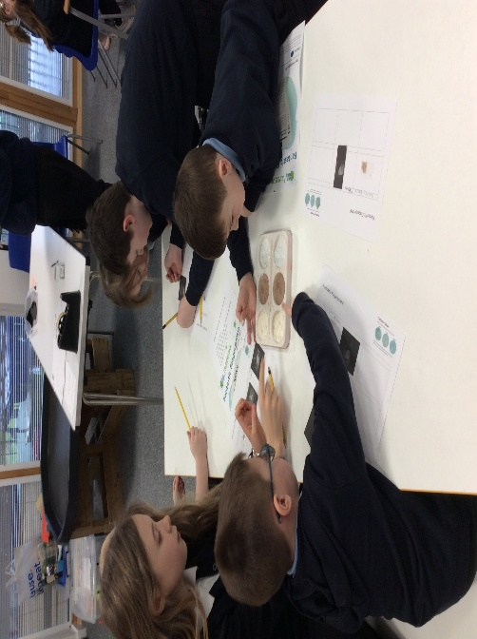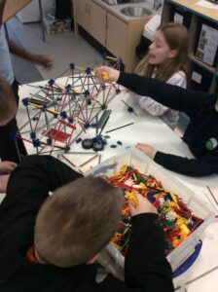  Miss Bell attended CLPL on how to access the STEM Nation Award and the type of evidence required for this. This will become part of our ongoing work on STEM next session in order for us to work towards national awards that highlight our good practice and the skills and qualities our children are developing.  Due to completing priorities and working with cluster schools on moderation of writing, as part of our commitment to the National Improving Writing Project, moderation within science was not taken forward this year. We intend to make this a priority for next session.  The impact of our STEM work is:  - all children have a greater awareness of the variety of STEM jobs that exist in their local community, nationally and globally and are aware that these jobs are for everyone.  - every child has received high quality learning and teaching experiences within STEM with new and current resources being used in collaboration with our partners.  - across the school, pupils are experiencing lessons with will help them to demonstrate their learning and success across all 5 Science organisers throughout each level.  Next Steps:  - To begin to consider what moderation in Science will look like across all levels in the school and begin to facilitate process to allow for a collection of evidence across the 5 science organisers across the level for each pupil.  - To make further use of E-Sgoil materials and certification to allow this to feed into pupil profiling for metaskills  - To further consider how British Science Week could be further enhanced and continue to build a bank of partners that can help to bring learning to life.  - To consider opportunities for further engagement of parents/carers to shape our approaches to STEM within the school.  DIGITAL  MPS Digital Planners are fully embedded and used by all teachers to plan for new learning and the application of digital skills.  This session staff have received training on the use of the TEAMS Tools from Gary Neilson, ICT Co-ordinator, EAC. Follow-up training was also provided from Aynsley Connor, Class Teacher and Digital Lead from Muirkirk Primary School. Self-evaluation evidence that this training has increased knowledge and confidence in staff, resulting in increased use of the TEAMs App within daily teaching in the classroom.  P4-7 pupils have demonstrated that they can access and complete tasks using ‘Assignments’ within Teams and useful emotional data is gathered after each Assignment using the ‘Reflect’ tool. All P4-7 teachers have trialled ‘Immersive Reader’ and ‘Reading Progress Assessment’ tools. Pupils are also gaining confidence in using these tools, with almost all children reporting that they really enjoy them. We will embed this practice next session.  ‘Whiteboard’ has been used for topic work to collaboratively gather thoughts and information.  Pupils have shown that they can use a range of apps to meet curricular tasks and are often given the choice of how they present their learning, e.g. when finding angles in the environment, P2/3 pupils chose a range of apps, including ‘Chatterpix’, ‘Camera’, ‘Mark up’, ‘iMovie’ and ‘Book Creator’. P1-3 pupils in particular, can confidently choose an iPad app that best suits their needs and are confident in using ‘Speech to Text’. ‘Clicker’ is used across all stages, as required, and in particular to support P1-3 pupils.  Computational Thinking and Coding skills have been taught from P1-7, building on the understanding and skills learned last year. Curricular feedback is occasionally given digitally, via email or through ‘Assignments’. A range of Assessment data is collected digitally and used, through GL, PASS and SNSA assessments.  Working through our Digital Action Plan, is supporting our work towards the Digital Schools Award. Our staff training, annual Internet Safety learning, increased Chromebook capacity and increased use of digital skills across the curriculum are key improvements that we have achieved.  Additional Chromebooks and a charging unit have been purchased through PEF, so that we have 2 full class sets.  Pupils on the Digital Committee took responsibility to label, organise and set them up in the new charging unit. Committee members also took responsibility for planning our Internet Safety Day.  Digital learning, as well as learning across the curriculum, has been shared with parents/carers through Online Learning Journals from P1-7 and more recently through the Learner Profile for P4-7. The Learner Profile was introduced to teachers, who created an Action Plan to introduce it to pupils and Parents/Carers. The profile allows pupils to add their own targets and achievements, at home or school, which will stay with them as they progress through primary, into secondary education and beyond. P1/2 pupils received digital homework via Boost Learning books and are given a range of websites that can be accessed at home. P3-7 pupils are encouraged to access Sumdog at home.  Classroom observations by SLT and peers, as well as sharing of practice during collegiate sessions, have identified quality digital teaching and learning across the school. Collegiate discussions around resources and learning, have supported a whole school approach and progression.  Within the ECC our STEM and Digital Champion, Lorraine Schendel has driven leadership in this area. ECC stuff MORE STUFF TO COME FROM ECC  https://sway.cloud.microsoft/x3WAGCD0LDuNVsWn?loc=swsp  READING SCHOOLS  Reading Schools form part of both our action plan for improvement as well as having a direct impact into our Core Level Reading Schools Action Plan. A Reading Schools Pupil Leadership Group was established and worked closely with the DHT to put our plans into action.  We established and embedded daily opportunities for reading for pleasure through DEAR time across the school and ECC after every breaktime to allow staff and pupils to enjoy their own reading materials. We also implemented Story Swap every Friday after break where teachers and ECC staff swap classes to read a book to children in line with their interests and build in time for pupils to enjoy being read to.  In collaboration with the Pupil Leadership Group and their ‘fact finding’ with children in the school, we sourced and requisitioned furniture to create a new and inviting ‘cosy’ library area in the school with reading materials that are rotated to allow fresh materials to be available. Most classes now have their own library area within the classroom with books that have been selected in line with the class interests or IDL topic. A listening post was requisitioned to allow each class to listen to an audio book at the same time. This has further demonstrated to children that reading is accessible to all and that literature takes many forms that we can enjoy. Pupils who initially found engagement with reading difficult or have some additional supports needs within literacy have particularly enjoyed this approach within their classrooms.  Our reading materials in the school library are now being catalogued to ensure they can be put back in the correct place to keep the library tidy and clutter free and ensure that it is easy to find and pick a book that is of interest. This has also encouraged most children to look after their shared library space and enjoy being able to find a book quickly.  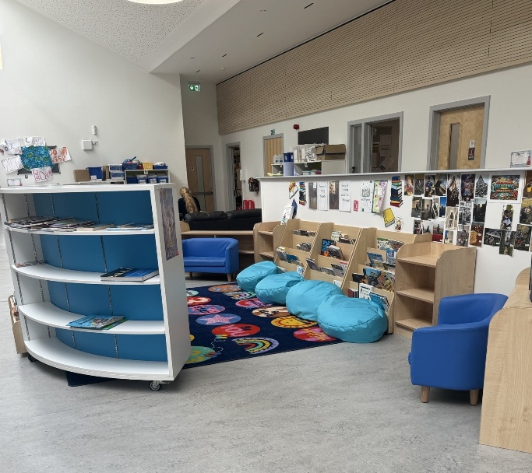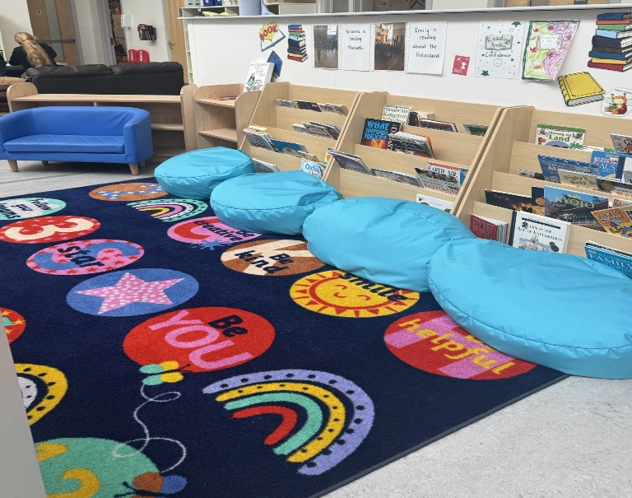  The Leadership Group created power of reading posters that are displayed around the school and library and created posters recommending books to other children each meeting that are displayed prominently in the library. These are updated when the group meets to ensure all ages and stages are targeted and there are new reading materials being highlighted to invite discussion.  We now provide more regular opportunities for pupils to share with each other what they have been reading. This is done through organising time after DEAR time for pupils to use ‘ask me what I am reading’ lanyards in class that the Leadership Group created. Each week at assembly, pupils also have the opportunity to come out and share what book they have been reading and to recommend it to others. This has allowed us to continue to promote reading for pleasure.  The Leadership Group created schedules and activity planners that all classes and the ECC used to mark World Book Day and Reading Schools Week, ensuring there was a focus activity that tied learning together and there were a variety of exciting and engaging reading activities throughout the week. Part of our activities were to model staff being readers and we ran a ‘Muirkirk Masked Reader’ event where pupils got to see staff read to them disguised in different outfits. The whole school came together for a reveal after a week-long event. This culminated in a parent and carer event where families were able to come into school to see our new library and the read to the children through a Sharing the Learning Event which was well attended and respond to positively.  A mascot competition was run for Muirkirk Reading Schools across the school and ECC with the winner received a book and the runner ups receiving a personalised bookmark. During Reading Schools Week, an Extreme Reading competition was run across the school and ECC to inject fun into reading for pleasure outside of the school building. The winner received books.  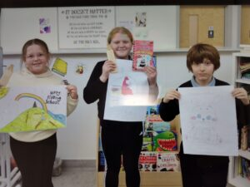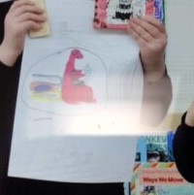  We conducted regular surveys to gain insight into how reading for pleasure is working within the school and what issues or challenges need to be addressed next. These ‘Pulse Surveys’ were used to curate different reading materials for the library as we all to consider adaptions to DEAR time and Story Swap to stop them from becoming stale. All children now show that they recognise that reading is something they can become better at through practice, and almost all children are responding positively to our new approaches towards reading for pleasure.  The Leadership Group also researched books with an equality and diversity focus to create a requisition list for further books that could be included to make our library more inclusive and inviting to all and as these books are purchased, they are showcased in the library.  Almost all children now have a membership card for East Ayrshire library service and make full use of the library bus which visits twice a month. Children have been enjoying selecting a book, looking after it and returning it on time to select another book at the library.  A BookBug and Read, Write, Count Event was held whereby children in the ECC and P1-3 were presented with their book to take home. Parents and carers were invited into the school to see their children receive their books, spend time reading to them and receive an overview for how they could support reading at home. The gym hall was set up with a wide variety of reading activities linked to the books to demonstrate to parents and carers that supporting reading did not have to cost anything but is something that could be made fun and engaging to all.  Staff have been fully involved in the action planning for Reading Schools and reading for pleasure. Training has been delivered on how to use the resources and good practice examples on the Reading Schools website and staff have received an input on contemporary Children’s literature. Staff surveys show an increased confidence in supporting reading for pleasure within the classroom, making wider links within IDL and supporting this and also seeing greater engagement from all pupils with reading within their classes and ECC.  Impact  - All children now show a growth mindset toward reading and are aware it is something they can become better at through practice  - Classes are using the new library area as a space to enjoy reading and listening to stories as an extension of the classroom. It is becoming a more prominent feature in weekly timetables.  - The listening posts are used frequently in class to build in a multimedia approach to literacy education.  - Children are now more willing to discuss what they have been reading and have a greater knowledge of different authors and genres of books. More children are now volunteering to share what they have been reading both within class and at assembly.  - There is a greater variety of reading materials for children to select from, and most are now able to find a book in line with their interest.  - There are now higher engagement levels with reading for pleasure, and most pupils are enjoying the new approaches such as DEAR time and Story Swap. There is an improvement in the number of pupils who chose to read in their free time and wider acknowledgement that reading is something that we can become better at.  Next Steps  - After being accredited with our Core Reading Schools Award, create and action a plan to be awarded Silver  - Continue to monitor engagement with reading for pleasure and monitor how this impacts on attainment data as reading for pleasure becomes further embedded  - Consider how the wider community can become further involved in supporting reading for pleasure at home and what workshops or events would support this  - Continue to update the library with contemporary books in line with the children’s interests
Next Steps | - Continue to update and embed use of Excellent Lesson/Recipe for SHARP Learning  - Continue to participate in Leaders of Learning Opportunities.  - Work towards STEM Nation Award  - Continue to work towards Digital Schools Award  - Embed the work of Core Reading schools work and develop our practice as we aim for Silver accreditation

Improvement Priority  (Expressed as outcomes for learners) | Improvement Priority  To further improve inclusion of our groups of children most likely to not be present, participating, supported and achieving. As a result, all our learners will experience a nurturing and inclusive ethos, will have behaviour supported in a way that suits them, and attendance data will increase from 91% to 95%  To improve Health and Wellbeing of all pupils through:  - Targeting support where it is most needed  - Enhancing wellbeing programmes across the school  To improve Health and Wellbeing of all pupils through participation in Everyone’s ~Included Programme (ECC) and Genser 10 (Primary). | Education Service Improvement Plan Priority 3: Our Wellbeing and Belonging  We want all of our young people to feel supported by people who know them well and feel included in all of our schools and centres. Our staff need to be supported in their working with our young people, especially in times of adversity. As a key universal service, it is our vision that all young people attend our establishments on a full-time and regular basis to support them in their development at all stages.
Our Wellbeing and Belonging
Progress and Impact | This session we introduced a ‘Skills’ Group for our P7 pupils who were not ‘on track’ to National expectations and were transitioning to secondary with a lack of social skills. 5 pupils were involved in this group. This was run by a classroom assistant in collaboration with SLT. The purpose of the groups was to provide skills for life, learning and work, that could be easily transferrable to secondary environments. Mrs Burns our CA, took ownership of this group. During the session they were able to visit the local shop and Food Larder to purchase ingredients they could use to bake with, thus teaching them the value of money, manners, creating a shopping list etc. They learned how to make tablet, following a recipe, bagging it and selling it at our Christmas Fayre. They also learned how to make simple lunches like toasties, salad and soup. This group has been a great success. The children who were part of this group have become more engaged and focussed and have utilised metaskills they will use in the wider world.  Time has not allowed us to develop work on The Promise. This will be a priority next session in our School Improvement Plan  The Relationships Framework has been embedded within our establishment to support learners with dysregulation. This has allowed is to identify triggers, offer interventions and track progress. We will continue to utilise this resource into next session.  Staff completed an Inclusive Classroom Checklist at the start of the session. SLT’s first observation of the session is a Learning Walk, to ensure all aspects of the Classroom Checklist is in place. Follow up discussions were then scheduled with the children and then teaching staff around aspects missing or not evident.  All staff have continued to embed the use of The Circle Framework as a practical tool for inclusion as well as using this tool to support pupils with additional support needs. Teachers have evaluated its effectiveness and particularly see the tangible benefit of looking at the learning environment to improve participation and inclusion. We will continue to use this tool to ensure we are considering the needs of our pupils across a variety of domains.  Staff worked collaboratively with the SLT on analysing the assessment data from the PASS baseline assessments. Discussion centred around patterns and trends that could be identified in groups, cohorts and whole classes and interventions were put in place based on this data, with discussion around how we would know there has been improvement. Where individual data gave concerns, staff worked collaboratively with the SLT to determine appropriate interventions using PASS guidelines and good practice materials and these individuals were monitored through additional PASS assessments throughout the session to assess positive impact and to adapt where needed in a timely manner. Staff commented positively on being involved in this process and felt empowered to consider what interventions would make a difference within their classrooms and increased their confidence in being data literate and informed.  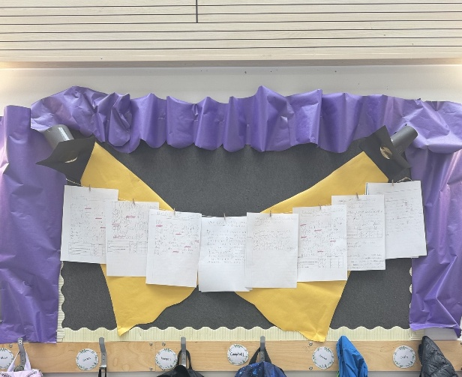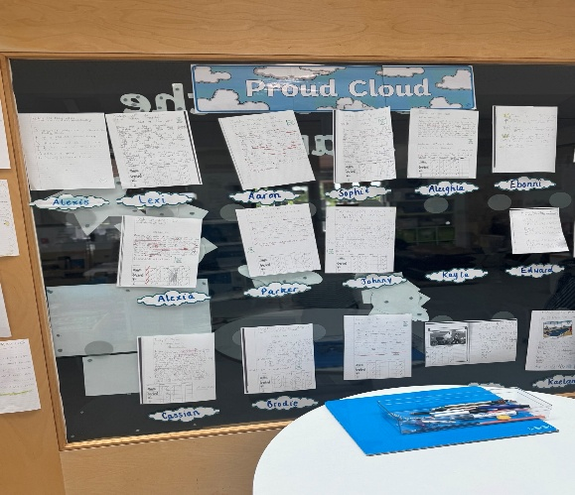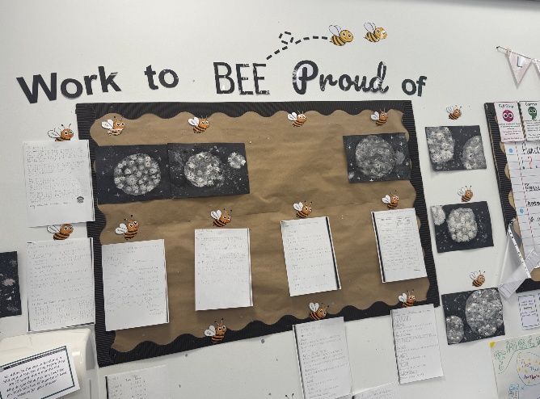  BEAR cards were used to support individuals within school to help build a resilience plan, where it was felt appropriate. This intervention was used to support the children to recognise their support network around them and identify people that they trusted to help them with dysregulation. The resilience plan also helped the children to recognise and understand areas of strength they have in relation to managing challenging situations and identify areas where they would need support in partnership with home and with school. These plans were used within a wider variety of H&W interventions to support these individuals and allowed for a wider and more holist picture of H&W data to be gathered.  A playground buddies’ group was established to help begin to empower pupils to dealing with any playground issues that arose in a positive and impactful way. A Pareto chart was completed in partnership with the pupil group and classroom assistants to identify the main issues that cause conflict out in the playground. The three areas that came out as the most common were: Rough Play, Fair Play Rules and Not Giving People Space. The group received playground buddies training that used materials from the Everyone’s Included and PATHS materials to develop their confidence in recognising and responding to issues appropriately. The group helped to re-zone the playground to include a quiet area that children could go to when they needed space as well as zone off areas where games could be run with the playground buddies as leaders. Leader also monitored the use of the astro area outside to remind pupils of the fair play rules and moved football to only lunchtime to give all children access to the astroturf throughout the week to engage in other activities. To ensure continuity of the group, children in Primary 5 and Primary 6 were trained alongside Primary 7 pupils in order to have a rolling program of playground buddies. This new approach was delivered through assemblies and posters were put up around the school and in the outside areas reminding pupils of key courtesies they should remember when playing – ‘no means no’, ‘check faces’ and ‘hands and feet to ourselves’. This has led to an increase in playground issues being resolved in the playground and more pupils being able to take part in a purposeful restorative conversation. Most pupils highlight that they now enjoy the playground more and have a space that they look forward to. Most pupils have commented positively on the changes to the zones and enjoy being able to use the astroturf for activities other than solely football.  Our Health and Wellbeing Curriculum is now supported and delivered through the refreshed 2-year East Ayrshire Framework rolling program. Adherence to this model is discussed through planning meetings and in quality assurance of termly overviews. Through tracking and monitoring discussions, those pupils who are on individual pathways for H&W are discussed in detail in terms of what addition provision they require and what supports are needed in order to continue to secure progress. This has led to the development of different H&W interventions this session including social skills groups and developing the young workforce group, using the expertise of our classroom assistants to deliver meaningful interventions that have been shown to positively impact on the H&W of targeted children.  Impact  - There is now a wider variety of H&W interventions within the school which help target a wider variety of H&W needs, utilising staff expertise  - Senior pupils in the school have been able to assist in making a positive impact in the playground by actioning changes that support children with dysregulation and creating whole school messages that support all children  - Staff are now more data driven and are increasingly confident in developing interventions at individual, group and class level and understand how to monitor the impact these interventions have.  - H&W issues are regularly discussed and identified in a timely manner in order to better support pupils  Next Steps  - To continue to use BEAR resilience cards as an intervention where appropriate  - To continue to consider wider H&W interventions and work with a NEST representative to deliver training to staff, pupils and parents on how to better support neurodivergent children  - To continue to engage all staff in analysing PASS assessments to empower staff in determining the most appropriate interventions for the children in their class.
Next Steps | - Continue our good practice in this area.  - Further build confidence and capacity in staff to use data to implement meaningful H&W interventions in class

Improvement Priority  (Expressed as outcomes for learners) | Improvement Priority  Improve children’s attainment in writing at P4 from 72% to 81% by June 2026  Throughout this session we will integrate meta-skills within the school culture and curriculum so all children can develop the use of and identify meta skills.  By the end of the session all pupils in P4 – P7 will feel empowered to reflect on, articulate and take ownership of their learning. | Education Service Improvement Plan Priority 4: Our Attainment, Destinations and Achievements  We want the very best for all of our young people in East Ayrshire. We aim to ensure that all young people secure a positive destination through excellent achievement and attainment at all levels.
Our Attainment, Destinations and Achievements
Progress and Impact | WRITING  This session Miss Hall, our P4/5 teacher joined Cohort 3 of the National Improving Writing Project with the aim of improving attainment in writing within our P4/5 class. This began in September 2025 when a baseline writing assessment was conducted and marked against the first and second level tools for writing. The baseline was low with 0% of pupils achieving all tools for writing across first and second level. This assessment formed a pareto chart which then informed our stretch aim for the year and teaching aims:  Stretch Aim:  - By June 2026, 75% (9/12) P4 pupils will have achieved first level CfE writing.​ Baseline, August 2025 - 8% (1/12). ​This equates to a move from 1/12 (8%) to 9/12 (75%).​Therefore, looking for 87% increase which is 8 pupils.​  - By June 2026, 100% (8/8) P5 pupils will have achieved 2.1 targets in writing. ​Baseline, August 2025 - 0% (0/8)​  We are delighted to report that by June 2026, these targets have been achieved and exceeded, with some with P4 pupils achieving not only first level but 2.1 writing assessments. A huge 90% of our pupils are on track and 54% are exceeding National expectation in P4. In our P5 cohort from the P4/5 class 100% are on track and 62% are, infact, exceeding national expectation  Teaching Aims:  Aim 1  By 31st October 2025 75% (9/12) of P4 pupils will be able to link sentences using conjunctions (baseline 0%).  and, but, because, so, then​  By 31st October 2025 100% (8/8) of P5 pupils will be able to link sentences using conjunctions (baseline 0%).  ​and, but, because, so, then, after, before​  Aim 2  By 30th January 75% (9/12) of P4 pupils will be able to write 4 correctly punctuated sentences (baseline 5%).  capital letters, full stops, question and exclamation marks, commas  By 30th January 100% (8/8) of P5 pupils will be able to write 4 correctly punctuated sentences (baseline 26%).  letters, full stops, question and exclamation marks, commas, speech marks and apostrophes  Aim 3  By 20th March 2026 83% (10/12) of P4 pupils will be able to include 4 different sentence openers in their writing (baseline 0%)  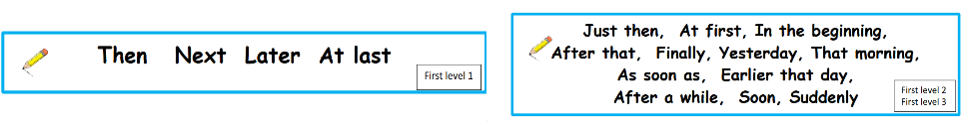  By the 20^{th of} March 2026 100% (8/8) of P5 pupils will be able to include 5 different sentence openers in their writing (baseline 0%).  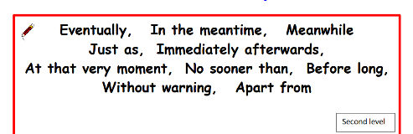  Aim 4  By the 12^{th of} June 2026 78% (10/13) of P4 pupils will be able to use 3 examples of interesting vocabulary in their writing (baseline 50%)  adjectives, verbs, similes, alliteration  By the 12^{th of} June 2026 100% (8/8) of P5 pupils will be able to use 5 examples of interesting vocabulary in their writing (baseline 63%)  adjectives, verbs, similes, alliteration, onomatopoeia  Writing lessons implemented the full writing ‘bundle’ consisting of:  - Children writing 3 – 5 times per week  - Writing for 15 minutes with 5 minutes to self-check  - Teacher input aligned to aim (stimulus, dialogue, model)  - Sharing the LI and SC, making sure they are explicit  - Assessment and feedback given against SC  - Children involved in the process - showing the run chart, suggestions of writing stimulus, ‘Free Choice Friday’ writing, making writing relevant by linking to worldwide issues and IDL topics  We have had many successes through the NIWP including:  - 100% of children in P4/5 achieving our first aim (connectives – baseline 0%).  - Pupils who have previously struggled with writing and had gaps in their learning have been able to achieve our 1st writing aim.  - A pupil who had gaps in their learning and struggled with literacy has achieved 1st level writing.  - Pupils enjoying writing, creating an enthusiastic ethos towards writing in the classroom  - A group of pupils who require support for writing are now writing with more independence than before  What has worked throughout the implementation of the NIWP:  - Having a consistent and familiar approach to teaching which has been a flipchart in line with our LI and SC for Muirkirk Primary School – Muirkirk’s Learning Tree  - Linking to meta-skills  - The 15 minutes of writing has allowed pupils to produce a better quality and quantity of writing  - Despite not being genre focussed, the NIWP has allowed us to explore genres and achieve these better as the tools for writing are consistently at the forefront of the SC  - No ceiling cap on pupils learning – P4 pupils learn and are encouraged to include 2nd level aspects of writing  Next steps will include:  - Implementing the NIWP across all classes, from August 2026  - Continuing to track learner progress using pareto and run chart  - Continuing to introduce genres to allow pupils apply their writing targets across a range of stimuli  - Continuing to celebrate the success and wins of pupils writing  - Adapting where required to support and challenge pupils such as the use of digital technologies  - Provide an opportunity for parents to be involved in the writing bundle and the writing process  - Working with other staff in the school for quality assurance purposes  METASKILLS AND LEARNER PROFILE  Throughout the session, staff took part in several Skills Development Scotland (SDS) CLPL that raised confidence in using The Learner Profile online tool and on navigating and using the Metaskills Land online resource effectively.  As part of our ongoing work with the Muirkirk Learning Tree, metaskills are now discussed at the outset of literacy and numeracy lessons. All classes have display materials that are consistent and clearly identify the focus metaskills.  Primary 4-7 pupils have now all set up their on Learner Profile and are beginning to compile this with information.  A staff working party created guidance and overviews for how The Learner Profile would be implemented within school and how information would be shared with parents and carers.  Metaskills land was introduced to all pupils through assemblies that introduced the characters and allowed pupils to hear other children detail what metaskills are from schools who have already embarked on their journey. Every fortnight, a new skill is selected by pupils across one of the three themes of ‘self-management’, ‘social intelligence’ and ‘innovation’. The Tree of Knowledge resources (purchased through PEF) are used to introduce the skill in an engaging way for the pupils with a recap video being watched in class. At the end of each fortnight, 2 pupils are selected at random from each to meet with the SLT as part of ‘bonus ball conversations’ to discuss how their knowledge of the focus metaskill and metaskills in general has developed and how this is implemented and shared in class. The class whose representatives are able to detail the most are then awarded with the Muirkirk Metaskills Masters award which is displayed outside their classroom.  The impact of Metaskills:  - Our overall attainment data has increased this session. There are a number of reasons for this. However, through children being able to analyse information, think critically and solve problems our attainment has certainly been impacted.  - The use of metaskills helps our pupils have a deeper understanding of concepts as well as strengthening communication and collaboration.  - Use of metaskills also prepares our pupils to prepare for future careers.  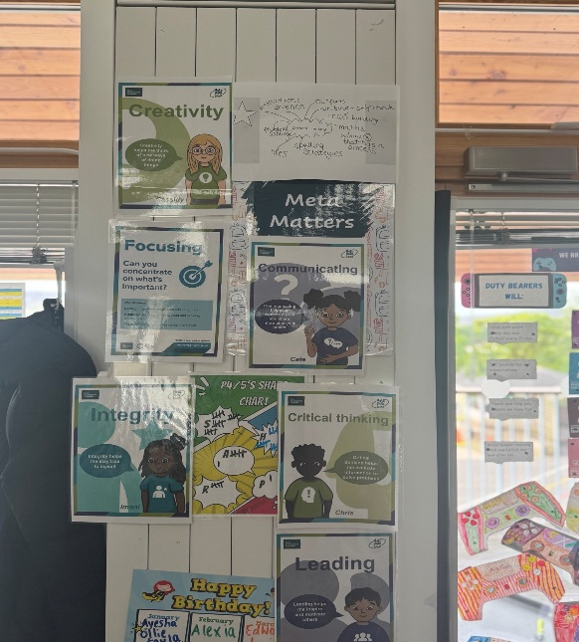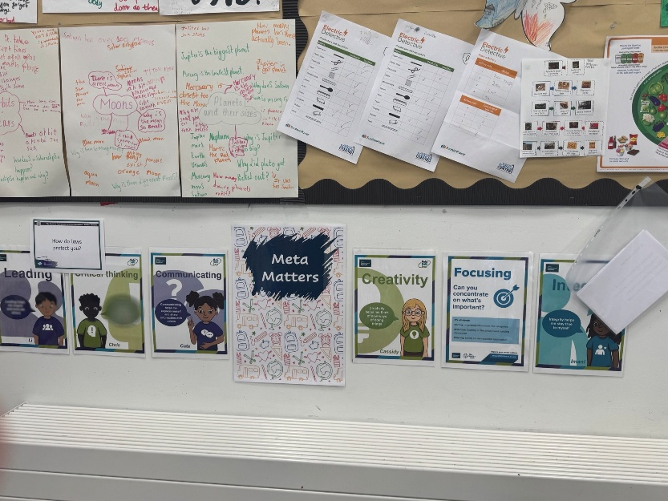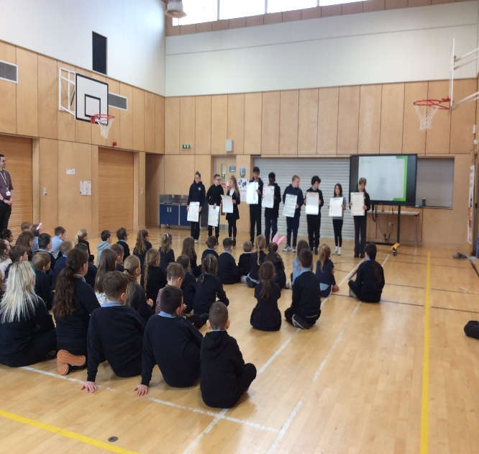
Next Steps | - Implementation phase of NIWP  - Embed Metaskills from this session and introduce remaining Metaskills.  - Continue the use of Learner Profiles from P4 – P7

Pupil Equity Fund: Evaluation
Approach/Intervention | Impact  Report on how you have improved outcomes for learners impacted by poverty | What evidence do you have of positive impact?  Outline the data that supports your findings.
STEM resources to support curriculum. | - Resources have been purchased based on our 3-year wider curriculum planners. Pupil engagement in STEM, has increased significantly. Learners reported confidence and enjoyment in STEM -related activities especially when engaged in hands-on practical learning. Pupils have developed key skills for life and work, including problem solving, creativity, collaboration and critical thinking.  - Participation in STEM learning was broadened and barriers reduced, ensuring all pupils had an equal opportunity to benefit from future-focused, high-quality learning. | Detailed in Standards and Quality Report for STEM above.
Continued purchase of GL Assessments (PASS) | - GL Assessment tools have enabled the school to take a more robust, data informed approach to identifying gaps, targeting interventions and measuring progress. Data helped pinpoint specific gaps in reading comprehensions, numeracy and reasoning skills, supporting more timely interventions. Baseline and follow up GL data allowed us to measure progress over time and evaluate the effectiveness of PEF funded strategies | Detailed in Standards and Quality Report above.
Appoint a Class Teacher 0.4 for Numeracy ‘Boost Groups’ providing support and challenge as required, to narrow the poverty related attainment gap. | - The class teacher appointed worked with targeted groups of learners. Learners received small group support focused on challenging within Numeracy and Matrhs.  - Pre and post intervention data shows progress in numeracy areas targeted. Targeted interventions contributed to an overall improvement in attainment in Numeracy and Literacy, particularly for learners identified through SIMD data. | Detailed in Standards and Quality Report for Literacy and Numeracy above.
Purchase of Chromebooks | - Children have access to IT resources impacting their skills, knowledge and attainment. | Detailed in Standards and Quality Report for Numeracy above
Payment of transport to attend extra-curricular events as well as providing children with wider achievement and wider curricular opportunities. | - Children have been able to participate in events like Sportshall Athletics, STEM Transition (P6), Bill Shankly Football Tournemant that otherwise they would not be part of.  - Children have had opportunities to develop their skills and wider achievement oppotunities | Children are able to represent their school at East Ayrshire and Community Education Group events.  Develops a sense of belonging and pride as children will testify.
Continued subscription to Rising Stars and Sum Dog | - These digital platforms were used to build core skills in numeracy and literacy with a focus on raising attainment and increasing engagement for learners experiencing disadvantage.  - Use of these digital platforms, led to clear gains in fluency, mental maths, spelling and reading comprehension. This is evident from assessment and progress reports and GL data. Attainment across the school has also improved and can be contributed in part to some of these approaches. | Detailed in Standards and Quality Report for Numeracy above
Continued subscription of online Learning Journals to support sharing the learning with parents/carers. | - The continued use of Online Learning Journals (OLJ) is aimed at enhancing assessment, parental engagement and pupil voice. OLJ allow parents/carers who previously engaged less with paper-based systems to access and interact with their child’s Learning more regularly, bridging the gap between home and school.

Establishment Self Evaluation: How Good is Our Early Learning and Childcare? Quality Indicators
Quality Indicator 1.3 Leadership of Change | 5
Quality Indicator 2.3 Learning, Teaching and Assessment | 4
Quality Indicator 3.1 Ensuring Wellbeing, Equality and Inclusion | 5
Quality Indicator 3.2 Securing Children’s Progress | 4

Establishment Self Evaluation: How Good is Our School? 4 Quality Indicators
Quality Indicator 1.3 Leadership of Change | 5
Quality Indicator 2.3 Learning, Teaching and Assessment | 4
Quality Indicator 3.1 Ensuring Wellbeing, Equality and Inclusion | 5
Quality Indicator 3.2 Raising Attainment and Achievement | 4

Establishment Capacity for Improvement
Muirkirk Primary School and ECC has a 3-year self –evaluation for self-improvement cycle. We take a collaborative approach, ensuring there is a focus in learner’s successes and achievements. Staff have a specific remit and leadership responsibility each year – for example, the P7 teacher has led Eco/Clean Green Approaches, the P4 teacher has led UNCRC and the P5/6 has led STEM throughout the school.

The School Improvement Plan is reflected upon regularly and updated to highlight how far on the journey we are towards those targets we want to improve upon and next steps identified. Staff are fully aware that children need to be settled and happy in order to make progress in their learning and we all have high standards when it comes to creating a nurturing and positive environment as this is the first step towards full realisation of pupil aspirations. As a small school with a nurturing environment, we are acutely aware of the circumstances in the local community that affect children’s lives and learning. We have poverty proofed our school to ensure the best outcomes for all learners. This is why we established ‘Me to You’ and work in partnership with various community groups, including The Community Association and MEG. These circumstances are always at the forefront in what we do as a school.

Our recent HMIE report documented practice worth sharing more widely as:

“Nurturing, inclusive environment across Early Childhood Centre and Primary School. Over recent years, staff across the school and early childhood centre, have continued with their approach to develop and sustain strong, trusting relationships with all children and their families. Staff are welcoming to all, have an open-door policy and provide opportunities for families to access additional supports through the school. Staff’s collective responsibility and accountability for children’s wellbeing and welfare is evident. Children reflect on their feelings and emotions well, and know that there is someone, not always an adult, for them to talk to. Staff have created a safe, nurturing, inclusive environment where all children feel valued and that they belong. Together, staff have developed a culture where children can thrive. As a result of this approach, there is a very strong sense of community.”
Muirkirk Primary School & ECC SIF 2022

The ethos and culture of the school reflects a commitment to children’s rights, positive relationships and a nurturing approach. This is evident in the day-to-day interaction of pupils, staff and visitors to the school. Our practice has been shared with Education Scotland who have used created a Case Study of best practice. This can be found at:
https://education.gov.scot/resources/bullying/responding-to-bullying/high-quality-professional-learning/professional-learning-at-muirkirk-primary-school/

Almost all children are engaged in their learning as is evident through observations, tracking and monitoring meetings, planning and evaluations. Those children not engaged have support plans and interventions from a variety of professionals, including Educational Psychologist, CAMHS, The Exchange Counselling Service and LIAM

Almost all children are motivated in their learning and are keen to lead learning and change through their classwork and participation in wider achievement opportunities. Children lead assemblies, leadership groups, initiatives within the school and charity events. These opportunities develop life skills, confidence and communication skills.

Teaching and learning is underpinned by a shared vision and values, created by staff, children, parents and partners. The vision, values and school motto of “Every pupil counts and every moment matters” is displayed throughout the school. All staff and all children demonstrate the vision, values and motto in their day-to-day interactions across the school, leading to a safe, nurturing and positive environment and relationships. SHARP Superhero certificates celebrate those pupils who show values in practice.

Staff, pupils and parents also worked collaboratively to create ‘The Excellent Lesson’ example, which sets out lesson expectations within the school. This in turn, leads to high quality and engaging learning experience for all children with a joint understanding of expectations for all stakeholders. This session a Child Friendly Excellent Lesson has been created by the pupils, to give them more ownership of their learning

Children have access to the classroom; break out space, balcony area, and community Rooms/kitchen as well as the local area. The Kirk Plantation in particular, is utilised by all stages, ECC – P7 to promote and develop learning in the outdoors. The school also makes good use of the local environment, shops, farms and the local wind farm.

Relationships within the locality are key. Thanks to a local shop owner, the school have been able to share learning within the community, by using the shop window to celebrate the ongoing learning within the school.

Wellbeing, equality and inclusion are at the forefront of all we do. We are a Poverty Proofing establishment with a ‘Me to You Project’ which allows clothes to be recycled throughout the year. We work in partnership with the Community Association to support the food larder and provide fuel and food vouchers to those who need them most.

Staff plan over different timescales to meet the needs of all learners. Learners are involved in planning at all stages. This needs to be developed further to ensure a consistent approach. Staff meet with the HT termly to discuss their plans and ensure, through professional dialogue, that the seven principles of curriculum design have been considered in the planning cycle.

Tracking and Monitoring Meetings are scheduled 3 times per session. As a result, we have clear tracking information for every child, including ECC 4 year olds. Those children who are not on track with learning, need support or appropriate challenge have possible supports discussed during these meetings and targets for improvement set, siting supports to be put in place and evidence that needs to be collected to discuss impact. We use this data to evaluate the impact of interventions. We also analyse data of different groups, including those in SIMD 1, Young Carers and LAAC.

Our recent HMIE inspection can be found at
https://education.gov.scot/inspection-and-review/find-an-inspection-report/find-an-inspection-report/details?id=3765

