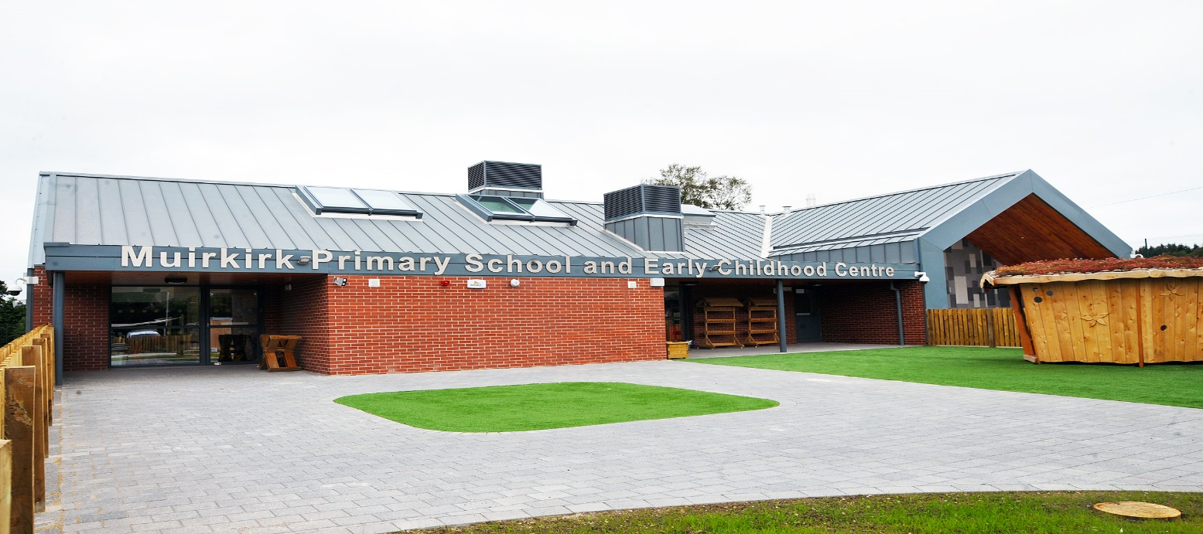

Muirkirk Primary School and Early Childhood Centre
Burns Avenue
Muirkirk
KA18 3RH

Telephone No: | 01290 661350
Email: | anne.mclean@east-ayrshire.gov.uk  or  anne.mclean@eastayrshire.org.uk
School Blog:
Twitter:
School App: | Available on appropriate mobile devices
Denominational Status (if any): | Primary, Co-educational, Non-denominational
Further information: | www.east-ayrshire.gov.uk/schoolhandbooks

Dear Parent/Carer

Welcome to our school handbook. I hope you find the information helpful and informative.

When your child joins us at Muirkirk we are entering into a partnership with you, with the joint aim of helping him or her get the best out of the learning and teaching offered and thus develop his/her personality, talents and mental and physical abilities to his/her fullest potential.

Our key goal is the valuing of each pupil individually and equally. All pupils are individuals with different needs and we recognise this through our curriculum, the teaching approaches used, and the supportive ethos and nurturing environment. Only by recognising pupils as individuals with different needs can we assist them to reach their full potential.

We value your involvement in the education of your child, and I am a strong advocate of positive relationships between home and school in supporting our pupils in their learning.
Together, we can achieve more.

I would like to stress the importance of keeping in touch with the school and centre. We have an open door policy for parents/carers. Please feel free to contact us if you have any questions or concerns, either in person or by phone, you will be made most welcome.

I wish you and your child a happy relationship with our school and centre.

Yours sincerely

Mrs Anne McLean

SECTION 1

Current Roll: 2 year olds 5
ECC 24
P1 18
P2 15
P3 16
P4 11
P5 14
P6 16
P7 21

Accommodation: All classes are housed in one building with a Community Wing attached.

Community Facilities: The Community Wing is available for meetings and social events. This accommodation is used regularly by the community.
Application for lets should be made to:-

Mr Gordon McGuire (Chairman)
Muirkirk Community Association

Associated Secondary: Robert Burns Academy St. Joseph’s Academy
Auchinleck Road Grassyards Road
Cumnock Kilmarnock
Telephone: Telephone: 01563 526144

SCHOOL AND EARLY CHILDHOOD CENTRE AIMS

` At Muirkirk Primary and Early Childhood Centre our aims are:

- Through continuous improvement in learning and teaching create a climate of high expectation, confidence and achievement.

- To offer equal opportunities for every child to achieve his/her potential in a welcoming, happy, healthy and secure environment.

- To foster a positive ethos, to care for and work with each other.

- To promote responsibility and pride in all aspects of school and community life.

- To work meaningfully with parents, the community and external agencies to provide support and opportunity for all.

Our Vision and Values are:

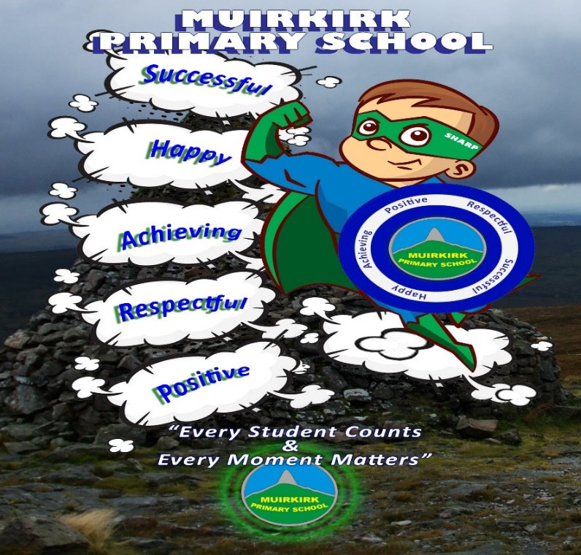
Children learn by example and in Muirkirk we are committed to creating a caring atmosphere. We foster the development of concern and respect for each other. We celebrate achievements at our weekly assembly, in class and in the community.

SECTION 2

SUMMARY OF TIMES FOR CONTACT WITH PARENTS/CARERS

ECC
February / March - Application for Registration. Transition visits for new starts. Letters of invitation are sent out. These visits take place the month before your child starts. Individual meetings with child’s keyworker approximately four weeks after child starts to discuss how your child is settling and next steps in learning.
October / November – Stay and Play Sessions. Parents/Carers are invited to visit the Centre during their child’s session to observe and take part in activities.
May - Parents/Carers individual meetings with child’s keyworker to discuss progress over the session. Parents/carers are asked to choose a suitable time.
June - Celebration of Progress
June - Sports Day and Outing.
Workshops and meetings are arranged throughout the session.
All of the above are intimated in regular newsletters and through notices on the Noticeboard. We also have a school/ECC app which provides information to all parents/carers. Please check the windows for information as you approach and leave the Centre. Parents/carers are encouraged to contact the Head Teacher or Centre Staff at any time if they have any concerns or comments.

SCHOOL

January – Enrolment for P1
June – Parents/Carers of children due to start in August are invited to a Transition Meeting with the Head teacher and time to meet the class teacher. P7 parents have meeting with secondary staff.
August – P1 parents/carers workshop (Phonics) and time to have lunch with your child.
October and March – Parents’ Evenings. Individual appointment times available from 3.30pm to 5.00pm and 5.45pm to 7.30pm are arranged twice each year in November and March.
We keep regular contact with parents through newsletters and the school app and Online Learning Journals. Informal notes may be made in pupils’ homework diaries by parents/carers and class teachers. Pupils have a blue homework bag to keep their diary, homework and any correspondence in. Please ensure your child brings this to school every day.
There are many more events e.g. Science & Engineering Week, Health Week, visits to classrooms to take part in activities, end of topic celebrations, Christmas and Easter Services, Nativities, School shows and Scottish Assemblies which you will be invited to throughout the year. Please check your child’s bag and School App for newsletters and invitations.

HOME AND SCHOOL LINKS
Parents are welcome in the school at any time to discuss matters regarding their child’s education or welfare. This is in addition to those specific two parents’ evenings set during the school year. We also have open times when parents/carers can take part in activities with their children. We welcome the assistance of parents/carers in class, on school outings, concerts and in fund raising events. Any parent wishing to volunteer for school activities will be subject to a PVG Check.

Parents/carers of children enrolling at the school are encouraged to attend transition meetings with the early year’s staff and to maintain that connection during the child’s time at the Centre/school. Similarly the parents/carers of the primary seven children are given the opportunity to meet the Secondary Teachers well in advance of the transfer period.

TRANSITION
Throughout the session our 4 year olds from our Early Childhood Centre work with Primary 1 in planned active learning activities. Early Learning and Childcare Practitioners and teachers meet to share information about children’s needs, learning styles and progress.

Parents of children who are not in our ECC will be notified of transition arrangements by letter or telephone.

Teachers and Early Learning and Childcare Practitioners have (stage to stage) transition meetings throughout the session to share assessment, evaluation and progress information about pupils.

Our Primary 7 children have the opportunity to participate in a series of planned transition activities throughout the school session, when they mix with their P7 peers from other establishments and work in teams to complete tasks. Staff from the secondary also visit the school to meet with the children.

Transition meetings take place in P6 and P7 for pupils with Additional Support with Learning Needs to begin preparations for a smooth transition between primary and secondary school.

Staff of Muirkirk PS & ECC, together with other schools within Barony Education Group, meet regularly with Robert Burns Academy Academy staff to discuss pupil progress and to plan programmes of study across the curriculum.

Early Childhood Network
Muirkirk Early Childhood Centre is a member of the South Authority Network.

Learning Community
Muirkirk Primary School is a member of the Robert Burns Academy Learning Community.

The school and ECC is a member of the Robert Burns Academy Learning Community which brings together a wide range of services to benefit young people. The principal purpose of the learning community is to ensure that services are better co-ordinated in order to meet the needs of young people and raise attainment. Learning Communities support the government’s approach to GIRFEC (Getting It Right For Every Child). This means that is a child/young person needs support then, where possible, there will be one co-ordinated assessment and one plan for that child/young person.

At Muirkirk Primary School and Early Childhood Centre we try to build on pupils’ strengths and we use different strategies to tackle any learning difficulties. These difficulties may be caused by a lengthy absence, inattention or simply that the child found a concept difficult to grasp. Responsibility for additional support needs within the school lies with the Head Teacher and Class Teachers. The EAST teacher, who is a member of the East Ayrshire Support Team, visits the school each week, to assist pupils and to advise and support Class Teachers. They specialises in supporting pupils with additional support needs and work with small groups and individuals to provide intensive support.

We work closely with parents/carers, educational psychologist and partnership agencies to co-ordinate the best support for each individual.

Regular monitoring and evaluation of the learning support is by continuous assessment of the pupil’s level of attainment with the Support Team staff. This is reported to parents on Parents’ Evening and at specially arranged interview/meetings.

SECTION 3

SCHOOL HOURS

Opening 9.00am
Interval 10.40am to 11am
Lunchtime 12.40pm to 1.20pm
Closing 3.00pm

EARLY CHILDHOOD CENTRE HOURS

8.45am – 2.45pm

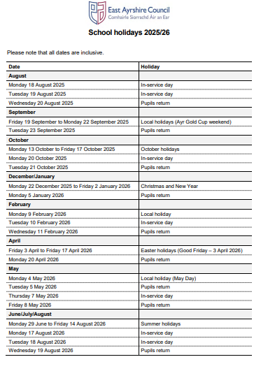ABSENCES
If your child is absent, please contact the school on the first day of absence (by 9.15am).

ANTI BULLYING POLICY

East Ayrshire Council is committed to creating and sustaining a safe, positive and inclusive environment, where respect is shown to and is given by all of its children, young people, staff and parents/carers. A number of initiatives and policy documents are in place to support, protect and encourage children and young people to lead happy and successful lives. Every child and young person should grow up free from bullying behaviour and in Muirkirk Primary School and Early Childhood Centre we are implementing the Respectful Relationship Policy and teach children using the ‘Respect Me’ resource.

PROMOTING POSITIVE BEHAVIOUR

In order to facilitate learning, the school must have a high standard of discipline. Our aim is that each child should be taught to accept responsibility for his/her own behaviour and to show consideration for others. To achieve this we have adopted a set of values that the whole school community live by,

These values are displayed throughout the school and a copy is placed inside each child’s homework diary at the beginning of the session. Parents/carers are asked to reinforce these values at home, and throughout the year some school assemblies are linked to the values.

If a pattern of unacceptable behaviour seems to be building up, or an incident is very serious, the Head Teacher will contact parents/carers to discuss the problem and to seek a joint approach to finding a solution. This co-operation between school and parents/carers usually results in an improvement in behaviour and prevents more serious action, such as exclusion, being taken.

RESTORATIVE APPROACHES

At Muirkirk Primary School and ECC we value happiness, respect, honesty and achievement. We want everyone in our school to value their own happiness and the happiness of those around them, to show respect towards others and themselves, to be honest and own up to any mistakes they have made and to be able to achieve and reach their full potential. Building and nurturing relationships is at the heart of these values.

Restorative Approaches is an approach to dealing with behaviour and conflict. It focuses on building and repairing relationships rather than managing and controlling behaviour.
Restorative Approaches help us differentiate between the person and his / her behaviour. Restorative Approaches are grounded in the understanding that individuals are responsible for their actions, and within our school community when an action has caused harm, those involved have a responsibility to put things right. Restorative Approaches favour discipline over punishment.

SCHOOL UNIFORM
The school, with the strong support of parents/carers, is keen to encourage the wearing of school uniform. We believe that the wearing of school uniform fosters a sense of belonging and pride in the school and encourages good attitudes towards learning and behaviour. Muirkirk Primary School uniform consists of navy blue sweatshirt and sky blue polo shirt with school badges and dark trousers/skirts. Children may also wear a white shirt and Muirkirk Primary School tie. As items of clothing and belongings are often misplaced please write your child’s name on all of his/her clothing and property.

EARLY CHILDHOOD CENTRE

Access to the Early Childhood Centre is restricted. All doors are fitted with a fob entry system. Only authorised personnel have an appropriate fob to gain access. No parent / carer or member of the public will be allowed entry without first making themselves known to the janitor, senior clerical assistant or centre staff. All visitors must sign in at the School Office. They will then be escorted to the Early Childhood Centre. On leaving visitors must ensure they have signed out.

It is expected that a responsible adult will bring your child to and from the centre and sign the child in and out each day. In the interests of your child’s safety it is essential that you tell the Head Teacher and Centre staff if someone not known to them is going to collect your child. If your child is unable to attend please contact the office by 9am.

The school SEEMIS messaging system holds one main contact and will send attendance notifications to the main contact only. It is not possible to generate the automated message necessary to inform all parents/carers. However, should a parent/carer have a significant concern that the main contact is not sharing key information regarding attendance, they should contact the school to discuss possible alternative solutions.

SCHOOL

Access to the school is also restricted. All doors are fitted with a fob entry system. Only authorised personnel have an appropriate fob to gain access. No parent / carer or member of the public will be allowed entry without first making themselves known to the janitor or senior clerical assistant at the school office, signing the visitors’ book and being issued with the appropriate pass. At the end of the visit the pass holder will ensure that he / she is signed out. If parents / carers are taking their child from school for any reason, they should report to the school office first, to inform the Head Teacher, and sign the Out of School Slip.

There can be no exception of this rule during the school day.

HOMEWORK

Homework is always related to current class work and will cover a variety of topics. Pupils will be set tasks appropriate to their own level and ability and therefore should be confident in approaching the task and should gain success in completing them.

It is important that parents take an interest in their child’s work and helping with their homework is an ideal opportunity to be part of their school life.

MEALS AND SNACKS
At Muirkirk ECC the children have a healthy snack and a drink of milk or water every day. They also have a warm meal at lunch time. Our daily menu is displayed on the notice board and can be accessed via the School App. To encourage a nurturing environment where the children can develop choice, independence and self-help skills, we have regular group time snacks throughout the week. Our Early Learning and Childcare Practitioners attend regular food hygiene courses. When choosing snacks with the children our practitioners are following advice given in the ‘Nutritional Guidance for Early Years’ document. Our children are encouraged to brush their teeth after snack. A personal toothbrush and toothpaste is provided and the initiative is monitored by the NHS Oral Health Promotion Team.

In the primary school, lunchtime meals are prepared at another kitchen and delivered to our school. Our Catering Service is operated by EAC’s Onsite Services and a three week rotational menu is sent out to parents/carers at the beginning of each session. Medically prescribed diets and meals for ethnic and religious requirements can be provided by contacting the school office

Meals are available to any child each day . School dinners are free for all children at this time.

Muirkirk Primary School operates a Family Service at lunch time, whereby all the children sit down together around preset tables. Two courses are available each day, with a choice from three main courses. Bowls salad are always available on the tables. Proper crockery and cutlery are used and children are encouraged to use good table manners.

Parents/ carers of our primary 1 children are invited to try our meals and find out how our family service operates prior to their children starting in primary 1.

Children who bring packed lunches also have their lunch in the school dinner hall.

BREAKFAST CLUB
Breakfast Club runs every day 8.15am to 9.00am. It is free for every child thanks to funding the school have received.. Breakfast Club is supervised by 2 members of staff each morning.

SNACKS
A healthy tuckshop of fruit is operated by our school catering staff during the morning break. This is free for all children.

INFORMATION IN EMERGENCIES
We make every effort to maintain a full service, but on some occasions circumstances arise which lead to disruption. Establishments may be affected by, for example, severe weather or temporary interruption of power. In such cases, we shall do all we can to let you know about the details of closure, temporary arrangements or re-opening. We shall keep you in touch by using letters, text message, the school App, the Council website, notices in local shops, the press and on local radio.

MEDICAL INFORMATION
It is the parents’ responsibility to inform the establishment of any particular medical requirements that their child may have. Written parental consent will be required for the administration of medicines. Parents must inform the Head Teacher if emergency contacts or medical conditions change and arrangements to be made should a child require to be taken home. Mrs Murdoch is our First Aider and has undergone appropriate training.

EXCURSIONS AND CONSENT FORMS
When outings or excursions for children are planned, the Head Teacher or a member of staff will advise you in advance. You will be asked to complete a consent form giving your permission for your child’s participation. Please note that children cannot take part in outings unless completed consent forms have been submitted by their parent/carer.

MOBILE PHONES
In consultation with staff, pupils, parent body, and in line with local authority guidelines, we encourage children NOT to bring their mobile phones to school. If your child brings his/her mobile phone to school, then this phone must be switched off before entering the playground. The phone must be kept out of sight in his/her school bag during the school day.

THE PARENT COUNCIL
As a parent/carer of a child in attendance at the school, you are automatically part of the Parent Forum of the school. The membership of the Parent Forum is made up of all parents/carers who have a child at the school. The Parent Forum can decide to form a smaller body called the Parent Council. The Parent Council is a group of parents/carers selected by members of the Parent Forum to represent them.

The Chair of the authorities’ Parents Steering Group has a place on Council Cabinet to help influence decision making about all matters relating to education. The authorities’ Parent Steering Group is composed of representatives from Parents Council across East Ayrshire and this group will represent the views of parents in the school sector.

SECTION 4

LEARNING AND TEACHING

Our curriculum is developing in line with Curriculum for Excellence.

From our Early Childhood Centre to Primary 7 we are committed to ensuring that children experience the highest quality learning and teaching experiences possible. We promote active involvement of pupils in their own learning which should be motivating, challenging and fun!

A range of teaching methods and contexts for learning are used, including active and enterprising learning, which encourages young people to become enquiring; learning across the curriculum which helps young people make links between subjects, and learning outside classrooms in the outdoors and in the community, which gives opportunities for learners to deepen their learning in real-life context.

In our Early Childhood Centre into Primary 1, our curriculum is play-based. Through this children are developing their language, creativity and co-ordination skills, which contribute to healthy growth and development, knowledge and understanding and capacity to learn.

LANGUAGES AND LITERACY

Our language programme consists of three components - Reading, Writing and Talking & Listening.

The principal Literacy Approach used throughout the school is “Active Literacy”. Various support and reinforcement materials augment this approach. All pupils are involved in reading and writing challenges as supported by East Ayrshire Council’s Literacy Strategy. P2- 7 pupils will also undertake the study of a novel.

In addition, French is taught throughout the school from P.1 to P7.

In Primaries 1 – 7 Active Literacy, Spelling and Grammar are used to promote the children’s knowledge, understanding and development of reading and writing skills. A variety of stimuli are used throughout the school to encourage the children to create their own texts.

MATHEMATICS
To assist our teaching and learning we have adopted the ‘Raising Attainment in Numeracy’ Practice
throughout the school. Scottish Heinemann Mathematics and TJ Mathematics are used from P1 – 7.
This scheme is supported by materials prepared by the staff and a wide range of other additional
resources. Practical mathematics begins in the early stages and continues throughout the school. All
children are involved in oral and mental calculation activities on a daily basis, to encourage confidence
in counting and understanding number relationships. ICT is used throughout the school to support the
learning and teaching of Mathematics.

In both Mathematics and Language we have a range of differentiated materials suited to the varied needs of our pupils.

SOCIAL STUDIES

Social Studies experiences and outcomes include

- People, past events and societies
- People, place and environment
- People in society, economy and business

Through social studies children and young people develop their understanding of the world by learning about other people and their values, in different times, places and circumstances and how their environment has been shaped. An emphasis will be placed on Scotland’s history and place in the world as well as links with the local community.

EXPRESSIVE ARTS
This covers the subject areas of Art & Design, Drama, Music and Dance.

- Art and Design - Through Art and Design pupils are encouraged to express themselves visually and to appreciate and enjoy their own and the work of other artists. All pupils are encouraged to develop their creative talents through participating in activities that include the use of different materials.

- Drama - Children from their earliest years use imaginative play to explore, order and make sense of themselves and the world about them. Drama extends and builds on this natural process and helps to build confidence and self-esteem. Pupils will have the opportunity to role play, improvise, use movement and mime and sound to express their own and others’ ideas. Pupils are also given opportunities to work with professionals and to perform at school concerts and shows.

- Music - Music is a most important part of our social culture and enriches our lives personally, intellectually and socially. All pupils are provided with opportunities to explore music using their voice, using instruments and listening to pieces of music. The Sounds of Music scheme is used throughout the school.

- Dance - Through Dance pupils are encouraged to explore and express themselves creatively through movement, to take part in dance sequences and to perform dances from Scottish and other cultures.

HEALTH AND WELL BEING
As a health promoting school, we place a high importance in promoting pupils’ physical, emotional, mental and social wellbeing. We promote the health and wellbeing of our children at all stages in the school.

Areas for study include food and health, substance misuse, relationships and sexual health, road safety and personal safety.

The school have a focus on the social and emotional well-being of our children and use the PATHS resource to support this.

PHYSICAL EDUCATION
All of our pupils take part in two hours of physical education per week. Pupils develop skills in gymnastics, athletics and games & fitness.

We work closely with our Active School Coordinator, Vibrant Communities and Community Rugby and Football development officers, to provide a variety of activities for our pupils.

RELIGIOUS AND MORAL EDUCATION
Religious and Moral education is taught throughout the school. Religious education is developed through Christianity and other world religions.

Any parent/carer wishing their child to be withdrawn from religious education can exercise their right to do so by informing the head teacher in writing.

SCIENCES
Sciences experiences and outcomes include:-
- Planet Earth
- Forces, electricity and waves
- Biological systems
- Materials
- Topical science

Through learning in the sciences, children and young people develop their interest in, and understanding of, the living, material and physical world. They engage in a wide range of collaborative and investigative tasks.

TECHNOLOGIES
Our aim is to prepare children to take their place in a changing technological society and thus computers are used to enhance and assist in all areas of the curriculum. We presently have a number of laptops and Ipads which are timetabled for all classes. Each classroom has a computer and a smartboard within it.

Pupils develop practical skills and problem solving strategies in technology through exploring materials, tools and software.

OUTDOOR LEARNING
All children and young people will have regular opportunity to learn outdoors both in the school grounds and in the local community. Parents are requested to consent to this regular localised outdoor learning once at the beginning of session, with medical and emergency contacts being requested. Thereafter parents will be notified of the venues and dates of off site visits, in order that pupils come adequately prepared. However it is the parents’ responsibility to inform the school if emergency contacts or medical conditions change or if they don’t wish their child to participate in a visit. Our ECC children experience outdoor play on a daily basis. They enjoy this play experience and the opportunity to take their play outdoors. Curriculum for Excellence has outdoor learning as one of its key principles and advocates daily outdoor activities for pupils in all weather and to support learning in the environment. Please ensure you child comes to the Centre and school with suitable shoes/boots and a rain jacket/coat.

SECTION 5
Curriculum for Excellence emphasises that assessment is an integral part of day-to-day teaching and learning. Learners’ progress will be closely monitored by staff, who reflect with them on their strengths, learning needs and next steps, and take action based on this. Learners themselves will be increasingly involved in this process, as they develop the skills needed to be able to make effective judgments on their own learning; skills that will be important to them throughout life. Testing will continue to be part of the framework of assessment, providing additional evidence of what learners know, understand and are able to do, and helping teachers plan learning experiences which are motivating and challenging.

SECTION 6
Children’s progress is continuously being assessed by their teachers through questioning, the marking of written work, observation of their pupils at work and reflecting with them on their strengths, learning needs and next steps.

Children who may have additional support needs, or who require a Child’s Plan or an Individual Learning Plan, will be assessed in a way suited to their individual requirements. Further information is available from the Head Teacher.

Written progress reports will be issued to parents/carers in March/April giving details of progress made, incorporating the four capacities of CfE, levels achieved and setting out the next steps in learning. Parents’ meetings are held shortly after the issue of reports to allow parents/carers and teachers to meet and discuss individual children’s progress.

Parents/carers, however, do not need to wait until Parents’ Evening to discuss their child’s progress. Parents/carers are welcome to visit the Head Teacher at any time. Meetings with teachers can be arranged through the Head Teacher.

SECTION 7

Further information can be found on the following webpages:

www.youngscot.org (learners)

www.parentzonescotland.gov.uk (parents and carers)

www.sqa.org.uk (information on qualifications)

www.hmie.gov.uk (standards, inspections)

www.itscotland.org.uk (teaching practice and support)

www.engageforeducation.org (share ideas and questions about education)

www.scotland.gov.uk/cfeinaction (real-life examples)

The establishment has:

- Developed stimulating and challenging experiences in Numeracy across every stage.
- Developed a stimulating, engaging and challenging approach to the teaching of Literacy across every stage.
- Achieved Silver Accreditation with the UN Convention on the Rights of the Child, developing rights respecting values and ethos.
- Developed and embedded high quality transition links between ECC and Primary and P7 to S1.
- Developed a shared understanding of play based learning between ECC and primary.
- Provided challenge and depth of learning through early level play based pedagogy.
- Developed and embedded the nurturing school methodology.
- Provided a safe, warm, caring and nurturing environment within which 2 year old children can learn and develop as they play.
- Improved and integrated the role of early years support in children and families’ lives, by increasing the amount and flexibility of early learning and childcare. (2 year old room)

The establishment’s priorities for improvement:

- Improved outcomes in writing for all pupils in P4 through participation in the National Improvement in Writing Programme (NIWP)
- Developing and embedding the use of Meta Skills
- To track pupil progress and to raise standards within problem solving and maths.
- To develop a love for reading for enjoyment through Reading Schools Accreditation

Muirkirk Primary & Early Childhood Centre continues to have strong links with the community and we aim to foster and develop these links. The school is represented on the Muirkirk Enterprise Group, has links with the Community Association and are involved in ongoing developments around the village.

Many school activities e.g. concerts, health fairs, assemblies etc. are open to the community and are well supported. The school has played an important part in the Heritage Park and the development of the Community & Kirk Plantation and pupils are encouraged to attend community events. Each year two of our pupils are chosen to switch on the Christmas lights. Each May our pupils are involved in the John Lapraik Festival in the village and take part in the Young People’s Speaking Competition. We are a member of the Robert Burns World Federation.

