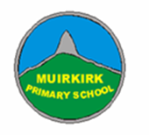
P7 Home Learning Pack

Complete activities on the grid in any order and at a time that suits you.

Send pictures/videos of your completed tasks to Mr Jackson by posting in your Learning Journal or by sending an Email (c.jackson@eastayrshire.org.uk).

P7 Learning Grid
Literacy | Numeracy | Health & Wellbeing | Learning across the Curriculum
Research Project-  Choose a city you would love to visit. Create a fact sheet (handwritten or typed on Notebook or Word, or a short PowerPoint)  - What is the currency?  - What are the main attractions/landmarks?  - What is the weather like? | Addition to 100  Using a deck of playing cards (or write out some numbers on pieces of paper). Flip over a card and add the number on. Your target is to reach 100! If you can, try playing in pairs and see who gets to 100 first.  Extension: Multiply instead of adding and try to reach 500. | Word Art  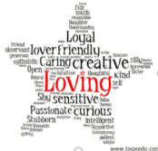  Draw or go to https://wordart.com/ and create a word art picture filled with compliments for someone that means a lot to you. | French Colours  Practise your colours in French using this website:  https://www.french-games.net/frenchtopics  Choose ‘Colours’ then try the activities and games.
Newspaper Challenge-  Using a newspaper, magazine or a book find words that you don’t know the meaning to. Write them down and use a dictionary (online dictionary is fine) to find a definition for them. | Sumdog-  Spend 45 minutes on Sumdog- if your teacher has set your class a challenge, complete this first. If not, choose your own games!  https://pages.sumdog.com/ | Lunch time  Make a healthy lunch for yourself and family, set the table then wash the dishes afterwards too. | Cereal Box Challenge  What can you make out of an empty cereal box?
Superhero Cartoon  Design yourself as a superhero and create a comic strip of your adventures. | Topmarks Rocket Rounding  Choose your own level of challenge when rounding numbers:  https://www.topmarks.co.uk/maths-games/rocket-rounding | Physical Education  Put on your favourite music and dance for 30 minutes!  Or try some Go Noodle https://video.link/w/IrpBc | Design Task  Design a suit to protect people against coronavirus. Write about and describe its features.
ABC Order-  Write the words you used in your newspaper challenge out in alphabetical order.  Word Search-  Create your own word searches using your words. Or use this link to get your computer to do it for you.  http://puzzlemaker.discoveryeducation.com/ | Challenge  Each row, column and mini grid must contain numbers 1 to 6. Don’t guess, use logic!  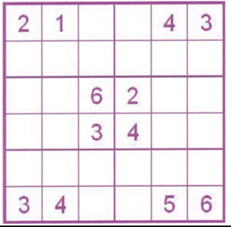 | Mindfulness Hands Art-  Draw around your hands and decorate inside of the hand to show your emotions.  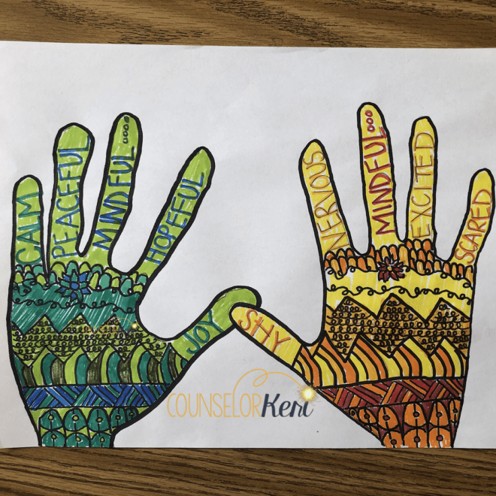 | History Detective  Look at this artefact:  What do you think it is and why?  Who might have used it?  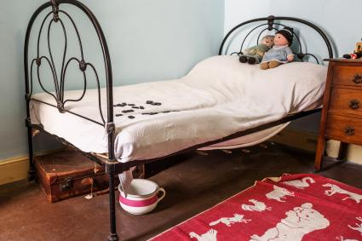
Reading for Enjoyment  Get comfy and read a book/magazine/anything at home. Alternatively, create a free parent account to access online books at: https://www.oxfordowl.co.uk/for-home/find-a-book/library-page/ | Topmarks Toy Shop Money  Choose your own level of challenge to add up amounts of money or practise giving change:  https://www.topmarks.co.uk/money/toy-shop-money | Physical Education  Make up your own sport. My favourite is to lie on your back with rolled up socks beside your feet and a basket at your head, then use your feet to pick up the socks and lift them up and over into the basket. | Farm to Plate-  Complete the Bitesize topic: Farm to Plate.  https://www.bbc.co.uk/bitesize/topics/zfmpb9q/articles/z4tbn9q  *Challenge- figure out the food miles and journey for the food in your fridge.

