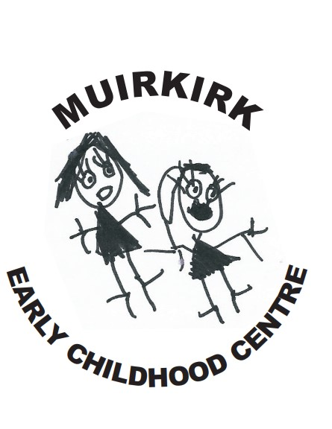
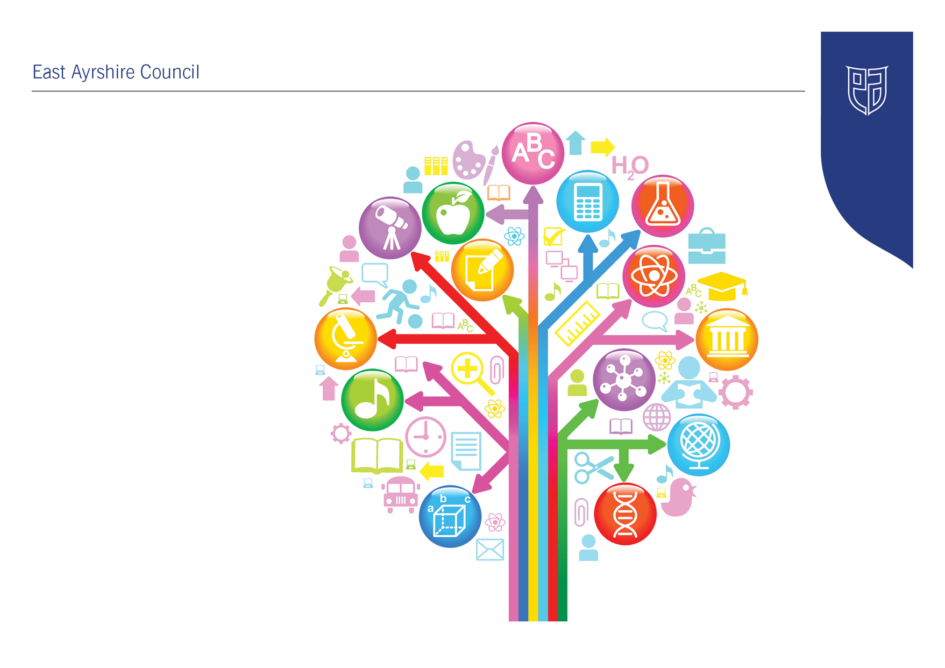
Standards and Quality Report
2024-25

Muirkirk Primary School & ECC
Establishment Context
Muirkirk Primary is in a new build Primary School and Early Childhood Centre located in the heart of Muirkirk. This new build has given staff, pupils, parents/carers and the local community huge pride in their community.

The school is non-denominational and provides an inclusive, differentiated and appropriate curriculum for all pupils. We are proud of our multi campus provision, which enables us to build early partnerships and work together with parents/carers to ensure that children progress from one sector to next, continually building on their prior learning.

In session 2024/2025 the final school roll was 106 pupils in 5 mainstream classes and an Early Learning and Childhood Centre with the provision and support for 2-year-old places.

90% of the children in the school lived in SIMD decile 1.

33% of our pupils were in receipt of free school meals.

38% of our pupils are on the ASN log

The Senior Leadership Team includes Mrs Anne McLean, Head Teacher, Mrs Laura Clapperton, Deputy Head Teacher and Jenna Richmond, Senior Lead ELCP. This session the Senior Leadership Team has been well supported by the addition of Mr Christopher Jackson, a PEF appointed Principal Teacher of STEM. The school is also well supported by permanent and peripatetic teaching staff, ELCPs, as well as the invaluable input of non-teaching staff in the form of our classroom assistants, clerical assistant and our janitorial, cleaning and catering staff. Parents/carers and a range of community partners also provide support which enables us to provide high quality learning experiences for all our pupils.

Key strengths:
Our self-evaluation processes and HMIE report shows we have the following strengths:

- The headteacher, and all staff, demonstrate a clear commitment to improving outcomes for all children. They value children as individuals and constantly seek opportunities to help them develop as successful, happy, achieving, respectful and positive (SHARP) people.
- Staff have a clear, shared understanding of the local context and of the increased challenges for children and their families.
- Staff have created a calm, positive, nurturing learning environment that reflects the school’s vision and values. This ethos is underpinned by mutual respect and a commitment to children’s rights. Children benefit from being part of this strong learning community in which there are positive and respectful relationships with staff and peers. Children are considerate of others, respectful, helpful and mannerly.
- At all stages, children have regular opportunities to learn outdoors. The local area is used extensively in interdisciplinary learning activities. Children engage well in these activities and are developing an awareness of how to be a responsible citizen.
- The school has an open door policy and prioritises building positive relationships with children and their families. Parents appreciate being kept up to date with the work of the school through regular use of the school app, newsletters, website and texts.
- Staff provide a safe, nurturing, inclusive environment where all children feel valued and included. Respectful relationships, based on mutual trust, honesty and kindness are evident across the school. Children are very aware of the wellbeing indicators and what each means for them. They talk confidently, for example, about what it means to be safe and achieving.
- Staff help children recognise and celebrate diversity through lessons and school assemblies. The school is working towards the Rights Respecting Schools silver award which is helping children recognise and value individual similarities and differences. Staff promote equality for all and actively seek to create an environment where everybody is represented, included and valued for who they are. The inclusive nature of family service at lunchtime exemplifies this.

In November 2024, the school had an Authority Learning Visit which highlighted the following strengths:

- The staff have a clear understanding of their local context and the challenges for children and families. They work in partnership to negate the impact of these and improve experiences and outcomes for learners.

- The relationships throughout the school are strong, respectful and caring.

- The school have strong links with partner agencies within and out with the local community to better address the needs of their families.

- The school has a positive ethos with an inclusive environment.

- The SLT lead a strong strategic vision for improvement and are clear on the schools next steps for progression moving forward.

In arriving at our improvement priorities, we took account of East Ayrshire’s Integrated Children and Young People’s Service Plan and East Ayrshire Council’s Community Plan. We also took account of the legislative responsibilities in respect of GIRFEC, parental involvement, health promotion, disability and equality. Further consideration has been in line with on National Improvement Framework and HIGIOS 4

In our Early Childhood Centre we also take account of the principles set out in the Pre-birth to Three guidelines, Realising the Ambition and the local priorities detailed in The Best Start in Life document. Further consideration has been given to HGIOELC.

Our recent HMIE inspection can be found at
https://education.gov.scot/inspection-and-review/find-an-inspection-report/find-an-inspection-report/details?id=3765

Our excellent work in leading improvements with dysregulated behaviours can be found

https://education.gov.scot/resources/bullying/responding-to-bullying/high-quality-professional-learning/professional-learning-at-muirkirk-primary-school/

Establishment Vision, Values and Aims
Our “Sharp” Values for the pupils in our school is for them to be:
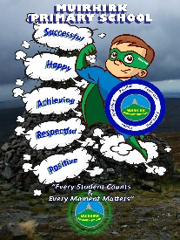
Successful
Happy
Achieving
Respectful
Positive

Our motto and vision is “Every Student Matters and Every Moment Counts.”

Establishment Aims

- Through continuous improvement in learning and teaching create a climate of high expectation, confidence, achievement and resilience

- To offer equal opportunities for every child to achieve his/her potential in a welcoming, happy, healthy and inclusive environment.

- To foster a positive ethos, to care for and work with each other.

- To promote responsibility and pride in all aspects of school and community life.

- To work meaningfully with parents, the community and external agencies to provide support and opportunity for all.

Improvement Priority  (Expressed as outcomes for learners) | Improvement Priority (Expressed as outcomes for learners)  To develop staff and children’s leadership skills through participation in Leadership groups.  To embed children’s rights throughout the life of the school, supporting the holistic development of all pupils. | Education Service Improvement Plan 1: Our Leadership  We actively support, promote and enact leadership at all levels. Our young people are supported to be leaders of their learning in our centres, schools and wider life experiences. All staff have ready access to appropriate CLPL and experiences to promote leadership in every classroom, playroom and centre.
Our Leadership
Progress and Impact | Following discussion with the pupils, around they types of Leadership Groups they would like to participate in, thus ensuring pupil voice, staff ‘signed up’ to a leadership Group of interest to them. This also formed part of their PRD.  Children from P4 – P7 were then given the choice of which Leadership Group they wanted to participate in. Staff then worked collaboratively with the pupils to consider what the aims of the group would be. Groups met monthly, to work towards their goals. Notice boards for each group were created so information was easily shared. Information was also disseminated at assemblies led by the children. Members from each group were also responsible for ensuring the P1 – P3 classes were kept informed of ongoing work. Details and impact of each group are described below:
  Leadership Group | Aims | Success and Impact
  STEM  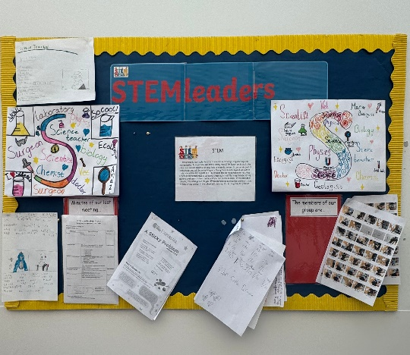 | - To promote STEM awareness and engagement throughout the school and ECC.  - To develop critical thinking and problem solving skills  - To build a supportive STEM culture throughout the whole school community | This group have led science, technology, engineering and mathematics this session. They participated in STEM lessons themselves, so they could teach others in the school, becoming ‘STEM Ambassadors.’  The group organised our STEM week and worked with all children across the school and ECC to ensure that everyone received their ‘CREST’ Award.  Parents have been more involved in the work of STEM through learning with their children during STEM Week and Sharing the Learning sessions.  Through staff and pupil self-evaluation we believe that the profile of STEM subjects has been raised across the school and ECC.
  Leadership Group | Aims | Success and Impact
  Rights Respecting School Steering Group  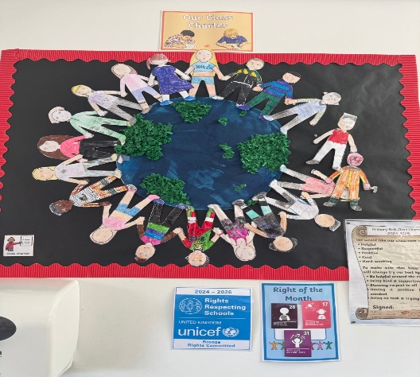 | - To promote awareness and understanding of Children’s Rights.  - To build on our respectful and inclusive school culture.  - To empower pupils voice and participation.  - To build further partnerships with the wider school community | This group explored Children’s Rights and have introduced the Right of the Month to the school and ECC. This Right then became a focus for the whole school for that month.  The Group organised Children in Need. They have also been preparing for our Silver Award Accreditation, which takes place in October 2025. We have committed to paying for this accreditation given the amount of hard work the children and staff have put into this group.  The group created a Dining Room Charter and Playground Charter ensuring there was a consistent approach to UNCRC across the school.  In self-evaluation of Leadership Groups 100% of children reported that they knew more about children’s rights and could talk about them.
  Communication Friendly Group  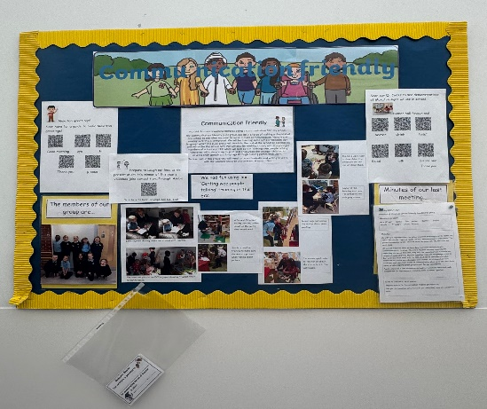 | - To promote effective Communication skills throughout the school and ECC.  - Build on our inclusive school environment.  - Empower pupil voice and participation.  - To promote positive social interactions. | Mrs Wright and her group began preparing for our Communication Friendly Accreditation (CFA). Unfortunately, CFA is no longer being progressed by EAC and Speech and Language, so all the work that has been completed, has been done without the support of a mentor or SALT support.  The group have assessed our environment, created an Action Plan, introduced some simple changes across the school to ensure a consistent approach and evaluated progress. Changes have included consistent labelling in classrooms and across the school, ensuring all classes use a map of the day and introducing the use of visuals as a means of communication.  They have learned some Makaton to share with all the other pupils in the school and ECC.  Following training in “Getting Wee People Talking” the children in this group were able to visit the ECC and talk with and play with our youngest pupils. They also demonstrated their talking and listening skills with P1 play.  Thanks to their hard work and the work of the whole school community we awarded Community Friendly Accreditation is May 2025.  The impact of this group has ensured there is a consistency across the school and everyone feels valued and respected no matter their communication style.
  Digital Leaders Award  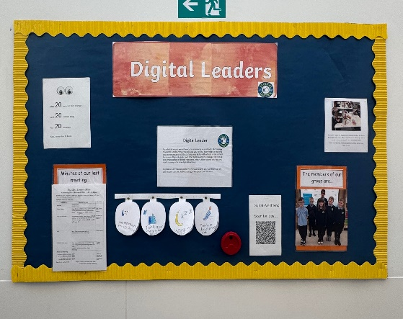 | - To promote digital literacy and skills development.  - To encourage responsible and safe online behaviour.  - To support teachers and peers with technology integration. | This group chose to focus on Assistive Tools, Digital Well Being, Coding and the Beebot, so they could help provide Curriculum Support as Digital Leaders.  They learned about the Accessibility features of our laptops and now know how to utilise and support others in using these.  The group have chosen ways to share their Digital Well-being messages too.  The impact of this group is that staff and pupils have an increased awareness of accessibility tools that can be used when engaged in digital technologies. There is also a better understanding of safe digital practices and how to look after our wellbeing when online.
  Eco/Clean Green Award  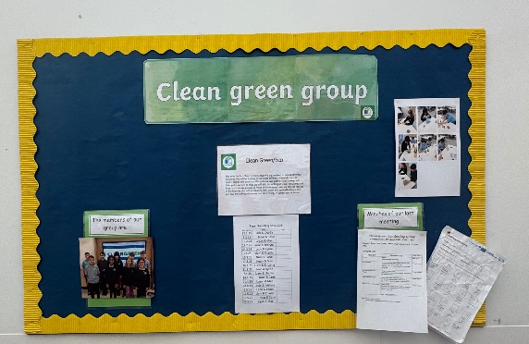 | - To raise environmental awareness.  - To promote sustainable practices  - To build on our green and healthy school environment.  - To engage the wider community. | This group joined The Big Battery Hunt, recycling old batteries. They raised awareness of the power of recycling both at home and at school.  They carried out a litter survey within Muirkirk and then carried out a local litter pick to make the community litter free.  They carried out a ‘Dog Fouling’ project follow this litter survey as they noted the amount of dog fouling in the area was immense. The children created posters reminding the community to pick up their dog’s mess. They then created ‘poo bag stations’ throughout the village, where people could collect bags to clean up after their dogs.  This group have worked hard towards their bronze Clean Green Award.
  Pupil Council/RESPECT ME  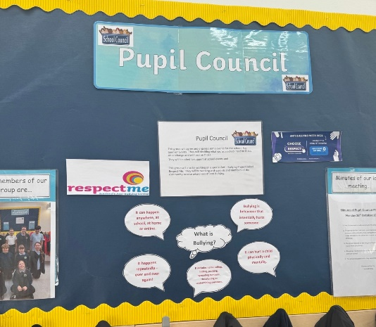 | - To promote pupil voice and participation in school matters.  - To enhance communication and collaboration  - To raise awareness and understanding of bullying through ‘Respect Me’ Programme.  - To empower pupils to speak up and support others. | This group have completed various self-evaluation of the school and noted that new playground equipment was needed. The group created a list of their requirements which was ordered to improve out outdoor environment.  Pupils carried out self-led research on bullying and created information to share with all pupils. PowerPoints, posters and leaflets were shared during assemblies, parents’ evening and through the school app so the whole school community were better informed on bullying matters.  The pupils had training on Restorative Approaches and became Peacekeepers in the school playground, helping other children to cope with conflict.
  There have certainly been increased leadership opportunities for all learners through Leadership Groups being established. In Children’s self-assessment of Leadership Groups, the following results were found:
  - 100% of the children enjoyed participation in Leadership Groups.
  - There was an increase in the leadership skills children knew about and had utilise. Children noted the skills they have learned are teamwork, communication, problem solving and decision making.
  - 100% of the children reported that they felt their ideas and opinions are asked for and considered.
  Link to all results can be found at: https://forms.office.com/Pages/ResponsePage.aspx?id=oyzTzM4Wj0KVQTctawUZKfnkrBiL0VBGoU2lzi2M4F1UOEtET1MxVkVNUERLQUhHTEI5RkRZWks5Ni4u
Next Steps | - Continue participation in Leadership Groups based on next session’s priorities and children’s interests.  - Develop Meta skills within the school, so children fully understand the skills they are working on and achieving.

Improvement Priority  (Expressed as outcomes for learners) | Improvement Priority (Expressed as outcomes for learners)  To embed three year, Wider Curriculum Planners, ensuring all aspects of the curriculum is covered over this period, with no gaps in learning and teaching.  To develop a whole school approach to STEM to equip pupils with critical thinking and problem-solving skills that are essential in a rapidly changing technology-driven world. | Education Service Improvement Plan Priority 2: Teaching and Learning Together  Our young people should experience a teaching, learning and curriculum offer that meets their needs, and those of our local and national context. All staff should be supported to deliver in new and innovative ways by accessing CLPL relevant to their needs and those of our young people.
Teaching and Learning Together
Progress and Impact | CURRICULUM PLANNING  Last session, quality assurance of curriculum planning, highlighted that children were not experiencing appropriate breadth or coverage of the wider curriculum. As a staff, a self-evaluation exercise was completed. It was felt, that the main reason our current planning was not effective was due to our backdrop planners being too packed, making it hard to keep up with the coverage expectations for the year. Therefore, it was agreed that a refresh of the wider curriculum was required.  Mrs Clapperton (DHT) led this change. Through research and consultation with the whole school community, it was agreed that the best way to take our curriculum refresh forward, was by moving to a three-year curriculum overview, which would allow for a more balanced distribution of all experiences and outcomes. This would also provide opportunities for more sufficient time to ensure appropriate depth of learning. A three year curriculum planning overview was created at the end of last session with a view to pilot in session 2024/ 2025.  At the beginning of the session, time during the in-service days was allocated to ensure staff were clear on what the expectations were with the new planning documentation. The refreshed curriculum overviews ensured that staff were clear on what experiences and outcomes should be covered over the session, however, staff would create termly overviews, where they had autonomy over when particular areas of the curriculum would be taught throughout the year. The refreshed curriculum planning documents also encouraged staff to plan meaningful interdisciplinary learning experiences; opportunities for personal achievement; outdoor learning opportunities and links to the local community.  After staff had the opportunity to pilot the new planning documentation in term 1, an audit carried was then out to allow SLT to quickly alleviate any issues or problems that were encountered from using the new planning documentation. Professional discussion were then had to support staff using the documentation and ensure there was a consistent approach. On the whole, all staff were happy with the new planning documentation and felt that there were less demands on them to teach too many experiences and outcomes throughout a term, resulting in more depth of learning across the curriculum. However, it was highlighted that it would be advantageous to have more time allocated at the beginning of the session to look at the year ahead, so that staff could make meaningful and appropriate links through deciding which terms particular experiences and outcomes would be covered. From an SLT viewpoint, it was highlighted that not all curricular areas had to be taught through inter disciplinary learning and in some cases in order to teach the appropriate skills, some subjects may need to be taught discreetly, particularly subjects such as expressive arts.  Planning meetings were also organised at the beginning of each term. Staff commented very positively on having the opportunity to have professional discussions about their reflections on the term before. As well as the planned experiences across the curriculum, discussions also included how staff were considering pace, support and challenge within literacy and numeracy; opportunities for choice; target setting and how children will know if they have achieved success. The planning meetings also enabled SLT to evaluate the impact of the new planning documentation.  At the end of the session, another self-evaluation audit was completed gathering both the views of all staff and children. All staff were asked ‘How beneficial has the introduction of the 3 year Curriculum Planners been? All staff rated this question as a ‘5’. Indicating that the use of these planners has been most beneficial.  Staff were also asked what the impact of using these planners has been. Reponses included:  - They have streamlined our planning.  - Ensure a consistent approach throughout the school.  - Allows for depth of learning as not trying to cover everything.  - Means staff and pupils stay focused on the desired outcomes.  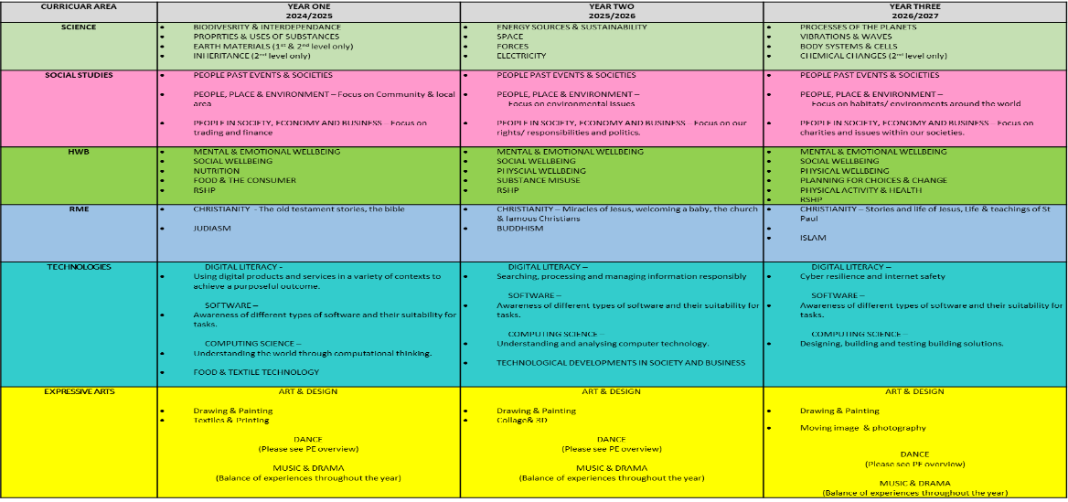  - Ensures continuity and progression in learning from one class to another, avoiding gaps or unnecessary repetition.  STEM  Last session, we indicated our intention to appoint a PEF Funded Principal Teacher of STEM. Unfortunately due to HR issues, our PT was not contracted until Term 4. That being said, Mr Jackson, our appointed PT, happily led the development of STEM throughout the school and ECC, despite receiving no remuneration for this.  At the start of the session, self-evaluation and surveys were completed by staff (both ECC and Primary), pupils and parents/carers. Analysis of these acted as a mean of determining our STEM priorities. Although interest in STEM was high and there was an understanding of the need to prioritise the learning and teaching of this area, confidence in being able to sufficiently meet learner’s needs was low, and pupils were not aware of many STEM careers or inspiring individuals who work in this field. The pupil surveys also highlighted a need to show that STEM was for everyone as a small number of children has a gender imbalance when it came to STEM careers.  P4-7 Survey  P1-3 Survey  STEM - Parent Survey  STEM - Staff Survey  A STEM policy and Assessment Guidance was created at the beginning of the year and through collaboration with staff, was fine tuned to suit our needs and context. The policy ensures there is consistency in the teaching of STEM across the school and our assessment evidence focusses on skills acquisition of pupils. It also highlights pupils who would benefit from some support during lessons, but also those who are excelling and need further challenge.  Working with RAiSE Officers, staff received training in areas where their confidence was the lowest in terms of delivering effective learning and teaching and gathering evidence. Training was delivered on Engineering, Science Investigative Skills, Let’s Do Science (Planning) and Coding. Staff were also introduced to a variety of CPD opportunities online and referred to different resources they could access for free to enhance their lessons. ECC staff joined primary staff for a number of these sessions. This boosted staff’s confidence in planning and delivering engaging STEM lessons which were then delivered in the class and playroom.  In line with our 3-year planners, our STEM room was resourced (PEF) with general tools and scientific equipment to deliver science investigations. High quality learning materials were purchased to deliver the topics from the Year One in the Science planner. A timetable was also created to ensure all classes and ECC could access the room at least once per week. This ensured that pupils were developing their scientific skills using appropriate tools and instruments. Discussions to ensure this was considered as a vital part of learning and teaching took place during termly planning meetings with SLT.  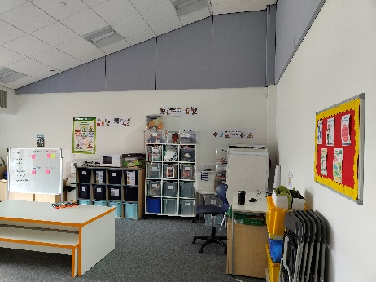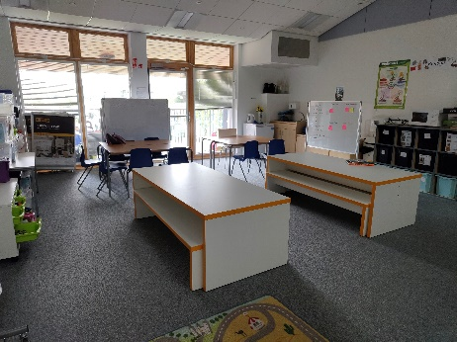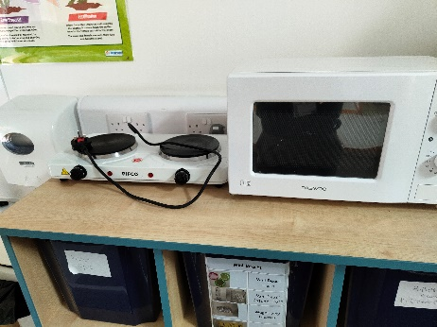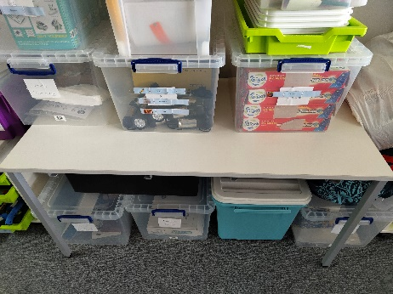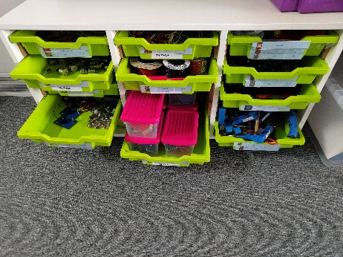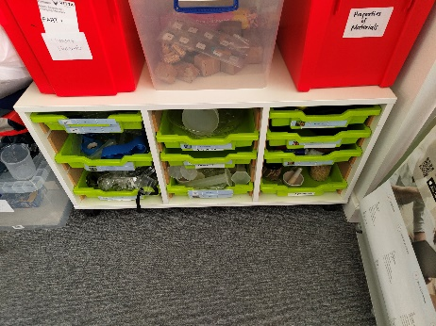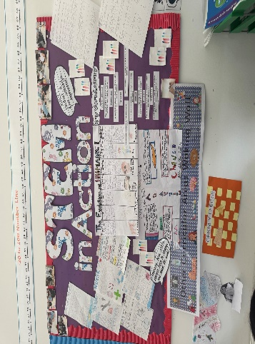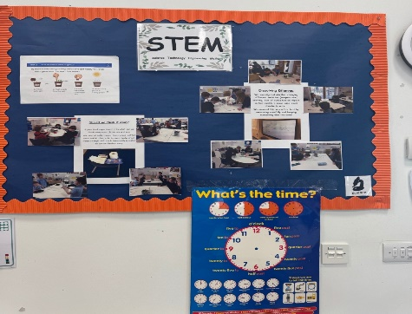  Through our new 3-year planners, pupils were able to experience more depth in lessons, due to class teachers having more time to deliver topics that were focussed and not over-burdening. Throughout lessons, pupils were being explicitly made aware of the skills they were developing and what careers these skills would be useful for. Teachers were able to access a wide range of high quality online resources to help deliver engaging and inspiring lessons to pupils.  Links were made with E-Sgoil to deliver online lessons that focussed on DYW. These allowed classes across the school to participate in different lessons that focussed on Engineering and on an Introduction to Work. E-Sgoil also delivered a session to staff during an in-service day to show them what could be offered from their website in terms of themed events, pre-recorded session and live lessons that could be accessed for their class. This is something that all classes will take advantage of going forward to bring learning to life for pupils.  Two members of staff have been trained to deliver the Young STEM Leader Award in classes and to act as internal verifiers. Unfortunately, due to access issues with the online journals pupils need to complete through Chromebooks, this has proved tricky. This is something that will continue to be implemented next session in order to get our senior classes working towards this accreditation.  Our PT STEM also attended an Education Scotland National Moderation Event for Science and the information gleaned from this session, will be used to help determine how we can better capture pupil evidence next session.  The school also successfully received funding to run British Science Week. The vast majority of money was spent on resourcing activity boxes to help class teachers deliver CREST lessons. By completing at least 6 activities, all pupils in the school from ECC to P7 were able to be awarded with a CREST certificate. Networks were created with businesses and individuals that can be utilised again. These ranged from Pharmacists to Aeronautical Engineers, Artic Explorers to Oil and Gas Engineers and a strong partnership with Ayrshire College continued. All classes also received time to use VR equipment and work with coding and robots.  As part of British Science Week, a timetable was created to ensure all classes were able to take advantage of live lessons, guests and exciting equipment loaned from East Ayrshire Council’s Lending Library. Most classes also had the opportunity to visit different places of work in order to see STEM skills in action. The school also formed a partnership with East Tennessee State University where a group of trainee teachers came in to deliver lessons to a senior class on a specific science topic. A network of contacts was also built through the STEM Ambassadors website to allow the pupils to experience as many real life STEM champions as possible. Our STEM Leadership group helped to design the timetable, acted as ambassadors in class and delivered lessons to the lower stages in the Primary School and the ECC.  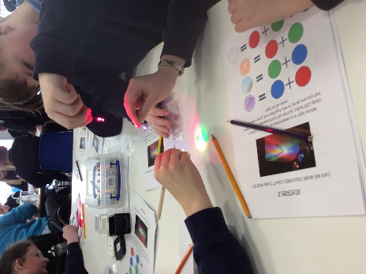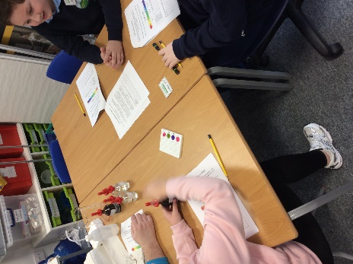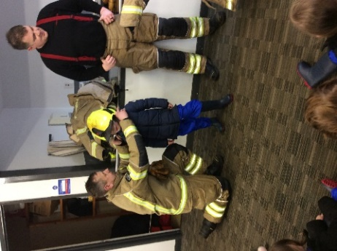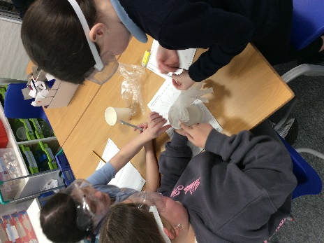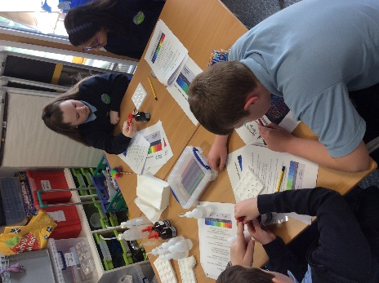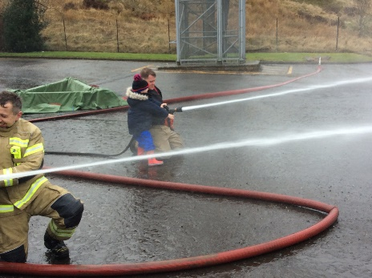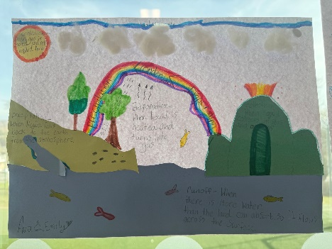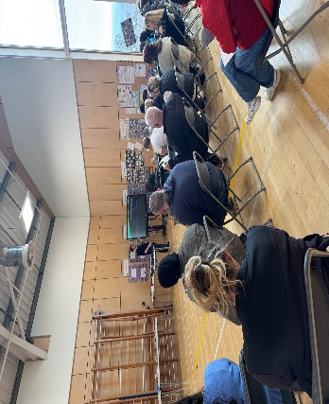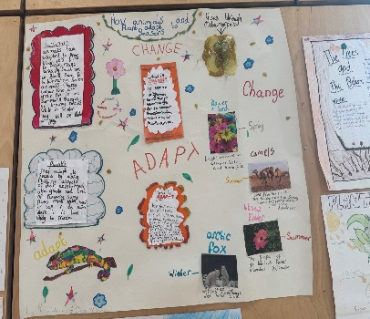  Parents and carers were invited into the school at the end of our British Science Week to listen to a short presentation that updated them as to STEM developments in the school. They were then able to visit their child’s class to take part in a STEM lesson to see our approach in action. The feedback from this event was overwhelmingly positive.  Staff self-evaluation of this improvement priority at the end of the session has shown that staff are more confident in delivering engaging STEM lessons, are engaging with a larger variety of tools and resources to make lessons interesting and are invested in ensuring pupils are developing their STEM skills in a way that will lead to successful careers in the future. They are also making STEM links explicit across the curriculum where appropriate.  Children’s self-assessment shows they have an increased knowledge of STEM. 93% of children said they now know more about STEM subjects. They also had opportunity to work with a variety of partners to develop their skills for life, learning and work.  DIGITAL  Muirkirk Primary's progressive Digital Technologies Planners, created last session, have been utilised from P1- P7 and assist teachers in providing coherent and progressive learning. There is a dedicated Digital Learning block every week for every class, as well as flexibility throughout the week to use digital skills across the curriculum. The use of digital skills across the curriculum is an area that we are actively working to improve, through sharing of skills, ideas, training and resources, and this will continue to be a focus in 2025/26. Pupil skills and independence have greatly increased, relating to software, digital literacy and computer science (see pupil feedback – sample of 3 pupils per class). Apps and software are used across the school, in an age-appropriate way, and pupils can open, use and close these. Taught skills are being applied purposefully, e.g. Micro:Bit skills used to design and develop a device to encourage recycling (example by P6/7 pupils) or iMovie skills to practice spelling phonemes by recording photos and voice (example by a Primary3 pupil). These opportunities display confidence in pupils and develop independence and creativity. Links are also made between the skills pupils are learning and their use in the workplace.  The Digital Literacy Policy for MPS was created in 2020 collegiately. This policy has been updated this year and shared with staff via the Class Teachers Team ‘Policies’ folder. In addition to this, an Action Plan has been created for 2024-26. These documents set clear expectations and a vision for our digital journey towards excellent educational experiences and the Digital Schools Award.  Resources  Resources have been organised so that every pupil has an allocated Chromebook, and P1-3 pupils have an allocated iPad to save their work on. All pupils from P2-3 to P6/7 and 7 pupils in P1/2 are able to log into their allocated Chromebook independently. Chromebooks are timetabled for a weekly digital learning slot for each class, as well as flexible use out with this. More Chromebooks have been purchased, along with replacement iPad charging cables and Beebot resources, to enable resources to be readily available to facilitate use across the classes and curriculum. A new digital Lunch Ordering System was implemented in April 2025, allowing pupils and teachers to self-order using the Promethean Board. Clicker 8 software has been purchased to support writing skills across the school. This has provided motivation for some reluctant writers and independence through spelling support for others who have ideas in Writing but find it challenging to put their ideas on paper. The range of iPad and Chromebook apps, software and websites used has vastly increased this year, and pupils are comfortable and confident in using the resources which best suit their tasks/needs.  As part of the Digital Schools Scotland Primary Award, staff digital skills were audited using the Digital Skills Toolkit, through Kahoot. This provided data relating to staff training needs, as well as showcasing an assessment tool that could be used in class. Following this, Teams tools and One Note training was booked with Gary Neilson, EAC ICT Co-Ordinator. Teachers in most classes have utilised Kahoot in general lessons and P6/7 pupils are now using One Note. Other staff require further detailed training on OneNote, using Microsoft Learning Pathways. Staff needs identified will inform the SIP and collegiate calendar for 2025/26. The Digital Lead teacher, accessed additional training relating to Scratch and Micro:Bits, which increased her skills and confidence in teaching and applying computational thinking and programming skills, which in turn empowered pupils and supported them to develop their understanding and enthusiasm. All staff are up-to-date with essential digital training provided through Learn Pro, which ensures an awareness of relevant information, policy and procedures and how to manage and report digital risks.  The Digital Leadership Group has provided the pupil members with opportunities to improve Digital Wellbeing of the School Community, develop their own skills, in order to support others, and help organise resources and software for school use. Key activities included researching Digital Wellbeing then raising awareness through the use of iMovie via a QR code, PowerPoint, digital posters and hand drawn posters; testing, labelling and organising iPads for easy use; installing docs extension onto every Chromebook, so that P1-3 pupils can access Word, Excel and PowerPoint; developing their own coding skills and knowledge of accessibility features to enable them to support others in their classes. Committee pupil members said the Digital Leadership group was “interesting”, “fun” and “helpful” (link to Digital Committee annual review).
Next Steps | - To continue our 3 Year Curriculum Planner work  - To continue to embed STEM practices within the school and ECC.  - To continue our Digital Schools work focusing on TEAMs and Learner Profiles.

Improvement Priority  (Expressed as outcomes for learners) | Improvement Priority  To improve Health and Wellbeing of all pupils through:-  - Targeting support where it is most needed  - Enhancing wellbeing programmes across the school  - Revisiting the ‘Respect Me’ Programme.  Staff participation in CLPL. | Education Service Improvement Plan Priority 3: Our Wellbeing and Belonging  We want all of our young people to feel supported by people who know them well, and feel included in all of our schools and centres. Our staff need to be supported in their working with our young people, especially in times of adversity. As a key universal service, it is our vision that all young people attend our establishments on a full-time and regular basis to support them in their development at all stages.
Our Wellbeing and Belonging
Progress and Impact | PASS ASSESSMENTS FOR WELLBEING  Last session, GL assessments were purchased using PEF. Within this suite of assessments, Pupils Attitudes to Self and School Survey (PASS) was included to support assessment of social and emotional wellbeing. From piloting this assessment with targeted health and wellbeing groups in the previous session, it highlighted valuable information. Therefore, this session it was agreed to administer PASS assessment with all stages across the school. This was firstly carried out at the end of October when the children were settled within their new classroom environment and relationships between staff and children had been formed.  In previous sessions, once the HWB assessment had been administered and targeted interventions with individuals had been identified, there was little engagement with the assessment data, particularly at class level. Therefore, as a staff it was agreed that there should be a focus on class level interventions as well as individual assessments.  In order to achieve this, health and wellbeing (HWB) meetings were organised with the class teachers and DHT. Assessment data was shared a week in advance of the meeting to allow class teachers the opportunity to view their data, consider suggested interventions at both class and individual level. The HWB meetings then provided professional dialogue to discuss the data and action plans to be decided.  To ensure that class teachers are considering the PASS data and actions from this, PASS data and interventions agreed upon formed part of monitoring and tracking meetings. This encouraged class teachers to continue to reflect throughout the session on the interventions that have been put in place and what the impact has been or if any interventions need to be reviewed/ adapted.  Throughout the school many whole class interventions have formed part of daily activities/ interactions. Examples include ‘proud clouds’ for each child to showcase work that they are proud of to promote self-esteem, daily check in charts, question box to allow children to ask questions they might not want to ask verbally.  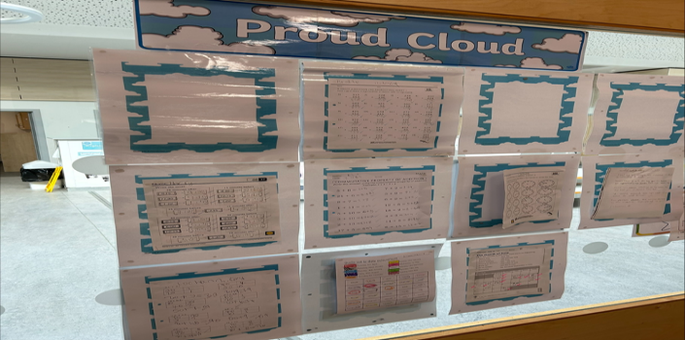  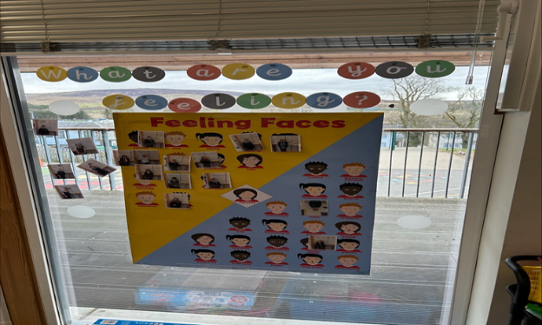  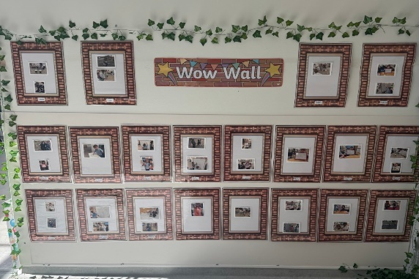  The impact of moving to this format has had many positive impacts across the school. This was evident in our post assessment across the school. For those individuals that were tracked and bespoke strategies put in place after the initial data, 60% (9 out of 15) showed overall improvement in their scores, 34% (5 out of 15) showed improvement in some areas and only 6% (1 out of 15) showed no improvement in their data.  Individual meetings were held with class teachers to analyse May 2025 data to consider further class interventions that could be put in place. Individuals were also identified and interventions discussed that could be put in place for the rest of the session, including the good practice gained from the Circle Framework training staff had undertaken. This information will form part of our transition documentation to keep strategies consistent for pupils as they move into new classes. Class teachers were more confident in determining positive strategies that would have a direct impact on wellbeing indicators for pupils and detailing ways they would achieve this in class.  Next session, more focus will be placed on discussing PASS assessments with pupils as they are being conducted. This is due to staff identifying that they felt some questions with a 'double negative' were misunderstood by pupils and perhaps skewed the data results. We want our data to give us a clear and reliable picture of how we can further develop our approaches to developing the health and wellbeing of our pupils.  The data was also used to help identify those pupils who would benefit from a Transition Passport ahead of moving into their new classes, so we are also meeting our responsibilities of being a Communication Friendly School.  Next session, PASS assessments will be continued to be administered as our HWB assessment tool across all stages. It has enabled more engagement with staff, where they have taken more ownership and accountability of how targeted interventions are going at class and individual level. However, as a staff we recognise that pupil voice was not included during the decision making process of interventions from the data. Therefore, next session our next action will be to involve pupils more by sharing the data and discussing interventions to ensure pupil voice is considered more.  WE WERE EXPECTING YOU & THE CIRCLE FRAMEWORK  Throughout the school, there is an increase in the number of children who are displaying Neuro diverse behaviours. As a staff, it was agreed that CLPL would be beneficial to support staff to consider the environment and approaches/strategies used. Also to ensure there is consistency across all stages. After consultation with our Education Psychologist, it was agreed that they would lead and deliver CLPL throughout the session using the programme ‘We Were Expecting You’ by the National Autism Implementation Team. The pre assessment data from PASS was used as a baseline to help identify particular issues and what interventions may be most beneficial for those children who have been targeted.  CLPL began during the October in-service day. However, it quickly became apparent through staff evaluations at the end of the training, that this programme did not provide the practical approaches/ strategies that staff had hoped for. Therefore, as a staff it was agreed that this CLPL would not continue. Instead, SLT explored other CLPL opportunities and decided that a focus on the Circle Framework would be more beneficial. A session at the February in-service was delivered by Debbie Thomson (EAST). Feedback from this training was much more positive, staff felt more confident using the Circle Framework Assessment Checklist and using this information to put into practice the recommended approaches/ interventions within this framework.  Staff then were given time to complete a Circle Framework assessment for the children in their class that were targeted and a follow up session was provided for the staff to consult individually with Debbie Thomson on strategies that they had implemented.  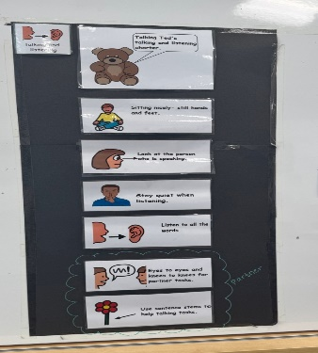  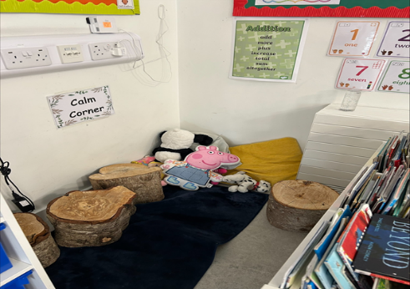  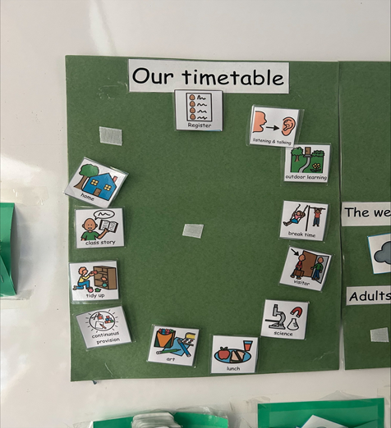  The use of this approach has helped staff identify and address barriers to participation and learning, not just for those children with ASN. There has been a shift in mindset from “What’s wrong with the child?,” to “What can we change in the environment, routines or teaching?” confidence of staff has really increased. The use of the Circle Tools allows staff to act early and has reduced escalation in some children. This in turn has enhanced and reinforced our whole school ethos of equity and positive relationships.
Next Steps | - Continue to embed the use of PASS to improve the well-being of our young people.  - Embed the use of The Circle Framework.

Improvement Priority  (Expressed as outcomes for learners) | Improvement Priority  To improve children’s writing attainment.  To achieve Communication Friendly Accreditation  To develop the children’s Problem Solving ability. | Education Service Improvement Plan Priority 4: Our Attainment, Destinations and Achievements  We want the very best for all of our young people in East Ayrshire. We aim to ensure that all young people secure a positive destination through excellent achievement and attainment at all levels.
Our Attainment, Destinations and Achievements
Progress and Impact | LITERACY  This session we have continued to embed EAC Early Level Writing and PM Writing and throughout the school. The PM Writing Approach does not necessarily mean there is an extended piece of writing each week, but what it does provide is explicit and systematic instruction in writing, incorporating shared, guided and independent writing and linked independent reading. Through our self-evaluation using HGIOS 4 and HGIOURS we know that our pupils have a secure understanding of the different text types. From our moderation activities we have been able to clearly assess that pupils are able to apply the different genre-specific writing structures. Pupils’ vocabulary and language skills have also become more enhanced. This is evidenced through our attainment data in writing for session 2024-2025.  This session we collaborated in writing moderation sessions to promote professional dialogue and a clearer, collegiate understanding of the achievement of a level with the aim of further improving professional judgement. Staff from the school and ECC paired up to plan collaboratively within and across levels, planning quality, relevant learning experiences from the Experiences and Outcomes.  At the planning stage staff worked in collaboration to plan a writing lesson (using PM Writing resource). They discussed the Es and Os to be assessed, the learning experiences, learning intentions and success criteria and approaches to assessment.  During the deliver stage, staff shared classes to team teach and deliver planned learning. This gave staff a broad overview of the range of ability and progression within the level. This also provided a solid foundation against which they had dialogue around progress and achievement in relation to the benchmarks.  During the assessment stage staff had professional dialogue around progress and achievement in relation to the benchmarks of work completed.  Staff’s fed back that this approach:  - Ensured consistency and fairness, building trust in the assessment process.  - Improved assessment accuracy. Staff gained a clearer understanding of what constitutes different performance levels.  - Provided opportunity for collaborative discussions about pupils’ work, teaching approaches and feedback.  - Encouraged reflective practice where staff considered their own approaches in light of others’ perspectives.  - Promoted a shared language and standards around what quality work looks like.  Parents and carers were invited into the school to attend an Active Literacy morning where our refreshed approach to spelling was outlined. Teachers took the guests through Stage One, Stage Two and Three and Stage Four to Seven Active Literacy spelling to aid understanding of this approach and demonstrated different ways they could support their child at home. Pupils were given a ‘take home’ pack for spelling that was stage appropriate and included a variety of materials for pupils to complete Active Literacy tasks at home. This catered for the mixed views we received from parents regarding homework where 50% did not want any and 50% wanted traditional homework – this pack allowed families to dip in and out of spelling activities where they could. Parents and carers were then invited into the classroom to see this approach in action and spend time with their child on Active Literacy activities.  ORACY  Following new guidance in the planning folder and our assessment policy, our approach to Oracy is now further embedded. Pupils are now assessed 6 times throughout the year – twice for listening, twice for a solo talk and twice for group work and this allows for more meaningful discussion during tracking and monitoring meetings. Listening and Talking opportunities are now more natural within the classroom rather than stand-alone and most teachers are actively planning for these opportunities when planning each term, particularly at Early Level. This has initially led to a dip in progress and teachers are more aware of the benchmarks and the skills progression for Listening and Talking and are actively teaching listening and talking skills. It is expected that this initial dip is corrected when pupils are more accustomed to this more formal way of teaching and assessing listening and talking skills. Further work is needed to embed group listening and talking skills within the classroom and build negotiating and resilience skills during group activities.  COMMUNICATION FRIENDLY ACCREDIATATION  In August a new Communication Friendly Leadership Group was set up with their first task to audit the environment. This had already been done by the Communication Champion and an initial group, however this time we looked in depth at the Communication Friendly Audit and the leadership group offered a fresh perspective and ideas that had not been considered.  It was evident that although labelling etc was developing consistency, there were still some classroom areas that needed developed further, including making the best use of working walls and ensuring all classes had access to quiet spaces and support resources.  We began to work on points raised from the audit including: making sure to include the dinner/gym hall in labelling, focusing in on the use of talking buttons to invite comment and extend use of working walls, quiet areas available for all classes, games, support materials etc and the use of QR codes and videos particularly on the parent board.  The use of Makaton has also increased this session. Mrs Wright has taught signs to the leadership group, who then teach the signs to the rest of the school. The group created certificates they give out to pupils spotted using Makaton. QR codes with clips of the children demonstrating signs are on both the school and parent communication board to encourage awareness and use of this at home as well as school.  The communication friendly group have also taken part in ‘Getting wee people talking’ training led by Mrs Wright. They enjoyed this and have been able to take this training into the ECC and P1/2 where they have spent time working with the younger children. They were able to discuss how they could support our younger children with their speech and listening and talking skills, including how to encourage this without leading/taking over the conversation or activity.  Every class has also implemented the use of the board maker writing targets as a means of self and joint assessment and informing next steps. This is linked to our work on feedback with our Leader of Learning and has ensured consistency and progression across all classes and stages, as well as increased use of self-assessment at all stages.  As part of our transition and to support pupils across all stages, Mrs Wright created a ‘communication passport’ for children who require additional support. This details behaviour, triggers, supports, friendships and information about children who require extra support/ have difficulties in regulating emotions.  In May 2025 eventually had our visit from Communication Friendly Assessors and were awarded Communication Friendly Schools status. Mrs Wright and the leadership group presented to the assessors and were able to talk about the work they had done and the impact it had had on the school. The Leadership group also presented to the whole school and parents at our celebrating success service in June.  GL ASSESSMENTS  This session we have continued the use of GL Assessments to support us to track and monitor attainment in Literacy and Numeracy. We have successfully used the data from the assessments to impact targeted interventions. At tracking period 1, we discussed the children’s baseline GL Assessment results, including their standard age scores and percentile rankings. Following these discussions, Boost Groups to support and challenge children were identified with a focus on those children who were on the cusp of achieving their level. Miss Hall led these boost groups which focussed on spelling and writing interventions. Sample data below shows the impact of this intervention  Impact of Spelling Intervention  NUMERACY  Staff worked with Robert McCallum, QIO for Numeracy on a book study of ‘The Thinking Classroom’. At each session, staff worked collaboratively to discuss the approaches within the book and work together to implement these approaches within the school and their own classroom. Staff teachers were challenged in their thinking and approaches to the teaching of numeracy, mathematics and problem solving, specifically in terms of the how the teacher interacts with pupils and imparts knowledge and how the classroom environment is set up.  This led to small tests of change in each classroom where questioning, seating and positioning were considered in order to promote better engagement with problem solving. Pupils are now beginning to be more engaged in problem solving approaches and collaborate with their peers in random pairings and groups more readily. Digital resources and games have also been used more frequently in class as a means of promoting problem solving and thinking skills. Class teachers are utilising the use of vertical surfaces to make learning visible for children participating in group work. This , fosters collaboration and communication and promotes active thinking. Resources were purchased to support this approach including large transportable whiteboards and pens that can be used to write on windows.  Our GL Assessment Data shows that almost all classes improved in their problem-solving abilities across the year. Primary 3 and 4 are now above the national average when it comes to their problem-solving abilities. Primary 5, 6 and 7 are below the national average but for Primary 5 and 6, the gap has been reduced.  Further work is needed to complete the book and continue with this approach before it is fully embedded in practice.  Staff are very keen to continue this TLC Group next session with a focus on other elements.  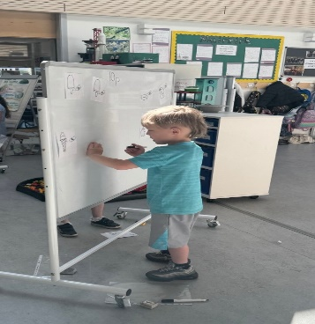  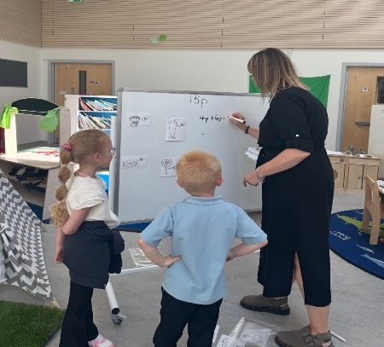  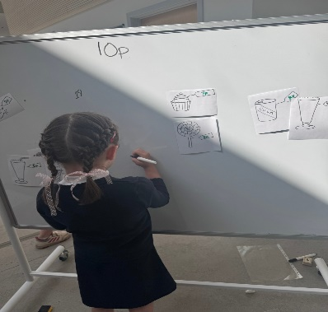  Our problem solving planners now form part of a class teachers planning documentation and outlines the strategies that are planned to be taught as well as the resources and links to other areas of mathematics. These will continue to be used to ensure consideration is given to the problem solving method being specifically taught and how it links with core areas of numeracy and mathematics that are planned to be taught each session.  This session, moderation centred around writing. Staff are now more confident in collaboratively planning for the teaching and learning of writing and ensuring assessment is considered at the planning stage. There is more consistency and agreement around pupil achievement of a level. Next session, the focus will be on numeracy and using the problem solving pedagogy and the approaches staff teachers have developed this session. This will then feed into the moderation process where staff will collaborate and plan together to deliver problem solving approaches in class and assess these together in order to build a consistent picture on achievement of a level.  Parents and carers were invited into the school on two occasions – once to see our refreshed approach to spelling in action and another time to see the school approach to STEM subjects. Next session, the focus will be on inviting parents and carers to be see our approaches in mathematics and gain knowledge on how they can support their child at home and the simple and free tools they can access for this.  EXCELLENT LESSON  At the beginning of term 1, we revisited our expectations of an Excellent lesson ensuring that we are creating consistent, high quality learning experiences that lead to improved outcomes for all learners. Our Leader of Learner, Miss Hall led this activity. We updated our expectations and then aligned this to our Quality Assurance paperwork, in particular lesson observations. Staff are clear what the expectation is in each lesson and use this to plan, deliver and assess the learning. The SLT can clearly see evidence of the excellent lesson in use during ‘walk arounds,’ classroom observations and when popping in and out of classes daily.  During our moderation, sessions staff used The Excellent Lesson to support their planning and as a means of delivering peer feedback. This proved to be very successful and is certainly a tool we will use again.  During our authority Learning Visit we were asked to consider creating a child friendly version of the excellent lesson. So with the collaboration of the Pupil Council a child friendly version was created by the children, as seen below. Sharing this with the children sets high expectations, encourages the children to think about their own learning and helps reinforce high standards.  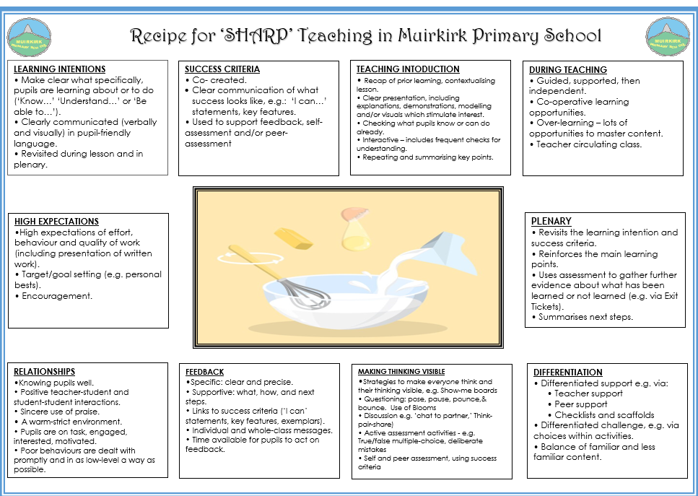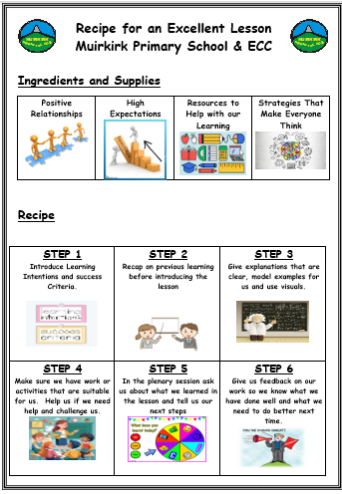
   | P1 | P2 | P3 | P4 | P5 | P6 | P7
  2023-2024 | 71% | 63% | 75% | 67% | 42% | 62% | 47%
  2024-2025 | 71% | 73% | 67% | 93% | 88% | 90% | 71%
  Name | Spelling Result September 2024 | Spelling Result December 2024 | Spelling Result June 2025 | Difference
  Child 1 | 70% | 78% | 89% | +19%
  Child 2 | 69% | 78% | 96% | +27%
  Child 3 | 65% | 77% | 71% | +6%
  Child 4 | 71% | 78% | 88% | +17%
  Child 5 | 63% | 77% | 81% | +18%
  Child 6 | 79% | 83% | 88% | 19%
  Child 7 | 78% | 88% | 94% | +16%
  Class | PTM Problem Solving (Start) % | PTM Problem Solving (End) % | Difference % | National % | National Difference %
  3 | 18 | 50 | +32 | 46 | +4
  4 | 28 | 51 | +23 | 41 | +10
  5 | 22 | 30 | +8 | 38 | -8
  6 | 37 | 46 | +11 | 50 | -4
  7 | 30 | 27 | -3 | 37 | -10
Next Steps | - Continue to take part in staff training with regards to Communication Friendly strategies.  - The Circle Framework will be fully embedded with assessments and supports used to provide the best learning experiences for all learners.  - To implement the child Friendly Excellent Lesson  - To continue work on The Problem-Solving Classroom.

Improvement Priority  Expressed as outcomes for learners) | Improvement Priority  Use quality improvement methodology to make changes to improve the wellbeing score for children with Additional Support Needs.  The wellbeing score of children with Additional Support Needs will show improvement.  To tackle gender bias and build respectful relationships in both the ECC and Primary through participation in Everyone’s Included and Gender 10 Project | Education Service Improvement Plan Priority 3: Our Wellbeing and Belonging  We want all of our young people to feel supported by people who know them well and feel included in all of our schools and centres. Our staff need to be supported in their working with our young people, especially in times of adversity. As a key universal service, it is our vision that all young people attend our establishments on a full-time and regular basis to support them in their development at all stages.
Our Wellbeing and Belonging
Progress and Impact | Our health and well-being aim this session, within the ECC was By June 2025, improve the average daily wellbeing score of children with additional support needs from 2.8 to 4 (using Leuven Wellbeing Scale).  In the first instance, all staff carried out an Audit of Practice to determine the strengths and developmental needs within the ECC with regards to meeting the needs of the children requiring additional support needs. This was in the form of a Fishbone exercise (photo below). Staff then worked together to complete a driver diagram to help in the self- evaluation process. We were supported by The Children and Young People’s Collaborative (CYPIC), through numerous online and face to face meetings. The drivers that became our focus was ‘the environment’ and ‘staff confidence.’  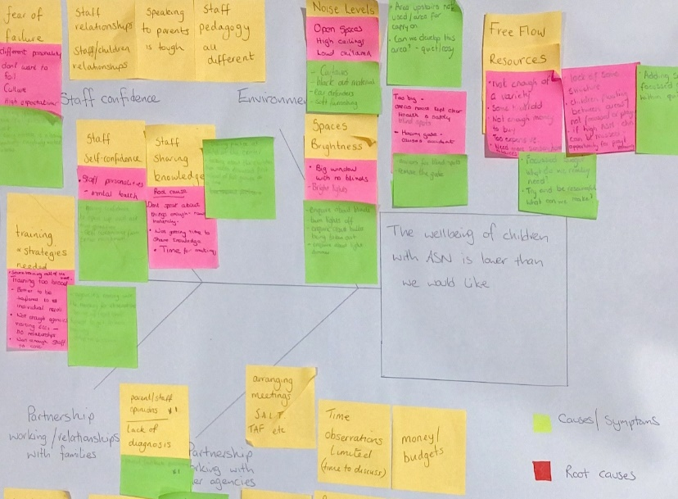  The PDSA cycle (Plan, Do, Study, Act) was used to test and improve interventions and changes. Using this cycle, staff were able to plan, implement the change, study the results and data and then act on what we had learned.  The team then worked to create a driver diagram which had the aim of considering primary drivers, secondary drivers and change ideas.  Change ideas we focussed on were  - To utilise the 2 year old room to support children displaying dysregulated behaviours.  - To use the quiet room with children who have increased sensory needs to support behaviours and confidence.  - To introduce an emotions check-in when entering the quiet room, using ‘The Colour Monster.’  - To use the Leuven Scale to assess levels of regulation and utilise resources to prevent further dysregulation.  - To introduce signallers and visuals to support transitions within the playrooms.  Great consideration was given to the environment within each room. Staff utilised their Communication-Friendly knowledge to ensure the ECC rooms promoted equity and inclusion. The use of visuals became very important.  We noted that most dysregulated behaviour occurred during transitions, like tidy up time, lunch time, outdoor play, so introduced a song and visual to signify the end of one activity. This offered a consistent signal that change was coming and helped the children feel safe and secure. It also gently shifts children’s attention from one activity to the next.  We tracked children’s wellbeing score at various points throughout the day using the Leuven Scale to assess if there was an improvement in score, following time in any of these rooms. Staff used run charts to track variations and progress towards their aim  Training was provided from a number of sources to help support staff, better support the children. Christine Barr, Speech and Language Therapist & Joanne Reilly, Occupational Therapist provided a session on making best use of the environment and spaces. This resulted in staff giving consideration to creating a bespoke area within the playroom as opposed to out with, to help children with dysregulated behaviours. This work will continue into session 2025-2026, with a bespoke ‘quiet place’ being created offering some children the choice of regulating their behaviours within the ECC playroom, not being removed to another space.  As a result of this input a new daily average wellbeing score was recorded as 3.6. An increase of 0.8. This can be seen in the diagram below.  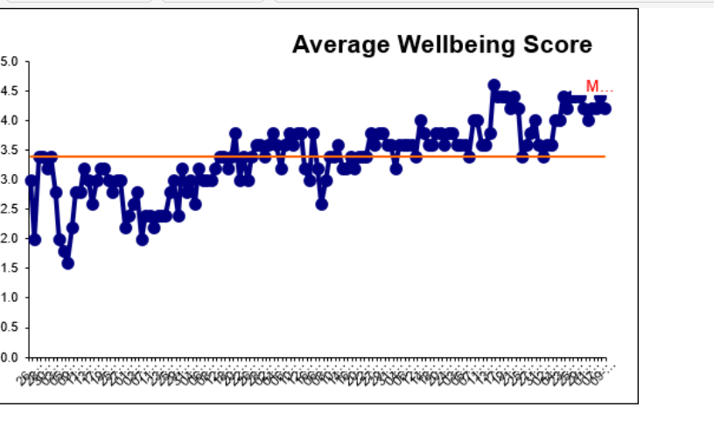  From our evaluation we note that this approach has been successful based on the cconsistent approaches used by the staff team and their ability to share this with the parents. Staff also utilised the data effectively. At every stage of the improvement cycle we had clear evidence as to why we were, making changes and the differences the changes were making.  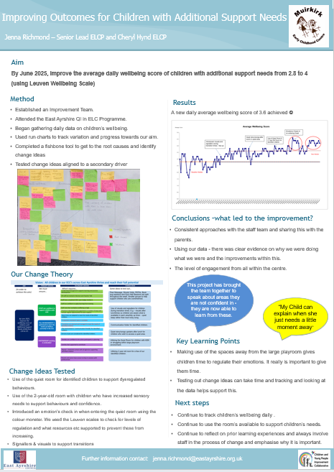  Gender Equality  The school and ECC participated in Primary Gender Based Violence Pilot during Terms 1 and 2. Through the training with Education Scotland and NHS we learned that there is a direct link between gender inequality and gender based violence with gender stereotypes perpetuating inequality and reinforcing the difference between men and women. Gender stereotyping from a young age can have negative consequences for both boys and girls including limiting what children can do, be and become with future decisions being influenced by gender divisions.  Following the extensive training we decided to evaluate our school and ECC environments asking ourselves the questions: “Do our environments encourage non-gendered norms and expectations? Do children feel accepted and celebrated for their individuality?” We have created an action plan and intend to work through this priority next session.
Next Steps | - Embed the use of a ‘Quiet Area’ within playroom.  - Continue to support dysregulated behaviours  - Continue to embed work on equality.

Pupil Equity Fund: Evaluation
Approach/Intervention | Impact  Report on how you have improved outcomes for learners impacted by poverty | What evidence do you have of positive impact?  Outline the data that supports your findings.
Appoint a PT (0.2) to drive forward improvements in STEM across the ECC and school.  STEM resources to support curriculum.  White Rose Science subscription | - Due to HR issues, The PT Post was not filled until April 2025.  - Resources have been purchased based on our 3-year wider curriculum planners. Pupil engagement in STEM, has increased significantly. Learners reported confidence and enjoyment in STEM -related activities especially when engaged in hands-on practical learning. Pupils have developed key skills for life and work, including problem solving, creativity, collaboration and critical thinking.  - Participation in STEM learning was broadened and barriers reduced, ensuring all pupils had an equal opportunity to benefit from future-focused, high-quality learning. | Detailed in Standards and Quality Report for STEM above.
Continued purchase of GL Assessments (PASS) | - GL Assessment tools have enabled the school to take a more robust, data informed approach to identifying gaps, targeting interventions and measuring progress. Data helped pinpoint specific gaps in reading comprehensions, numeracy and reasoning skills, supporting more timely interventions. Baseline and follow up GL data allowed us to measure progress over time and evaluate the effectiveness of PEF funded strategies | Detailed in Standards and Quality Report for GL Assessments above.
Appoint a Class Teacher 0.4 for Literacy and Numeracy ‘Boost Groups’ providing support and challenge as required, to narrow the poverty related attainment gap. | - The class teacher appointed worked with targeted groups of learners. Learners received small group support focused on identified gaps in literacy and numeracy based on assessment data.  - Pre and post intervention data shows progress in literacy and numeracy areas targeted. Targeted interventions contributed to an overall improvement in attainment in Numeracy and Literacy, particularly for learners identified through SIMD data. | Detailed in Standards and Quality Report for Literacy and Numeracy above.
A Classroom Assistant will support Literacy Numeracy across the school and support with interventions to better support children. | - A classroom Assistant was able to provide targeted support to identified groups of learners. This has enhanced both the quality and equity of in class support.  - CA support was tailored to support in areas such as phonics, reading, fine motor skills and emotional regulation.  - Pre and post intervention data shows progress in literacy and numeracy areas targeted. Targeted interventions contributed to an overall improvement in attainment in Numeracy and Literacy, particularly for learners identified through SIMD data. | As above
Resources to support the pedagogical approaches from the book ‘Thinking Classrooms’ | - This funding enabled us to invest in professional learning, targeted resources and staff capacity to embed thinking routines and visible learning strategies across the school.  - There has been improved engagement and participation in lessons structured around thinking routines and problem solving. Learners are developing skills in reasoning, questioning and analysis through structured opportunities to think deeply and share ideas.  - There has been an improvement within GL Assessment data, with particular regard to problem solving. | Detailed in Standards and Quality Report for The Thinking Classroom above.
Continued subscription to Rising Stars, Sum Dog and Heinemann Active Maths. | - These digital platforms were used to build core skills in numeracy and literacy with a focus on raising attainment and increasing engagement for learners experiencing disadvantage.  - Use of these digital platforms, led to clear gains in fluency, mental maths, spelling and reading comprehension. This is evident from assessment and progress reports and GL data. Attainment across the school has also improved and can be contributed in part to some of these approaches. | Detailed in Standards and Quality Report for Numeracy above
Continued subscription of online Learning Journals to support sharing the learning with parents/carers. | - The continued use of Online Learning Journals (OLJ) is aimed at enhancing assessment, parental engagement and pupil voice. OLJ allow parents/carers who previously engaged less with paper-based systems to access and interact with their child’s Learning more regularly, bridging the gap between home and school.

Establishment Self Evaluation: How Good is Our Early Learning and Childcare? Quality Indicators
Quality Indicator 1.3 Leadership of Change | 5
Quality Indicator 2.3 Learning, Teaching and Assessment | 4
Quality Indicator 3.1 Ensuring Wellbeing, Equality and Inclusion | 5
Quality Indicator 3.2 Securing Children’s Progress | 4

Establishment Self Evaluation: How Good is Our School? 4 Quality Indicators
Quality Indicator 1.3 Leadership of Change | 5
Quality Indicator 2.3 Learning, Teaching and Assessment | 4
Quality Indicator 3.1 Ensuring Wellbeing, Equality and Inclusion | 5
Quality Indicator 3.2 Raising Attainment and Achievement | 4

Establishment Capacity for Improvement
Muirkirk Primary School and ECC has a 3-year self –evaluation for self-improvement cycle. We take a collaborative approach, ensuring there is a focus in learner’s successes and achievements. Staff have a specific remit and leadership responsibility each year – for example, the P1/2 teacher has led Communication Friendly Approaches, the P4 teacher has led UNCRC and the P5/6 has led Eco Schools Award throughout the school.

The School Improvement Plan is reflected upon regularly and updated to highlight how far on the journey we are towards those targets we want to improve upon and next steps identified. Staff are fully aware that children need to be settled and happy in order to make progress in their learning and we all have high standards when it comes to creating a nurturing and positive environment as this is the first step towards full realisation of pupil aspirations. As a small school with a nurturing environment, we are acutely aware of the circumstances in the local community that affect children’s lives and learning. We have poverty proofed our school to ensure the best outcomes for all learners. This is why we established ‘Me to You’ and work in partnership with various community groups, including The Community Association and MEG. These circumstances are always at the forefront in what we do as a school.

Our recent HMIE report documented practice worth sharing more widely as:

“Nurturing, inclusive environment across Early Childhood Centre and Primary School. Over recent years, staff across the school and early childhood centre, have continued with their approach to develop and sustain strong, trusting relationships with all children and their families. Staff are welcoming to all, have an open door policy and provide opportunities for families to access additional supports through the school. Staff’s collective responsibility and accountability for children’s wellbeing and welfare is evident. Children reflect on their feelings and emotions well, and know that there is someone, not always an adult, for them to talk to. Staff have created a safe, nurturing, inclusive environment where all children feel valued and that they belong. Together, staff have developed a culture where children can thrive. As a result of this approach, there is a very strong sense of community.”
Muirkirk Primary School & ECC SIF 2022

The ethos and culture of the school reflects a commitment to children’s rights, positive relationships and a nurturing approach. This is evident in the day to day interaction of pupils, staff and visitors to the school. Our practice has been shared with Education Scotland who have used created a Case Study of best practice. This can be found at:
https://education.gov.scot/resources/bullying/responding-to-bullying/high-quality-professional-learning/professional-learning-at-muirkirk-primary-school/

Almost all children are engaged in their learning as is evident through observations, tracking and monitoring meetings, planning and evaluations. Those children not engaged have support plans and interventions from a variety of professionals, including Educational Psychologist, CAMHS, The Exchange Counselling Service and LIAM

Almost all children are motivated in their learning and are keen to lead learning and change through their classwork and participation in wider achievement opportunities. Children lead assemblies, leadership groups, initiatives within the school and charity events. These opportunities develop life skills, confidence and communication skills.

Teaching and learning is underpinned by a shared vision and values, created by staff, children, parents and partners. The vision, values and school motto of “Every pupil counts and every moment matters” is displayed throughout the school. All staff and all children demonstrate the vision, values and motto in their day-to-day interactions across the school, leading to a safe, nurturing and positive environment and relationships. SHARP Superhero certificates celebrate those pupils who show values in practice.

Staff, pupils and parents also worked collaboratively to create ‘The Excellent Lesson’ example, which sets out lesson expectations within the school. This in turn, leads to high quality and engaging learning experience for all children with a joint understanding of expectations for all stakeholders. This session a Child Friendly Excellent Lesson has been created by the pupils, to give them more ownership of their learning

Children have access to the classroom; break out space, balcony area, and community Rooms/kitchen as well as the local area. The Kirk Plantation in particular, is utilised by all stages, ECC – P7 to promote and develop learning in the outdoors. The school also makes good use of the local environment, shops, farms and the local wind farm.

Relationships within the locality are key. Thanks to a local shop owner, the school have been able to share learning within the community, by using the shop window to celebrate the ongoing learning within the school.

Wellbeing, equality and inclusion are at the forefront of all we do. We are a Poverty Proofing establishment with a ‘Me to You Project’ which allows clothes to be recycled throughout the year. We work in partnership with the Community Association to support the food larder and provide fuel and food vouchers to those who need them most.

Staff plan over different timescales to meet the needs of all learners. Learners are involved in planning at all stages. This needs to be developed further to ensure a consistent approach. Staff meet with the HT termly to discuss their plans and ensure, through professional dialogue, that the seven principles of curriculum design have been considered in the planning cycle.

Tracking and Monitoring Meetings are scheduled 3 times per session. As a result we have clear tracking information for every child, including ECC 4 year olds. Those children who are not on track with learning, need support or appropriate challenge have possible supports discussed during these meetings and targets for improvement set, siting supports to be put in place and evidence that needs to be collected to discuss impact. We use this data to evaluate the impact of interventions. We also analyse data of different groups, including those in SIMD 1, Young Carers and LAAC.

Our recent HMIE inspection can be found at
https://education.gov.scot/inspection-and-review/find-an-inspection-report/find-an-inspection-report/details?id=3765

