Rights Respecting Schools

**We are becoming a UNICEF UK Rights Respecting School!**

What does it mean to be a Rights Respecting School (RRS)?

The Rights Respecting School Award (RRSA) is an initiative run by UNICEF UK, which encourages schools to place the UN Convention on the Rights of the Child (CRC) at the heart of the life of the school.

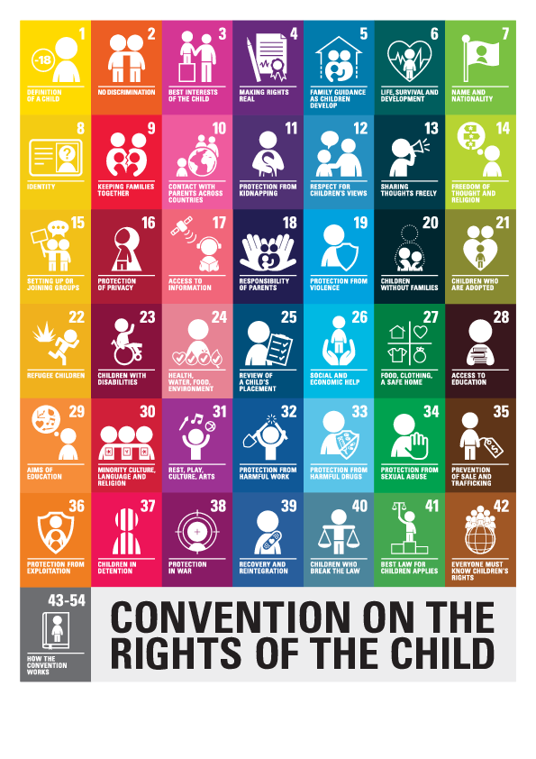

Our journey so far

Session 2023/2024 – Began our RRS journey

June 2024 – Achieved our Bronze Award – We are Bronze Rights Respecting School!

Session 2024/2025 – Working towards achieving our Silver Award

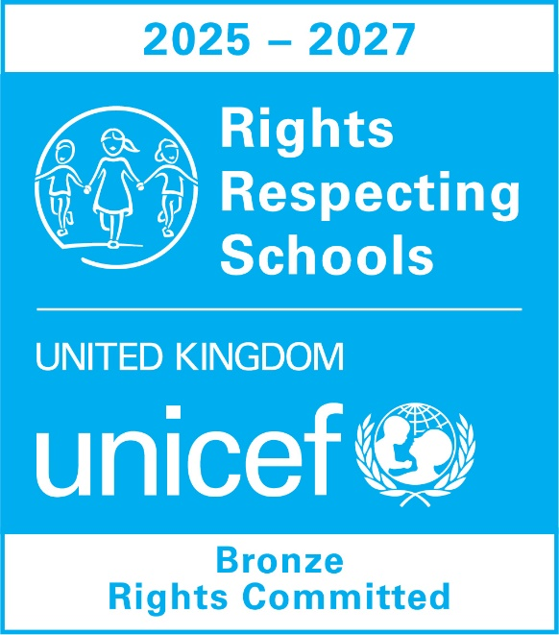

How are we achieving this?

Muirkirk Primary School are working on creating a community where children’s rights are taught, learned, practiced, respected, protected and promoted. To achieve this, we have:

* A Rights Respecting leadership group who meet once per month
* Celebrate a ‘Right(s) of the month’
* Follow our individual class charters which relate to our SHARP values
* Follow our dinner hall and playground charter
* Raised money for Children in Need through hosting a dress down day
* FUN31 every Friday to exercise our right to rest and play

Our RRS leadership group

Since forming in October 2024, our leadership group have been very busy organising, overseeing, creating, designing and presenting. We are now working on providing you with a newsletter to update you on our RRS journey!

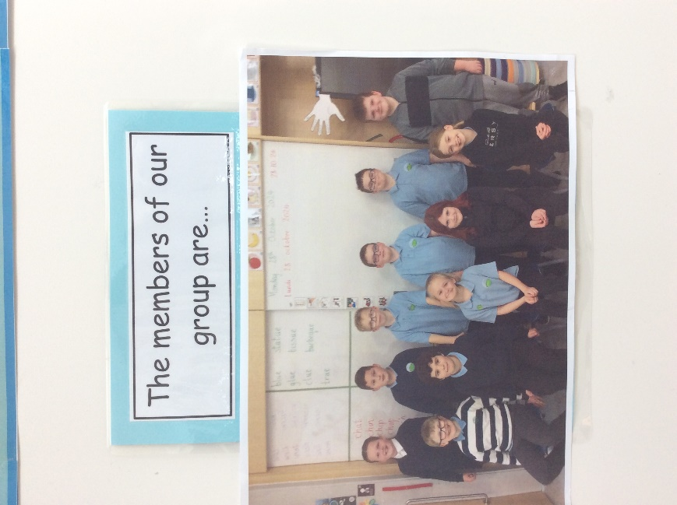

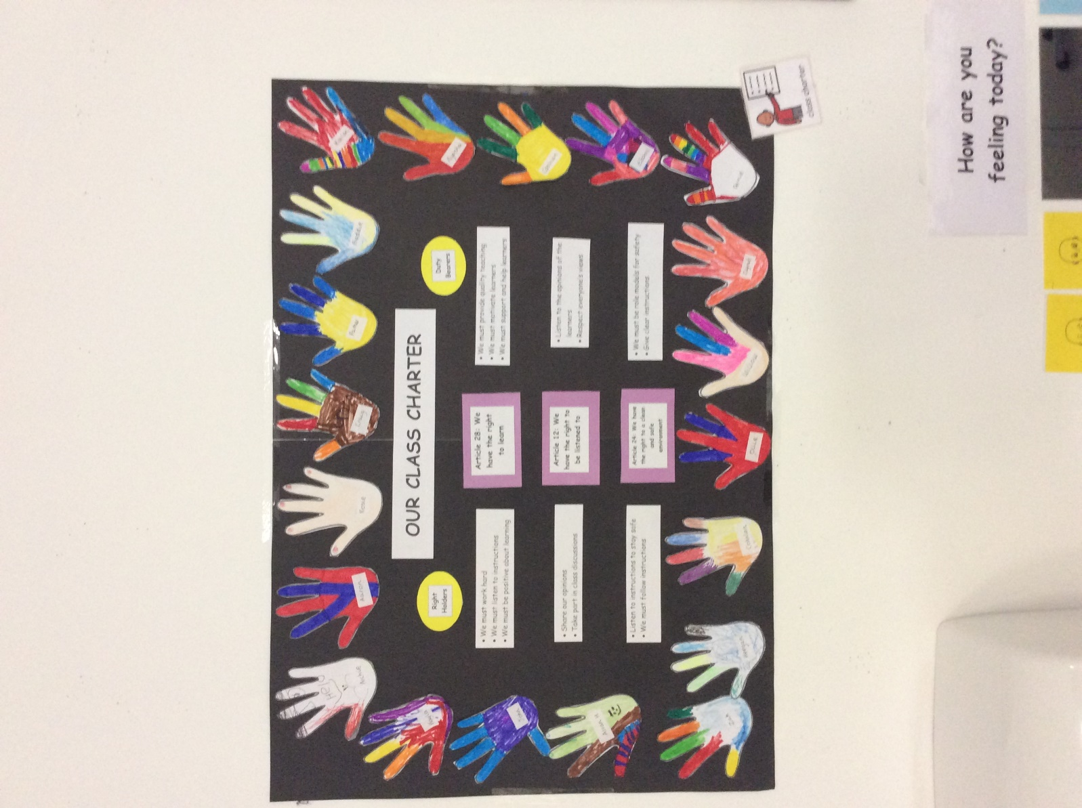Our charters

Here are some examples of our charters from in class as well as our playground and dinner hall charters.

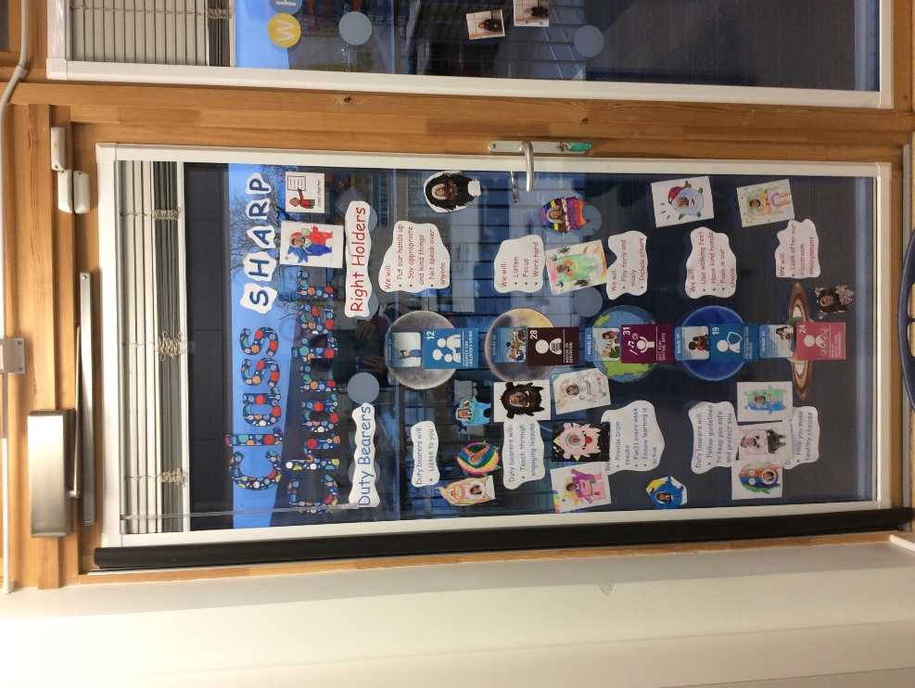

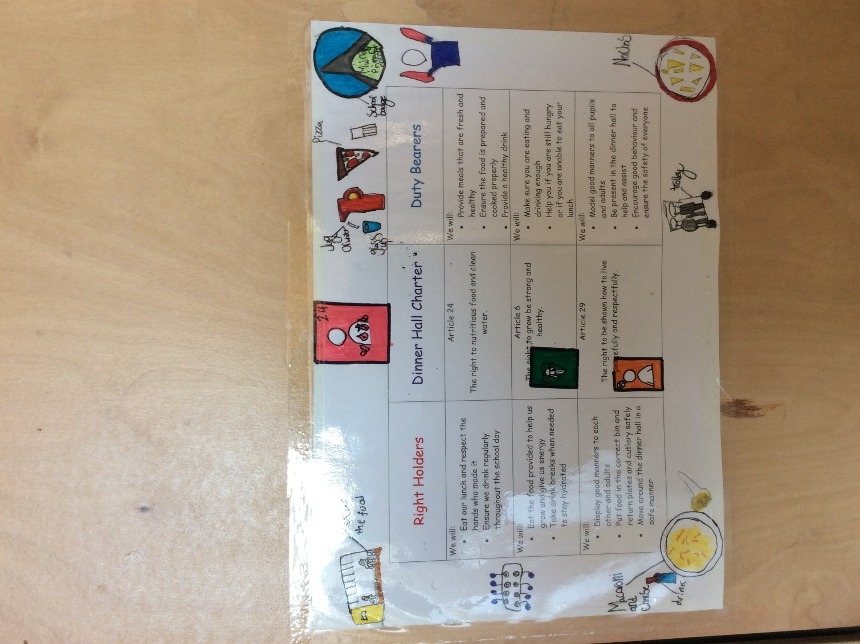

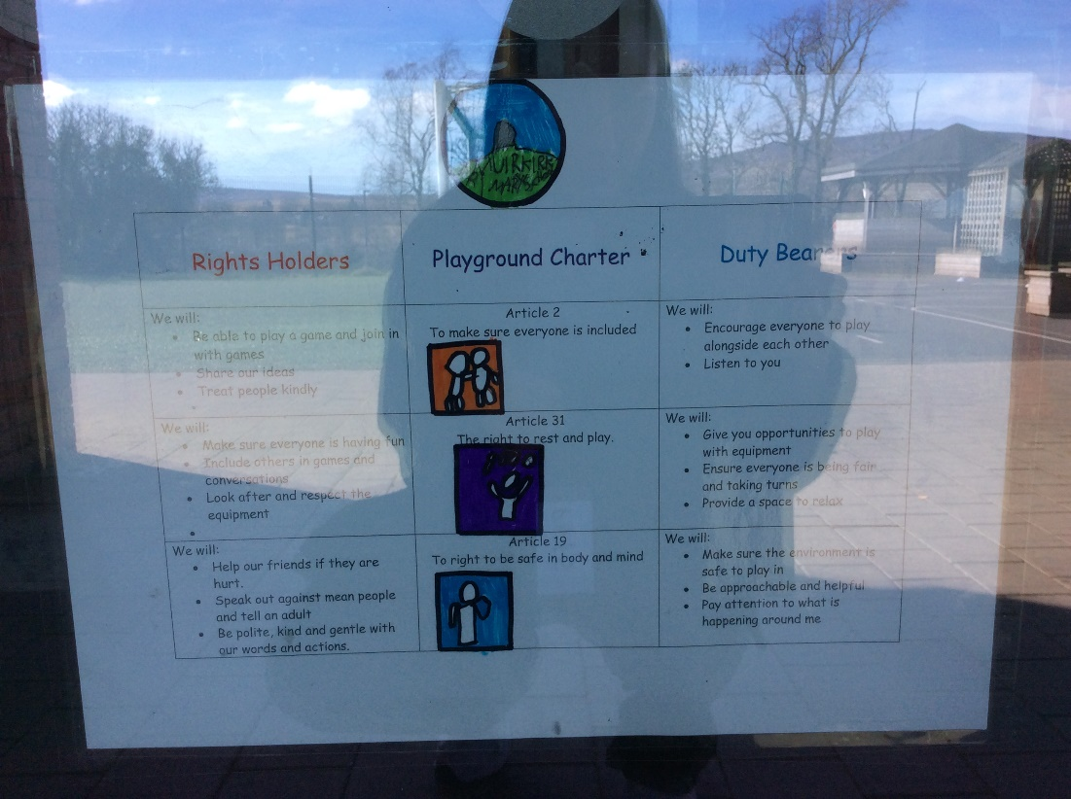

Additional information

For further information about Rights Respecting Schools, please visit: <https://www.unicef.org.uk/rights-respecting-schools/>

The pupils are still becoming used to the language we are using related to RRS. The following link provides the language and vocabulary associated with rights and being rights respecting: <https://www.unicef.org.uk/rights-respecting-schools/wp-content/uploads/sites/4/2023/11/RRSA-Vocabulary_Final_Nov-2023.pdf>