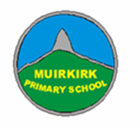
P7 Self Isolation Home Learning Pack B

Complete activities on the grid in any order and at a time that suits you.

Send pictures/videos of your completed tasks to your teacher by posting in your class Team or by sending an Email (lee.wallace@eastayrshire.org.uk). You can alternatively open Notebook in your class Team and type any answers directly onto the document which will save automatically.

The learning grids will be saved on your class Team in the Self Isolation Channel so you can access the links.

P7 Learning Grid B
Literacy | Numeracy | Health & Wellbeing | Learning across the Curriculum
Research Project-  Choose a city you would love to visit. Create a fact sheet (handwritten or typed on Notebook or Word, or a short PowerPoint)  - What is the currency?  - What are the main attractions/landmarks?  - What is the weather like? | Addition to 100  Using a deck of playing cards (or write out some numbers on pieces of paper). Flip over a card and add the number on. Your target is to reach 100! If you can, try playing in pairs and see who gets to 100 first.  Extension: Multiply instead of adding and try to reach 500. | Word Art  Draw or go to https://wordart.com/ and create a word art picture filled with compliments for someone that means a lot to you. | French Colours  Practise your colours in French using this website:  https://www.french-games.net/frenchtopics  Choose ‘Colours’ then try the activities and games.
Newspaper Challenge-  Using a newspaper, magazine or a book find words that you don’t know the meaning to. Write them down and use a dictionary (online dictionary is fine) to find a definition for them. | Sumdog-  Spend 45 minutes on Sumdog- if your teacher has set your class a challenge, complete this first. If not, choose your own games!  https://pages.sumdog.com/ | Lunch time  Make a healthy lunch for yourself and family, set the table then wash the dishes afterwards too. | Cereal Box Challenge  What can you make out of an empty cereal box?
Superhero Cartoon  Design yourself as a superhero and create a comic strip of your adventures. | Topmarks Rocket Rounding  Choose your own level of challenge when rounding numbers:  https://www.topmarks.co.uk/maths-games/rocket-rounding | Physical Education  Put on your favourite music and dance for 30 minutes!  Or try some Go Noodle https://video.link/w/IrpBc | Design Task  Design a suit to protect people against coronavirus. Write about and describe its features.
ABC Order-  Write the words you used in your newspaper challenge out in alphabetical order.  Word Search-  Create your own word searches using your words. Or use this link to get your computer to do it for you.  http://puzzlemaker.discoveryeducation.com/ | Challenge  Each row, column and mini grid must contain numbers 1 to 6. Don’t guess, use logic! | Mindfulness Hands Art-  Draw around your hands and decorate inside of the hand to show your emotions.  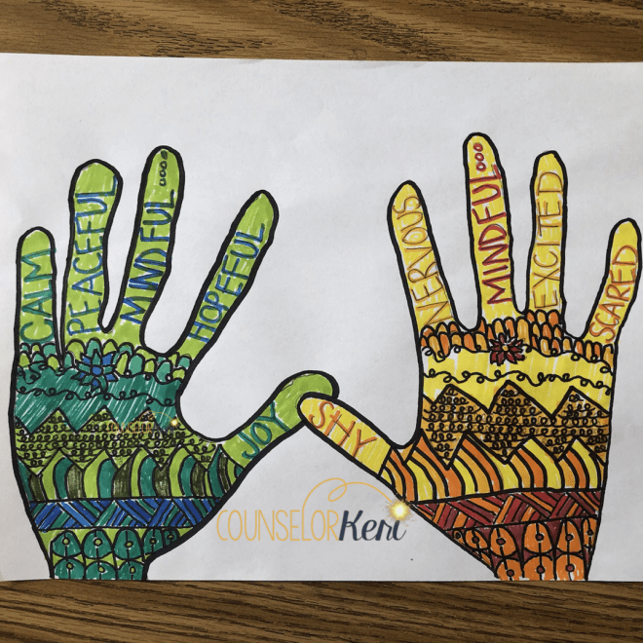 | History Detective  Look at this artefact:  What do you think it is and why?  Who might have used it?  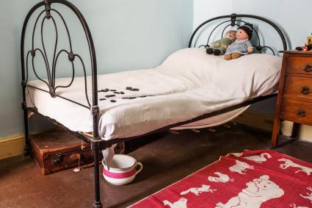
Reading for Enjoyment  Get comfy and read a book/magazine/anything at home. Alternatively, create a free parent account to access online books at: https://www.oxfordowl.co.uk/for-home/find-a-book/library-page/ | Topmarks Toy Shop Money  Choose your own level of challenge to add up amounts of money or practise giving change:  https://www.topmarks.co.uk/money/toy-shop-money | Physical Education  Make up your own sport. My favourite is to lie on your back with rolled up socks beside your feet and a basket at your head, then use your feet to pick up the socks and lift them up and over into the basket. | Farm to Plate-  Complete the Bitesize topic: Farm to Plate.  https://www.bbc.co.uk/bitesize/topics/zfmpb9q/articles/z4tbn9q  *Challenge- figure out the food miles and journey for the food in your fridge.

