P3 Self Isolation Home Learning Pack B

Complete activities on the grid in any order and at a time that suits you.

Send pictures/videos of your completed tasks to Mrs Clapperton by posting in your class Team Self Isolation section or by sending an Email (laura.clapperton@eastayrshire.org.uk). You can alternatively open Notebook in your class Team and type any answers directly onto the document which will save automatically.

The learning grids will be saved on your class Team in the Self Isolation channel so you can access the links.

P2/3 Learning Grid B
Literacy | Numeracy | Health & Wellbeing | Learning across the Curriculum
Design a Starbucks Smoothie-  Starbucks want you to design a new smoothie for their Spring/Summer collection.  Write the recipe-  - List the ingredients  - Method- how do you  make it?  - Draw a picture of  what it will look like. | Top marks Place Value Basketball  Choose your own level of challenge:  https://www.topmarks.co.uk/learning-to-count/place-value-basketball | Lunch time  Help make a healthy lunch for yourself and family, set the table then wash the dishes afterwards too. | Mapping  Draw a treasure map for inside your house.  Hide a toy and put x to mark the spot on your map.  See if someone at home can find the hidden treasure (toy).
Roy the Zebra Sentences Game  (Skip advert)  https://www.roythezebra.com/reading-games/sentences-that-make-sense-1-1.html  Click on the sentence that makes sense then build the online jigsaw as your reward. | Sumdog  Spend 20 minutes on Sumdog- complete your class challenge, set by your teacher, first. Then, choose your own games!  https://pages.sumdog.com/ | Physical Education  Make up your own sport. My favourite is to lie on my back with rolled up socks beside my feet and a basket at my head, then use my feet to pick up the socks and lift them up and over into the basket. | Nature watch  Look outside – what do you see?  Do you see animals?  What is the weather like?  What plants are growing?  What do the trees look like?  What has stayed the same or changed from yesterday?
Reading for Enjoyment  Get comfy and read a book/magazine/anything at home.  Have a chat about what you liked about the book and any interesting words you found.  Alternatively, create a free parent account to access online books at: https://www.oxfordowl.co.uk/for-home/find-a-book/library-page/  or read your books allocated by Mrs Wright on My Rising Stars https://my.risingstars-uk.com/Default.aspx?ReturnUrl=%2f | Topmarks Blast Off  Choose ‘Count on & Back’ then select your own level of challenge: https://www.topmarks.co.uk/learning-to-count/blast-off | Mindfullness  Relax with Cosmic Kids Zen Den – Be the Pond  https://video.link/w/frpBc | Sustainability  Watch the clips on BBC Bitesize about what to do with your rubbish https://www.bbc.co.uk/bitesize/topics/zwxsr82/articles/zdf9kmn  Is there anything more you can recycle or re-use at home?  Share the recycling message with someone to help get more people on board.
Alphabetical Order  (Skip advert) Look at the first letter of the word and put the words into the order of the alphabet.  https://www.roythezebra.com/reading-games/alphabetical-order-1.html | Topmarks Symmetry Matching  Try to find the other half of the symmetrical pictures, shapes and patterns.  https://www.topmarks.co.uk/symmetry/symmetry-matching | Physical Education  Try a Joe Wicks workout  https://video.link/w/srpBc  Try the ‘You Are The Best’ dance https://video.link/w/lrpBc | 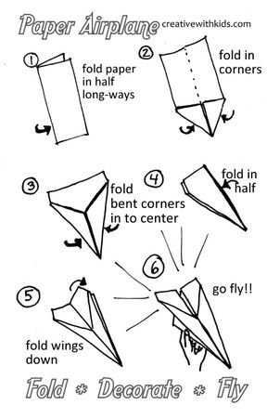
Acrostic Poetry  Acrostic poems are fun! The first letter in each line spells out a word. They do not have to rhyme, but the words should be carefully chosen for the best effect.  e.g. ALIEN  Awesome aliens have  Landed on Earth  Incredible but true  Everyone is flabbergasted  No one can see them but you!  Choose your word for down the side and have a go at our own acrostic poem! | Information Handling  Look at the pictograph and answer the questions.  https://www.softschools.com/math/data_analysis/pictograph/games/ | Giving Compliments  Say something nice to everyone in your house. | History Detective  Look at this artefact:  What do you think it is and why?  Who might have used it?  