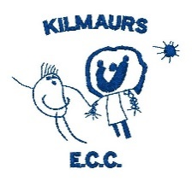**Curriculum Rationale**

**Our Vision**

At Kilmaurs ECC, we are committed to providing a fun, inclusive and nurturing environment where children are motivated to reach their full potential through learning and play

**Our Values**

* Happiness and Wellbeing
* Partnership with Parents
* Caring
* Respect
* Inclusion

We do this through promoting a holistic approach to the wellbeing of the child where kindness and self-care are vital.

**Our Learning Environment**

At Kilmaurs Early Childhood Centre (ECC), we provide an enriched learning environment designed to support the development of each child through a balanced approach to child-led, adult-led, and adult-initiated learning. Our pedagogy is grounded in play-based learning, with a strong emphasis on active engagement, both indoors and outdoors, promoting curiosity, creativity, and critical thinking.

Learning Spaces

Our carefully designed learning spaces are central to our approach, providing diverse environments that stimulate children's exploration and inquiry. Kilmaurs ECC is divided into three main areas:

1. The Rainbow Room (for 2-year-olds): This nurturing environment is designed for our youngest learners, with a focus on supporting their early development through play-based learning. Two dedicated staff members plan collaboratively, following the Realising the Ambition (RTA) well-being indicators, ensuring that the emotional and social needs of each child are met while encouraging their natural curiosity.
2. The Jungle Room (for 3-5 year-olds): This dynamic space is further divided into themed zones that cater to different areas of learning:
   * The Swamp: A creative area where children can engage in expressive arts, using various materials to explore art and design.
   * The Forest Floor: A writing table and mark-making zone, where children can develop early literacy skills through drawing, scribbling, and writing.
   * The Savannah: Our STEM area, where children can engage in problem-solving activities, construction, and scientific inquiry.
   * Mezzanine 1: Our Treehouse: A sensory and nurture space designed to provide a calming environment where children can explore sensory experiences or take quiet time to relax and reflect.
   * Mezzanine 2: The Canopy: A small world and storytelling area that encourages imaginative play and language development through storytelling, role play, and small-world exploration.

3. Our Garden: Our outdoor space is accessible to all children and plays a vital role in our curriculum. We believe that outdoor learning fosters resilience, independence, and an appreciation for nature. The garden is used for free exploration, as well as structured outdoor learning activities that support physical development, environmental awareness, and imaginative play.

**Collaborative Planning and Assessment**

Staff work closely together to ensure that planning is responsive to the children’s interests and developmental needs. Planning for the 3-5 year olds is structured across the zones of the Jungle Room, ensuring a holistic approach to learning. We utilise Curriculum for Excellence Tracking to assess and monitor the progress of each child, tailoring our teaching to meet their individual needs.

For our 2-year-olds in the Rainbow Room, the planning is carefully tailored to align with the RTA well-being indicators, focusing on nurturing emotional security, social interaction, and early learning milestones.

**Realising the Ambition: Being Me**

Our curriculum follows the principles of Realising the Ambition: Being Me, emphasising the importance of creating stimulating spaces, fostering quality interactions, and providing exciting learning experiences. The unique design of our learning environments, both indoors and outdoors, reflects our commitment to encouraging active play, inquiry, and meaningful engagement.

**Planning and Learning Documentation 3-5 year olds**

Our planning follows a dynamic 4-week cycle:

1. Finding the Threads (Week 1): Through observations, we identify children's emerging interests.
2. Sewing the Threads (Weeks 2-3): Experiences are designed to deepen learning through a blend of child-led and adult-initiated activities.
3. Reflection and Evaluation (Week 4): We reflect on the learning journey, evaluate outcomes, and identify next steps for each child.

Learning is captured through digital Learning Journals, where key learning moments and achievements, known as "WOW moments," are recorded. These journals are shared with families, ensuring ongoing collaboration between the ECC and home. Every 4 weeks, we publish a learning blog that documents the journey of the group, shared through GLOW, our ECC foyer TV, and the Learning Journals.

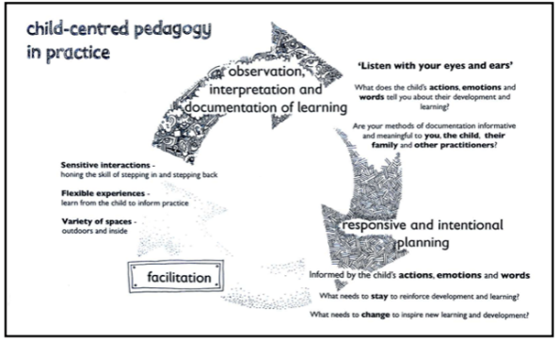Realising the Ambition (2020), talks about ‘growing and learning’ through the interactions, experiences and spaces. Through our Learning Journal observations we focus on quality interactions and meaningful experiences and we ensure that we create interesting spaces for the children to explore and develop.

**Planning for 2-year-olds**

Planning for 2-year-olds at Kilmaurs ECC over a 4-week period, following Realising the Ambition: Being Me (RTA), focuses on key areas: Well-being, Movement & Coordination, Confidence, Coordination & Curiosity, Literacy Learning, and Numeracy & Mathematical Learning. These areas are chosen based on observations of children's play and discussions with families.

Weekly Structure:

* Week 1: Staff observe children's engagement and identify focus areas, such as Movement or Confidence.
* Weeks 2-3: Child-led activities are tailored to support development in these areas, like introducing physical tasks for Movement & Coordination or counting games for Numeracy.
* Week 4: Reflections are shared in a weekly Learning Journal, showing photos and describing the children's experiences.

At the end of each month, a lived story blog highlights key learning moments, linking children's progress to the RTA focus areas. This process ensures a holistic and responsive approach to supporting development.

**7 Principles of Curriculum Design**

At Kilmaurs Early Childhood Centre (ECC), we are committed to providing a rich, nurturing, and stimulating environment for children. Our pedagogy is rooted in play-based learning and guided by the 7 principles of curriculum design: Challenge and Enjoyment, Breadth, Progression, Depth, Personalisation and Choice, Coherence, and Relevance. These principles form the foundation of our approach, ensuring that every child is supported in their unique learning journey through a balanced mix of child-led, adult-led, and adult-initiated learning.

The 7 principles of curriculum design are woven throughout our pedagogical approach, ensuring a rich, holistic learning experience for every child:

1. 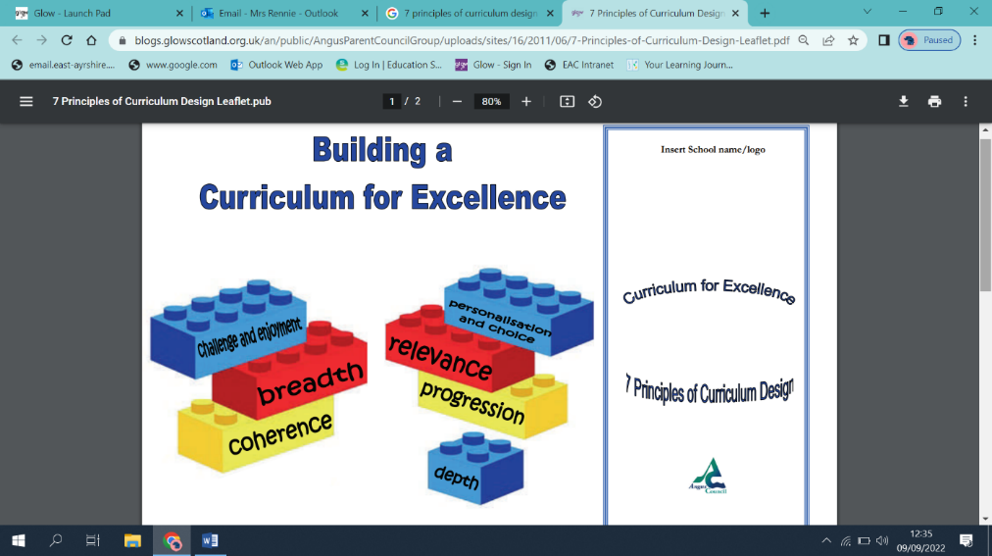Challenge and Enjoyment: Our child-led, play-based approach allows children to engage deeply with learning experiences that are both enjoyable and appropriately challenging. Whether indoors or outdoors, children are constantly encouraged to think critically and explore new ideas.
2. Breadth: Our varied learning spaces and activities provide a broad range of experiences, ensuring that children develop skills across all areas of learning—creativity, literacy, STEM, social-emotional development, and physical well-being.
3. Progression: Our planning cycle ensures that children’s learning progresses over time. We track individual progress using Curriculum for Excellence Tracking, adjusting our teaching strategies and learning opportunities to support each child’s continuous growth.
4. Depth: The 4-week planning cycle allows for sustained inquiry. During the “Sewing the Threads” phase (Weeks 2-3), children are encouraged to explore topics in depth, developing a deeper understanding of concepts through hands-on experiences.
5. Personalisation and Choice: Our curriculum is responsive to children’s interests, providing opportunities for personalisation in learning. By observing and following each child’s inquiries, we give them autonomy in their learning while also providing structured opportunities to extend their thinking.
6. Coherence: Learning experiences are interconnected across the curriculum. For example, a STEM exploration in the Savannah may inspire mark-making in the Forest Floor or creative expression in the Swamp, ensuring that learning is cohesive and integrated across different areas.
7. Relevance: We ensure that learning is meaningful by connecting it to the children’s everyday lives and experiences. Our educators use real-life contexts to make learning relatable and engaging, whether through nature-based play in the garden or storytelling in the Canopy.

Our whole approach is to build the foundations of learning, creating opportunities for children to develop at a manageable pace. Supporting play based learning promotes the skills necessary for reading, writing, and mathematical thinking as well as promoting curiosity, building resilience and improving cooperation, coordination and movement.

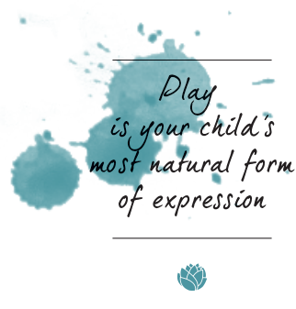At Kilmaurs ECC we strive to provide a nurturing, stimulating, and inclusive environment where every child can thrive and develop a lifelong love of learning.