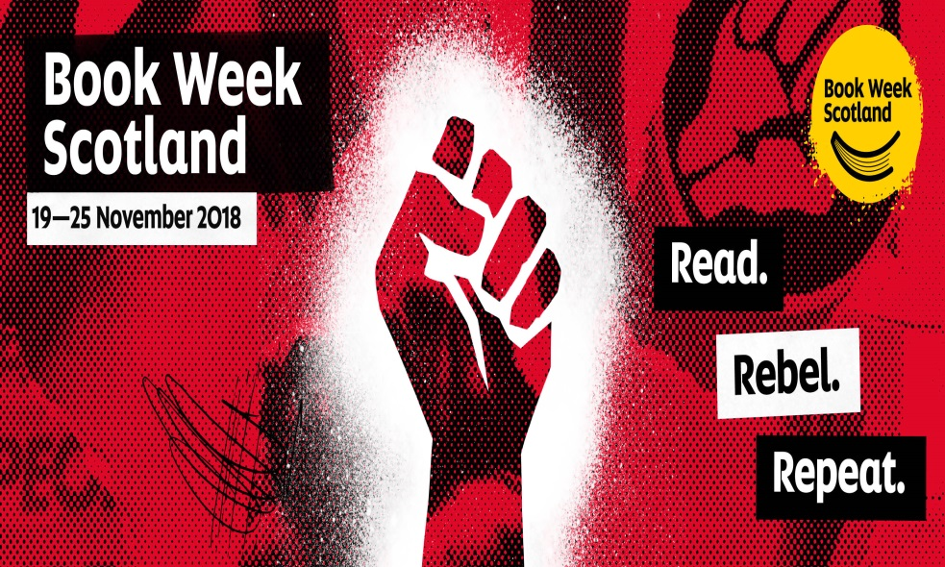
Grange Academy Library Newsletter
ISSUE 4 – NOVEMBER 2018
Book Week Scotland brought out the rebels in us this month!

It’s that time again, folks! Welcome to the latest edition of the library newsletter – I hope you’ll be interested to see what we’ve been getting up to throughout November…

Book Week Scotland
This month we celebrated Book Week Scotland from the 19th to the 25th of November. The theme for this year was “Rebel” which we explored by encouraging staff and pupils to tell us about something rebellious that they have done in the past. The submissions were posted on a display board in the library alongside a collection of stories featuring rebellious characters, and non-fiction books about real-life rebels such as Rosa Parks.
Thank you to everyone who contributed a submission – the display turned out really well and pupils had a lot of fun reading through the shenanigans we all got up to in the past!
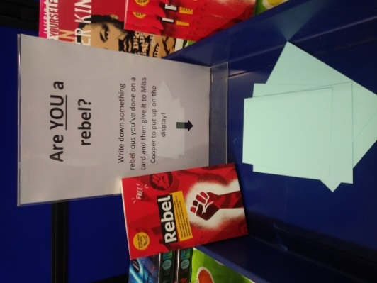

Graphic Novel Club This is a new club that has been in the works for some time and is finally up and running. My brilliant team of S4 girls kicked off our first meeting on Thursday 22nd.
The club will continue to run every Thursday and Friday interval in the library, where we will learn how to create our own comic books! The girls involved took part in a graphic novel workshop last term with Will Morris (graphic novel artist/author) and are keen to pass on the skills they learned to new S1 pupils.
Watch this space to see what we create in the weeks to come…

Movie Club
Our little movie club has been going great over the last few weeks! So far, we have focussed on animated short films as these allow us to watch the whole film and then discuss what we thought of it afterwards. Pupils have really engaged with the films we have watched, including “Alma”, “For the Birds” and “In a Heartbeat” – all of which are available to watch on youtube if you have a spare few minutes to fill.
Recently, pupils voted for the Christmas movie they would like to watch throughout December and the winner by a landslide was “The Grinch” – please encourage any other pupils to come along at lunchtimes on Thursday if you think they would enjoy it!

Bully Box & Worry Box
To coincide with anti-bullying week, a Bully Box has now been set up in the library. Pupils who are being bullied – or those who witness someone else being bullied – can post a slip in the box, which will be passed on to the guidance department.

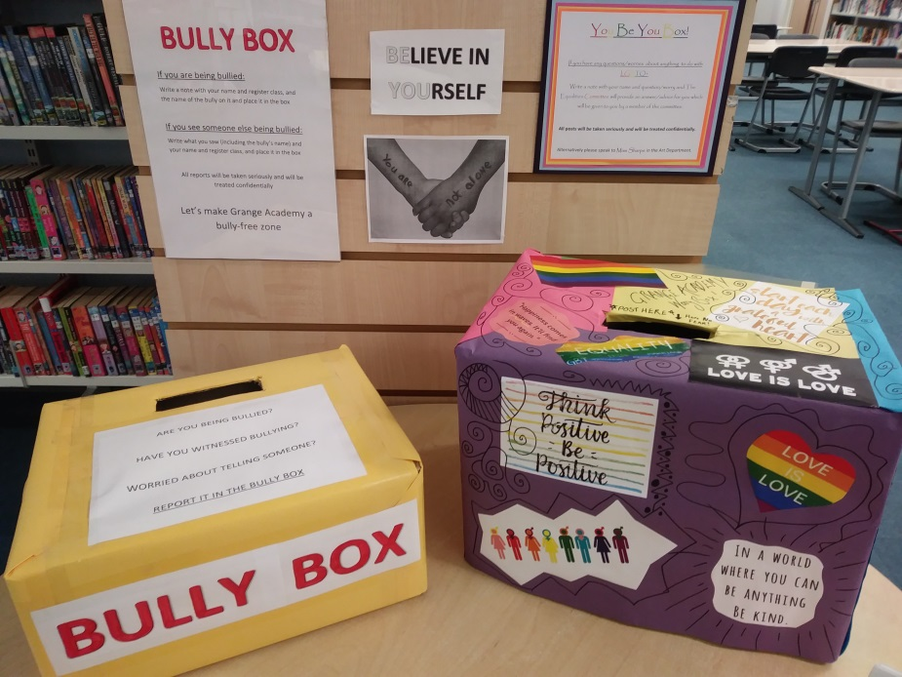

The Bully Box and the You Be You Box are now ready for pupils to use

Meanwhile, the “You Be You” worry box has been organised (and beautifully decorated!) by the Equalities Committee for pupils to post questions, comments and concerns relating to LGBT+ issues. We are hopeful that this will help Grange Academy become an even more inclusive school than ever.

The boxes are a good way for pupils to seek help and advice if they are not confident enough to approach staff in person, and all reports will be dealt with confidentially.

Mental Health First Aid Kits
Please continue to remind pupils about these. Resources are available to be borrowed from the library for as long as pupils need them.

If anyone would like more information about Mental Health First Aid Kits, don’t hesitate to get in touch with me.

Coming Soon…
As always, thanks for taking the time to read my little updates. I should have plenty more news for you next month - I’ll be hosting the Scholastic Book Fair during the first week in December so hopefully I’ll be able to report back to you all about what a success it was!

Also, I’ve been able to restrain myself from breaking out the Christmas decorations so far but I can’t promise that will last much longer…

Until next time!
Karen

