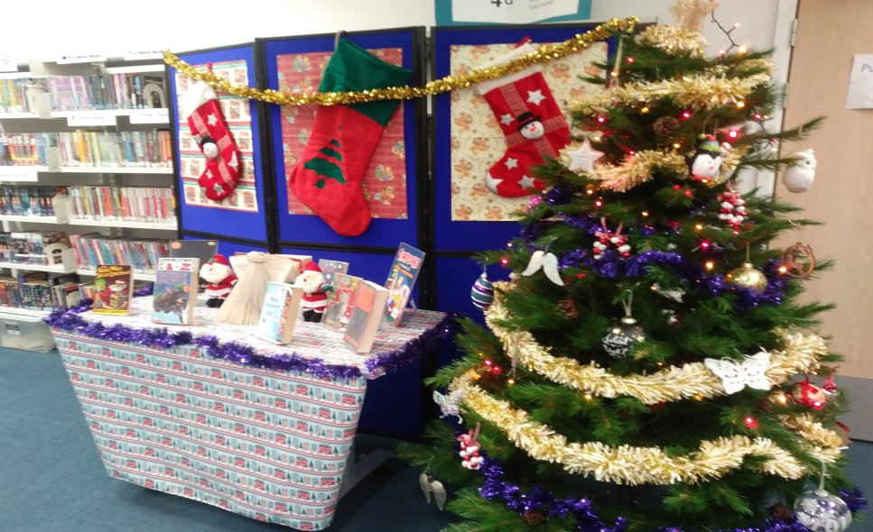
The Christmas books are out on display – Season’s Readings, everyone!
ISSUE 5 – DECEMBER 2018
Grange Academy Library Newsletter

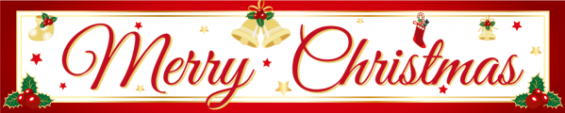
In the words of the great Noddy Holder…
“IT’S CHRISTMAS!”
Before you dash away home for the holidays, here’s your final update of the year on what’s been going on in the library.

Scholastic Book Fair
From the 30th of November to the 6th of December the library played host to the Scholastic book fair.
Pupils and staff were encouraged to come along and grab themselves a bargain as everything was on sale at half price – and the shoppers among you certainly didn’t disappoint! We ended up raising almost £400 for Scholastic, which translated into a hefty bundle of free new books for the school library. Many thanks to everyone who made a purchase!

Secret Santa with a Twist! As you know, instead of running a traditional Secret Santa among the staff this year, the fabulous ladies of the Art department came up with something a little bit different.
The money we would have spent on novelty gifts for each other was instead put towards buying presents for children across East Ayrshire which were then collected by the charity ‘Cash for Kids’.

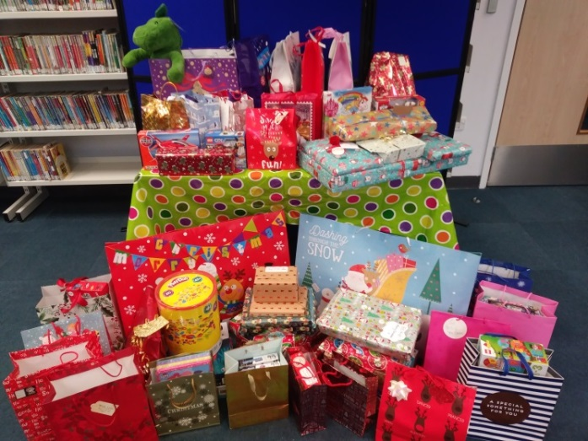
As you can see, Grange staff went above and beyond with their generosity! In addition to all the gifts, we were also able to gather over £150 in cash, all of which goes towards putting a smile on a child’s face this Christmas.
Thanks so much to all the incredible staff who made a donation.

Staff Christmas Lunch
On Wednesday 19th the library was the venue for our staff Christmas lunch. Each department was in charge of bringing a little something for the buffet, and the result was a banquet fit for a king (or several hungry teachers, at least!)
Kevin Dorrian gave a star turn as our very own Rab C. Nesbitt and had us all in stitches while he handed out prizes to everyone on the “Naughty and Nice” list.
Thanks again to the Art department for all their hard work organising, setting up and clearing up afterwards!

Craft Club
Over the past couple of months, Audrey Brotherston has been meeting with a small group of crafty pupils in the library during lunch breaks in order to make decorations to sell at the Christmas fair.
Their hard work certainly paid off as, at the fair on Saturday 8th the group managed to raise £111 for the school fund and completely sold out everything they had made!
We hope that some of the money raised can go towards supplies so that the group can continue to meet and create more beautiful crafts in the future.

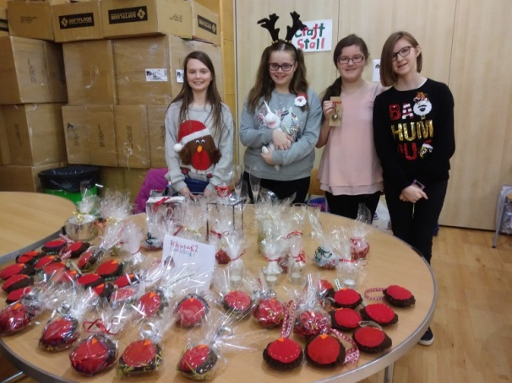

Merry Christmas
That’s it from me for this month, and in fact for this year!
I hope you all have a magical Christmas and a wonderful New Year when it arrives. All the best, and I’ll see you all in 2019

