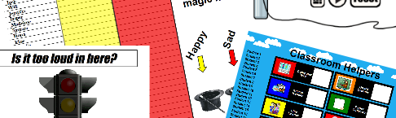
Learn PrometheanUKI 2018
To assist with your lesson preparation we have pulled together some video and document resources with support, training, hints, tips, ideas and advice to help you get the most out of your P…
Go to this Sway

