My name is Hazel Wills,
I am the Community Practitioner for
Lainshaw ECC

These are my contact details:
Mobile - 07876878835
Email – hazel.wills@east-ayrshire.gov.uk

If I’m not available, please contact my Lead Community Practitioner
(see below).
Times I am available are:
Monday to Thursday afternoons
1pm to 3pm

What I can help with?
*Bedtime routines *Creating and maintaining boundaries
*Challenging behaviours *Behavioural expectations
*Toilet training
*Weaning *Fussy eating *Cooking *Budgeting
*Communication & Language — SPARK/4 Is to Socialise
*Parent Groups — Bookbug/Families Connect/PEEP
*One-to-one support *Emotional support
*Telephone Support

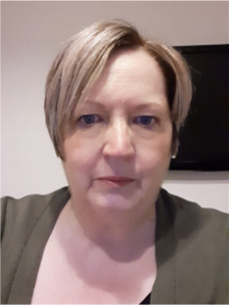
This is Liz Baird, my Lead Community Practitioner
To contact Liz
Telephone - 07920845405
Email -elizabeth.baird@east-ayrshire.gov.uk

Community Practitioners - North Team
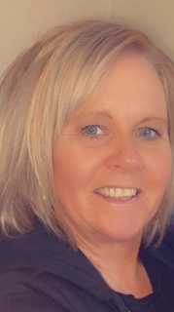
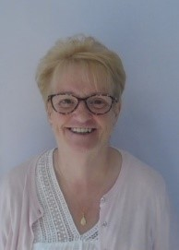
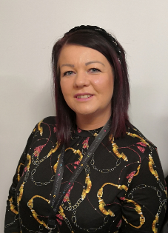
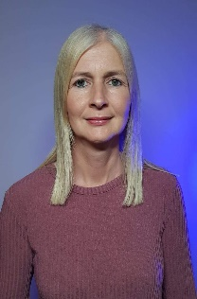

Alison Amanda Elaine Michelle Hazel
McLeod Latif Rutherford Colquhoun Wills

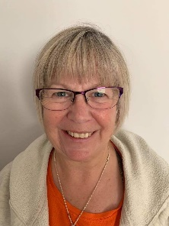
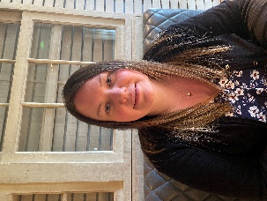
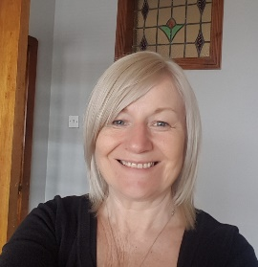

Karen Karen Lorraine Lynnette Gillian
Connor Love Skeoch Milligan Salmon

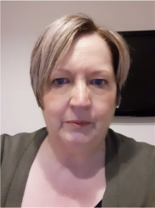
Liz
Baird
Lead Practitioner

How we support the ECC
We offer confidential support and guidance to parents, carers and families for a variety of reasons. It can be for parenting support, practical support or emotional support. We can also signpost you to various other services.
Our help can enhance your understanding of your child’s behaviour, their communication style and why they sometimes do the opposite of what you ask them to do. The Community Practitioner can meet with you in the ECC, meet at place more convenient to you or speak with you over the telephone.
We aim to run parent/carer groups on various subjects including social wellbeing, understanding children’s behaviour, communication and language as well as baby massage and fun, art/craft groups. These are for parents/carers to enjoy with their children both indoors and outdoors.

For support, please contact us direct via telephone/email or speak to a member of the ECC. All of our individual support is in confidence.

