**Wee Rid Motor**

In my wee rid motor

I can gang for miles

Up an doon the gairden

Through the lobby whiles.

Mony a bigger motor

Gangs tae toons afaur

Nane can gang whaur I gang

In my wee rid caur.

[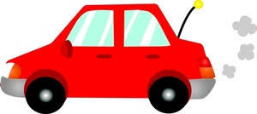](https://www.google.co.uk/url?sa=i&url=https%3A%2F%2Fblogs.glowscotland.org.uk%2Fer%2Fmchclclassof2023%2F2017%2F01%2F30%2Fscots-poetry%2F&psig=AOvVaw32ci7Gsfj0ZsrHDFHVA79F&ust=1611048035602000&source=images&cd=vfe&ved=0CAIQjRxqFwoTCNinl-GTpe4CFQAAAAAdAAAAABAI)