Lainshaw Early Years Home Learning

Day six: Monday 18th January

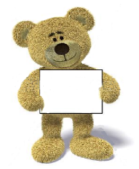

* **Health and Wellbeing Move to the Groove Activity:**
* Todays sway hwb link will be……
* Our Shake it off dance! Please click on this video within the sway link to carry out.



**Literacy:**

* Today’s literacy activity is to……
* read a story you have in the house and talk about what happened next, after the story has finished. Do some story recall. Can you predict parts of the story? Tell us about what happened in the story and what you think might happen next



**Numeracy:**

* Today’s Numeracy activity is…..
* will be exploring mathematical language, can you empty and fill containers… it is half full/full/empty. You can use rice, pasta, dirt, soil, water…and for containers you can use empty bottles, cups, bowls – anything at all! It is super fun and highly beneficial for enhancing mathematical language.



* **Arts & Crafts**
* Today’s arts and crafts activity is….
* Can you use cotton buds to paint pictures using dots. This technique is called Pointillism. See pic for reference.

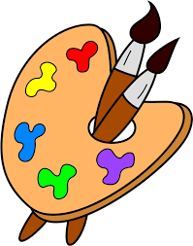



**How these experiences benefit your child:**

* This learning experience will develop your child’s inquiry, curiosity and discovery skills.
* In art they will use a variety of fine motor skills, hand eye-co-ordination, and develop their concentration and problem solving abilities and ultimately their communication skills.
* In numeracy they will enhance numeracy language.
* In literacy they will learn prediction and enhance language skills.

**Science & Technologies:**

* Today’s science & tech activity is…..
* Can you discuss changing states and make some playdough. See picture for reference and recipe.

|  |  |
| --- | --- |
| * **This weeks Celebrations are:**   See the source image | * **We will also have:** * Song time * Story time * Makaton link/staff Makaton |



**Our Fun Friday task this week is…….**

**TO MAKE A CAKE!!! Show us the pics!**