Lainshaw Early Years Home Learning

Day Two: Tuesday 12th January

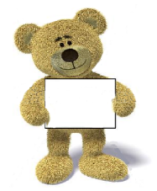

* **Health and Wellbeing Move to the Groove Activity:**
* Todays sway hwb link will be……
* Our I like to move it dance! Please click on this video within the sway link to carry out.



**Literacy:**

* Today’s literacy activity is to……
* will be to read a story with mummy/daddy and retell your favourite part and draw a picture to go along with the story. This learning is listening, memory and story telling/sequencing.



**Numeracy:**

* Today’s Numeracy activity is…..
* will be a snap card game, don’t worry if you don’t have card you can make your own – draw some simple pictures on paper or shapes or colours and play snap this way 😊 Who was the winner!



* **Arts & Crafts**
* Today’s arts and crafts activity is….
* To draw your favourite story characters and tell us why!





**How these experiences benefit your child:**

* This learning experience will develop your child’s inquiry, curiosity and discovery skills.
* They will be using in literacy.. skills for listening, memory and story telling/sequencing.
* They will be using in numeracy… skills on attention, focus, quick thinking.

**Science & Technologies:**

* **Today’s science & tech activity is…..**
* **Grow a rainbow (see pic attached)**

|  |  |
| --- | --- |
| * **Today’s Celebrations are:**   See the source image | * **We will also have:** * Song time * Story time * Makaton link/staff Makaton |



**Our Fun Friday task this week is…….**

**TO MAKE A DEN!!! Show us the pics!**