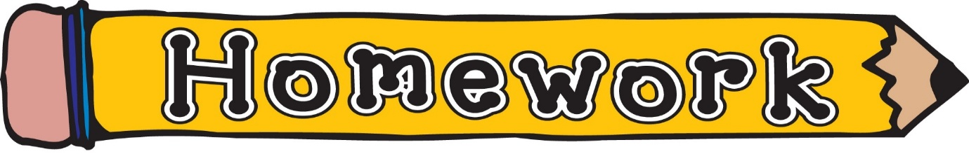

Tuesday 20th October
Please use the song below to reinforce the difference between letter names and sounds.
Alphabet Phonics Song – YouTube – Epic phonics
https://www.youtube.com/watch?v=5PmB3SIjNdQ

“Walk the Walls” our classroom phoneme song. This will be updated as new phonemes are taught.
sh, th, ng, ch, wh, ph, ee, oo, ck, ai, oi, oa, ea, ‘y’ (as in ay), ss, ll, ff, ow (as in owl), ‘ou’, ‘oi’, ‘igh’, ‘y’ (as in fly), ‘i-e’, ‘o-e’, ‘a-e’, ‘e-e’, ‘a-e’, ‘e-e’, ‘u-e’, ‘ew’, ‘ue’, ‘ow’ (as in snow), ‘mb’, ‘aw’, ‘wr’. ‘wa’

Phoneme ‘wa’ | - Check homework jotter for word list  - See front page of homework jotter for ideas for phonic/spelling tasks
Reading Book(s) | - Please read your child’s reading book as often as possible. Using the questions at the back is also helpful

