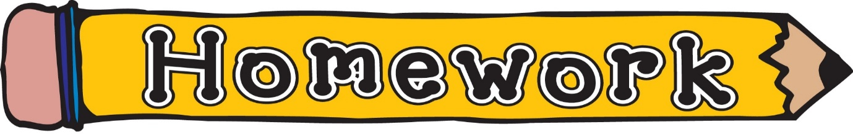

Tuesday 22nd September
Please use the song below to reinforce the difference between letter names and sounds.
Alphabet Phonics Song – YouTube – Epic phonics
“Walk the Walls” our classroom phoneme song. This will be updated as new phonemes are taught.
sh, th, ng, ch, wh, ph, ee, oo, ck, ai, oi, oa, ea, ‘y’ (as in ay), ss, ll, ff, ow (as in owl), ‘ou’, ‘oi’, ‘igh’, ‘y’ (as in fly), ‘i-e’, ‘o-e’, ‘a-e’, ‘e-e’, ‘a-e’, ‘e-e’, ‘u-e’, ‘ew’, ‘ue’, ‘ow’ (as in snow), ‘mb’, ‘aw’

Phoneme Strips | Consolidation tasks are being completed in class. New weekly phoneme will commence Monday 28th September
Reading Book(s) | Please read your child’s reading book as often as possible. Using the questions at the back is also helpful.
Numeracy | Sumdog – Details how to login are inside the front cover of their homework jotter.

