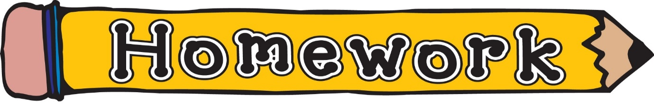

Monday 14th September
Please use the song below to reinforce the difference between letter names and sounds.
Alphabet Phonics Song – YouTube – Epic phonics
“Walk the Walls” our classroom phoneme song. This will be updated as new phonemes are taught.
sh, th, ng, ch, wh, ph, ee, oo, ck, ai, oi, oa, ea, ‘y’ (as in ay), ss, ll, ff, ow (as in owl), ‘ou’, ‘oi’, ‘igh’, ‘y’ (as in fly), ‘i-e’, ‘o-e’, ‘a-e’, ‘e-e’, ‘a-e’, ‘e-e’, ‘u-e’, ‘ew’, ‘ue’, ‘ow’ (as in snow), ‘mb’, ‘aw’

Phoneme Strips | Consolidation tasks are being completed in class.
Reading Book(s) | Please read your child’s reading book as often as possible. Using the questions at the back is also helpful.
Maths | Number bonds to 10/20 –  Topmarks – Hit the Button  https://www.topmarks.co.uk/maths-games/hit-the-button  This is the site the children are familiar with. They are also aware of how to practise this without going online.

