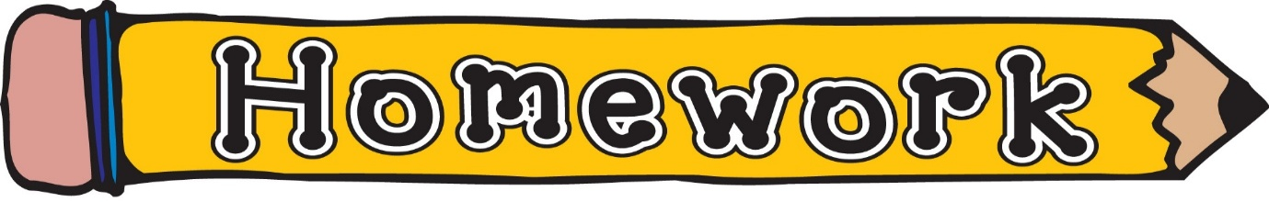
Monday 1st June
- New reading book issued (see book wallets in school bags)
- Common words revision (see front page of homework jotter)
- Ailen Attack – Click the link https://mathsframe.co.uk/en/resources/resource/469/Coordinates-Alien-Attack or search Alien Attack Coordinates
Remember to always challenge yourself!

