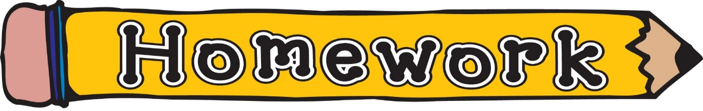
Monday 18th May
- New reading book issued (see book wallets in school bags)
- Common words revision (see front page of homework jotter)
- Sumdog challenge
Remember to always challenge yourself!

