Walk to School Week
18th – 22nd May 2026

Monday | Wear odd socks | 
Tuesday | Wear bright  Accessories  (school uniform still to be worn) | 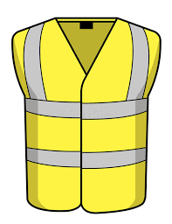
Wednesday | Wear a hat and/or sunglasses |   
Thursday | Wear odd  shoes | 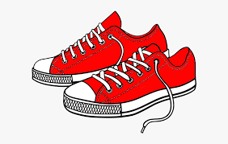
Friday | Crazy hair  Day!!! | 

