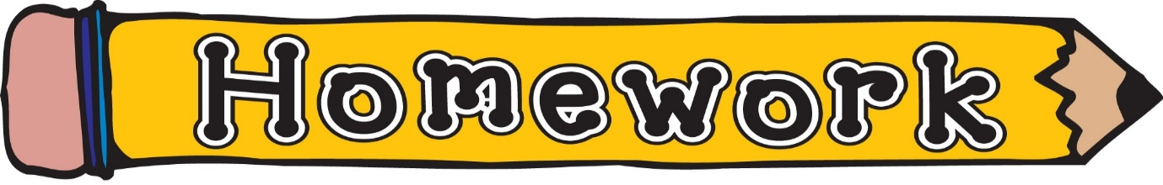
Monday 16th March
- New reading book issued (see book wallets in school bags)
- Phonics/spelling task (see front page of homework jotter)
- Money– Click the link or Google Topmarks Toy Shop https://www.topmarks.co.uk/money/toy-shop-money
Remember to challenge yourself!

