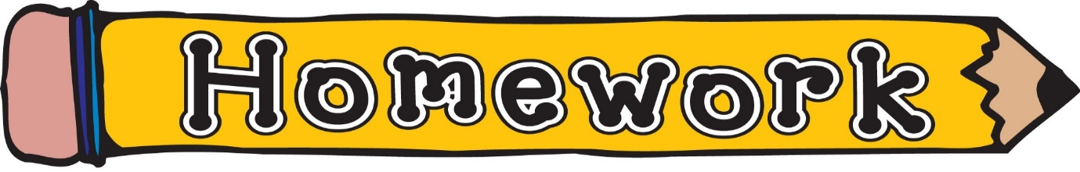
Monday 16th February
- New reading book issued (see book wallets in school bags)
- Phonics/spelling task (see front page of homework jotter)
- IDL homework task (see homework jotter)
Knights & Castles
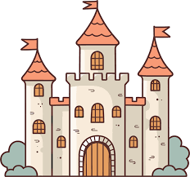
Your challenge is to make a model of a castle. You could do this by using lego, recyclable materials or clay etc… Your castle must be no bigger than 50cm wide and 1m tall.

You should be prepared to talk to the class about your castle. You might want to bring notes with you or create a small poster to support you when discussing your castle to your class.
Your teacher will be looking for 3 things while you are speaking;
1 – Clear, loud voice
2 – Eye-contact
3 – A description of your castle and the features you have included
Although you may need some adult help, the majority of the work should be your own. Be creative!

Please hand work in on Monday 9th March

