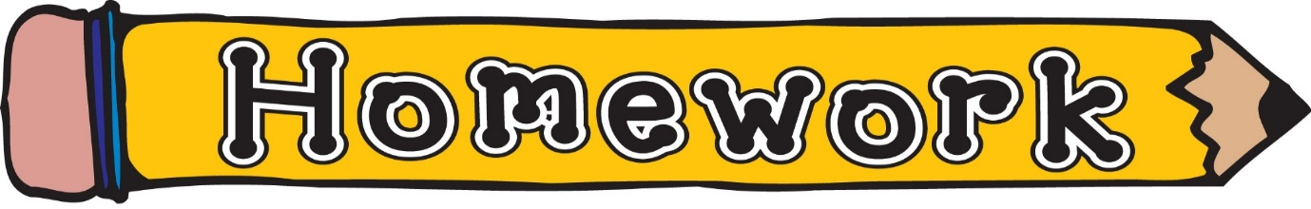
Monday 26th January
- New reading book issued (see book wallets in school bags)
- Phonics/spelling task (see front page of homework jotter)
- Time – Click the link on our class blog to access the matching pairs game or Google Topmarks and search the matching pairs time game
https://www.topmarks.co.uk/Flash.aspx?f=matchingpairstimev3
Remember to always challenge yourself!

