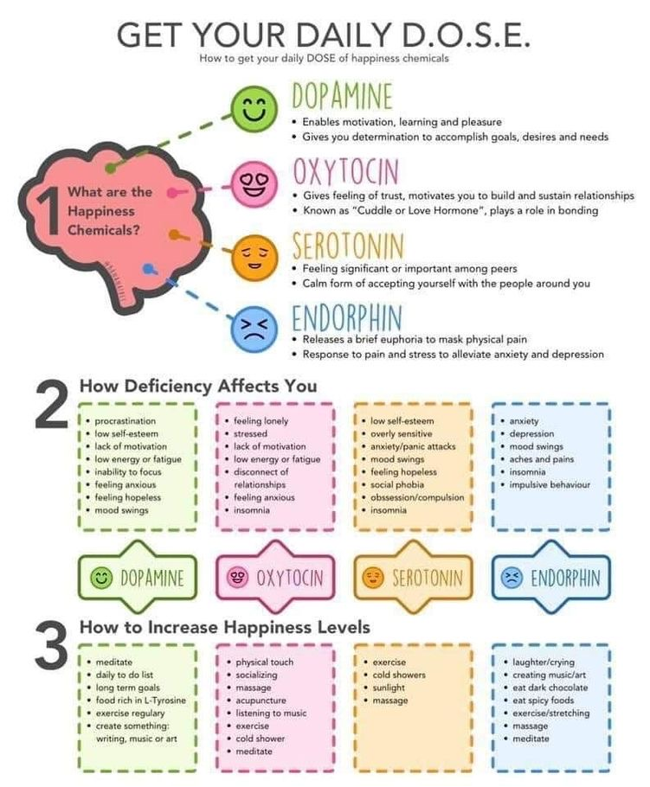

Your Daily Dose of Happy Chemicals.
Dopamine, Oxytocin, Serotonin, Endorphins
Do as many of these activities as you can and tick box when an activity is completed:

Mindfulness
Self-care
Sing/listen to music
Dance
Laugh/smile
Go for a walk
Draw/puzzles
Cuddles
Complete task list
Chat to friends and loved ones
Yoga
Meditation
Go outdoors
Show gratitude
Stop and take 3 deep breaths

