Fun at home:
Activity: Where are all the
Numbers ?

You will need: no resources needed!
Just your eyes

How to Play: When you are out and
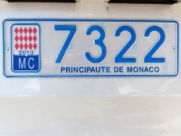
about, look around you for all the numbers you can find: on houses, on buses, in shops, in lifts ( press the button of your floor), on car registrations... Try adding up the numbers on the houses in your street or the numbers on your mum or dad’s car number plate.

Literacy and Numeracy activities

# ScottishAttainmentChallenge

