Fun at home:
Activity: Playdough Geometry

You will need: cocktail sticks,
playdough
How to Play: Roll the playdough into
small marbles. Start getting creative
making shapes and structures with the sticks and dough: squares, rectangles, triangles.
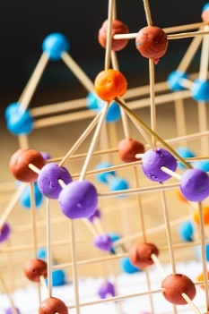
You can experiment with more complicated 3D structures. Count how many dough marbles and sticks you needed for
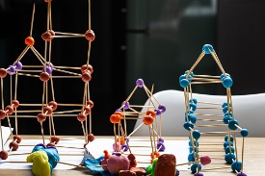
each shape you have created

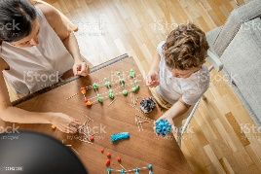
Have a competition to see how can build the strongest structure. Which structure can hold up the most weight. Try to see if you can work out what made the sturture so strong and see if you can make structures which are even stronger.
Literacy and Numeracy activities

# ScottishAttainmentChallenge

