Fun at home:
Activity: Pipe cleaner Alphabet

You will need: pipe cleaners
Card, glue, scissors

How to Play: Have fun practising
your writing skills with pipe cleaners. Bend them to shape the letters of the alphabet; you can straighten and reuse them as often as you like You can also write your name and glue it on a piece of card to make a name plaque for your room.
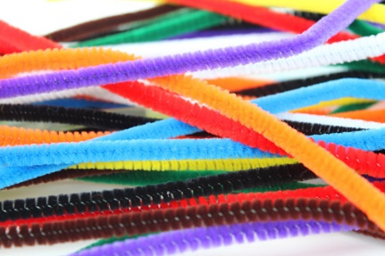
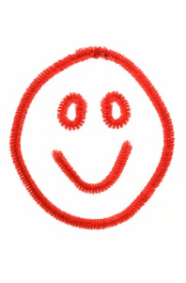
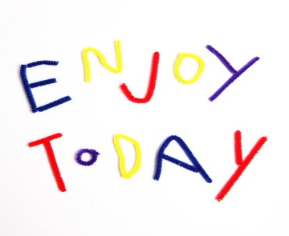

Literacy and Numeracy activities

# ScottishAttainmentChallenge
