Fun at home:
Activity: Counting and Sorting
games

You will need: pine cones, conkers,
leaves

How to Play: Gather cones, leaves
and conkers; sort them out in three
groups: put all the conkers together, do the same with the cones and leaves. Next count how many of each you have; do you have more cones than conkers? How many? Do you have more conkers than leaves? Can you
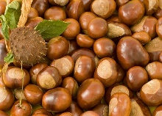
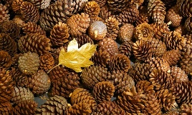
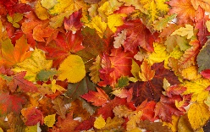
tell how many? Remember to write all the numbers down. To finish, sort out all your cones, leaves and conkers from biggest to smallest
Literacy and Numeracy activities

# ScottishAttainmentChallenge

