Fun at home:
Activity: Alphabet Tree or Garland

You will need: leaves, cardboard,
string, glue, markers

How to Play: collect leaves
of different shapes and colours
Write the letters of the alphabet on the leaves.
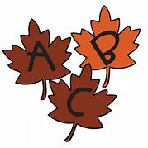
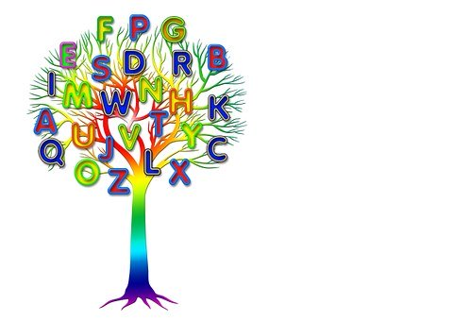
- Next cut out a cardboard tree shape and glue all the lettered leaves to make your tree.

- To make a garland instead, string all the leaves together.

- Mix up the leaves and then randomly pick 10 leaves. See who can make the most words or the longest word with their leaves.

- Select one of your words and make up a story about your word and tell someone in your family your story.
Literacy and Numeracy activities

# ScottishAttainmentChallenge

