Fun at home:
Activity: Tray Scrabble

You will need: a tray filled with sand
rice or rice puffs, card, scissors,
markers (or scrabble letters)

How to Play: Fill the tray with rice or
sand. Write several complete sets of
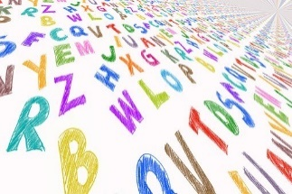
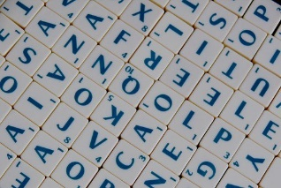
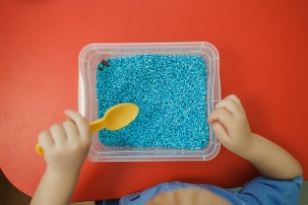
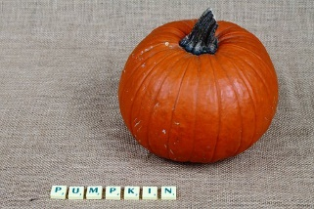
alphabets, cut the letters out and hide them in the sand or rice. The players in turn must find 7 letters and make a word. Each word scores a point for each letter. After 5 turns, each player adds up his/her points; highest score wins the game. Happy spelling and adding
Literacy and Numeracy activities

# ScottishAttainmentChallenge

