Fun at home:
Activity: Comparing Game

You will need: 2 apples (or any fruit
or vegetable you have in the house)
kitchen scales, a measuring tape
How to Play: weigh and measure
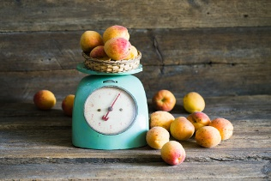
the 2 apples. What is their total weight? What is their weight difference ? Next, with a measuring tape, measure their circumference; is one apple fatter than the other ? By how many centimetres and millimetres? Write all the measurements down. You can weigh, measure and compare any objects you like, even your toys!
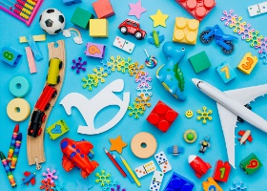
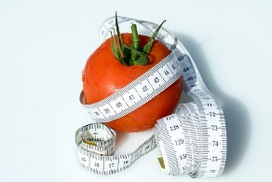
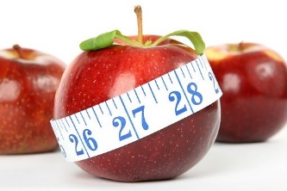
Literacy and Numeracy activities

# ScottishAttainmentChallenge

