Fun at home:
Activity: Pumpkin Seeds Fun
Maths

You will need: 1 small + 1 large
pumpkin, a few drops of food
colouring, wire (or large needle and string or wool) cardboard, scissors
How to Play: The players must weigh
the two pumpkins and calculate their difference in weight; next they must“guesstimate” the number of seeds in each pumpkin: does the big pumpkin contain more seeds than the small one? Are the seeds bigger, smaller?
Wash, dry and count out 100 seeds, then colour ¼ of the seeds red; ¼ blue; ¼ green, ¼ yellow. How many seeds of each colour do you have in each ¼?
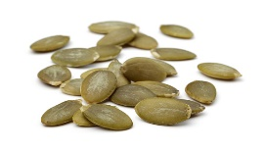
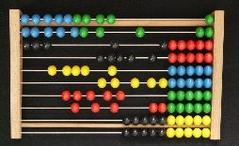
Use the seeds to make an abacus by stringing them on bits of wire and attaching them to a cardboard frame
Literacy and Numeracy activities

# ScottishAttainmentChallenge

