Back to school - friendships - primary

What is this?
These activities provide opportunities to talk about the importance of friendships.

For children at nursery and P1
- Talk to your child about a friend they are looking forward to playing with again. Explore with your child why they enjoy playing with them.
- Help your child draw a picture of them and their friend playing together.
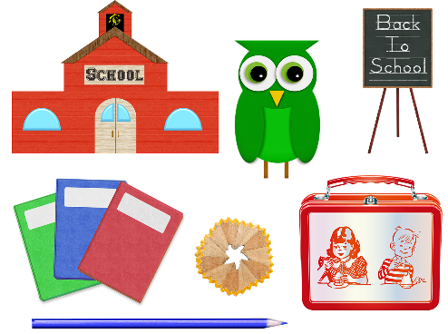

For children at P2/P3/P4
- Talk together about how it might feel to see people you have not seen for a while. Ask your child if they think people may look different. For example, have grown taller, have a different hairstyle, lost or gained teeth.
- Talk about what has changed about you since you last met friends and family members. Encourage your child to think about what might be different about them too.
- Together draw or write down things that have changed about your child and things your child has done in recent months. These things can provide helpful prompts for your child to talk about with classmates and when making new friends.

For children at P5/P6/P7
- When talking about returning to school and meeting up with friends again, discuss with your child their thoughts on their different friends and what it is about them that they like. What qualities are important to them for a friend to have? Can they see these qualities in different friends?
- Together, use words and drawings to create a picture of what makes a good friend. Ask your child if every good friend needs to have the same qualities? Are some qualities more important to them than others?
- Ask your child about how they would like other people to think of them. Encourage your child to ask family members to tell them what they think are some of your child’s best qualities.
